Introduction
Biodiversity Response Planning (BRP) is a long-term area-based planning approach to biodiversity conservation in Victoria. It is designed to strengthen alignment, engagement and participation between government, Traditional Owners, non-government agencies and the community.
DELWP Regional staff have been working with stakeholders on actions to conserve biodiversity in specific landscapes, informed by the best available science and local knowledge.
These Fact Sheets capture a point in time, reflecting data and knowledge available in 2020. They provide information for many (but not all) landscapes across Victoria, containing general information on the key values and threats in each area, as well as the priority cost-effective actions that provide the best protection of biodiversity. Fact Sheets are intended to provide useful biodiversity information for the community, non-government and government organisations during project planning and development.
Further information and the full list of Fact Sheets is available on the Department’s Environment website.

Landscape description
This 7,230ha area encompasses Point Nepean and Mornington Peninsula National Parks, as well as the coastline on the southern side of the peninsula that links them. The landscape has 52% native vegetation, and 45% public land.

Cultural importance
We recognise that the entire landscape has high cultural value for the Bunurong People. The area (as pictured below) has recorded over 450 cultural sites of importance with the discovery of shell midden sites, quarry sites and artefacts recovered and recorded.
Pulpit Rock at Cape Schanck is also recognised as a place of spiritual importance to the Bunurong People as it holds the resting place for the creator spirt Bunjil as told in the dreamtime stories. Point Nepean is the place the Bunurong women were abducted by sealers and taken across Bass Strait to Tasmania, and finally the Moonah Forest in Point Nepean is the resting place for elders’ remains, with the most recent remains placed there in 2019 – information shared by Bunurong Land Council.
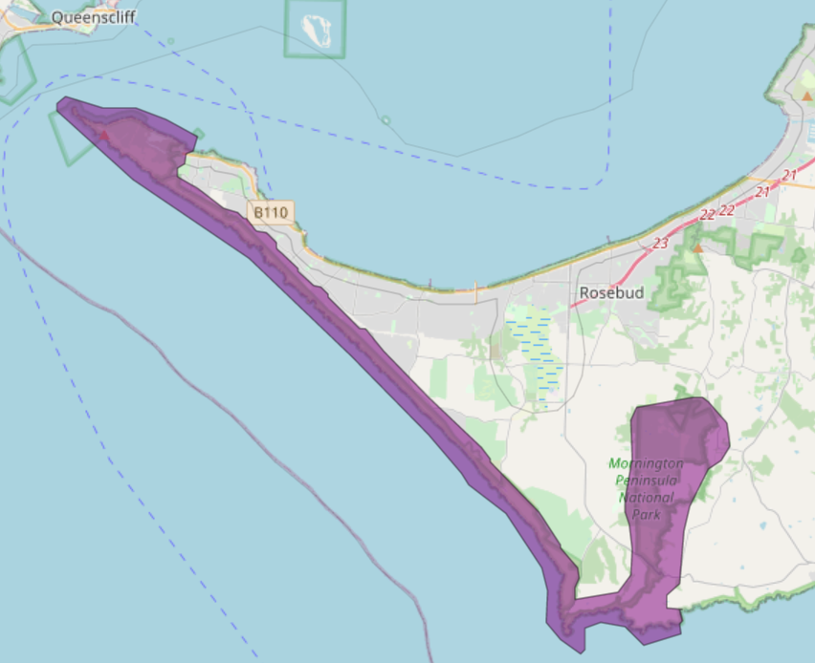
Figure 1: Map showing location of Point Nepean and Mornington Peninsula National Parks landscape (purple).

Habitat Distribution Models identify 4 species with more than 5% of their Victorian range in this landscape | Traditional Owners, stakeholders and community groups identified the following species of interest
- 4 Plant species  - 1 species with more than 10% of their Victorian range in this landscape  - Notable species: Coast Bush-pea (rare, 16% statewide range in area), Venus-hair Fern (endangered, 8.9% statewide range in area), Coast Bitter-bush (vulnerable, 6.4% statewide range in area), Frankston Spider-orchid (endangered, 5.1% statewide range in area) | - Poa poiformis var. ramifer  - Adraina quadripartia  - Nicotiana maritima  - Stackhousia spathulata  - Colobanthus apetalus var. apetalus  - Lotus australis  - Zygophyllum billardierei  - Olearia sp 2  - Berula erecta  - Pultanaea canaliculata  - Glycine latrobeana  - Euphrasia collina  - Rare and Endangered orchids - Caladenia robinsonii, Corybas sp. aff. diemenicus, Corybas despectans, Cobra Green Hood, Leafy Green hood  - Wood Sorrel  - Dainty Maidenhair Fern
- 0 Mammal species with more than 5% of their Victorian range in this landscape | - Long-nosed Bandicoot  - White-footed Dunnart
- 0 Reptile species with more than 5% of their Victorian range in this landscape | - Swamp Skink
- 0 Bird species with more than 5% of their Victorian range in this landscape  - Notable species: Hooded Plover (vulnerable, 2.0% statewide range in area), Black-faced Cormorant (near threatened, 1.2% statewide range in area), Sooty Oystercatcher (near threatened, 1.2% statewide range in area) | - White-bellied Sea Eagle  - Powerful Owl  - Lewin's Rail  - Black Falcon  - Chestnut-rumped Heathwren  - Grey-crowned Babbler  - Hooded Plover  - Ruddy Turnstone  - Sooty Oystercatcher  - Spotted Harrier  - Australasian Bittern
- 0 species of amphibians with more than 5% of their Victorian range in this landscape | - Southern Toadlet

Strategic Management Prospects
Strategic Management Prospects (SMP) models biodiversity values such as species habitat distribution, landscape-scale threats and highlights the most cost-effective actions for specific locations. More information about SMP is available in NatureKit.
Actions with area in the top 3% and top 10%
Specific Action | Area in top 3% (ha) | Area in top 10% (ha)
Control Rabbits | 30 | 3,846
Control Total Grazing Pressure | 636 | 2,101
Control Overabundant Kangaroos | 51 | 1,618
Control Weeds | 0 | 1,543
Control Foxes | 0 | 888
Control Cats | 0 | 858
Control Domestic Grazing | 0 | 724
Permanent Protection | 0 | 603
Revegetation | 0 | 215
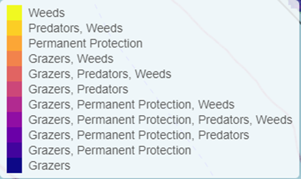
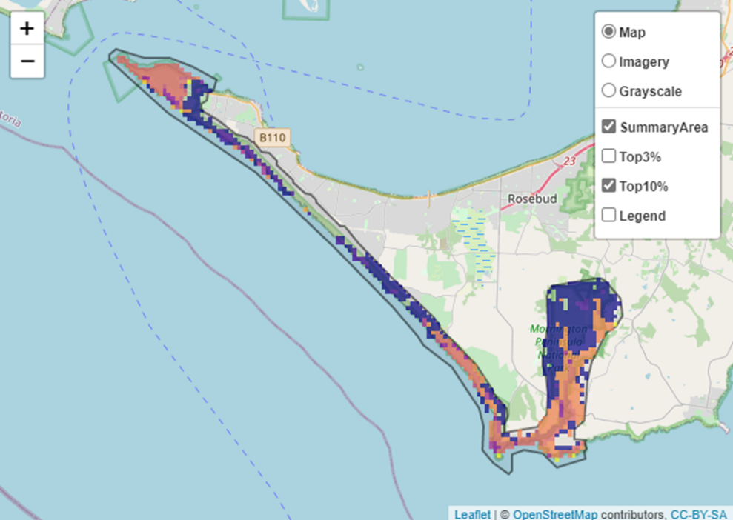
Areas of Point Nepean and Mornington Peninsula National Parks shown in Figure 2 have highly cost-effective actions (within the top 10% of cost-effectiveness for that action across the state) that provide significant benefit for biodiversity conservation.
Figure 2: The SMP priority actions which rank among the top 10% for cost-effectiveness of that action across the state. “Grazers” includes deer, domestic grazing, goats, horses, over-abundant kangaroos, pigs, rabbits and total grazing pressure

The most cost-effective action for flora and fauna
Plants – Control rabbits
Mammals, Birds, Reptiles – Combined cat and fox control
Amphibians – Control total grazing pressure

For a further in depth look into SMP for this landscape, please refer to NatureKit.

Current actions in Point Nepean and Mornington Peninsula National Parks
Specific Actions | Current actions – top 10% (ha) | Current actions – outside top 10% (ha)
Cat Control | 482 | 1,084
Weed Control | 214 | 875
Fox Control | 159 | 1,019
Rabbit Control | 85 | 2
Domestic Grazing Control | 21 | 55
Permanent Protection | 0 | 76
Revegetation | 0 | 2

Current actions – top 10% = The area (ha) of the specific action currently occurring in locations identified by SMP as being in the top 10% for cost-effectiveness for that action across the state
Current actions – outside top 10% = The area (ha) of the specific action currently occurring in locations within this landscape that are not identified by SMP as being in the top 10% for cost-effectiveness for that action across the state

What you told us
SMP is just one tool to use in the process of understanding biodiversity values. Feedback from our stakeholders is also vitally important and forms the basis of our understanding of knowledge gaps.

Stakeholder interest

Important landscapes
- Point Nepean National Park
- Mornington Peninsula National Park
- Cape Schanck
- Mornington Peninsula Biolink Area – from Greens Bush to Arthurs Seat and from the back beach up to point Nepean
- Central ridgeland core of the Peninsula
- Streamlines of the Mornington Peninsula providing biodiversity protection and connectedness (Main Creek)

Additional important communities
- Vegetation communities: Coastal Moonah Woodlands, Heathland, Cool Temperate Rainforest, Sand Heathland communities, Tall Marsh

Current activities/programs/partnerships
- Works on Council reserves and roadsides (Mornington Peninsula Shire)
- Mornington Peninsula Biodiversity Hubs – Port Phillip and Westernport CMA
- Various Friends of groups, Landcare groups and other community groups focusing on biodiversity conservation
- Parks Victoria Peri-urban Weed program at Point Nepean
- Trust for Nature land covenanting program

Additional threats
Threats identified through the consultation process (in addition to those modelled in SMP):
- Sea level rise/climate change
- Storm surge
- Coastal trampling
- Coastal Moonah Woodland Ecological Vegetation Class threatened by residential development
- Fragmentation of remnant patches

