Glenelg Hopkins Catchment Management Authority has been using the Department of Sustainability and Environment’s EnSym software to prioritise bids in its Wetland Tenders for private landholders, making the tender process more objective and streamlined.

EnSym is a computer program which helps to prioritise natural resource investment. It uses scientific modelling to help users predict changes in land use and quality as a result of management actions such as revegetation, weed and pest control.

The Wetland Tender run by Glenelg Hopkins CMA gives private landholders a management plan and funding to look after their wetlands, helping to preserve swamps, billabongs, lakes and the animals they support.

GHCMA Biodiversity Projects Coordinator Jody Chinner said using EnSym and working with the EcoMarkets team in DSE has made her see her role in a different way.

“Since working with EcoMarkets, I think more about the ways environmental services can be modelled and measured. We give a lot of thought to the flow-on effects of the work we do and local landholders do.

“We used EnSym for our first Wetland Tender in 2009. Wetland Tender helps landholders to better protect their wetlands while providing an opportunity for them to earn additional income.

“Through the first Wetland Tender we were able to provide funding for management of over 200 hectares in the area.

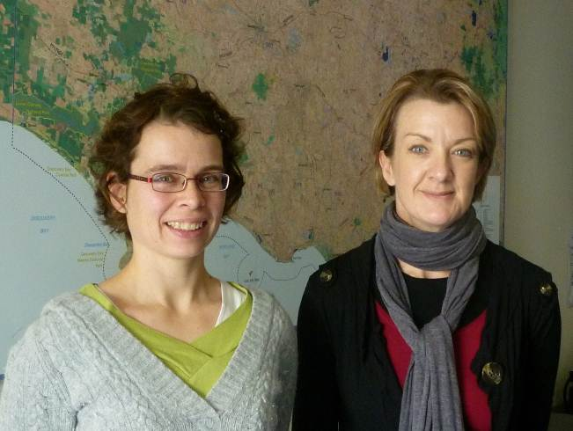

Jacinta Hendriks (left) and Jody Chinner, from Glenelg Hopkins Catchment Management Authority

“We used EnSym to develop management plans for each property and then for conducting annual audits of site condition.

“EnSym takes the subjectivity out of it and we can use the same set of priorities each time.

“We’re now using EnSym for other grants and tender projects. It gives us a quantified measure of what we can achieve.

“While the EnSym system is constantly evolving, the overall process we use for

Wetland Tender is well established and it works. Wherever possible, we keep it simple.

“The EcoMarkets team has been really good to work with, their support has always been great,” she said.

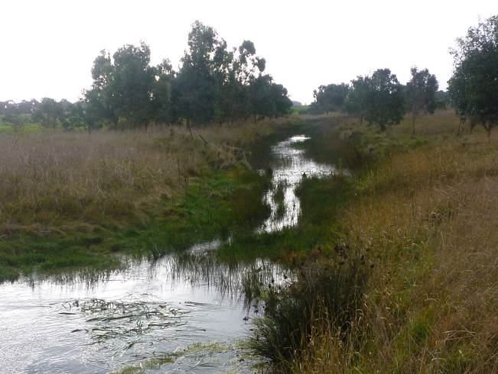

Wetland in the Glenelg Hopkins catchment

