Nature Fund 2023
Common Questions
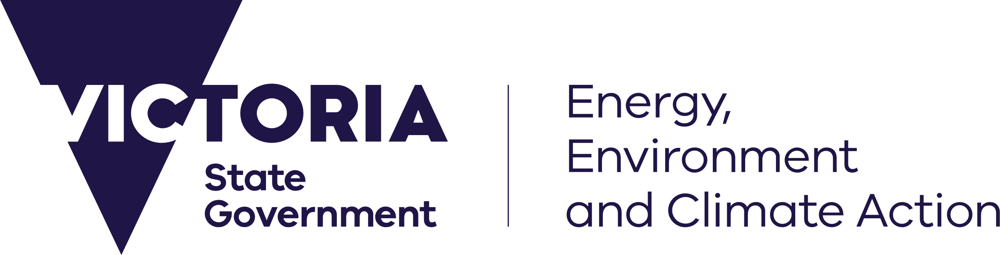
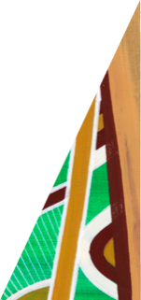
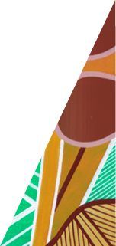
deeca.vic.gov.au

Nature Fund Common Questions – 2023
If your question is not answered in the information below, please contact the Nature Fund by emailing naturefund@delwp.vic.gov.au

What is the Nature Fund?
The Nature Fund has been established by the Victorian Government to support high impact projects that deliver on the goals of Protecting Victoria’s Environment – Biodiversity 2037 (Biodiversity 2037), the Government’s plan to stop the decline of native plants and animals and improve the state’s natural environment. To achieve all we’ve set out to do in Biodiversity 2037, we know we need to work together and across different sectors.
The Nature Fund will encourage collaboration and partnerships between government, business, philanthropy and the community to deliver high impact projects that contribute to improving Victoria’s biodiversity.
In 2023, the Victorian Government has invested a further $3.5 million in the Nature Fund, adding to the $10 million of funding to 22 projects in 2022.
Projects supported through the Nature Fund need to demonstrate their ability to make a high impact contribution to improving Victoria’s biodiversity through either habitat restoration or actions to improve the outlook for specific threatened species.

What is the minimum and maximum amount of funding available for a project?
The minimum funding a project can request from the Nature Fund is $20,000. There is no maximum funding, however projects seeking funding will need to demonstrate good value for money, providing at least matched funding from non-government sources.

Is there a time-limit on the length of a project?
Yes. Projects will need to be delivered within a maximum of two years.

What projects are eligible to apply for the 2023 Nature Fund?
To be eligible for support through the Nature Fund projects need to:
- Deliver benefits for Victorian biodiversity by:
    - improving habitat (preferred) or
    - benefiting threatened and/or culturally significant species.
- Secure (or have the potential to secure by the end of a 6-month planning period) matched co-funding from non-government sources, excluding volunteering and in-kind support.
- Have a plan for ensuring ongoing biodiversity benefits beyond the term of the funding, such as through permanent protection.
- Partner or engage with Traditional Owner groups.
- If you do not fit these criteria please get in touch via naturefund@delwp.vic.gov.au to discuss options.

Who can apply for the Nature Fund?
- not for profit organisations
- government agencies
- private sector businesses and agencies
- educational institutions
- local government authorities
- (Individuals cannot apply)

What types of projects were funded in the first round of the Nature Fund?
The first round of the Nature Fund in 2022 was $10 million in total, split across a $8.6 million General Stream and a $1.9 million Caring for Country stream. Funded projects included a range of threatened species and landscape scale actions. A full list of funded projects is on the Nature Fund webpage.

How will projects be selected?
Projects will be assessed based on the extent to which they can align with the assessment criteria, of biodiversity benefit, co-investment, and their delivery risk. The Expressions of Interest will be assessed by subject matter experts within DEECA, who will recommend projects for funding to senior executives within DEECA and the Minister.

What are eligible types of co-investment?
To be eligible for funding under the Nature Fund, projects will need to demonstrate that they have secured, or have the potential to secure, matched funding within the first six months of the project commencing.
The co-funding can include a combination of financial donations (including donations from philanthropy, businesses and individuals) but cannot include funds obtained from government sources (e.g. Federal, State, or Local Government grants programs and funding through statutory entities such as water authorities or Parks Victoria). Funding must be cash, not in-kind.

Are staff salaries eligible as co-funding?
Up to 10% of the Nature Fund can go towards project management and project coordination. If the project is funding a new role for the project, it will be considered co-investment. If the project is funding an existing role, it would not contribute to overall additionality and will not be considered co-funding.

Is there a maximum amount of the project budget that can be allocated to staff salaries?
Yes, up to 10% of Nature Fund budget can be allocated to project management and coordination.

Can the Nature Fund support works on private land?
Yes. The Nature Fund can help respond to new conservation opportunities and to environmental threats as a co-investment for a project on private land.
Projects on private land must demonstrate a clear public benefit. The project will need to demonstrate it will make a significant difference and represents good value for money, leveraging co-funding from non-government sources.
For example, the Nature Fund could fund construction of a predator-proof fence as part of a larger project that involved the purchase of a priority property to establish a safe haven to protect threatened species from predation by foxes and cats.
Projects must have land owner / land manager approval.

Can the Nature Fund contribute to the purchase of private land?
Yes. The Nature Fund will support high-impact Victorian conservation projects to top up investment from non-government organisations. The project will need to demonstrate how it will make a significant difference and represents good value for money, leveraging significant co-funding from another source.

Can the Nature Fund support work on public land?
Yes. Projects must have land owner / land manager approval.
DEECA supports the self-determination of Traditional Owners. For projects on public land, partnership with Traditional Owners should be undertaken as early as possible in the project development, in line with Pupangarli Marnmarnepu ‘Owning Our Future’ Aboriginal Self-Determination Reform Strategy 2020-2025 — for example, discussions at a relevant forum, a site visit on Country and/or demonstrated ‘in principle’ support from the Traditional Owner group specific to that area. Projects should factor in adequate budget for Traditional Owners to be adequately renumerated and resourced. Sufficient time should be allocated, and timelines must incorporate Traditional Owners’ governance structures and ways of making decisions.
DEECA can assist to facilitate engagement with Traditional Owners where required.
To find found out who the Formally Recognised Traditional Owners are for an area, you can search the Aboriginal Cultural Heritage Register and Information System (ACHRIS), available at https://www.aboriginalheritagecouncil.vic.gov.au/victorias-current-registered-aboriginal-parties and to find details of non-formally recognised Traditional Owner groups in Victoria, please visit the (Commonwealth) Office of the Registrar of Indigenous Corporations (ORIC). DEECA is clear that any Traditional Owner group(s) with an interest in the project should be included and engaged with. You are strongly encouraged to read the relevant Country Plan for the group you will be engaging (if they have one) prior to commencing any engagement and understand the Traditional Owner group’s legal status and rights under the relevant legislation.

Where can I find the list of threatened species?
The Flora and Fauna Guarantee (FFG) Act Threatened List is available at https://www.environment.vic.gov.au/conserving-threatened-species/threatened-list.

Do I need to include a map – and how do I do this?
Yes. You need to include a map and spatial data of the proposed project location. Please ensure that the location information is as accurate as possible.
NaturePrint’s Strategic Management Prospects (SMP) dataset should be used to guide the location of your activities. SMP helps biodiversity managers consider and compare which actions to do and where. To deliver the Biodiversity 2037 goals and targets and to try to prevent more species from becoming threatened, we need our management efforts to deliver the most positive change for biodiversity. For more information including guidance on how to use the SMP tool visit Choosing Actions for Nature (environment.vic.gov.au).
You need to submit your map in the form of a GIS shapefile of the proposed work location, in addition to a “.pdf” map of your project area.
Both the shapefile and “.pdf” map can be created using NatureKit (https://naturekit.biodiversity.vic.gov.au).
You need to overlay the Bio2037 Priority Areas, in SMP version 4 (SMPv4).
To do this, open NatureKit, toggle on “Strategic Mgmt Prospects v4” and the “Bio2037 Priority Areas” layer group and select your action of interest.
- Your project area can be created by clicking on the “General Tools” toolbar, then using the drawing tool. Click on “Point” and change this to “Polygon”, then draw your project area on the map.
- You project area can then downloaded by selecting “Export Drawings”.
- The “.pdf” map can be downloaded using the “Map With Legend” tool, also in the “General Tools Toolbar”, and following the instructions.
If you are experiencing issues, the NatureKit User Guide (https://www.environment.vic.gov.au/biodiversity/naturekit/naturekit-tools) will help you to navigate the map interface and use the different functions and tools.
If you cannot find a solution in the User Guide, contact NatureKit support (biodiversity.info@delwp.vic.gov.au) or use the contact form in the “Help and About” toolbar in NatureKit.

Where can I find more information about actions for a specific species?
If your proposal is focused on a particular threatened species, DEECA may have additional information to assist with developing your proposal.
For example, DEECA’s Threatened Species Action statements contain information on key threats and potential conservation actions to address these threats. Action statements also include links to other DEECA resources that may help you identify possible species-specific actions, including NatureKit and Species Forecast Reports. You can use these resources to identify how likely a species is to persist under current management, or if more direct or specific actions are required.
Before submitting your proposal, you are encouraged to contact DEECA via the Nature Fund team (naturefund@delwp.vic.gov.au) to help inform your proposal’s alignment with data on the species.
Alternatively, if there is not current information or data about the species, an evaluation should be undertaken of the benefits of the proposed action(s). This would be done using DEECA’s approach for the identification and prioritisation of biodiversity actions and knowledge gaps – using the manual available here: Biodiversity 2037: Manual for the identification and prioritisation of biodiversity actions and knowledge gaps. This evaluation work can be done before submitting your EOI, or your EOI can note the need for this evaluation work to be done as part of further developing the proposal. Again, you are encouraged to email naturefund@delwp.vic.gov.au to discuss your idea and seek advice.

Do I need an auspice?
If your organisation does not have adequate insurance (see Program Guidelines) or are not incorporated/registered as a not-for-profit will need to partner with another group or organisation, known as an auspice, who does meet the requirements.

How do I apply?
The Victorian Government is calling project proposals through an Expression of Interest (EOI) process.
Please refer to the Program Guidelines when preparing your EOI.
Apply at https://www.environment.vic.gov.au/nature-fund. From this web page, click on the Start a new application button.
Applicants are encouraged to email naturefund@delwp.vic.gov.au to discuss their idea and seek advice.

Will receipt of my application form be acknowledged?
Receipt of your application will be acknowledged via a Grants Online system generated email to your registered email address. You can also login to deeca.my.site.com to access your draft and submitted applications

I have submitted my application (EOI), now what happens?
DEECA will undertake a preliminary review of the proposal to ensure the organisation and proposal are eligible for funding and assess how well the proposal aligns with the objectives of the Nature Fund. The assessment of eligible projects will occur at the completion of the EOI period. Further feedback to applicants will be provided during this period.

Who is responsible for approvals?
DEECA is responsible for arranging the approval of funding from the Nature Fund.
The organisation submitting an EOI is responsible for:
- preparing the proposal (the EOI), including any supporting documentation and/or providing subsequent information requested by DEECA to enable a funding decision and
- seeking any relevant approvals under state and Federal law (for example, if proposing to translocate a nationally-listed threatened species into a proposed safe haven) — and please note that funding provided through the Nature Fund does not guarantee subsequent approvals.

If my application is unsuccessful, can I ask for feedback?
Yes, and we encourage you to ask for feedback. If your application is unsuccessful, we will contact you and include details on who to contact for feedback.

Where can I find out more?
For more information, please visit https://www.environment.vic.gov.au/nature-fund or contact the DEECA Nature Fund program team at naturefund@delwp.vic.gov.au.

Who can I contact for more help?
You can contact the DEECA Customer Contact Centre on 138 186.
The Nature Fund program team can be contacted at naturefund@delwp.vic.gov.au.
For technical issues with Grants Online, email grantsinfo@delwp.vic.gov.au.

