Creating spatial features for reporting: weed control
This guide applies to Victorian Government funded weed control activities where the objective is biodiversity protection, to be used in conjunction with Biodiversity 2037 Activity Data Requirements (PDF, 337 kB).

This guide describes how to prepare accurate spatial features for reporting weed control (weeds, overabundant or out of range native plant management).
When conducting a weed survey (assessment) as a standalone activity and the area is not under regular management for long-term weed control the activity should be recorded and reported as an ‘Assessment’.
The associated data fields that should be attached to each feature being reported is provided in the Biodiversity 2037 Activity data requirements (PDF, 337 kB).
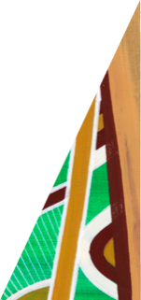
Templates, tools, and further information about spatial reporting for biodiversity protection are available on the activity data webpage.
deeca.vic.gov.au

Weed search and control information is used to prepare accurate spatial features.
Weed control occurs at points, along lines or within areas. It is where weeds are searched for and treated where they are found. For reporting, weed control areas are represented by polygons (shapes) so that the area treated or managed can be calculated.
The information provided for reporting weed control comes from the weed assessments and treatment activities. The weeds identified during assessments or searches determine the treatment methods applied. The search area can be included as part of weed control where it results directly in weed treatment and ongoing management of the area.
Also see When to record weed assessment or weed search as an ‘Assessment’ and not ‘Weed control’.
This guide describes how to provide an accurate spatial representation of weed control for reporting. A range of scenarios are described to illustrate how to spatially represent weed control that is undertaken at points, along lines, or within areas.
Key data to link to the polygon for reporting are weed species controlled; area the weed covers (%); weed arrangement; and control method. Each control method and main weed species combination should be reported separately. It is important to indicate for each weed control area whether all weed species present are controlled, this is not always the case. See Biodiversity 2037 Activity data requirements (PDF, 337 kB)
Often weed management is a part of a project. The project area should not be reported as the weed control area unless the entire area is actively managed.
Weed control for biodiversity benefit has a range of approaches and is rarely a one-off. Approaches vary according to species present and stages of maturity. For example, mature woody weeds may be treated mechanically, while a different method may be used for immature weeds of the same species, and not necessarily in the same year.
Over time accurate weed control reporting will illustrate main species of weeds controlled, reduction of weed cover (%) and arrangement. It is important to include when the control occurred, other weeds present, and whether they are treated or not. This information is reported alongside specific species management.
Just as there are different approaches to controlling weeds there are different approaches to mapping their locations. This mapping contributes to the weed control record, assists with informing future control operations and informs success of control over time.

Point locations of weeds
Point data of weed species’ locations from assessments or searches are recorded along with information about the weeds, for example, maturity, size, arrangement, and density of infestation. This information is used operationally for planning and delivering like treatments for weeds at other locations.
Areas searched and that result in control are combined as the weed control area.

Weed control polygons
Polygons representing the weed search and control areas (or points) should be created. See example in Table 1. The areas that are searched and treated are represented as weed control. Data linked to the mapped feature must be provided – see Biodiversity 2037 Activity data requirements (PDF, 337 kB).
Table 1: An example of field data for species records and operations, and summarised data for reporting.
Field Data for species records and operations | Summarised data for reporting
The area is searched: Weed species are identified at points and each species’ density and distribution recorded for species records, operations, and summarised for reporting. | The field data is summarised. Exact (point) locations of the weeds and weed control is not reported. Polygon feature of weed control including searching is reported including the total number of weed species observed and treated.
Example year 1: Field data collection including locations of weeds for species records and to support control operations.  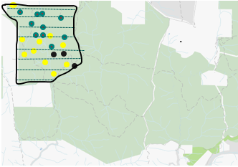  Site 1 | Example year 1: feature reported with summarised data of weed control.  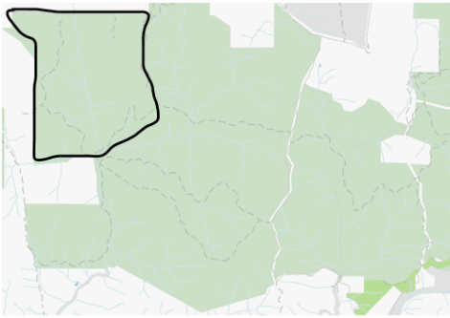  Site 1
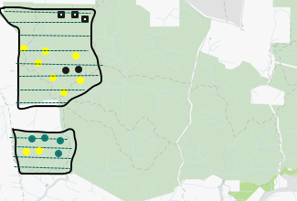  Example year 2: Site 1 is re-searched, and new area Site 2 searched.  Site 2  Site 1 | Example year 2: features reported with summarised data of weed control.  Site 1  Site 2
Example year 3: Sites 1 and 2 are re-searched and an additional area Site 3 searched.  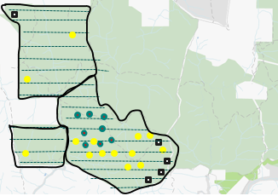  Site 3  Site 1  Site 2 | 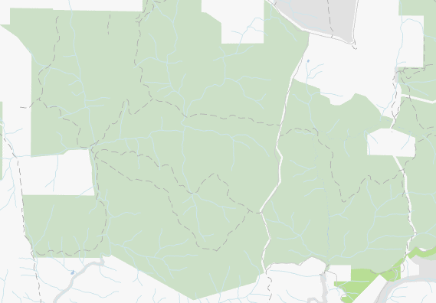  Example year 3: Features reported with summarised data of weed control.  Site 1  Site 3  Site 2

Using geographic information systems (GIS) to create accurate spatial features for line locations of search and control
In some cases, weed control is delivered along roads, tracks, including walking tracks, or streams but not further across entire areas as in Table 1. A polygon representing the weed search and control areas should be created via buffering 20 metres either side of the line (roads, tracks, streams).
A GPS track log of the assessment or treatment can be used as the basis of the features. If this is not available, the roads and tracks can be selected from spatial layers or identified within existing mapping tools. The associated species and treatment information recorded during operations will be the basis of the information that is tied to the feature - see Biodiversity 2037 Activity data requirements (PDF, 337 kB).

Preparing spatial features from line locations in GIS
Line locations of weed control, including searching, should be buffered by 20 metres either side of the line.
Each buffered line becomes the spatial feature and the associated information should be attributed to the feature. See Biodiversity 2037 Activity data requirements (PDF, 337 kB).
Each control method and main weed species combination should be reported separately. For each weed control feature it is important to indicate if all weed species present are controlled, this is not always the case.

Creating a multi-part polygon
Multiple lines features can be dissolved to create a single feature. Again, the information associated with the control such as species cover (%) and arrangement should be tied to it, and it may be necessary to repeat the feature if there are differences in control method and weed species combinations.
For guidance on buffering and dissolving lines please refer to ArcGIS Desktop buffer guide.

Table 2: A road and track (line) weed control example illustrating how to create polygons and multi-part polygons for reporting. The areas that are searched and treated are represented as weed control. Data linked to the mapped feature must be provided – see Biodiversity 2037 Activity data requirements (PDF, 337 kB).
The area is searched: Weed species identified along the line (GPS points may mark the start and end of species occurrence) or at points. Each species’ density and distribution recorded for species records, operations, and summarised for reporting.  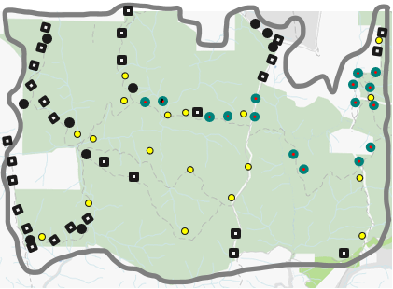 | 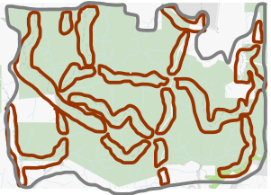  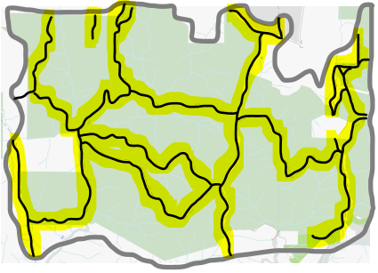  The roads where weed control, including searching was delivered  Roads are buffered by 20 metres each side of the line creating the polygon for reporting. The exact (point) locations of the weeds are not required for activity reporting however are useful for species records.
The polygon can be copied to separately report a different control method and/or species cover and arrangement combinations where necessary. Generally, only key species need to be reported along with indication if there are other species present that are or are not treated.

Preparing a spatial feature from line locations where GIS is not available.
Where GIS is not available, polygons outlining the roads, tracks and streams where weed control was delivered should be drawn. Each polygon will be a spatial feature and the information associated with the control should be tied directly to the feature.
Depending on the spatial recording tool used it may be possible to merge multiple polygons to become a multi part polygon, that is one feature made up of two or more polygons. This will be useful where the same information should be linked directly with all of the merged polygons - see Biodiversity 2037 Activity data requirements (PDF, 337 kB).
Table 3: The roads and tracks that are searched and treated are represented as weed control. Data must be linked to the mapped feature – see Biodiversity 2037 Activity data requirements (PDF, 337 kB).
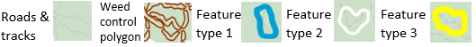
The area is searched: Weed species identified along the line (GPS points may mark the start and end of species occurrence) or at points. The species’ cover and arrangement is recorded for operations and for reporting. Generally, only key species need to be reported along with an indication if there are other species present that are not treated. | A polygon is drawn around each road where weed control, including searching, was delivered. In this case, the polygons are joined to create one feature that is reported along with the main species treatment, cover and arrangement. The exact (point) locations of the weeds are not required for reporting.
A polygon is drawn around each road where weed control, including searching, was delivered. In this case, the blue polygons are merged as one feature, the yellow polygons as another feature and the white as the third feature. Each represents a different control method and/or species cover and arrangement combination.  Each (multi-part) feature is reported along with the main species treatment, cover, and arrangement. | 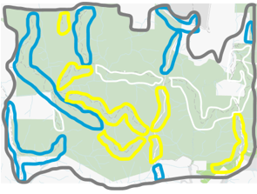

When to record a weed assessment or search as an ‘Assessment’ and not ‘Weed control’
When conducting weed assessments as a standalone activity and not as part of medium to long-term (more than three years) weed control, the activity should be recorded and reported as an ‘Assessment’ using Biodiversity 2037 Activity data requirements (PDF, 337 kB). ‘Invasive Species’ should be selected under ‘Type’ when reporting an Assessment.
Note: The same steps for creating buffers for lines and points can be applied to create the features for reporting weed assessments.

Data fields and values to attribute to the features
Attributes must be attached to each feature, regardless of how the feature was created. ‘Common Attributes’ and ‘Weed Control’ attributes are required for each feature, see Biodiversity 2037 Activity data requirements (PDF, 337 kB).
Many organisations have activity recording systems where some of the fields and values are described differently and may require translation, or the fields and values may not exist. Where possible, data providers are asked to supply the fields and values in the Biodiversity 2037 Activity data requirements (PDF, 337 kB).
Templates, tools, and further information about spatial reporting for Biodiversity protection are available on the activity data webpage.

An extra note - Sharing species observations with the Victorian Biodiversity Atlas (VBA)
Contributing your pest weed records to the VBA helps to get an authoritative picture of the extent of weed invasion and prioritise action to protect native species. Contributing data to the VBA is open and available to all!
Your weed control actions are an important source of species observations for Victoria. Observations can be shared directly into the VBA. Direct entry allows you to link your project identifier to the records, include information such as control actions or multiple records at a single site, as well as use the 'batch upload' function for bulk upload of records.
The VBA is a tool to help Victorians to understand more about their local biodiversity. By sharing your species observations, including weeds, you are helping ensure that the VBA:
- is continually updated to reflect the current distributions of plant and animal species, including weeds
- data is current and supports more robust modelling of habitat distribution and future climate change impacts
- provides evidence-based assessments of species distribution changes over time and where key threats are.
VBA data is a core input to most government processes and programs that impact native species. VBA data contributes to the knowledge bank that underpins the modelling, mapping and decision-making tools that are essential for climate adaption policies, emergency and forest fire risk management and land use planning. The VBA is a foundational dataset for assessing the progress and targets of Protecting Victoria’s Environment – Biodiversity 2037.

We acknowledge Victorian Traditional Owners and their Elders past and present as the original custodians of Victoria’s land and waters and commit to genuinely partnering with them and Victoria’s Aboriginal community to progress their aspirations.
© The State of Victoria Department of Energy, Environment and Climate Action September 2023
Creative Commons
This work is licensed under a Creative Commons Attribution 4.0 International licence, visit the Creative Commons website (http://creativecommons.org/licenses/by/4.0/).
You are free to re-use the work under that licence, on the condition that you credit the State of Victoria as author. The licence does not apply to any images, photographs or branding, including the Victorian Coat of Arms, and the Victorian Government and Department logos.
ISBN 978-1-76136-431-0 (print)
ISBN 978-1-76136-431-0 (pdf)
Disclaimer
This publication may be of assistance to you but the State of Victoria and its employees do not guarantee that the publication is without flaw of any kind or is wholly appropriate for your particular purposes and therefore disclaims all liability for any error, loss or other consequence which may arise from you relying on any information in this publication.
Accessibility
To receive this document in an alternative format, phone the Customer Service Centre on 136 186, email customer.service@deeca.vic.gov.au, or contact National Relay Service on 133 677. Available at DEECA activity data webpage (https://www.environment.vic.gov.au/biodiversity/activity-data).

