Assessing genetic risks to Victorian flora and fauna

Peter Kriesner and Andrew Weeks

cesar, 293 Royal Parade
Parkville VIC 3053

AND

Emma Razeng and Paul Sunnucks

School of Biological Sciences, Monash University
Clayton VIC 3800

ISBN 978-1-76105-313-9 (pdf)
Table of Contents

Executive Summary 3
Introduction 4
Importance of genetic diversity in biodiversity conservation 4
Fragmentation and population size in Victorian flora and fauna 4
Integrating genetics into policy and conservation planning 5
Project brief and aims 6
Methods 7
Data collection 7
Genetic risk index 10
Results 11
Overview of data 11
Genetic assessments 15
Demographic assessments 20
Combining genetic and demographic data 30
Towards a genetic risk index for Victorian flora and fauna 30
Candidates for genetic interventions 34
Priority species for collecting genetic data 34
Research gaps 35
Taxonomic groups 35
Threatened species 36
Fragmentation 36
Chromosomal differences 36
Genetic rescue and other genetic intervention strategies 37
Case studies 38
Risk frameworks for genetic interventions 44
Conclusion 45
References 46
Appendix 1. Background information 49
What is genetic diversity and how is it measured 49
Importance of genetic diversity for species persistence 51
Fragmentation, small population size and inbreeding 52
Fitness consequences of habitat loss/fragmentation & small population size 54
Threatened species and genetic risks 56
Executive Summary
Genetic diversity is intrinsically linked to the adaptive capacity of populations. Small, fragmented and isolated populations have reduced capacity to evolve in response to changing environmental conditions, and elevated risk of extinction due to random genetic drift and inbreeding. Yet while these concepts are well-known in the scientific and conservation communities, they are rarely considered more broadly in conservation planning and policy. The State Government of Victoria, through the Department of Environment, Land, Water and Planning, engaged our team to undertake a broad project on the State’s flora and fauna with the overall aim of determining how to incorporate genetic diversity considerations into biodiversity conservation planning. In this project we generated a large database that combines available genetic and demographic data for 1100 species of flora and fauna found in Victoria. The demographic data were carefully chosen to help provide surrogate information in the absence of genetic data. Assessment of the genetic data highlighted the relative paucity of information available on species and populations, and particularly genetic information that can be used to inform genetic intervention strategies. Even in threatened species where we expected more genetic data to be available, this was true only for fishes and mammals. While the demographic data provided parameters for many species that can be used as surrogates for genetic data, there was often a large amount of uncertainty around these data. We developed a framework for combining genetic and demographic parameters into a genetic risk index that enabled us to classify the 1100 species broadly into low, medium, high, very high and uncertain risk categories. While the index needs further refinement and validation, the framework provides a method for incorporating genetic diversity into biodiversity conservation planning in Victoria. We highlight broad research gaps from our assessments, including very limited data for plants, invertebrates and many threatened species. We also develop case studies highlighting genetic management strategies when high quality genetic data are available versus when there is only typical information. Finally, we discuss frameworks for assessing risk associated with genetic interventions. The work described here indicates that the genetic health of many species present in Victoria is not robust and is under threat, so there are likely to be substantial benefits for population and species persistence if genetic health can be improved through incorporation of evolutionary thinking in conservation management.

Introduction

Importance of genetic diversity in biodiversity conservation

Genetic diversity is an important component of biological diversity. Natural populations of animals and plants rely on genetic diversity to enable adaptation to change in their environment including habitat loss, new diseases, parasites, competitors and changing climatic conditions. When natural populations become fragmented and small, random genetic drift and inbreeding can lead to losses of genetic variation and fitness within populations, increasing the chance of population- and ultimately species extinction (Frankham et al. 2017). Studies linking genetic diversity to individual fitness and population persistence underscore the importance of conserving the breadth of existing genetic variability within and between populations (Keller and Waller 2002; Willi et al. 2006; Hoffmann et al. 2017). Accordingly, the IUCN recognizes maintenance of genetic diversity as one of three global conservation priorities. It is therefore crucial to incorporate genetic diversity considerations in biodiversity conservation planning, so that at-risk species and populations can be identified, and appropriate management actions can be defined and implemented.

Two key factors therefore in the maintenance of genetic diversity in a species are the genetically effective population size, and connectivity among populations (see below and Appendix 1). Genetic data can be used to directly estimate genetic diversity (or genetic health) within populations, and also effective population size and extent of gene flow (evaluating level of realized fragmentation) between populations, enabling more informed conservation management decisions. However, the extent and quality of genetic data available across flora and fauna, as well as their interpretation, has precluded their inclusion in broader conservation planning and government policy in Australia to date. Yet this information can be particularly informative for determining genetic management strategies for threatened species, and also for identifying species that are likely to be at increased risk of extinction owing to immediate or future risk of losing genetic diversity, adaptability and population fitness (Frankham 2005).

Fragmentation and population size in Victorian flora and fauna
Challenges faced by flora and fauna that persist as small populations are highly significant given the massive impact that human activities have had on populations in very recent times.
In addition to the sheer scale of habitat loss, there is also pervasive fragmentation of much of what remains, which places considerable stress on ecosystems and new pressures on flora and fauna. As a result, there is now an urgent need for conservation and restoration measures to improve landscape connectivity to increase total effective population sizes of species (Haddad et al. 2015).

This phenomenon is particularly relevant to Victoria, which has the highest human population density of any Australian state or territory, and historically the greatest proportion of land-clearing and habitat fragmentation. Most of this has occurred within the last two hundred years.
Victoria has a high diversity of landscapes and ecosystems within a relatively small area. Consequently, ecological communities in some parts of the State were naturally quite fragmented long before European settlement, although generally this applied on significantly larger scales than the finer-grained fragmentation that is now typical.

In addition to land-clearing, the construction of roads, fences, dams and weirs, as well as invasive predators and competitors, altered fire regimes and climate change, have all acted to create barriers between (and within) previously connected populations or subpopulations for a great many species.

Unfortunately, however, in the absence of genetic data, it is inherently challenging to assess the true extent of fragmentation that currently exists between populations of individual flora and fauna species. Whether two populations of a given species are actually isolated from each other depends on the capacity as well as tendency of effective-breeding individuals (or propagules) to disperse and/or migrate between the populations (Appendix 1). The ability of different animal species to disperse beyond their natal territory varies by several orders of magnitude – birds may travel hundreds or thousands of kilometres, while small invertebrates may move only a few metres in a lifetime. Dispersal of organisms can also be limited to certain life stages, or be gender-biased. Consequently, for most organisms, lifetime dispersal can be estimated from field observations with only limited accuracy. This is even more complicated for flora, where dispersal can be dictated by breeding system and a range of biotic and abiotic dispersal vectors.

Integrating genetics into policy and conservation planning
Natural habitats are now significantly or highly fragmented across much of Victoria. This fragmentation is likely to have led to a multitude of recently isolated small populations in a broad range of taxa, with the relatively limited number of studies that have directly addressed this issue tending to confirm this hypothesis. Even though there is ample scientific evidence that inbreeding depression and low evolutionary potential are detrimental for species conservation (Appendix 1), genetic principles are still rarely taken into account for conservation planning by governments anywhere (Pierson et al. 2016; Weeks et al. 2016; Cook and Sgrò 2017, 2018, 2019).
Often the focus of conservation practitioners and managers is on species that are currently listed as threatened, but more timely intervention may prevent many species from reaching threatened status. Realistically, if we are to preserve most of our current biodiversity, not just as one or a few remnant populations of individual species in restricted localities, but as integral parts of broader healthy ecosystems, managers will need a better understanding of which populations are small (or getting smaller) and their genetic isolation from other populations of the same species. Therefore, managers and conservation practitioners need to integrate genetic data into conservation planning so that threats to species and biodiversity can be more effectively evaluated and mitigated.
In the absence of genetic data, demographic, ecological and biological data combined with general evolutionary genetic principles may help to inform management decisions. We therefore need to develop frameworks for including genetic information and principles into biodiversity conservation management, and proxies when genetic data are unavailable.

Project brief and aims
Towards incorporating genetic diversity into biodiversity conservation management and planning
Collating all available genetic information on species and determining the gaps is a first step in being able to incorporate genetic diversity considerations into biodiversity conservation planning. Utilizing current genetic data to inform different types of genetic interventions, and situations where they are applicable and warranted, can enable more efficient planning around priority investments for managers. In the absence of genetic data, there may be opportunities to use proxies such as ecological/biological attributes of some species or groups for indicating where genetic issues may be apparent, or where issues may arise under environmental change. These attributes and/or genetic data could then be incorporated into tools such as the Victorian Government’s Strategic Management Prospects, enabling managers to consider different actions and their potential consequences more broadly on biodiversity conservation, and enabling more efficient management interventions to be undertaken.
The Victorian Department of Environment, Land, Water and Planning (DELWP), engaged our team to undertake a broad genetic project on the State’s flora and fauna to initiate the incorporation of genetic diversity considerations into biodiversity conservation planning. Specifically, the overall aims were to:
- Collate current knowledge on genetic data for Victorian biodiversity and how these data inform their management.
- Collate ecological/biological attribute data for plants and animals that could potentially be used as proxy indicators of genetic health of a population and / or impact on it under environmental change (e.g. distribution, fragmentation, population size, reproductive system, social structure, dispersal potential).
- Document knowledge gaps and research opportunities for investment that improve actions/outcomes for genetic management.
- Develop guidelines around genetic intervention strategies with and without genetic data, and present case studies.
- Investigate whether genetic data and/or ecological/biological attributes of populations/species/groups (and resultant genetic intervention actions) could be incorporated into DELWP’s Strategic Management Prospects.
To address these aims, we first collated all the available genetic and ecological/biological data for a large proportion of the State’s animals and plants. We collated ecological/biological attribute data from a variety of sources likely to be informative about genetic health, particularly in the absence of genetic data, and also assess, as far as practical, the uncertainty in these data. We then establish a framework that incorporates this information into a genetic risk index for all flora and fauna assessed in this project. We identify key knowledge gaps from the data, highlighting potential future research opportunities. Finally, we use case studies to demonstrate how genetic strategies can be implemented into conservation programs in the presence and absence of key genetic data.

Methods

Data collection
The aims of data collection were to:
- Assess genetic data currently available for all Victorian species of flora and fauna.
- Collect information that could allow for assessment of genetic risk for a given species.

To enable assessment of genetic risk, we reviewed a range of genetic and demographic data relating to Victorian species using a variety of different sources (Table 2). The review process consisted of three main steps:
1. Identification of species to include in the review (limited by scope of project)
2. General assessment of available genetic data
3. Review of literature and database construction.

This was followed by exploratory analysis to identify general patterns and trends related to genetic health of Victorian flora and fauna populations, and identify species that may be considered to be at genetic risk. The following section explains these steps in more detail.

Species covered
For the purposes of this review, we considered species to be taxonomic units with an accepted species status. Sub-species and variants were considered together under the nominal accepted species. Some species (for example some microbats) have recently undergone taxonomic revision and are likely to be formally recognised as separate species in the near future.
Table 1 explains the scope of species considered under each taxonomic group. For most of these groups there was no apparent authoritative list of species particular to Victoria, so we relied on lists of species’ attribute data supplied by the Arthur Rylah Institute for Environmental Research (ARI) where appropriate, also referring to other sources such as VicFlora for plants.

Table 1. Descriptions of criteria used for inclusion of species in each taxonomic group assessed, and the number of species included in the final database. The overall total was 1100 species.
Group | Species included | Description
Amphibians | 36 | All amphibians that occur in Victoria.
Birds | 349 | All birds that occur in Victoria for at least part of the year on a regular basis. This includes resident and migratory species. Excludes marine birds that have no Victorian breeding colonies.
Fishes | 53 | All freshwater fish that occur in Victoria. This includes fish that permanently reside in freshwater, as well as estuarine and amphidromous fish that may migrate between freshwater systems and the ocean.
Invertebrates | 62 | Only species that are listed under Victoria’s Flora and Fauna Guarantee Act were included, as well as one species of freshwater crayfish, the Yarra River Spiny Crayfish (Euastacus yarraensis). Covering a wider variety of invertebrates was beyond the scope of the project.
Mammals | 74 | All terrestrial mammals that occur in Victoria. One marine mammal, the Burrunan dolphin (Tursiops australis), was included due to its significance to Victoria and conservation concern.
Plants | 414 | A selection of around 12.5% of the higher plants that occur in Victoria, including species for which we could identify that some genetic data had been generated, all endemic FFG listed species, and  and a broad range of non-listed plants chosen to give a representation of broader taxonomic groups.
Reptiles | 112 | All reptiles that occur in Victoria.

Determining species with published genetic data
We performed an automated database search using a script created in R, to scrape the Web of Science (WoS; www.webofknowledge.com) journal database for any published literature relating to genetic data for 3979 Victorian species (Table 3).

We performed searches using two different sets of search terms, the first focused on terms relating to genetic data, and the second focused on terms relating to population genetic concepts. This was done to uncover studies that have used genetic data and those that will be most relevant to the population genetic questions of interest. The script detected population genetic studies (most relevant), and other genetic work such as phylogenetics or physiology (less relevant). Some articles detected may have discussed genetics, but were not based on genetic data (not relevant). The script produced a list stating the number of detected journal articles found for each species. This allowed for initial assessment of the number of species likely to have genetic data, and assisted with determining which plants to include.

Data collection
For each species, we reviewed available information on a set of demographic and genetic traits that were targeted towards identifying genetic risk to populations. Demographic traits, such as dispersal capacity, generation time, and population cohesion can be useful proxies for assessing genetic risk to populations, when actual genetic data are lacking or difficult to acquire (Hughes et al. 2013). Further demographic traits like estimated population size or geographic extent of the species may inform on relative rarity or narrowness of niche, which also contribute to genetic risk (Frankham 2003). Genetic traits such as evidence of inbreeding or population genetic structure based on empirical genetic data may provide more accurate estimates of genetic risk.

Database creation
Information about demographic and genetic traits was collected and entered into a database created in Microsoft Excel. A copy of this database has been provided to DELWP, under the file name 0702CR20_VicGeneticData_FinalV1.xlsx.

Data sources
This was a rapid review of information readily available for each species. A standard set of sources were used during the review process (Table 2).

Table 2. Information sources used for compiling the database.
Journal database | Web of Science
Websites | Atlas of Living Australia  https://www.ala.org.au/  IUCN Red List of Threatened Species  https://www.iucnredlist.org/  NatureKit  http://maps.biodiversity.vic.gov.au/viewer/?viewer=NatureKit  Species Profile and Threats database (Australian Government)  https://www.environment.gov.au/cgi-bin/sprat/public/sprat.pl  VicFlora  https://vicflora.rbg.vic.gov.au/
Other documents | The Action Plan for Australian Birds 2010  The Action Plan for Australian Butterflies 2002  The Action Plan for Australian Mammals 2012  FFG Action Statements (where applicable)  National Recovery Plans (where applicable)
Books | Menkhorst, P. (1995). Mammals of Victoria: Distribution, ecology and conservation, Oxford University Press.  Menkhorst, P., et al. (2017). The Australian bird guide. CSIRO Publishing.  Pizzey, G. and Knight, F. (2003). The Field Guide to the Birds of Australia. Harper Collins Publishers.  Cogger, H. (2014). Reptiles and amphibians of Australia (7th ed.). CSIRO publishing.  Wilson, S. K., & Swan, G. (2017). A complete guide to reptiles of Australia (5th ed.). Reed New Holland.  Clulow, S. and Swan, M. (2018). A complete guide to frogs of Australia. Australian Geographic.  McCormack, R.B., 2012. A guide to Australia's spiny freshwater crayfish. CSIRO Publishing.  Menkhorst, P. and Knight, F., 2001. Field guide to the mammals of Australia (3rd ed.). Oxford University Press.  Allen, G.R., Midgley, S.H. and Allen, M., 2002. Field guide to the freshwater fishes of Australia. Western Australian Museum.

Expert consultation
Additional to the sources in Table 2, we also consulted the following experts for general information and leads regarding genetic data:

Fish: Tarmo Raadik (ARI)
Reptiles: Nick Clemann (ARI)
Plants: Elizabeth James (Royal Botanic Gardens Victoria), Susan Hoebee (La Trobe University)
Species attribute data: Matt White, Jim Thomson, Tracey Hollings (ARI)

A range of other experts were also consulted on individual species when available. “Grey” sources of genetic information (unpublished reports, datasets etc) were also utilised, although discovering them could not be comprehensive. These additional sources are noted directly in the database.

Genetic risk index
In developing the genetic risk index, we evaluated which of the genetic and demographic metrics that we gathered data for have potential to influence or contribute to overall genetic risk for a given species. We identified 17 potentially relevant metrics and then assigned weightings to the different factor levels for each of these. This initial assignment of factor weightings was determined through our judgement of relative impacts on genetic health of flora and fauna populations generally, based on knowledge gained from various existing studies. However, this approach requires further validation that was outside the scope of this project. The weightings are shown in the spreadsheet “Ratings” in the excel file “0702CR20_RiskRatingV3.xlsx”.

We have then derived an overall genetic risk score for each species by summing scores across each of the relevant genetic and demographic metrics. For instance, where it has been estimated that only small populations of a given species persist in Victoria, that species would receive a high risk score for metrics relating to population size, but this further depends on how many small populations there are likely to be across different population size categories. Independent of the likely number and sizes of persisting populations, a given species is assigned a separate score based on estimated dispersal ability.

There was inevitably varying levels of uncertainty around the assignment of particular factor levels for given species for several of the metrics that we gathered data for so we also, where applicable, estimated and assigned a weighting to the contribution of relevant factors to overall uncertainty around assessment of genetic risk. The uncertainty scores for each relevant metric were then summed to build an overall ‘doubt’ score for each species.

As a final step, we assigned risk categories to each of the species we assessed. Species have been classified as ‘uncertain’ for genetic risk rating if their doubt score under this method exceeds a certain level, or have otherwise been assigned to categories based on whether overall risk scores exceed certain thresholds. Determination of the doubt score threshold was based on our judgement of what may be considered tolerable in the broader context, but may be conservative from narrower perspectives. The initial risk category thresholds were set based on the relative distribution of scores across all assessed species that were not otherwise classified as ‘uncertain’. This also needs validation to test whether the indices and their uncertainties represent objective and useful measures of genetic health risk for a species.

The prospect of distilling existing (or potentially obtainable) genetic and demographic data for populations down to a single composite measure of genetic risk for individual species arose over the course of the current project. In the process of developing a workable methodology for deriving such a measure, it became apparent that some additional demographic metrics that were not explicitly factored into the initial data collection and database design phase would also likely be relevant – at least for a proportion of the species that we assessed. Capturing all metrics likely to be relevant for a practical yet credible assessment of genetic risk from the outset was challenging, particularly given the lack of precedent for such an undertaking. However, the exercise has provided considerably greater clarity around how this goal may be realized, the gaps in the current database, and additional relevant metrics that may be factored into future data collection efforts.

Results

Overview of data
Genetic and demographic data were assessed for a total of 1100 species of fauna and higher plants considered likely to be native to Victoria. Victoria has few vertebrate species that are endemic to the State. However, considering species where most populations occur within Victoria, or populations are mostly shared with only one other State, Victoria’s flora and fauna are a significant component of Australia’s overall biodiversity. A total of 27.5% of the 1100 species assessed here are in these categories. A further 18.5% have a relatively minor distribution in Victoria compared with elsewhere, while the remaining 54% have a widespread distribution across several States.
A previous report (Chapman 2009) provides estimates for numbers of living flora and fauna species for Australia overall. While most vertebrates and a large proportion of higher plant species are well characterized, it is estimated over two-thirds of Australia’s invertebrates are yet to be described. Some of the more relevant numbers from this 2009 report, along with a summary of numbers of species assessed for the current report are shown in Table 3. This emphasises the high level of endemism in Australia’s biodiversity, and therefore that Victoria’s flora and fauna are also important in a global context.

Table 3. Numbers of flora and fauna species assessed in detail for the current report, and for Australia overall. Numbers for Australia from Chapman (2009). ¹ Species that only or mostly occur within Victoria, or populations shared mostly with one other state. ² Excludes ~3,000 species of plant algae. ³ Includes lichens.
 |  | Australian species overall |  |  | Species assessed for this project
Category | Sub-category | Total for Australia | Australian endemism | Total for Victoria | Total assessed | Endemic to Victoria | Significantly in Victoria¹ | Minor in Victoria | Widespread
Amphibians |  | 227 | 94% | 36 | 36 | 2 | 17 | 8 | 11
Birds |  | 828 | 45% | 349 | 349 | 0 | 15 | 49 | 285
Fishes | Freshwater | 258 | 61% | - | - | - | - | - | -
 | Estuarine | 443 | - | - | - | - | - | - | -
 | Total: | 701 | - | 53 | 53 | 9 | 24 | 6 | 23
Invertebrates | Insects | ~205,000 | ~70%
 | Arachnids | ~31,340 | unknown
 | Other | ~84,130 | unknown
 | Total: | ~320,470 |  | unknown | 62 | 28 | 37 | 15 | 10
Mammals |  | 386 | 87% | 74 | 74 | 1 | 12 | 13 | 49
Plants | Higher plants | 19,324 | 92% | 3293 | 414 | 90 | 164 | 77 | 173
 | Lower plants² | ~2,200 | ~25% | unknown | 0 | - | - | - | -
 | Fungi³ | ~50,000 | unknown | unknown | - | - | - | - | -
Reptiles |  | 917 | 93% | 112 | 112 | 0 | 33 | 36 | 43
 |  |  |  |  | Totals: | 130 | 302 | 204 | 594

A significant proportion of assessed species are of conservation concern. This includes listing under the FFG Act, or inclusion on one of the current FFG advisory lists, listing under the Commonwealth EPBC Act, or rated as ‘Near Threatened’ or greater by the IUCN. Almost 43% of vertebrate species are regarded as rare, threatened or endangered (or in a handful of cases, data deficient). The most at-risk taxon was fishes, with 62% of species being of conservation concern, and 36% regarded as endangered or critically endangered. The conservation status of assessed species is summarized in Figure 1. Plants were chosen in part according to whether they were FFG-listed and hence their threat status is over-estimated here. All invertebrates were chosen due to being FFG-listed.
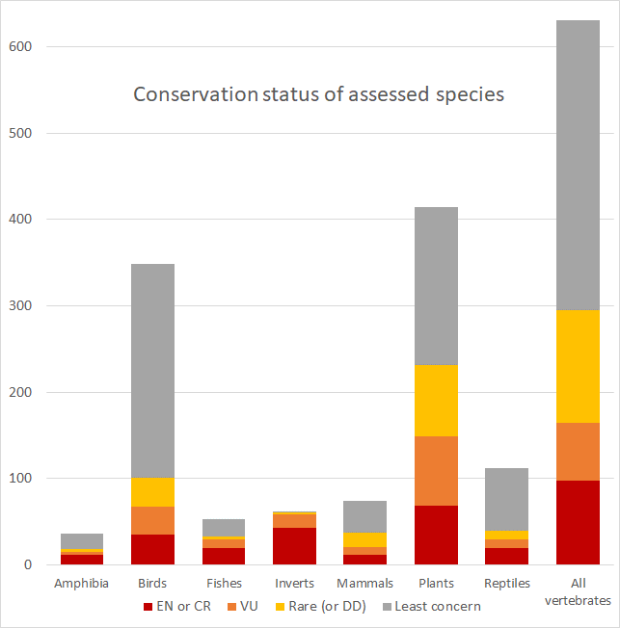
Figure 1. Number of assessed species by group currently listed as endangered or critically endangered (EN or CR), vulnerable (VU), rare, near-threatened or data deficient (Rare), or least concern.
Two species of fish included in the assessments are actually listed as regionally extinct in Victoria: Southern Purple-Spotted Gudgeon (Mogurnda adspersa) and Freshwater Herring (Potamalosa richmondia), with the Eastern-Barred Bandicoot (Perameles gunnii) also currently listed as extinct in the wild.

Genetic assessments
We identified the existence of some form of genetic data for 517 of the 1100 species of Victorian flora and fauna assessed based on our literature and database searches. For just over 60% of these species there were some data relating to field populations, but data that are likely to be informative for population structure or other population genetic factors within Victoria were identified for fewer than half of these (147 species). For each species where there were any genetic data, we assessed the most relevant purpose of the data for the current project (Table 4).
Table 4. Species with genetic data and how those data were used in the publications that generated them
Most relevant usage | Number of species | % of total
Informative population study | 147 | 28.4
Limited population study | 169 | 32.7
Species taxonomy or phylogenetic study | 91 | 17.6
Development of genetic markers only | 74 | 14.3
Hybridization in natural populations | 12 | 2.3
Extent of polyploidy (in plants) | 6 | 1.2
Other aspects of species' biology | 18 | 3.5
Total: | 517
When looking at the various taxonomic groups, the freshwater fishes had the highest number of species where there were at least some genetic data (45 species or 85%). The proportion was just over half for vertebrates as an overall group, but less than 6% for higher plants (Table 5).
Table 5. Proportion of Victorian species assessed that had genetic data, by major group.
Group | Victorian species | Species with any genetic data | % of total
Amphibians | 36 | 21 | 58.3
Birds | 349 | 142 | 40.7
Freshwater fishes | 53 | 45 | 84.9
Invertebrates* | 62 | 16 | 25.8
Mammals | 74 | 52 | 70.3
Plants | 3293 | 187 | 5.7
Reptiles | 112 | 54 | 48.2
Total: | 3979 | 517 | 13.0
All vertebrates | 624 | 314 | 50.3
* highly selective sample for invertebrates

There are few genetic data for plants across the various major families (Figure 2). Species of Myrtaceae, true ferns and Proteaceae were most likely to have data. Invertebrates would likely have even less genetic data than plants if all invertebrate species were included; we assessed only invertebrates that are FFG listed in Victoria, a small fraction of species present in the State.
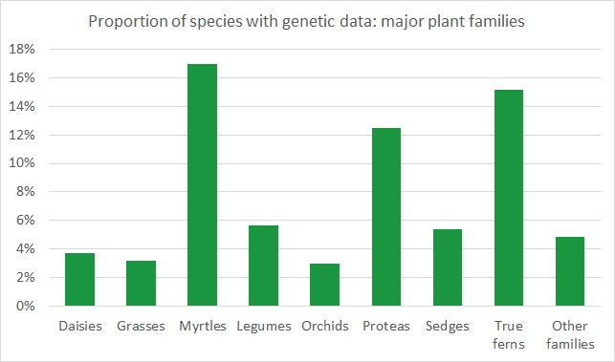
Figure 2. Proportion of Victorian plants with any genetic data for major plant families. These families include over half of all Victorian plant species. Daisies = Asteraceae, Grasses = Poaceae, Myrtles = Myrtaceae (eucalypts, etc.), Legumes = Fabaceae (acacias, etc.), Orchids = Orchidaceae, Proteas = Proteaceae (grevilleas, banksias, etc.), Sedges = Cyperaceae, True ferns = Polypodiopsida
There was some skew in the number of genetic studies towards species of commercial interest (e.g. Eucalyptus and Grevillea among plants) and some studies on migratory shorebirds for populations in Europe or North America. However, there was only moderate over-representation for threatened species across most groups, apart from species in the highest threat categories (Table 6; Figure 3).
Table 6. Victorian species with genetic data by conservation status.
Conservation status | Number of Victorian species | Species with any genetic data | % of total | Species with relevant genetic data | % of total
Endangered or Critical | 420 | 102 | 24.3 | 42 | 10.0
Vulnerable | 476 | 62 | 13.0 | 20 | 4.2
Rare or near-threatened (or data deficient) | 809 | 60 | 7.4 | 14 | 1.7
Least concern | 2274 | 293 | 12.9 | 71 | 3.1
Total: | 3979 | 517 | 13.0 | 147 | 3.7

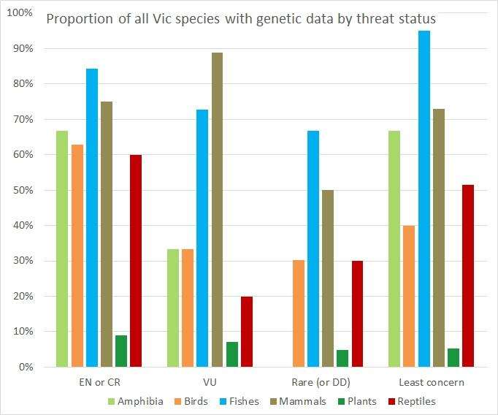
Figure 3. Proportion of Victorian species with genetic data by group and broad conservation status (excluding invertebrates).
For species with genetic data, the types of genetic markers applied were recorded. For many species, two or more types of marker were used in a given study - most frequently this was a combination of mtDNA and microsatellite (mSAT) markers (see Appendix 1 for explanation of marker types). The number of species for which particular types of marker were identified is shown in Table 7, summarized as a proportion of all Victorian species in Figure 4.
Table 7. Types of molecular markers identified for individual species by group. ‘Other’ is mostly significant genomic sequence data, or markers known as RAPDs, RFLPs, or AFLPs.
Group | Victorian species | Allozymes | mtDNA | mSATs | SNPs | Other
Amphibians | 36 | 5 | 12 | 10 | 2 | 2
Birds | 349 | 8 | 95 | 66 | 12 | 35
Freshwater fishes | 53 | 27 | 40 | 22 | 9 | 5
Invertebrates | 62 | 3 | 14 | 2 | 1 | 4
Mammals | 74 | 6 | 35 | 39 | 5 | 9
Plants | 3293 | 28 | 83 | 77 | 23 | 80
Reptiles | 112 | 8 | 35 | 29 | 1 | 7
All species | 3979 | 85 | 314 | 245 | 53 | 142
Vertebrates only | 624 | 54 | 217 | 166 | 29 | 58

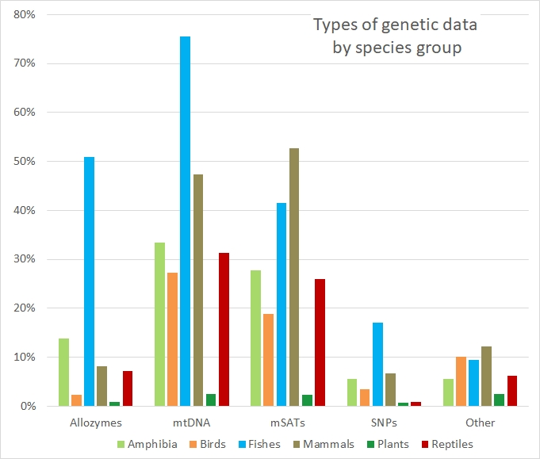
Figure 4. Proportion of Victorian vertebrate and higher plant species for which different types of genetic marker were identified by group (invertebrates not included).

Summary of Genetic Data
For species with genetic data, we made an assessment of the data (study outcomes) for informing several important parameters for determining overall genetic health of a species (Table 8). We assessed 349 species for evidence of genetic structure of populations, evidence for inbreeding within any populations, relative diversity within populations, and whether there was evidence for reduced effective size of populations (N_{e}). In many cases, interpretations were based on data obtained from studies on populations of the species outside Victoria (and in some cases, in other countries). For many species we could make an estimate for only one or some of these metrics because the available data were not sufficiently informative, and in some instances they were not interpretable with certainty.

Table 8. Estimates of strength of genetic attributes of populations for assessed species based on available and relevant genetic data
Strength of genetic attribute | Population structure | Evidence of inbreeding | Genetic diversity | Reduced N_{e}
High | 62 | 11 | 97 | 15
Moderate | 111 | 13 | 45 | 17
Little or none | 96 | 89 | 37 | 58
Varies | 0 | - | 70 | 33
Some populations | - | 52 | - | -
Uncertain | 20 | 4 | 12 | 2
Data deficient | 60 | 180 | 88 | 224
Total: | 349 | 349 | 349 | 349
We can deduce a number of general patterns from the results of the genetic data on Victorian species;
- Genetic data are broadly lacking for Victorian plant species, and the majority of Victorian invertebrate species. Plant species in threatened categories are particularly under-represented in terms of genetic data in comparison with threatened species of vertebrate fauna.
- Some form of genetic data are available for more than 50% of all vertebrate species, but less than a quarter of these data are likely to be useful for informing species’ genetic risks.
- The highest proportion of informative genetic data is available for freshwater fishes and mammals, and the threatened species categories critically endangered and endangered.
- Broadly, there is a lack of informative genetic data available across threatened species.

Demographic assessments
Most species were assessed as having satisfactory total population sizes (defined as >10,000 estimated individuals) across all of Australia. This was still the case excluding Victorian populations, but we estimated concerning or critically low overall numbers for some species (Figure 5). Additionally, 62 species were classified as ‘unknown’ for overall population size.
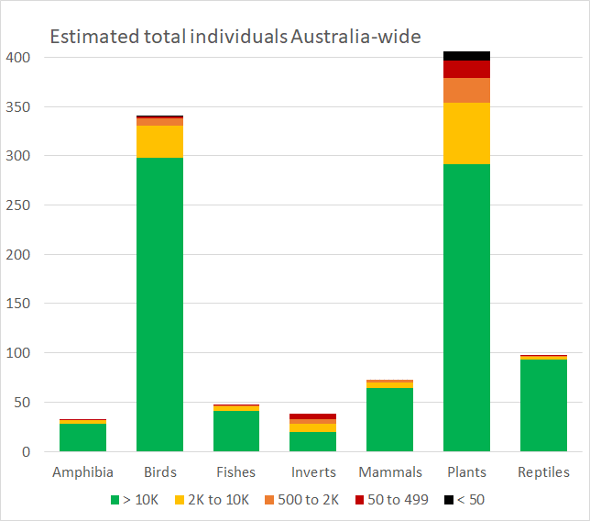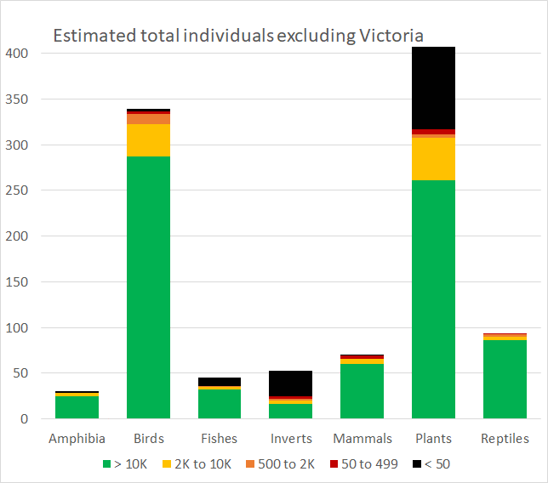
B
A
Figure 5. Number of species in categories for estimated total number of individuals, (A) Australia-wide, and (B) excluding Victoria: >10K = over 10,000; 2K to 10K = between 2,000 & 10,000; 500 to 2K = between 500 and 2,000; 50 to 499; and <50 = less than 50 or none. Excludes species estimated as ‘unknown’.
Assessing the likely number of separate populations for each species present in Victoria involved a high degree of uncertainty. We judged populations as separate if it was considered likely there is no, or only extremely occasional and sporadic, gene flow with any other populations of the given species.
For 76 species we were not confident of making any estimate for the likely number of separate populations (although for many of these it is likely to be more than one). A further 278 species were assessed as being at least somewhat fragmented (i.e. > 1 population) with varying degrees of confidence regarding the estimated minimum number of separate populations (e.g. > 1, > 3, or > 7). There was somewhat greater confidence for assessments of the remaining species. Overall, as expected given their relatively high mobility, birds showed the lowest population fragmentation with almost two-thirds of species considered likely to comprise a single population within Victoria. However, we assessed there was significant fragmentation for all other major groups (Figure 6).
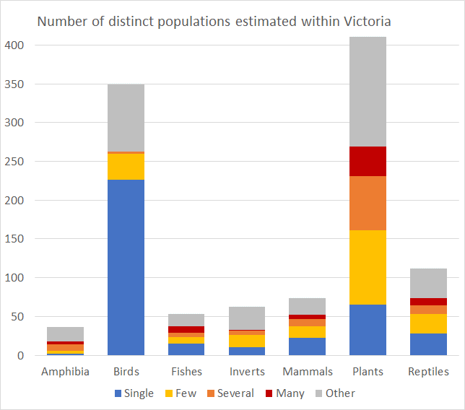
Figure 6. Distribution of the estimated number of distinct populations for each species likely present within Victoria: Single = all subpopulations likely to experience reasonable contemporary gene flow with other subpopulations; Few = likely between 2 and 7 populations; Several = likely between 8 and 14 populations, possibly more (includes ‘>7’); Many = likely more than 14 separate populations; Other = probably at least some fragmentation of populations for these species, but little confidence in further identifying the extent (includes ‘>1’ and ‘>3’).
We also made further estimates where possible of the likely average extent of cohesion of individual populations or metapopulations for different species. Generally, this entailed even greater uncertainty than the estimates of numbers of populations. In this context ‘cohesion’ is the converse of fragmentation, i.e. high cohesion equates to little likely effective fragmentation of a given population, whereas low cohesion equates to a population apparently quite highly fragmented where individuals persist within a metapopulation structure, but the various subpopulations are still likely to be receiving at least moderate gene flow.
In some cases, species were assessed as having several distinct populations, but that each of the separate populations were nevertheless mostly highly cohesive. By this metric many avian species were assessed as comprising a single, or only a few distinct populations, but that these populations are likely often highly fragmented compared to populations of many non-avian species. (Figure 7).
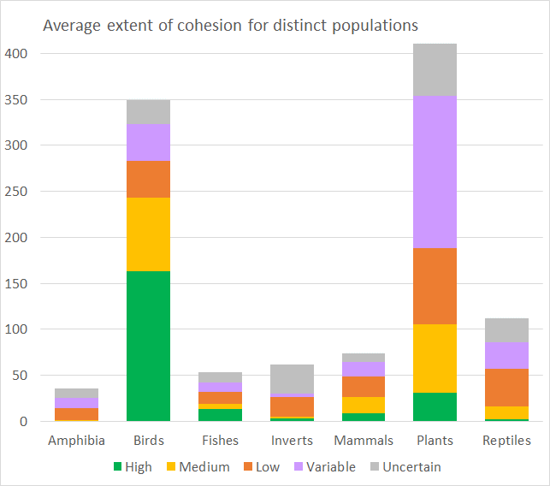
Figure 7. Number of species by groups for categories of average extent of population cohesion for distinct populations of the species within Victoria.
Where individual populations were considered separated or significantly fragmented, we assessed whether this was likely to have occurred pre- or post-European settlement, or both. Note that the criteria generally applied to identify separation in this context were broader than those used for the estimates summarized in Figure 6 (for example, situations are included where there may still be some gene flow between subpopulations but where there was likely considerably stronger connectivity in the past). This suggests a very considerable proportion of fragmentation occurring in the past 200 years (Figure 8). In many cases fragmentation is likely to be quite recent.
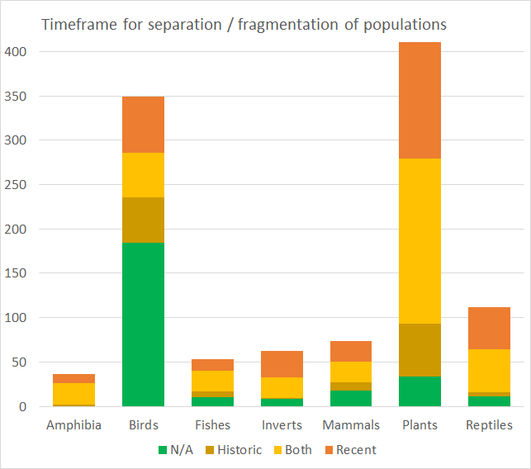
Figure 8. Number of species by groups for when separation or fragmentation of populations is likely to have occurred. N/A = no significant separation or fragmentation (i.e. quite likely only a single population within Victoria); Historic = pre-European separation only; Recent = post-European settlement; Both = some fragmentation prior to European settlement, and further fragmentation since.
Trends estimated for overall census population numbers for each species suggest nearly half (49.8%) of species were assessed to have declined (or fluctuated dramatically) in numbers across Victoria over the last few decades, with over 11% estimated to have severely declined (Figure 9).
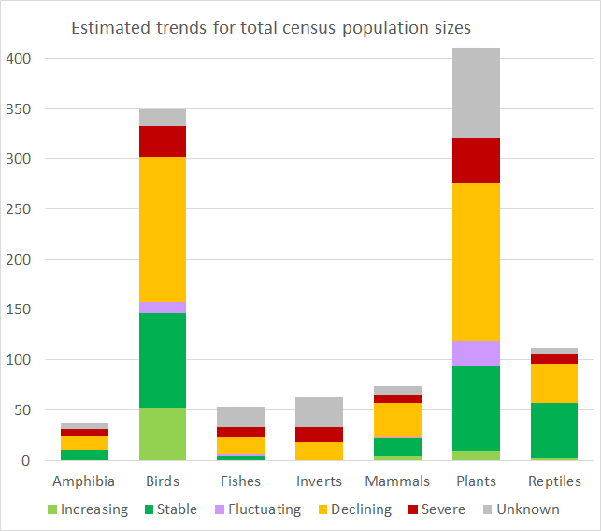
Figure 9. Number of species in categories for estimated trend in census population numbers of the species across Victoria. ‘Fluctuating’ includes species estimated to have experienced a population bottleneck overall; ‘Severe’ includes species estimated to have severely declined in numbers, or to have experienced one or more severe population bottleneck events in the last several decades.
The assessed species were quite evenly distributed across the six current DELWP regions, with ~ 600 to 700 species present in any one region. Gippsland had the highest number of species (705) and also the highest number of species occurring only in that region (79). Port Phillip yielded the fewest unique species (8). We also made a qualitative assessment of the distribution of each species within each DELWP region, ranging from a localized or scattered distribution, to widespread across much of the geographic extent of the region. A higher proportion of species were assessed as having a significant or widespread distribution across the Port Phillip region. This may reflect observational bias given that a large part of this region is urbanized. We also made a quantitative assessment of the distribution of each species within the DELWP regions based on the number of bioregions for which there were reliable occurrence records (Figure 10).
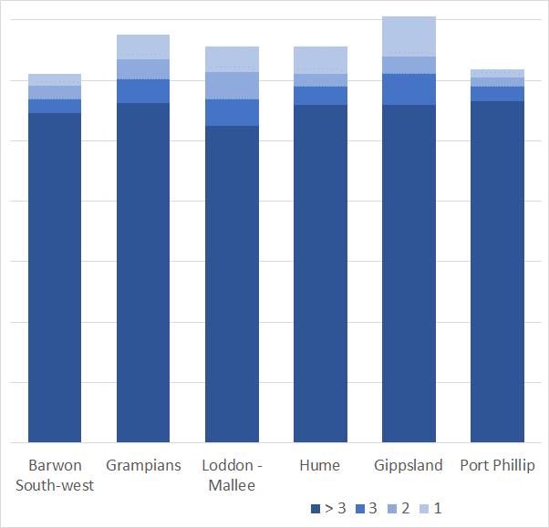
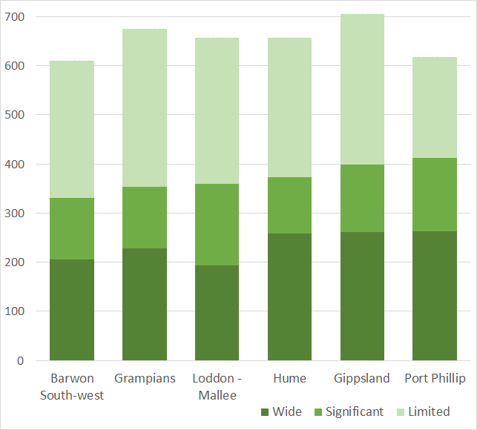
Figure 10. Occurrence of assessed species across current DELWP administrative regions indicating (A) categories of extent of distribution for individual species across each region, and (B) categories of number of bioregions each species occurs in within each DELWP region.
B
A
Occurrence and distribution of species across DELWP regions
To focus on potential genetic health risks to populations, in addition to the number of separate populations for individual species, we estimated the number of populations in five different categories of census size. The selection of these sizes was to help identify isolated populations that might be at elevated risk of genetic health issues now or in the near future. Particularly we posited that populations likely to have a census size of 500 individuals or fewer may be at significant risk of inbreeding depression given that effective population size (N_{e}) is likely to be considerably lower (on average ~ 1/10th the census size, Frankham et al. 2019).
Estimates of the number of populations of individual species were made where this was considered reasonable, but for most cases it was concluded the uncertainties were too great to specify a given number. In these cases, we used a binary indicator for whether or not there were likely to be at least some distinct populations of the species in the given size range.
This analysis indicated a high number of small populations, with 17.5% of species estimated as persisting only as populations of < 500 individuals within Victoria, and more than half of assessed species likely to have some populations of that size (Figure 11A). Extending this analysis to include populations estimated as having fewer than 2000 individuals further suggests a high proportion of the species assessed currently persist mainly as relatively small populations (Figure 11B). Populations of this size may not be at an immediate risk of severe inbreeding depression, but are likely to have reduced adaptative potential and could be expected to be at risk of losing genetic diversity at a concerning rate – particularly if population size fluctuates and/or for species with shorter average generation times.
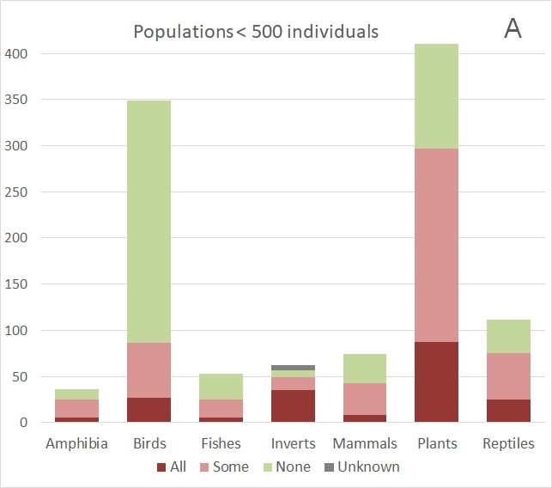
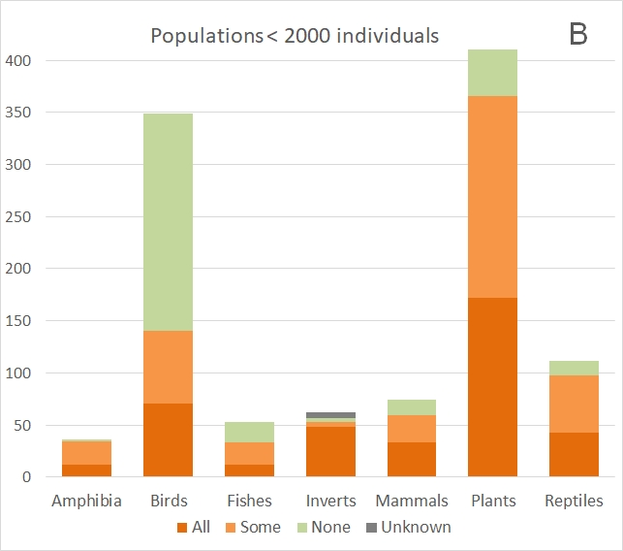
Figure 11. Number of species for main taxonomic groups where all, some or no populations were assessed as comprising (A) <500 individuals, or (B) <2000 individuals. No estimates were made for 6 species (indicated as Unknown).
To help guide assessments of likely connectivity or separation between subpopulations, we also estimated or recorded dispersal capacity for each species based on attribute data or knowledge of species’ biology. Generally, this was taken to be capacity for dispersal of reasonable numbers of potentially breeding individuals beyond their preferred habitat and across intervening habitat over their life cycle. For plants this was based on attribute data for animal-assisted dispersal of seeds where this was likely to be greater than pollen dispersal. In the absence of more specific information, dispersal was generally taken to be ‘low’ for insect pollination and ‘modest’ for wind pollination. For aquatic species it was taken to be dispersal beyond natal territories.
Given the wide range of variation in capability across different organisms, these estimates were made to the nearest half order of magnitude on a log scale – summarized for the major taxonomic classes (Figure 12).
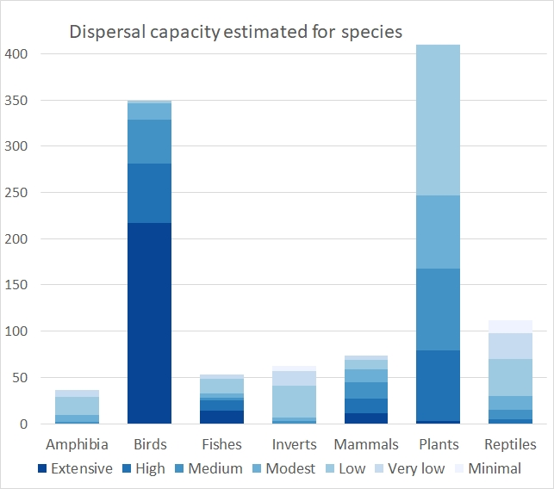
Figure 12. Number of species in categories of estimated average dispersal capacity: Extensive = ~100 km (or greater); High = ~32 km; Medium = ~10 km; Modest = ~3.2 km; Low = ~ 1 km; Very low = ~ 320 m; Minimal = ~ 100 m
For each assessed species we also evaluated the likely greatest barrier to dispersal of individuals between populations or suitable habitat patches. Again, there was considerable uncertainty around this analysis, but it suggests that for over half the species, the greatest barriers to connectivity of populations are the result of direct or indirect human activity since European settlement (Figure 13).
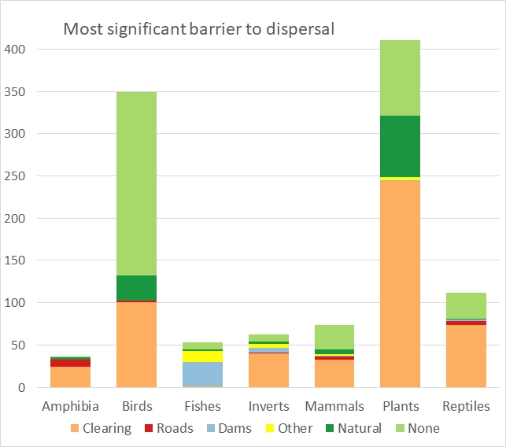
Figure 13. Number of species in categories of estimated single greatest barrier to dispersal for individuals of the given species. Clearing = native vegetation clearing post-European settlement, Other = presence of invasive predators (e.g. salmonid fish in lower reaches of waterways) or other structures such as fences, Natural = waterways or other natural discontinuities in habitat, None = dispersal generally limited only by individual stamina or broader climatic tolerance.
We also estimated average generation times (as opposed to maximum lifespan) for assessed species (Figure 14), significantly relying on IUCN red list or species attribute data. We separately recorded expected reproductive mode for these species (generally taken to be ‘sexual’ in the absence of specific information).
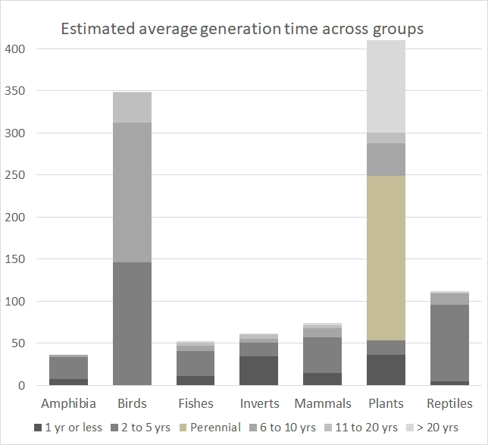
Figure 14. Number of species in categories for estimated generation times by groups. ‘Perennial’ category used only for non-annual and generally non-woody plants.
Consistent with declining population trends estimated for many species (Figure 9), we expect a sizeable proportion of species are currently experiencing, and will likely continue to face, significant threats in addition to fragmentation of populations. We estimated the likely most significant threat to a given species, in order to potentially help place genetic health risks in a broader context (Figure 15).
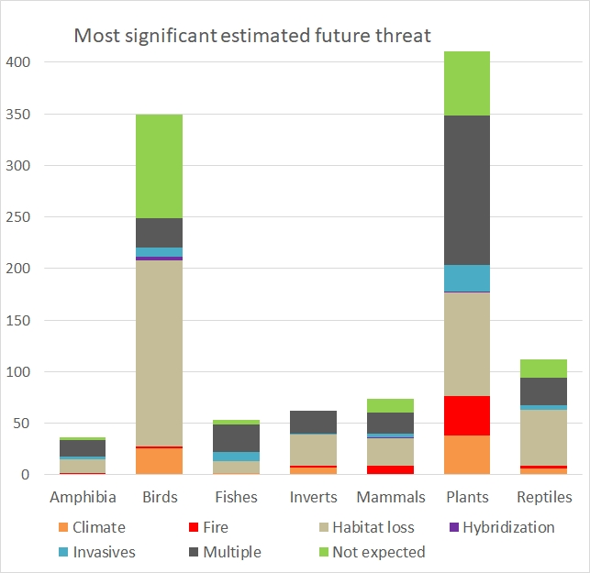
Figure 15. Number of species in categories of most significant estimated future threat by group. Climate = Aridity or Warming risk; Fire = risk of more frequent, or less frequent burning, or more intense fires; Multiple = uncertain which of two or more different threats is most significant; Not expected = no particular or imminent threat expected for Victorian populations of the species.

Combining genetic and demographic data

Towards a genetic risk index for Victorian flora and fauna
The database generated in this project combines key genetic and demographic data on 1100 species of Victorian flora and fauna. The data, and the uncertainty around key metrics, provides information for developing a genetic risk index for Victorian flora and fauna that can be integrated into conservation planning. The key metrics for determining genetic risk at the population and species level include effective population size (N_{e}), genetic fragmentation (gene flow between populations), genetic isolation, genetic variation and inbreeding. There are relatively few species where most of this information is available (<5% of the 3979 Victorian flora and fauna; only 147 species). The demographic parameters we assessed as part of this project were carefully chosen so that they could act as proxies for many of these genetic metrics. However, the data collection revealed that there is large uncertainty around many of these demographic metrics. Some of this uncertainty in the demographic metrics could be reduced by further ground-truthing of available data, while some could also be improved by further data collection (e.g. population size estimates, density, area of occupancy, dispersal, breeding system, etc).
We have started developing a framework for a genetic risk index, based on up to 17 genetic and demographic metrics and their combined uncertainty, to evaluate all 1100 species of Victorian flora and fauna assessed in this project.
In seeking to derive a genetic health evaluation for individual species, we considered it reasonable to assume that some metrics such as dispersal capacity, and whether all, some or no individuals likely persist within particularly small populations, will exert greater influence than other metrics.
We have initially identified 9 demographic and 3 genetic parameters that could be considered core metrics for the genetic risk index. For each of these, along with other metrics that currently contribute to our model, we have assigned different weightings to the various different factor levels, based on their estimated relative significance.
Our initial model simply sums scores across relevant metrics for a given species. Some mammalian examples of genetic risk assessments under this initial model are yellow-footed antechinus (moderate risk), greater glider (high risk), and fat-tailed dunnart (uncertain).
However, we note that interactions between factors for some metrics could potentially be multiplicative or even negative in some circumstances. Similarly, correlations between metrics are also possible and these may change weightings. A more robust future version of such a model could account for such interactions and correlations between metrics.
This genetic risk index also needs ground-truthing and sensitivity analyses to validate it. This can be done by several approaches such as comparing species that have accurate genetic, demographic and distributional data (e.g. Burramys parvus; Weeks et al. 2017) or where full population viability analyses (ideally including genetic parameters) have been undertaken on species. Once the approach has been ground-truthed and validated, the framework could be extended to other flora (and invertebrate fauna) found within Victoria not considered in this project. Based on our initial framework, the overall genetic risk status of species for the major taxonomic groups and by conservation status is shown in Figure 16.
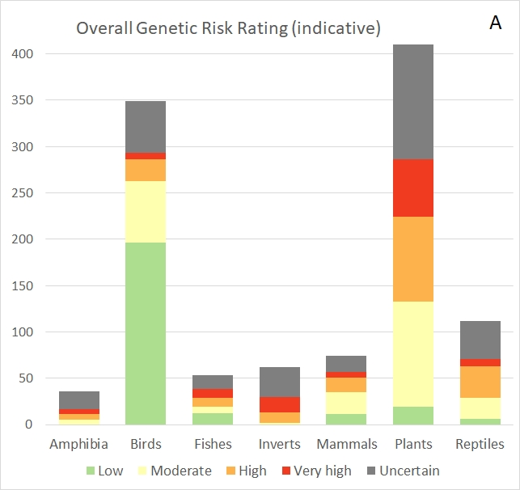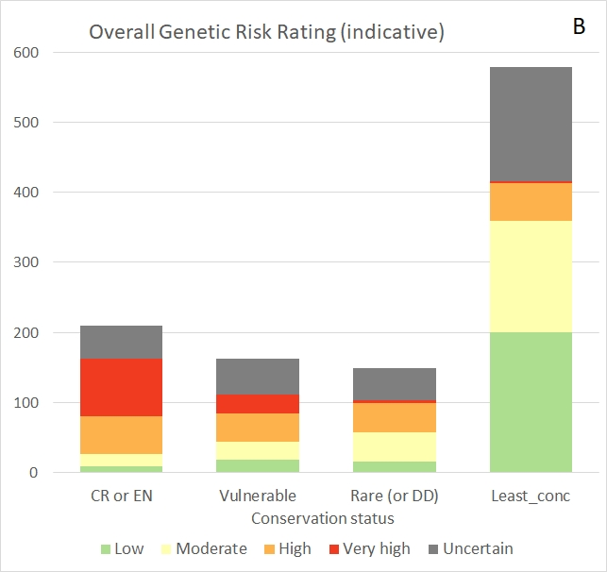
Figure 16. Genetic risk categories for Victorian species: number of species within major taxonomic groups (A), and by conservation status (B), based on available genetic and demographic data.
Approximately 30% of the assessed species fall into the very high (n = 115) or high (n = 191) genetic risk categories, while ~20% fall into each of the moderate (n = 242) and low risk (n = 244) categories. The remaining ~30% are uncertain (n = 308) due to a lack of information or high uncertainty across key parameters included in the risk index.
We have explicitly not incorporated species conservation status into this genetic risk index model. However, it would be reasonable to expect a significant degree of correlation between genetic health risk and extinction risk. The initial output result provides support for this: the majority (65%) of critically endangered / endangered species fall into the very high / high genetic risk categories, with 23% falling into the uncertain risk category. The few critically endangered / endangered species that fall into the low genetic risk category are all birds expected to have exceptionally high dispersal capacity and likely to be at conservation risk for reasons not directly related to genetic factors.
Some of the highest genetic risk rating species include; (i) mammals - brush-tailed rock-wallaby, Leadbeater’s possum, eastern barred bandicoot, mountain pygmy-possum, New Holland mouse, long-footed potoroo, broad-toothed rat; (ii) fish – Yarra pygmy perch, numerous species from the mountain galaxias complex, barred galaxias, Murray hardyhead, Murray cod; (iii) birds – black-eared miner, eastern bristlebird, grey-crowned babbler, regent honeyeater, orange-bellied parrot, plains wanderer; (iv) amphibians – Baw Baw frog, spotted tree frog, southern barred frog, Martin’s toadlet, growling grass frog; (v) reptiles – grassland earless dragon, mallee worm-lizard, alpine she-oak skink, alpine bog skink, pink-tailed worm-lizard; (vi) plants – Grampians pincushion lily, timbertop wattle, Anglesea grevillea, small golden moths, dwarf spider orchid, sunshine diuris.
Our assignment of species into risk categories has largely been based on relative risk score rankings. However, we anticipate that appropriate further adjustment of score weightings for different factors of metrics that contribute to the current model, allowance for non-additive interactions, and sufficient validation, can lead to risk categories that do have significant objective value.
Currently the genetic risk index is calculated at a Statewide scale, but could be weighted towards DELWP regions or State bioregions; the index could therefore be incorporated into decision-support tools, such as NaturePrint’s Strategic Management Prospects, to help biodiversity managers consider genetic risks in conservation planning. Importantly, individual metrics that are part of the genetic risk index can also be used to inform appropriate management decisions; for instance, inbreeding risk could indicate the need for genetic intervention-based strategies (such as genetic rescue or genetic augmentation).
An additional demographic parameter that was not specifically addressed in the course of our species assessments, but likely to be highly relevant for conservation planning is: for populations of a given species that are genetically separated, what is the extent of separation in terms of physical distance, and features present in the intervening landscape? Such data could inform whether restoration of population connectivity and adequate gene flow between such populations – through provision or restoration of landscape elements that can act as habitat corridors or stepping stones – is feasible or practical, or whether translocations of individuals is likely the only realistic management option. Combined with credible ratings of overall genetic risk to species, such information could significantly inform management decision-making around priorities for habitat restoration efforts.

Candidates for genetic interventions
We have also estimated the potential for management intervention to benefit some or all populations of each species within Victoria purely from a genetic health perspective, based on what was apparent from combined genetic and demographic data (Table 9). This was based on four separate criteria: the potential for genetic rescue of one or more significant populations of the species at immediate risk of inbreeding depression; the potential to re-establish one or more populations of the species to parts of its former range (or to rehabilitate habitat to allow existing populations to expand significantly) to increase overall population size (and therefore genetic resilience); the potential to increase adaptive capacity to populations through assisted gene flow from individuals likely to be locally adapted to regions that currently experience different average environmental conditions; and the potential to augment genetic diversity to populations currently likely to be losing genetic diversity (even if not at imminent risk of inbreeding depression).
Table 9. Estimates of potential for management interventions to benefit populations of species from a genetic perspective. Note for ‘Redundant’ we did not discriminate between genetic rescue being not necessary, and genetic rescue likely being unattainable due to lack of suitable source individuals.
Benefit of management | Genetic rescue potential | Re-establish potential | Adaptive provenance potential | Potential to augment genetic diversity
High | 51 | 284 | - | -
Moderate | 60 | 187 | - | -
Some | 59 | 123 | - | -
Total positive | [170] | [594] | 217 | 220
Redundant | 508 | - | - | -
Limited or not likely | - | 215 | 397 | 247
Uncertain | 422 | 291 | 486 | 633
Totals: | 1100 | 1100 | 1100 | 1100

There is great scope for genetic intervention-based management strategies for many of the 1100 species assessed in this project. Approximately 15-20% are likely to benefit from some form of direct genetic intervention, either genetic rescue or targeted gene flow/genetic augmentation. Over half the species assessed would benefit from re-establishing new populations to increase total population size and overall genetic diversity. Clearly there is large scope to improve the genetic health of populations throughout Victoria.

Priority species for collecting genetic data
Based on the demographic data, genetic attributes and likely threatening processes, we also prioritised groups for obtaining genetic data or additional genetic data for populations of Victorian species. Categories included ‘low’ or ‘medium’ where reasonable genetic data have already been generated or the extent or risk of fragmentation for populations of the species is relatively low, ‘primary’ where other threats are likely current or imminent and ‘urgent’ for those that should be addressed as a first priority (Figure 17). This is only for the assessed species in this project; invertebrates and plants should be considered the groups with the largest number of species for which information is lacking.
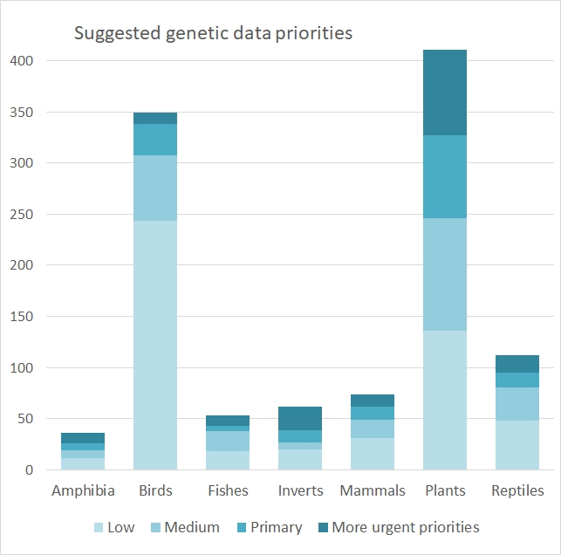
Figure 17. Number of species in four categories of estimated relative priorities for obtaining population genetic data by group.

Research gaps
This project has highlighted numerous gaps in our knowledge around genetic and demographic information that is important for determining the genetic risk of species and also to help inform genetic intervention approaches. Below we outline some of those broader gaps in knowledge.

Taxonomic groups
The largest gaps in our knowledge exist primarily for two taxonomic groups:
- Invertebrates – we assessed only 62 conservation-dependent species of invertebrates, including freshwater/burrowing crayfish, for which little data are available that can be used to help determine their genetic risk (>50% of assessed invertebrates were uncertain for their genetic risk). However, thousands or tens of thousands of species of invertebrates within Victoria were not considered here. It is likely that there is little information available for the majority of these species on their distribution, biology and ecology, let alone genetic information.
- Plants – only 414 of the State’s 3293 plant species (<13%) were assessed in this project. A high proportion of these (31%) were rated as uncertain for their genetic risk status, indicating a lack of information on metrics used in our risk index. In addition, we weighted the 414 selected species in favour of species that had genetic data; therefore, it is likely that there is little or no genetic data available for the remaining 2879 species. Similarly, for plants there is a general lack of knowledge around breeding systems for many species (e.g. self-incompatibility), which is an important factor in determining overall genetic risk status (Frankham et al. 2017, 2019).

Threatened species
Despite their conservation status, many threatened species have little genetic and/or demographic data that can inform their genetic risk status (~27% were assessed as uncertain across the critically endangered, endangered and vulnerable risk categories). Importantly however, there is only a low level of genetic data (<20%) available for species in these categories, and even less (<7%) that are informative for directly evaluating risk and informing genetic intervention strategies. Even when we consider only the critically endangered and endangered categories, informative genetic data are available for only ~10% of species; species in these categories are likely to be the most in need of genetic intervention and therefore should be considered high priority for obtaining genetic data that can be used to prevent their further decline or extinction.

Fragmentation
Population genetic fragmentation is a major genetic risk factor that can increase extinction risk (Ralls et al. 2018). Accurate demographic, ecological and biological data can be used to infer population fragmentation, but it will always be a conservative estimate of the level of genetic fragmentation across a landscape for a species. Much of the information in our database around population fragmentation (or connectivity) in species is generated from demographic and biological attribute data that includes dispersal capacity; therefore, there is great scope to improve our understanding of population fragmentation (genetic fragmentation) across diverse groups that often have assumed connectivity because of their dispersal capacity (e.g. birds). As fragmentation and dispersal are key metrics in our genetic risk index, this will improve the overall accuracy of this index for assessing genetic risk.

Chromosomal differences
Genetic strategies (e.g. translocation augmentations, gene pool mixing etc) for improving biodiversity outcomes often rely on an assessment of genetic risk (Frankham et al. 2011; Weeks et al. 2011). We discuss decision trees below that can help with assessing this risk, but often a key aspect to determining risk is information on chromosomal differences between populations (sub-species, evolutionary significant units etc). Chromosomal differences are an important predictor of outbreeding depression (where reproductive fitness is reduced in subsequent generations from crossing two distinct populations) (Frankham et al. 2011). Unfortunately there is little data on chromosomal differences between populations, sub-species or evolutionary significant units. These data are most directly and economically acquired through karyology, but the skills and capacity for this have strongly declined in recent decades. New sequencing methods can sometimes provide partial substitute information.

Genetic rescue and other genetic intervention strategies
Genetic translocations and other strategies aimed at improving population fitness, resilience and adaptive capacity are starting to be considered more broadly in conservation programs in Australia. Several genetic rescues have been initiated or undertaken for threatened populations over the last decade in Victoria alone, with programs in vertebrates on the Mountain Pygmy-possum (Weeks et al. 2017), helmeted honeyeater (Harrisson et al. 2016; P. Sunnucks et al. unpubl. data), eastern barred bandicoot (A. Weeks, unpubl. data), Macquarie perch (Pavlova et al. 2017; Pavlova et al. unpubl. data.), southern brush-tailed rock-wallaby (Weeks et al. 2014) and Leadbeater’s possum (P. Sunnucks et al. unpubl. data). Other strategies are also being considered or implemented for climate adaptation, targeted gene-flow, and augmenting genetic diversity to improve population and species resilience in both plants and animals. However, outcomes from these programs are largely in their infancy, and therefore data are needed on the merits of these different genetic strategies for improving threatened species outcomes. Currently this research gap hinders broader application in threatened species programs. Well-documented examples will provide confidence to managers in adopting these strategies and provide working examples on how to implement to increase the chance of success (including information needed to reduce risk).

Case studies
The following case studies illustrate the range of genetic information available for species that occur in Victoria, and from that, types of management actions for consideration to address genetic problems. The case studies also aim to illustrate links between conservation issues/natural history and genetic problems. We have grouped case studies into two broad categories; Best Practice and Typical Information.
Best Practice case studies
These represent species where high-quality genetic data have been collected that are able to inform future conservation management of the species. These examples include:
- Species where informed genetic management action has been undertaken and outcomes reported.
- Species where management action is yet to be taken, but strong recommendations for management or further research are supplied, based on high quality/informative genetic data.
The species included in the Best Practice case studies are: the Mountain Pygmy-possum Burramys parvus, the Trout Cod Maccullochella macquariensis, the Squirrel Glider Petaurus norfolcensis, the Button Wrinklewort Rutidosis leptorrhynchoides, and the Helmeted Honeyeater Lichenostomus melanops cassidix.
Typical Information case studies
These represent species where there is insufficient information to accurately assess the genetic health of the species/Victorian populations overall. These include:
- Species with the wrong kind of genetic data to inform on population genetics (e.g. genetic data relates to phylogenomics/taxonomic classification).
- Species with some high quality genetic data that are of restricted value for drawing overall conclusions about genetic health of Victorian populations (e.g., analysis performed only on a single population or subspecies, or performed in a different part of Australia).
- Species with no genetic data, but are suspected to be suffering from declines in genetic health.
The species included in the Typical Information case studies are: the Large Ant-blue Butterfly Acrodipsas brisbanensis, the Matted Flax Lily Dianella amoena, the Striped Legless Lizard Delma impar, the Southern Emu-wren Stipiturus malachurus, the Long-nosed Bandicoot Perameles nasuta, and the Murray Hardyhead Craterocephalus fluviatilis.
An overview of how genetic data have been used to inform genetic management of Victorian species, in six Best Practice scenarios are shown in Table 10. Similarly, an overview of how conservation actions could proceed when best practice information is not known (Typical Information case studies) are shown in Table 11.

Table 10. Summary of how genetic data have been used to inform genetic management of Victorian species.
Species | Type of genetic data used | Information that genetic data provided | Relevant findings | How information was used
1. Mountain Pygmy-possum  (Burramys parvus) | mtDNA  Microsatellites (8-24 loci) | - Evolutionary divergence among populations  - Genetic diversity  - Levels of inbreeding (F_{IS})  - Levels of population differentiation (F_{ST})  - Effective population size (N_{e}) | - Estimated approximate divergence times between northern, central and southern populations  - Showed highly fragmented populations indicative of dispersal limitation  - Showed rapid declines of diversity and effective population size in the Mt Buller population.  - Showed rapid recovery of genetic and demographic health after management actions | - Documented the critical situation for Mt Buller populations  - Justified the need for genetic rescue  - Identified appropriate levels of gene flow, and determine appropriate source population for translocations  - Documented success of genetic management actions
2. Grey-crowned Babbler (Pomatostomus temporalis) | Microsatellites (13 loci) | - Genetic diversity  - Population structure  - Levels of gene flow pre and post-fragmentation  - Effective population size (N_{e}) pre and post-fragmentation  - Evidence of genetic bottlenecks, drift and migration | - Revealed that treeless landscapes act as strong barriers to gene flow  - Showed that habitat fragmentation has led to genetic divisions between eastern and western populations  - Showed that levels of dispersal are extremely low, in contrast with historic connectivity  - Estimated that effective population size in eastern and western regions is now below that required for long-term population viability  - Strong evidence for genetic bottlenecking in most sub-populations | - Demonstrated that a loss of functional connectivity of landscapes has negative consequences for the future viability of this species  - Used as a basis to recommend management actions including habitat revegetation and translocations
3. Trout Cod (Maccullochella macquariensis) | mtDNA; Microsatellites (9 loci) | - Genetic diversity before and after captive breeding efforts  - Population structure before and after captive breeding efforts | - Showed that extant populations had moderate to extremely low genetic diversity  - All genetic diversity present derived from a single population (Murray River), that other populations were originally stocked from  - Showed that post-breeding program and release, populations were homogeneous, and diversity in the translocated population was the same as that in the Murray population | - Used to devise a breeding program that maximised genetic diversity and fitness of fish produced  - Proved that breeding protocols had been effective at maintaining the highest possible genetic diversity, and reducing genetic structure among stocked populations
4. Squirrel Glider (Petaurus norfolcensis) | mtDNA; Microsatellites (5-8) | - Evolutionary divergence between southern and northern/coastal populations  - Population structure before and after installation of highway crossing structures  - Estimated numbers of first-generation migrants and parentage | - Identified that the southern (VIC) and northern/coastal lineages are evolutionarily distinct  - Showed that gene flow was restored after installation of crossing structures, at sites where it was previously restricted  - Showed that crossing structures increased breeding events resulting from direct road crossings | - Recognition of the southern lineage of an ESU that contains important genetic diversity for the species  - Proved that highway crossing structures were effective at restoring direct gene flow across highways, and reducing energetic costs of crossing
5. Button Wrinklewort (Rutidosis leptorrhynchoides) | Karyology;  Allozyme (8);  Genomic DNA (thousands of SNPs) | - Genetic diversity  - Population structure  - Polyploidy (chromosome variation) across populations  - Evidence of genetic bottlenecking in ex-situ populations | - Showed considerable genetic differentiation based on geography  - Identified polyploidy (different populations have different numbers of chromosomes)  - Showed that ex-situ populations were bottlenecked  - Identified that one wild population was poorly represented in ex-situ stock  - Identified an important source population for genetic rescue | - Informed design of ex-situ breeding trials  - Indicated that ex-situ populations were not being managed optimally to promote genetic diversity  - Demonstrated successful genetic rescue in semi-wild conditions  - Provided advice for genetic rescue opportunities
6. Helmeted Honeyeater (Lichenostomus melanops cassidix) | Microsatellites (11-13 loci)  Nuclear sequence markers  mtDNA  Genomic DNA (thousands of SNPs) | - Evolutionary history  - Genetic diversity in captive and wild populations  - Levels of gene flow between subspecies  - Levels of inbreeding (F) | - Estimated approximate divergence times between subspecies  - Showed that genetic diversity continually declined in captive and wild populations over the last 40 years  - Indicated severe inbreeding  - Showed human impacts had reduced gene flow from the gippslandicus subspecies into Helmeted Honeyeaters | - Justified the need for genetic rescue by explicit assessment of risks and benefits  - Identified appropriate levels of gene flow between subspecies  - Informed design of captive breeding programs

Table 11. Overview of how conservation actions could proceed using current knowledge, and how management might be improved using more informative genetic information, for six Victorian species with varying levels of genetic information available.
Species | Type of genetic data used | How could current knowledge be used? | Information that further genetic data could provide | What could we learn from more informative genetic data? | How could genetic information inform management?
1. Large Ant-blue Butterfly (Acrodipsas brisbanensis) | None | - Lack of gene flow could be inferred from spatial isolation of extant populations  - Lack of gene flow could be inferred from similarity to more well-studied species (e.g. Eltham Copper Butterfly) | - Evolutionary relationships between VIC endemic A. b. cyrilus and other subspecies  - Effective population size (N_{e})  - Levels of gene flow  - Genetic diversity  - Levels of inbreeding (F_{IS})  - Levels of population differentiation (F_{ST}) | - Levels of differentiation between A. b. cyrilus and other subspecies  - What is the effective population size of extant populations?  - Is gene flow occurring? How much?  - Are populations showing signs of inbreeding? | - Contribute to understanding the urgency of conservation actions required  - Identify whether genetic rescue would be necessary/useful  - Identify appropriate populations or subspecies for translocations
2. Matted Flax Lily (Dianella amoena) | None | - Lack of gene flow could be inferred from lack of observed sexual reproduction  - Green house trials could be started using assumptions from similar species (e.g. Rutidosis leptorrynchoides) to test whether breeding plants from different populations increases reproductive success | - Genetic diversity  - Levels of inbreeding (F_{IS})  - Rate of self-fertilization (selfing)  - Levels of population differentiation (F_{ST})  - Effective population size (N_{e})  - Levels of gene flow  - Variation in chromosome number | - Is there evidence of small population size including mate limitation, biparental inbreeding or selfing?  - Is gene flow occurring? How much?  - Do populations have differing numbers of chromosomes that may cause genetic problems when different types cross? | - Contribute to understanding around lack of sexual reproduction  - Identify whether genetic rescue will be beneficial  - Identify appropriate populations for translocations
3. Striped Legless Lizard (Delma impar) | mtDNA;  Microsatellites (8 loci) | - Knowledge of ESUs could underpin more nuanced conservation planning (currently not incorporated into recovery/action plans)  - Patchy information on population structure and diversity could be used as a baseline for future work  - Findings from translocations in the ACT could inform management of future translocations in VIC  - Lack of gene flow over time could be inferred from recent fragmentation and low dispersal ability | - Levels of gene flow/migration rates  - A more complete picture of genetic structure across VIC  - Levels of population differentiation (F_{ST}) | - Is there evidence of gene flow/migration in recent generations? How much?  - Is genetic structure present that could be detected in a more comprehensive study? | - More accurate estimates of whether gene flow is still occurring among populations  - More accurate assessment of risk of local extinctions  - Identify relationships among populations, and centres of unique genetic diversity  - Provide advice for potential future translocations
4. Southern Emu-wren (Stipiturus malachurus) | mtDNA;  Genomic DNA (thousands of SNPs) | - Understanding of sub-species distribution is useful for refining conservation planning  - Genetic differentiation and inbreeding detected in the S. m. intermedius subspecies could be used as a basis for assuming VIC subspecies may be facing similar issues  - Lack of currentgene flow could be inferred from recent fragmentation and low dispersal ability | - A more complete picture of genetic structure across VIC  - Levels of population differentiation (F_{ST})  - Levels of gene flow/migration rates  - Genetic diversity across populations | - Is there evidence that populations are becoming genetically fragmented/structured?  - Is there evidence of gene flow/migration among populations? How much?  - Which populations contain the most/unique genetic diversity? | - Contribute to understanding conservation priorities for the two Victorian subspecies  - Provide a more accurate assessment of how the species is being affected by habitat fragmentation  - Provide an understanding of populations that contain important genetic diversity that may be useful for future genetic management actions
5. Long-nosed Bandicoot (Perameles nasuta) | Microsatellites (8-9 loci) | - Populations in large/well connected habitats are unlikely to be suffering from fragmentation or inbreeding depression  - Roads do not seem to prevent gene flow | - Genetic structure of VIC populations  - Levels of population differentiation (F_{ST})  - Genetic diversity across populations | - An understanding of genetic structure of VIC populations  - An understanding of whether smaller populations are suffering from genetic isolation  - An understanding of general genetic health of populations | - Provide a more accurate assessment of the conservation status of this species in VIC (is it as robust as we assume?)  - Provide an understanding of how fragmentation affects overall viability of VIC subspecies  - Provide baseline data as a benchmark for future comparisons
6. Murray Hardyhead (Craterocephalus fluviatilis) | mtDNA;  Allozyme (52 loci) | - Knowledge of differentiated populations (conservation units) could inform future translocations/captive breeding protocols  - Understanding that regional dispersal is currently restricted could be used to shape conservation planning (e.g. re-introductions, translocations, habitat restoration) | - Current genetic diversity  - Current levels of inbreeding (F_{IS})  - Current levels of population differentiation (F_{ST}) | - An understanding of genetic health of populations and levels of inbreeding after losses during Millennium Drought  - Has population differentiation changed/increased post-drought? | - Contribute to understanding urgency of conservation status  - Contribute to understanding how crisis management affected the genetic health of this species  - Identify need for translocations/targeted captive breeding program  - Identify appropriate populations for translocations if required

Risk frameworks for genetic interventions
Genetic interventions can carry some genetic risks (Tallmon et al. 2004; Edmands 2007). While these risks are often overstated (Frankham et al. 2011; Weeks et al. 2011), particularly for threatened species (Weeks et al. 2016), various decision support tools are now available to help guide genetic interventions. Broad decision frameworks have been developed by a number of researchers [e.g. Weeks et al. (2011), Hoffmann et al. (2015), Frankham et al. (2017)] that provide overall guidance around the need for genetic intervention and some of the risks that need to be considered. Frankham et al. (2011) developed a thorough decision tree for evaluating the risk of outbreeding depression, which was adapted in Frankham et al. (2017) and shown below (Figure 18). The tree highlights where genetic and karyological information is integral for informing risk of outbreeding depression from genetic interventions.

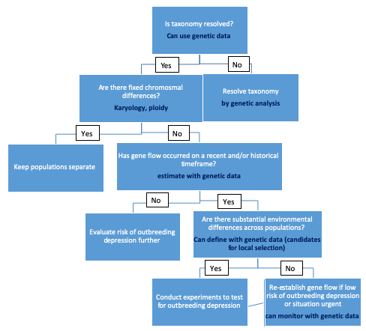
Figure 18. Decision tree for determining the risk of outbreeding depression when undertaking genetic translocations (adapted by Erin Liddell from Frankham et al. 2017 and further modified here).

Ideally, genetic data are used to inform any genetic intervention approach; however, this may not always be possible and in such situations, risk can still be evaluated (to some extent) through ecological and biological attribute data on source and recipient populations (e.g. breeding system, population size, inferred time of isolation, ecological differentiation etc). While some genetic translocations are likely to be relatively risk-free under these circumstances (e.g. reconnecting recently isolated populations or augmenting a population that has undergone rapid decline) it is always appropriate to consider genetic risks, and how these can best be mitigated before proceeding with a genetic intervention (translocation).

Conclusion
The genetic risk index developed from the database of genetic and demographic data for 1100 species of flora and fauna found in the state of Victoria has provided a basis for incorporating genetic diversity considerations into biodiversity conservation planning. The framework for the index considers 17 parameters of genetic and/or demographic data that are known to affect genetic diversity. We also incorporated uncertainty into this index, as there was a large amount of doubt around the accuracy of demographic parameters for many species. The framework for the genetic risk index needs validation, as does the definition of risk categories and their sensitivity to uncertainty. There is great scope to improve the index, by reducing the uncertainty around parameter estimates through gathering genetic data directly on species and improving estimates of the demographic parameters used in the framework. The genetic risk index can feed directly into tools such as the Department of Environment, Land, Water and Planning’s Strategic Management Prospects, to help biodiversity managers consider genetic risks in state and region-based conservation planning.

References
Aitken, S. N. and J. B. Bemmels. 2016. Time to get moving: assisted gene flow of forest trees. Evolutionary Applications 9:271-290.
Chapman, A. D. 2009. Numbers of living species in Australia and the world. Pp. 84. Australian Biological Resources Study, Canberra.
Cook, C. N. and C. M. Sgrò. 2017. Aligning science and policy to achieve evolutionarily enlightened conservation. Conservation Biology 31:501-512.
Cook, C. N. and C. M. Sgrò. 2018. Understanding managers' and scientists' perspectives on opportunities to achieve more evolutionarily enlightened management in conservation. Evolutionary Applications 11:1371-1388.
Cook, C. N. and C. M. Sgrò. 2019. Poor understanding of evolutionary theory is a barrier to effective conservation management. Conservation Letters 12:e12619.
Endo, Y., M. Nash, A. A. Hoffmann, R. Slatyer, and A. D. Miller. 2015. Comparative phylogeography of alpine invertebrates indicates deep lineage diversification and historical refugia in the Australian Alps. Journal of Biogeography 42:89-102.
Edmands S. 2007. Between a rock and a hard place: evaluating the relative risks of inbreeding and outbreeding for conservation and management. Molecular Ecology 16:463-75.
Frankham, R. 2005. Genetics and extinction. Biological Conservation 126:131-140.
Frankham, R., Ballou, J.D., Briscoe, D.A., 2010. Introduction to Conservation Genetics, Second edn. Cambridge University Press, Cambridge.
Frankham, R., J. D. Ballou, M. D. B. Eldridge, R. C. Lacy, K. Ralls, M. R. Dudash, and C. B. Fenster. 2011. Predicting the probability of outbreeding depression. Conservation Biology 25:465–475.
Frankham, R., C. J. A. Bradshaw, and B. W. Brook. 2014. Genetics in conservation management: Revised recommendations for the 50/500 rules, Red List criteria and population viability analyses. Biological Conservation 170:56-63.
Frankham, R., Ballou, J.D., Ralls, K., Eldridge, M.D.B., Dudash, M.R., Fenster, C.B., Lacy, R.C., Sunnucks, P., 2017. Genetic Management of Fragmented Animal and Plant Populations. Oxford University Press, Oxford
Frankham, R., Ballou, J.D., Ralls, K., Eldridge, M.D.B., Dudash, M.R., Fenster, C.B., Lacy, R.C., Sunnucks, P., 2019. A Practical Guide for Genetic Management of Fragmented Animal and Plant Populations. Oxford University Press, Oxford.
Gonzalez, A., O. Ronce, R. Ferriere, and M. E. Hochberg. 2013. Evolutionary rescue: an emerging focus at the intersection between ecology and evolution. Philosophical Transactions of the Royal Society B-Biological Sciences 368:8.
Haddad, N. M., L. A. Brudvig, J. Clobert, K. F. Davies, A. Gonzalez, R. D. Holt, T. E. Lovejoy, J. O. Sexton, M. P. Austin, C. D. Collins, et al. 2015. Habitat fragmentation and its lasting impact on Earth's ecosystems. Science Advances 1:9.
Hale, M. L., T. M. Burg, and T. E. Steeves. 2012. Sampling for Microsatellite-Based Population Genetic Studies: 25 to 30 Individuals per Population Is Enough to Accurately Estimate Allele Frequencies. PLOS ONE 7:e45170.
Hanson, J. O., R. A. Fuller, and J. R. Rhodes. 2019. Conventional methods for enhancing connectivity in conservation planning do not always maintain gene flow. Journal of Applied Ecology 56:913-922.
Harrisson KA, Pavlova A, Gonçalves da Silva A, Rose R, Bull JK, Lancaster ML, Murray N, Quin B, Menkhorst P, Magrath MJL, and Sunnucks P. (2016) Scope for genetic rescue of an endangered subspecies though re–establishing natural gene flow with another subspecies. Molecular Ecology, 25: 1242-1258.
Hoffmann, A., P. Griffin, S. Dillon, R. Catullo, R. Rane, M. Byrne, R. Jordan, J. Oakeshott, A. Weeks, L. Joseph, et al. 2015. A framework for incorporating evolutionary genomics into biodiversity conservation and management. Climate Change Responses 2:1.
Hoffmann, A. A. and C. M. Sgrò. 2011. Climate change and evolutionary adaptation. Nature 470:479-485.
Hoffmann, A. A., C. M. Sgrò, and T. N. Kristensen. 2017. Revisiting adaptive potential, population size, and conservation. Trends in Ecology & Evolution 32:506-517.
Keller, L. F. and D. M. Waller. 2002. Inbreeding effects in wild populations. Trends in Ecology & Evolution 17:230-241.
Mendez, M., M. Vogeli, J. L. Tella, and J. A. Godoy. 2014. Joint effects of population size and isolation on genetic erosion in fragmented populations: finding fragmentation thresholds for management. Evolutionary Applications 7:506-518.
O'Grady, J. J., D. H. Reed, B. W. Brook, and R. Frankham. 2008. Extinction risk scales better to generations than to years. Animal Conservation 11:442-451.
Pavlova A. Beheregaray LB, Coleman R, et. al. 2017. Severe consequences of habitat fragmentation on genetic diversity of an endangered Australian freshwater fish: a call for assisted gene flow. Evolutionary Applications 10:531-550
Pierson, J.C., Coates, D.J., Oostermeijer, J.G.B., Beissinger, S.R., Bragg, J.G., Sunnucks, P., Schumaker, N.H., Young, A.G., 2016. Genetic factors in threatened species recovery plans on three continents. Frontiers in Ecology and the Environment 14, 433-440.
Prado-Martinez, J., P. H. Sudmant, J. M. Kidd, H. Li, J. L. Kelley, B. Lorente-Galdos, K. R. Veeramah, A. E. Woerner, T. D. O'Connor, G. Santpere, et al. 2013. Great ape genetic diversity and population history. Nature 499:471-475.
Prober, S., M. Byrne, E. McLean, D. Steane, B. Potts, R. Vaillancourt, and W. Stock. 2015. Climate-adjusted provenancing: a strategy for climate-resilient ecological restoration. Frontiers in Ecology and Evolution 3.
Radchuk, V., T. Reed, C. Teplitsky, M. van de Pol, A. Charmantier, C. Hassall, P. Adamik, F. Adriaensen, M. P. Ahola, P. Arcese, et al. 2019. Adaptive responses of animals to climate change are most likely insufficient. Nature Communications 10:14.
Ralls K, Ballou JD, Dudash MR, Eldridge MDB, Fenster CB, Lacy RC, Sunnucks P, Frankham R. 2018. Call for a paradigm shift in the genetic management of fragmented populations. Conservation Letters 11:e12412.
Robinson, J. A., C. Brown, B. Y. Kim, K. E. Lohmueller, and R. K. Wayne. 2018. Purging of strongly deleterious mutations explains long-term persistence and absence of inbreeding depression in island foxes. Current Biology 28:3487-+.
Saura, S., O. Bodin, and M. J. Fortin. 2014. Stepping stones are crucial for species' long-distance dispersal and range expansion through habitat networks. Journal of Applied Ecology 51:171-182.
Spielman, D., B. W. Brook, and R. Frankham. 2004. Most species are not driven to extinction before genetic factors impact them. Proceedings of the National Academy of Sciences of the United States of America 101:15261-15264.
Tallmon DA, Luikart G, Waples RS. 2004. The alluring simplicity and complex reality of genetic rescue. Trends in Ecology and Evolution 19: 489-96.
Wang, F., L. C. Jiang, Y. Chen, N. A. Haelterman, H. J. Bellen, and R. Chen. 2015. FlyVar: a database for genetic variation in Drosophila melanogaster. Database-the Journal of Biological Databases and Curation:7.
Weeks, A. R., C. M. Sgro, A. G. Young, R. Frankham, N. J. Mitchell, K. A. Miller, M. Byrne, D. J. Coates, M. D. B. Eldridge, P. Sunnucks, et al. 2011. Assessing the benefits and risks of translocations in changing environments: a genetic perspective. Evolutionary Applications 4:709-725.
Weeks, A. R., J. Stoklosa, and A. A. Hoffmann. 2016. Conservation of genetic uniqueness of populations may increase extinction likelihood of endangered species: the case of Australian mammals. Frontiers in Zoology 13:9.
Whitlock, M. C. 2000. Fixation of new alleles and the extinction of small populations: Drift load, beneficial alleles, and sexual selection. Evolution 54:1855-1861.
Willi, Y., J. Van Buskirk, and A. A. Hoffmann. 2006. Limits to the adaptive potential of small populations. Annual Review of Ecology Evolution and Systematics 37:433-458.
Young, A. G. and M. Pickup. 2010. Low S-allele numbers limit mate availability, reduce seed set and skew fitness in small populations of a self-incompatible plant. Journal of Applied Ecology 47:541-548.

Appendix 1. Background information

What is genetic diversity and how is it measured
For natural populations of most species of higher organisms there are likely to be many genetic differences between individuals that make up the population. Several molecular features of DNA give rise to this genetic variation. The most common are changes in a single nucleotide base within an otherwise conserved stretch of DNA sequence. Known as single nucleotide polymorphisms (SNPs), these elements are typically scattered at various locations (loci) throughout the organism’s genome. Genomic insertions or deletions, differing lengths of DNA repeat regions, inversions, and other chromosomal rearrangements are also significant factors contributing to genetic variation.
As there are four types of DNA bases, technically there can be up to four different variants, or alleles, for any given SNP, but for real populations there will usually be no more than two alternative alleles at most SNP loci. However, for some other genetic loci, particularly DNA repeat regions, there may be many different alleles.
How much genetic variation is there in populations? As an example of the scale of genetic variation within the human population any two unrelated people are likely to differ at 1 in just over 1,000 base pairs of their DNA. Given the size of the human genome, this equates to an average of around 3 million genetic differences between individuals arising from SNPs alone. Compared to other species, human genetic variation is by no means exceptional – despite our vastly greater population size, most of the species of our nearest relatives, the great apes, are significantly more genetically diverse than we are (Prado-Martinez et al. 2013).
Even for organisms with much smaller genomes, such as the well-studied vinegar fly Drosophila melanogaster, there are likely to be hundreds of thousands of genetic differences between random individuals in natural populations (Wang et al. 2015). However, where populations of a given species are small in number, and have been isolated from other populations of the species over an extended period, genetic diversity may be substantially reduced.
Why do we need molecular techniques to quantify genetic variation? Very few of the potentially huge number of underlying genetic differences that may exist between individuals can be reliably inferred or quantified from external or phenotypic characteristics that follow simple patterns of inheritance. Consequently, reliable and informative analyses of population-wide genetic variation generally relies on laboratory-based assays of molecular markers.
Goldilocks – the right amount of variation for the question at hand To be informative, molecular genetic markers need to be selected or designed to target loci within the genome of the species of interest that are likely to vary from one individual to another by a useful extent – i.e. such that not too many individuals within a study population are likely to possess the same allele, but with not all possessing their own unique allele variant either.
Valuable inferences about the structure of natural populations of flora or fauna species, the extent of genetic diversity they contain, and their demographic history, can be made using a sufficient number of molecular markers of the right type, and DNA extracted from tissue samples obtained from a sufficient number of individuals.
Types of genetic marker This has become increasingly realistic and affordable over the past few decades through accelerating advances in molecular methods – particularly the capability to exponentially copy specific target segments of an organism’s DNA (using a method called polymerase chain reaction, PCR), and high-throughput, cost-effective ‘next-generation’ DNA sequencing technologies. It is also now increasingly possible to utilize DNA obtained with less invasive methods such as from hair, feathers or scats for population genetic studies.
Prior to the widespread adoption of PCR methods in the early 1990s, the molecular markers most commonly utilized for population genetics were allozymes – enzymes possessed by most organisms in which genetically-inherited variants can be visualized (separated by electrophoresis and then stained). This enables the genotype of a given individual to be determined at one or more allozyme loci, and for the frequency of particular alleles within a given population to be assessed directly.
Since then, a range of different genetic marker types have been established. Designing useful genetic markers without a priori knowledge of a target organism’s genome is challenging because random short segments of DNA may exhibit little or no variation between individuals, and where there is minor variation, such as the occasional SNP, it may be hard to identify without sequencing. Two categories of genetic markers have found particularly broad usage for population studies over the past several decades (mitochondrial sequencing and microsatellites), while new approaches based on next generation sequencing (NGS) technologies enables thousands of SNP loci across the genome to be genotyped (genomic SNPs).
Mitochondrial DNA (mtDNA) is inherited maternally, typically present in high copy number within animal cells, and tends to be considerably more variable than nuclear DNA as it is subject to ~10-fold higher mutation rate. The genome size of mtDNA is quite limited, ~ 14 to 18 kilobase pairs in most animals – and certain regions are highly conserved across many species. These features have made it relatively easy to design mtDNA genetic markers that may then be used, with only minor modification, for studies that may involve several other related species.
However, the extent of mtDNA variation typical within and between populations has seen these types of genetic markers used mostly for phylogenetic and taxonomic studies where separation and differentiation of populations has occurred over long timescales. The use of mtDNA markers for studies of contemporary processes that may be operating within populations has been quite limited. For plant species, mtDNA markers are less useful and reliable. However, plants also have chloroplasts, and the use of genetic markers designed for chloroplast DNA (cpDNA) for plant population studies being generally equivalent to the use of mtDNA markers for animal species.
Microsatellites (mSATs) are segments of DNA where short motifs of two or more base pairs are repeated a variable number of times. There are typically thousands of mSAT loci within an organism’s genome, and because this type of repetitive DNA has a much higher mutation rate than mtDNA or most other genomic regions, mSAT markers have proven to be highly useful for illuminating contemporary patterns of genetic diversity within populations. The initial design of mSAT markers typically requires some reasonable effort and investment, and the use of individual mSAT markers is generally restricted to one or a few closely related species. Once designed, mSAT markers can be readily used again for any future investigations of genetic diversity among other populations of the same species.
Genomic SNPs - with the very rapidly falling cost of DNA sequencing enabled by NGS technologies in just the last few years, it is increasingly realistic to obtain and analyze sequence data across genomes for many individuals sampled from a study population (or populations). There are now established methods to sequence a significant subset of the study species’ genome for many individuals within a single sequencing run. This can yield allele frequency data for thousands or tens of thousands of SNPs per individual that can enable fine-scale analyses of population processes. Common techniques include restriction-associated DNA (RAD), genotyping-by-sequencing (GBS), and whole-genome resequencing. These genomic SNP methods have substantially increased the power of detecting population genetic processes and provided opportunities to understand selection and genotype-phenotype associations in natural populations.

Importance of genetic diversity for species persistence
An organism’s DNA is the blueprint for that individual to develop and grow, and then maintain bodily health and metabolic functions throughout adulthood. The ultimate source of genetic variation that gives rise to phenotypic differences between individuals is DNA mutation, which tends to accumulate over evolutionary timescales e.g. thousands of years. Most DNA mutations are selectively neutral (or nearly so), in terms of their effect on individual organisms because they do not necessarily lead to changes that alter the function of genes. Genetic variation detected with typical population genetic markers is also likely to be neutral, and the extent of variation detected through molecular methods is generally taken as an estimate of variation present across the whole genome of an organism. Genomic SNP approaches, however, can provide information beyond neutral genetic processes (e.g. natural selection).
In finite natural populations, two separate factors also act to reduce genetic variation over time – genetic drift, and some forms of natural selection.
For most higher organisms, individuals inherit two non-identical copies of their genetic material – one from each parent. For each variable location in the genome of the species, if a parent has two different alleles (i.e. is heterozygous), each offspring will inherit one of the two alternative alleles at random. As the genetic contribution from each parent is substantially rearranged in the process, the genotype of each offspring will be a mosaic of the two parental genotypes. Thus, at any given location in their genome, a new embryo may be heterozygous if either or both of their parents is, and will be heterozygous if both parents have two copies of the same allele (i.e. are homozygous) but the parental allele types differ from each other.
Genetic drift reduces genetic variation and is stronger in smaller populations. Genetic variation is lost through the process of genetic drift when, by chance, a particular allele variant is not inherited by any of the individuals that form a new generation within a discrete population. When this occurs, that allele will be lost from the population as a whole and there will then be no possibility of it being passed on to subsequent generations.
Genetic drift is primarily responsible for the loss of neutral genetic variation from discrete populations over time. The expected rate of loss due to genetic drift for a given population is directly related to the initial frequency of particular alleles and the effective population size(N_{e}) – a term that refers to the subset of individuals in a population that contribute genetically to the next generation (i.e. successfully breeding adults).
Natural selection increases favourable genetic variation and reduces unfavourable genetic variation, but it is less effective in smaller populations. In addition to genetic drift, natural selection acts to remove alleles that are harmful to individual fitness. It generally promotes the retention and spread of fitness-conferring variation. Natural selection, however, is inefficient at removing alleles that are slightly deleterious (often recessive or partially recessive) - often referred to as a population’s genetic load.
In small populations, random genetic drift can win out over beneficial natural selection and remove even fitness-conferring variation. Because the fitness effects of particular alleles and the overall fitness of individual organisms are frequently highly context-dependent, it is generally beneficial for populations to have more rather than less genetic variation. Small populations have accelerated genetic drift by which they lose genetic variation. Some of the variation they lose might not be currently useful, but it might have been in the future. Importantly, even beneficial alleles can also be lost from small populations simply due to drift (Whitlock 2000).
Genetic variation to cope with environmental change. The environments in which most organisms live are highly variable. If individuals are genetically different, they are not likely to be equally vulnerable to periodic harsh temperatures, food scarcity or human interference. Similarly, introduced pathogens rarely wipe out entire populations that are large and genetically diverse because at least a proportion of individuals are likely to be naturally resistant. The direction and duration of environmental change is often unpredictable – particularly so for much of Australia where climatic variation can be extreme, driven by irregular El Niño–Southern Oscillation cycles as well as annual ones. The potential for species and populations to adapt to changing environmental conditions is largely genetically determined, and in this context, genetic diversity is an essential arsenal or toolkit for species and populations if they are to cope with adversity (Hoffmann and Sgrò 2011).
Over time, the extent of genetic diversity in a sufficiently-large and discrete population of individuals can be expected to be a dynamic balance among mutation, selection and genetic drift. The same can be expected for entire species provided there is sufficiently frequent migration and mixing of individuals across the species’ range.
However, when migration and connectivity between individuals of a species in different regions is limited, the extent of gene flow between subpopulations may also be an important influence on the extent of genetic diversity – small populations tend to lose diversity due to drift more rapidly, but immigration of new individuals into a subpopulation can add genetic diversity that counteracts drift.

Fragmentation, small population size and inbreeding
Some genetic variants can have substantially harmful effects on organism fitness – e.g. mutations that disrupt a key enzyme essential for some metabolic function. However, even such mutations may have little direct effect on the fitness of heterozygous individuals if the allele inherited from one parent can compensate for a harmful allele inherited from the other.
In large, outbreeding populations there may be little selective pressure to eliminate rare slightly harmful alleles that are recessive (only expressed in the homozygous state, when two copies are present within an individual). For instance, for a particular recessive deleterious allele present at 0.1% frequency in a discrete population, 1 in every 500 individuals can be expected to be carriers, but only 1 in a million offspring are likely to inherit two copies of the allele by chance as a result of any given random mating between individuals drawn from the whole population. For outbreeding populations that remain large over long timescales, significant numbers of various different types of such recessive (or partially recessive) deleterious alleles may accumulate - this is known as genetic load. Such alleles may vary in the severity of their deleterious effects for homozygous individuals, but if they are present at low frequency and inherited independently, each may be subject to only weak selective pressure, and thus persist within the population for an extended period - selection is therefore inefficient at removing these slightly deleterious recessive alleles from populations.
Inbreeding in small populations negatively impacts fitness. In sufficiently small populations however, there will likely be a higher incidence of matings between individuals that are at least somewhat related. The frequency of random inbreeding can be expected to rise exponentially with decreasing size of populations. Offspring from such matings will have a much higher probability of receiving two copies of alleles that are identical by descent, including recessive deleterious alleles – thus exposing harmful effects that would otherwise largely have been masked.
Habitat loss and fragmentation in Victoria. Challenges faced by flora and fauna that persist as small populations are highly significant given the massive impact that human activities have had on population sizes in very recent times.
In addition to the sheer scale of habitat loss, there is also pervasive fragmentation of much of what remains, which places considerable stress on ecosystems and new pressures on flora and fauna. As a result, there is now an urgent need for conservation and restoration measures to improve landscape connectivity (Haddad et al. 2015).
This phenomenon is particularly relevant to Victoria, which has the highest human population density, and historically the greatest proportion of land-clearing and habitat fragmentation, of any Australian state or territory. Most of this has occurred within the last two hundred years.
Victoria has a particularly high diversity of landscapes and ecosystems within a relatively small area. Consequently, ecological communities in some parts of the state were naturally quite fragmented long before European settlement, although generally this still only applied on significantly larger scales than much of the fine-grained fragmentation that exists now.
In addition to land-clearing, the construction of roads, fences, dams and weirs, as well as light pollution that diverts animals from previous migratory paths, and invasive predators that force native species to retreat into sheltering habitat, have all acted to create barriers between previously connected populations or subpopulations for a great many species.
Assessing the true extent of fragmentation that currently exists between populations of individual flora and fauna species is inherently challenging.
Whether two populations of a given species are, in effect, isolated from each other, depends on both the capacity and tendency of effective-breeding individuals to disperse and migrate between the populations (assuming no other populations exist that act as intermediaries).
The capacity for different organisms to disperse beyond their natal territory varies by several orders of magnitude – from birds that may travel hundreds, even thousands of kilometres, to small invertebrates that may move only a few metres over the course of their lifetime. Dispersal of organisms can also be limited to certain life stages, or be gender-biased. Consequently, for most organisms, lifetime dispersal can be estimated from field observations only with quite limited accuracy. This is further complicated for individuals of species that occupy habitat that is substantially fragmented and thus persist within metapopulations.
Metapopulation habitat structure caused by human actions can pose challenges to many species. A metapopulation is defined as a single population that extends over several discrete patches of habitat. Not all suitable patches may be occupied at a given time. Subpopulations within patches may go extinct from time-to-time due to chance events, with the probability of extinction of a given subpopulation related to its size, and to local environmental factors. Suitable patches are expected to be recolonized over time, also by chance, with the probability of recolonization depending on regional factors – distance from other, currently occupied patches, and the utility of intervening landscape features to facilitate dispersal of individuals.
Many species are already quite well-adapted to surviving with metapopulation structures because their preferred habitat naturally occurs in patches within a broader mosaic of different landscape elements. Individuals of many other species have more recently been forced to make their living largely within metapopulations due to substantial fragmentation of previously contiguous habitat.
Recent habitat fragmentation can place significant additional selective pressures on species that rely on that habitat. However, the long-term fitness consequences for affected populations, and whether the extent of fragmentation still permits sufficient connectivity between subpopulations to maintain genetic health, are often poorly understood.

Fitness consequences of habitat loss/fragmentation & small population size
In the absence of sufficient gene flow introduced by immigrants, many small populations will be likely to suffer from inbreeding depression (the negative fitness consequences of inbreeding caused by the expression of genetic load) and maladaptation over time (loss of genetic diversity through random genetic drift).
Most populations are likely to harbour a significant number of these deleterious recessive alleles (also known as segregating genetic load). If the size of such a population falls below a certain level over a number of generations, inbreeding depression is likely to result because increasing inbreeding will lead to the effects of many deleterious alleles being expressed in subsequent generations.
Levels of inbreeding depression can vary across different taxa, but it will usually have a substantial impact on the fitness of not just a few individuals but the population as a whole – typically with fewer, less-fit offspring produced, and a restricted ability for the population to cope with environmental challenges including other species (Keller and Waller 2002).
If inbreeding depression persists for a number of generations, the size of an affected population is likely to further decrease, with the population then entering a downward spiral. Inbreeding depression may be a greater risk for populations that were part of a much larger population, but have recently become isolated due to habitat fragmentation and reduced in size. These populations tend to have a higher segregating genetic load that is expressed when population size reduces quickly and there is no connectedness (gene flow) with other populations, leading to inbreeding depression.
Isolated populations are likely to be at significant risk of inbreeding depression where their N_{e} falls below around 50 to 100 over three successive generations. For populations of many species N_{e}is typically only around 0.1 to 0.2 of the census size, which implies that populations should comprise around 500 to 1000 individuals over time in order to minimize inbreeding depression risk (Frankham et al. 2014).
Some organisms, particularly plants, have evolved various cellular or morphological mechanisms to limit or prevent inbreeding. The most extreme form of inbreeding, which can be common for some plants, is self-fertilization. Other plants have evolved mechanisms that restrict self-fertilization and crossing with closely related individuals. However, for particularly small populations, these mechanisms can entail a significant trade-off: where availability of pollen from unrelated individuals becomes a limiting factor, many individuals in such a population may fail to set seed, and thus produce far fewer or no offspring rather than offspring that are less fit (e.g. Young and Pickup 2010).
Even if there is not a significant or immediate risk of inbreeding depression, loss of genetic variation over time in small, isolated populations through drift is inevitable, which will compromise their adaptive potential (Willi et al. 2006). There are some instances where small populations have persisted for extended periods (Robinson et al. 2018); this has generally occurred within particularly stable environments, and these are very much the exception - populations of most species typically occupy highly variable environments.
In the absence of regular gene flow sufficient to offset genetic diversity loss, small populations will inevitably lose their capacity to adapt to the prevailing environmental conditions - leading to maladaptation. The speed at which this is likely to occur will depend on the size of the population over time, the extent of genetic diversity present initially, and the rate and extent of environmental change.
In the current era of human impacts on natural environments such as the spread of invasive species and pathogens, chemical exposure and global warming, genetic diversity and associated adaptive potential are of greater importance for small populations than ever because the rate of environmental change is both rapid and accelerating.

Threatened species and genetic risks
Genetic issues are generally not the primary factor that lead to a species becoming threatened. However, for most species at risk of extinction, many if not all remaining populations have generally become small and isolated. Consequently, genetic issues are highly likely to add to pressures related to initial threatening processes, or may even supplant other factors as the greatest risk to persistence of the species (e.g. the genetic extinction vortex). There are likely to be few extinctions where genetic factors did not play a significant role (Spielman et al. 2004). In this context, the size of remaining populations of the species in question and the extent of gene flow between them will be crucial if appreciable genetic health issues are to be averted.

It has been estimated gene flow mediated by between 1 and 10 unrelated and effective-breeding immigrants per generation will be sufficient to counteract loss of diversity due to drift in subpopulations, and effective in masking deleterious alleles. This rate is generally irrespective of population size because larger populations are expected to proportionally lose existing diversity at slower rates. In the absence of gene flow, isolated populations may need an N_{e} of as much as 1,000 (equivalent to census sizes of up to 5,000 to 10,000 for many species) in order to maintain genetic diversity indefinitely, or at least avoid any significant rate of diversity loss. Smaller populations will not necessarily be at high risk in the short to medium term, but their ability to cope with change will likely erode over time, which will affect their long-term viability (Frankham et al. 2014).

How large do populations need to be? Realistic criteria can then be set to guide assessments of the likely ongoing viability of individual populations, and management actions that may be required to maintain their genetic health. An example might be to determine the effective size (N_{e}) of a population at the metapopulation scale likely to be required to maintain (say) 95% of existing genetic diversity over a period of (say) 100 years (Frankham et al. 2010). The rate of heterozygosity loss from small populations is related to generation time, and extinction risk for populations tends to scale better to generations than years (O'Grady et al. 2008). Accordingly, required N_{e} for short-lived species will be relatively high, whereas for some particularly long-lived species such as some Eucalypts, other conservation priorities over coming decades may be more pressing than loss of genetic diversity through drift.

Based on the above example, a species with an average generation time of 3 years would require N_{e} = 325, and a census population size (N_{c}) = 3,250 to meet the viability criteria, assuming 10% of individuals are effectively breeding.

Connecting populations to make the most of available genetic variation For populations that do not or may not meet size criteria in isolation, an important goal of managing habitat will be to aim to facilitate connections between metapopulation elements to allow for sufficient gene flow to maintain genetic diversity. This may require criteria to identify particular barriers and critical distances between subpopulations that define functional connectivity (Mendez et al. 2014), and if required, management interventions to restore, modify or provide intervening landscape elements that re-establish connectivity.
Conventional methods of habitat restoration do not always maintain or provide for gene flow, and failing to specifically account for this when setting priorities may underestimate the scale of conservation action required (Hanson et al. 2019). Smaller subpopulations will require more robust connections. Conversely, connectivity of habitat need not be continuous, and features in the intervening landscape that act as stepping stones or refuelling stations may be sufficient (Saura et al. 2014). Although functional connectivity is defined at the species level, habitat restoration actions may be targeted to benefit multiple species, or may benefit the greatest number of species if the focus is on those with the poorest dispersal abilities.

If restoring connectivity is not feasible in the short- to medium term, the remaining options for populations that are currently too small to remain genetically healthy in isolation are to increase habitat quality and extent where the population is currently to create conditions to enable the population to expand sufficiently, or translocation of individuals from other populations, or both.

Translocations should be carefully considered from a genetic perspective, but may be of considerable benefit to recipient populations under a range of circumstances in terms of genetic rescue (Weeks et al. 2011).

In addition to managing flora and fauna populations to maintain their adaptive potential to cope with stochastic events and unpredictable environmental change, there is a growing need to take account of future change – primarily likely to result from global climate change. For current populations of many species, the rate of local climatic change is likely to be considerably greater than they experienced in their recent evolutionary history.
To contend with this anticipated change – which will likely lead to local climatic conditions that will be significantly warmer, drier, or both – populations will need to shift their range, or, if they cannot move because of insurmountable barriers, they will need the capacity to adapt in situ. There is growing concern that the rate of change may exceed the capacity of many populations to adapt (Gonzalez et al. 2013; Radchuk et al. 2019).

Assessments will be increasingly required as to whether current populations of species can tolerate anticipated change in situ, or are experiencing stress suggesting they are approaching physiological limits, or whether there are likely to be climate refugia within their existing range large enough to continue to support viable populations (Hoffmann et al. 2015).
Where species cannot adapt unassisted, there may be considerable potential for evolutionary rescue of populations. Many species have a range that extends across a clinal gradient of environmental conditions. In many cases the distribution of populations of a given species may now be quite discontinuous along such a cline due to habitat fragmentation, and there may also be significant local adaptation to current climatic conditions.

Evolutionary rescue may be accomplished through adaptive provenancing or assisted gene flow of locally-adapted alleles or genotypes from populations of a species that currently experience environmental conditions to populations that are anticipated to experience similar conditions in the future (Prober et al. 2015). For plants, especially trees, there is evidence that selection for local adaptation can be strong, and that temperate trees in particular show consistent clines along environmental gradients that can guide decisions on assisted gene flow without necessarily needing species-specific knowledge (Aitken and Bemmels 2016).

Generally, populations with particularly high genetic diversity are likely to be valuable sources of adaptive variation, and these should be identified where possible. This may apply to broad regions such as the Australian alps where there has been comparatively little contemporary habitat clearing or fragmentation, but where highly variable landscapes and long-term separation induced by peaks and valleys has led to deep lineages and high genetic diversity across a broad range of taxa (Endo et al. 2015). However recent advances in genomics and bioinformatics mean that researchers are starting to be able to identify genomic regions that have, or could be involved in adaptive shifts (Hoffmann et al. 2015).

