Introduction
Biodiversity Response Planning (BRP) is a long-term area-based planning approach to biodiversity conservation in Victoria. It is designed to strengthen alignment, engagement and participation between government, Traditional Owners, non-government agencies and the community.
DELWP Regional staff have been working with stakeholders on actions to conserve biodiversity in specific landscapes, informed by the best available science and local knowledge.
These Fact Sheets capture a point in time, reflecting data and knowledge available in 2020. They provide information for many (but not all) landscapes across Victoria, containing general information on the key values and threats in each area, as well as the priority cost-effective actions that provide the best protection of biodiversity. Fact Sheets are intended to provide useful biodiversity information for the community, non-government and government organisations during project planning and development.
Further information and the full list of Fact Sheets is available on the Department’s Environment website.

Landscape description
The Eastern Riverina landscape covers an area of 160,521 hectares adjacent to Barmah Forest and the lower Goulburn River. Straddling the Broken Creek, just 3% of the area is public land and only 15% has native vegetation cover. Creating and enhancing linkages between the Broken Creek, Goulburn River and Barmah Forest in this agricultural landscape is a high priority for Trust for Nature as well as other organisations. Protection and enhancement of remnant native vegetation patches, paddock trees, and wetlands which are wet most of the time (providing drought refuge) are of great importance within this fragmented landscape. Trust for Nature’s Statewide Conservation Plan contains further information.

Cultural importance
We recognise that the entire landscape has high cultural value for Traditional Owners. Landscapes identified as having “notable” cultural importance are based on the density of recorded cultural heritage sites and knowledge shared by Traditional Owners. We also recognise that there are locations important to Traditional Owners not within these focus landscapes. This area falls within the Country of the Yorta Yorta People.

Stakeholder interest
As part of the BRP process, in October 2020 stakeholders were asked to nominate focus landscapes, values, threats and potential biodiversity actions. Representatives from DELWP, Parks Victoria, Trust for Nature, Goulburn Broken Catchment Management Authority, North East Catchment Management Authority, Taungurung Land and Waters Council, Yorta Yorta Nation Aboriginal Corporation, and the Alpine Resorts agreed on the boundaries and key aspects of this landscape.

Habitat Distribution Models identified 75 species with more than 5% of their Victorian range in this landscape area
According to SMP, there are 71 Plants with more than 5% of their Victorian range in this polygon, notably:
- Coolibah Grass (Panicum queenslandicum) which is Endangered and has 41% proportional distribution,
- Wavy Marshwort (Nymphoides crenata), which is Vulnerable and has 24% proportional distribution, and
- Swamp Star (Hypoxis exilis), listed as Vulnerable with 22% proportional distribution
There are 2 Amphibians with more than 5% of Victorian range in this Landscape:
- Rugose Toadlet (Uperoleia rugosa) which is Endangered and has 9% proportional distribution,
- Giant Bullfrog (Limnodynastes interioris) which is Critically Endangered and has 6% proportional distribution.
There are 2 Birds with more than 5% of Victorian range:
- Superb Parrot (Polytelis swainsonii), listed as Endangered and with 18% proportional distribution,
- Australian Painted Snipe (Rostratula australis), which is Critically Endangered, and has 6% proportional distribution

Strategic Management Prospects
Strategic Management Prospects (SMP) models biodiversity values such as species habitat distribution, landscape-scale threats and highlights the most cost-effective actions for specific locations. More information about SMP is available in NatureKit.

Additional threats
The consultation process identified the following threats in addition to those modelled through SMP:
- Landscape is subjected to intense agriculture (including irrigation) which results in high levels of habitat fragmentation. Agricultural infrastructure is changing (i.e. centre pivots) which is causing additional impacts on biodiversity.
- Feral animals, including rabbits, deer, and horses (though rabbits were not considered major threat, as heavy clay soils do not support large populations, which contrasts with SMP outputs).
- New and emerging weeds outcompete native vegetation, especially in response to a drying climate and changed agricultural practices.
Some individual threatened species may also require targeted intervention, beyond actions to manage landscape-scale threats, to improve their future prospects.

Which landscape-scale actions are most cost-effective in this landscape?
The coloured areas in the map below indicate where the landscape-scale actions are most cost-effective and will maximise biodiversity benefit across Victoria for multiple species.
The top 3 actions of the SMP priority actions which rank among the top 10% for cost-effectiveness of that action across the State are shown on the next page, in order of priority.

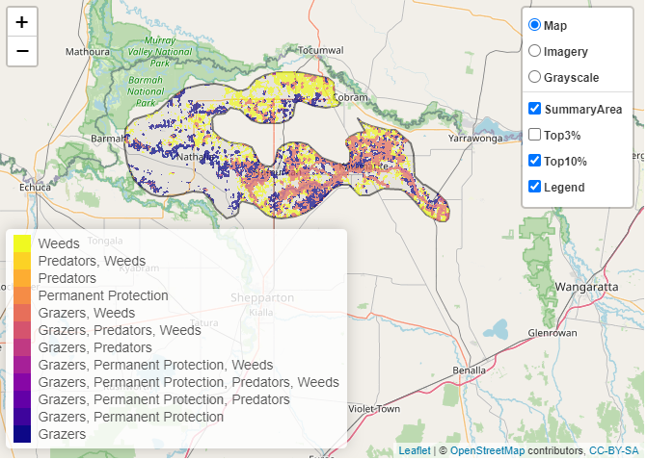

 | Control weeds 59,874 hectares
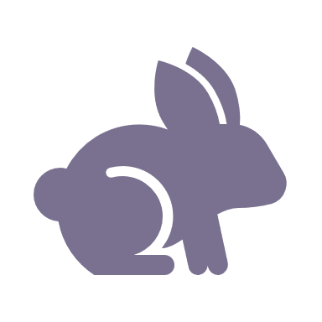 | Control rabbits 53,293 hectares
 | Control overabundant kangaroos 7,442 hectares

Of the top 10% of cost-effective actions, controlling weeds provide the most cost-effective biodiversity benefits when considering all flora and fauna.
Other biodiversity management activities identified through the consultation process include:
- establishing Trust for Nature Conservation Covenants on private land
- creating critical corridors and connecting remnant vegetation is important in this already fragmented landscape
- control of deer, as riparian areas along the Broken Creek and Goulburn River are movement corridors out of large forested areas such as Barmah Forest
- controlling horses in Barmah National Park and limiting their incursions into adjacent landscapes

The most cost-effective action for flora and fauna
Plants, Birds, Reptiles – Control weeds
Mammals, Amphibians – Control rabbits

For a further in depth look into SMP for this landscape, please refer to NatureKit.

