Introduction
Biodiversity Response Planning (BRP) is a long-term area-based planning approach to biodiversity conservation in Victoria. It is designed to strengthen alignment, engagement and participation between government, Traditional Owners, non-government agencies and the community.
DELWP Regional staff have been working with stakeholders on actions to conserve biodiversity in specific landscapes, informed by the best available science and local knowledge.
These Fact Sheets capture a point in time, reflecting data and knowledge available in 2020. They provide information for many (but not all) landscapes across Victoria, containing general information on the key values and threats in each area, as well as the priority cost-effective actions that provide the best protection of biodiversity. Fact Sheets are intended to provide useful biodiversity information for the community, non-government and government organisations during project planning and development.
Further information and the full list of Fact Sheets is available on the Department’s Environment website.

Landscape description
The Dja Dja Wurrung Clans Aboriginal Corporation Recognition and Settlement Agreement (RSA) landscape is 1,736,860ha in size, with 46% of the area covered in native vegetation. Public land makes up 16% of the area and includes the Dja Dja Wurrung Parks including;
- Hepburn Regional Park
- Greater Bendigo National Park
- Kooyoora State Park
- Wehla Nature Conservation Reserve
- Paddys Ranges State Park
- Kara Kara National Park.
Refer to the map at the end of this factsheet for geographical detail.
The RSA area for the Dja Dja Wurrung Clans Aboriginal Corporation has been included as a focus landscape, which formally recognises the Dja Dja Wurrung people as the traditional owners for part of Central Victoria.
This Focus Landscape has a full or partial overlap with the following focus landscapes: Lake Buloke, Lake Boort, Leaghur, Patho Plains, Wedderburn - Wychitella, Wellsford, Eppalock, Mid Loddon, Kamarooka - Whipstick, Muckleford, Upper Loddon, Maryborough - Paddy Ranges, Inglewood - Kooyoora, Daylesford - Wombat, Creswick, Pyrenees - Landsborough, Kara Kara - St Arnaud, Tunstalls - Dalyenong, Bealiba - Tarnagulla, Avon Plains, Kyneton Woodlands, Bendigo Creek, Moolort - Smeaton, Coliban - Campaspe, Victorian Volcanic Plains (VVP) - West, Range - Central, Range - West, Minyip, Donald and Warracknabeal.
For more information on any of these landscapes, please refer to the full list of Fact Sheets.

Cultural importance
We recognise that the entire landscape has high cultural value for Traditional Owners. Landscapes identified as having “notable” cultural importance is based on the density of recorded cultural heritage sites and knowledge shared by Traditional Owners. We also recognise that there are locations important to Traditional Owners not within these landscapes of interest. Dja Dja Wurrung culture is a living culture and all of Bujils creations (all of Country) are of cultural importance to Djaara.
Notable cultural importance for the Dja Dja Wurrung Clans Aboriginal Corporation are the following locations:
- Mount Franklin and Hepburn Regional Park. Baramul (Emu) has a place across Djandak and the persecution and hunting of this Murrup from Djandak has resulted in many issues which continue to damage and degrade the landscape. These continue to impact on the lives and health of our communities and the environment. Many species rely on Baramul to spread their seed, fertilise their germination beds and create homes for them on Djandak. Lalgambook (Mt Franklin) is the Emu’s nest and makes the most sensible place to target efforts to return this spirit to its place on Djandak.
- Woolshed Swamp Wildlife Reserve (WR) and Boort – Yung Balug (the clan group) – to heal the Murrup of Yung Balug there must be a return of Yung (Quoll) to Djandak.
- Ngarri-Mt Egbert – Yung Balug (the clan group) – to heal the Murrup of Yung Balug there must be a return of Yung (Quoll) and Ngarri (Sheoak) to Djandak.
- Tang Tang WR and Thunder WR.

Stakeholder interest
As part of the BRP process, in October 2020 stakeholders were asked to nominate focus landscapes and actions of interest. This landscape was nominated by Dja Dja Wurrung Clans Aboriginal Corporation.
Possible future investment/project development in this landscape will be available to any interested stakeholders who acts consistent with the RSA, in addition to those who nominated this landscape.

Ecological values identified by Traditional Owners, partners and community within this landscape

Revegetation of Djandak with:
- Buwatji (grasses used for grain)
- Witji (weaving grasses)
- Gatjawil Matorm (tuberous plants with scented flowers)
- Murnang (Yam Daisies) including Kangaroo grass
- Lomandra and Dianella species, Chocolate Lily, Vanilla Lily, Bulbine Lily
Forest and woodland thinning in Dja Dja Wurrung Parks:
- Hepburn Regional Park
- Kooyoora State Park
- Wehla Nature Conservation Reserve
- Greater Bendigo National Park
- Kara Kara National Park
- Paddys Ranges State Park
Wi (cultural fire) authorised and led by Dja Dja Wurrung on Djandak (Country).
Nominated cultural burns include:
- Dingee - Tang Tang Swamp Block 3 south east
- Thunder Swamp
- Dingee - Tang Tang Swamp Block 4 north east
- Dingee - Tang Tang Swamp BlocK 2 south west
- Kooyoora - Wehla-Kingower Rd
- Wehla - Lunatic Gully Tk
- Kooyoora - Melville Caves Rd
- Wehla - Logan-Kingower Rd
- Kooyoora - Halls Rd
- Rheola - Burnt Bridge Rd
- Wehla - Rodgers Tk
- Wehla - Perrys Tk
- Kooyoora - Kneebone Tk
- Wehla - White Box Tk
- Kooyoora - Kirawns Rd
- Wehla - Grassy Flat Tk
- Kooyoora - Barry Rocks Rd
- Kamarooka - Millwood Rd Block 1
- Kamarooka - Millwood Rd Block 2
- Whipstick - Nuggety Rd
- Huntly - Streamside Reserve south central
- Huntly - Streamside Reserve south
- Whipstick - Evans Rd
- Huntly - Streamside Reserve central
- Huntly - Streamside Reserve east
- Whipstick - Woodvale East Track
- Whipstick - Eaglehawk-Neilborough Rd
- Eaglehawk - Adelaide Hills Rd
- Whipstick - Rifle Range Rd
- Huntly - Streamside Reserve north
- Whipstick - Whipstick Nature Conservation Reserve
- Barkly - Kara Kara National Park Blue Gum Tk
- Barkly - Kara Kara National Park Teddington Rd
- Redbank - Richmond Tk
- Boort - Woolshed Swamp WR south west
- Boort - Woolshed Swamp WR west centre
- Boort - Dja Dja Wurrung Boort Yando Rd
- Boort - Woolshed Swamp WR west
- Boort - Woolshed Swamp WR south east
- Boort - Woolshed Swamp WR North
- Boort - Woolshed Swamp WR centre
- Strathdale - Scrub Tk
- Castlemaine - Kalimna Park Dja Dja Wurrung
- Castlemaine - Kalimna Park Dja Dja Wurrung
- Borung - Ngarri west
- Borung - Ngarri north
- Borung - Ngarri-Mt Egbert south
- Borung - Ngarri north east

 | Habitat Distribution Models identify 1,260 species with more than 5% of their Victorian range in this landscape area | Traditional Owners, stakeholders and community groups identified the following species of interest within this landscape
 | 996 Plants, notably:  - Southern Shepherd's Purse (Ballantinia antipoda), endangered with 100% of their Victorian range in area  - Whorled Zieria (Zieria aspalathoides subsp. aspalathoides), vulnerable with 100% of their Victorian range in area  - Seymour Wattle (Acacia verniciflua (1-nerved variant)), vulnerable with 100% of their Victorian range in area | - Known food and fibre plants  - Ngarri (Sheoak)  - Kangaroo Grass  - Murnang (Yam Daisies)  - Chocolate Lillies  - Bulbine Lillies  - Lomandras  - Dianellas
 | 23 Mammals:  - Yellow-footed Antechinus, with 27% of its Victorian range in area  - Brush-tailed Phascogale, vulnerable, with 19% of its Victorian range in area  - Fat-tailed Dunnart, near threatened, with 17% of its Victorian range in area | - Gal Gal (Dingo) at Gal Gal Gundidj – approximately in south east area of RSA, which is more heavily populated  - Baramul (Emu) is Lalgambook (Mount Franklin, Hepburn Regional Park)  - Yung (Quoll) including Woolshed Swamp WR, Boort, Mount Egbert Nature Conservation Reserve  - Lowan (Mallee Fowl) Guyura (Kooyoora State Park)
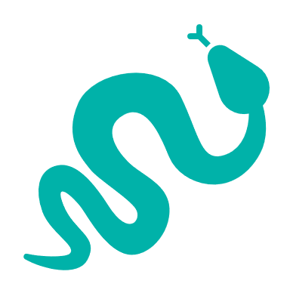 | 32 Reptiles:  - Pink-tailed Worm-Lizard, endangered with 100% of its Victorian range in area  - Woodland Blind Snake, near threatened with 34% of its Victorian range in area  - Bearded Dragon, vulnerable with 21% of its Victorian range in area
197 Birds:
- Swift Parrot, endangered with 34% of its Victorian range in area
- Speckled Warbler, vulnerable with 43% of its Victorian range in area
- Little Button-quail, near threatened with 34% of its Victorian range in area
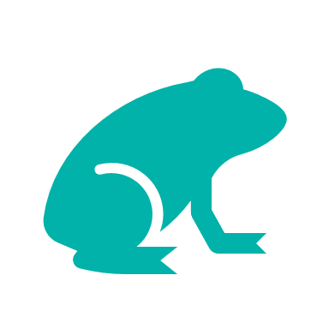 | 12 Amphibians:  - Brown Toadlet, vulnerable with 21% of its Victorian range in area

Traditional Owners, stakeholders and community groups identified the following threats within this landscape
Exclusion of Dja Dja Wurrung leadership (governance)
Lack of listening, hearing and respect for Dja Dja Wurrung ability to talk to Country – not utilising Dja Dja Wurrung knowledge-based tools and the bias toward western science decision support tools
Lack of enquiry and understanding of Dja Dja Wurrung customs and practice to provide an enabling and supportive environment so that Djaara can reconnect to land and reconnect stories and knowledge to place. Ask “How?” not “Why?”
Utilising past learnings and achievement to guide future effort – Dja Dja Wurrung participation in past and future biodiversity planning and delivery below the International Association of Public Participation (IAP2) level of ‘involve’ does not support Dja Dja Wurrung aspirations

Strategic Management Prospects
Strategic Management Prospects (SMP) models biodiversity values such as species habitat distribution, landscape-scale threats and highlights the most cost-effective actions for specific locations. More information about SMP is available in NatureKit.

Additional threats
Threats identified (in addition to those modelled in SMP) through the consultation process were:
- alterations to hydrology
- land salinisation
- soil erosion
- habitat degradation due to extremes of climate and weather and lack of regeneration in some vegetation communities
- recreational activities causing fragmentation
- loss of vegetation, and erosion
- legacy use of public land
- private land use impacting biodiversity
- inappropriate land use planning
- inappropriate fire regimes (planned burning and bushfires)
Some individual threatened species may also require targeted intervention, beyond actions to manage landscape-scale threats, to improve their future prospects.

Which landscape-scale actions are most cost-effective in this landscape?
The coloured areas indicate where the identified landscape-scale actions and locations are most cost-effective and will maximise biodiversity benefit across Victoria for multiple species.
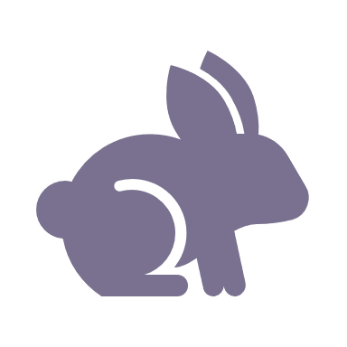 | Control rabbits 230,070ha
 | Control weeds 140,687ha
 | Control goats 78,692ha
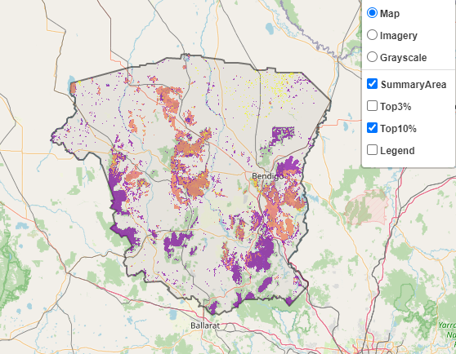
The SMP priority actions which rank among the top 10% for cost-effectiveness of that action across Victoria for much of the landscape are in order of the top 3 actions, see map and list below:
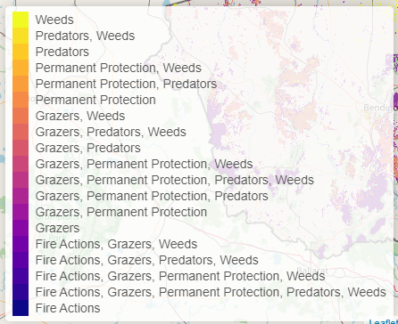

Of the top 10% of cost-effective actions, controlling rabbits provides the most cost-effective biodiversity benefits when considering all flora and fauna.

From the nomination process the following additional actions were also suggested for this landscape:
- cultural fire
- returning spirits to Djandak
- revegetation

The most cost-effective actions for flora and fauna
Plants, birds, amphibians - Control rabbits
Mammals, reptiles - Combined cat and fox control

For a further in depth look into SMP for this landscape please refer to NatureKit.

