Introduction
Biodiversity Response Planning (BRP) is a long-term area-based planning approach to biodiversity conservation in Victoria. It is designed to strengthen alignment, engagement and participation between government, Traditional Owners, non-government agencies and the community.
DELWP Regional staff have been working with stakeholders on actions to conserve biodiversity in specific landscapes, informed by the best available science and local knowledge.
These Fact Sheets capture a point in time, reflecting data and knowledge available in 2020. They provide information for many (but not all) landscapes across Victoria, containing general information on the key values and threats in each area, as well as the priority cost-effective actions that provide the best protection of biodiversity. Fact Sheets are intended to provide useful biodiversity information for the community, non-government and government organisations during project planning and development.
Further information and the full list of Fact Sheets is available on the Department’s Environment website.

Landscape description
This 166,000ha area has significant native vegetation (63% cover) and has significant public land (59%). It is defined by the Murray River and Riverine Grassy Woodland or Forests Ecological Vegetation Classes.
It has a major overlap where it extends inland at Lindsay / Wallpolla / Mulcra and also at Hattah Lakes, where it overlaps with Murray Scroll Belt and Hattah West - Raak landscapes respectively. You can find further information on these focus landscapes in the full list of Fact Sheets.

Cultural importance
We recognise that the entire landscape has high cultural value for Traditional Owners. Landscapes identified as having “notable” cultural importance is based on the density of recorded cultural heritage sites and knowledge shared by Traditional Owners. We also recognise that there are locations important to Traditional Owners not within these landscapes.
Notable cultural importance for the First People of the Millewa Mallee Aboriginal Corporation and the Tati Tati Wadi Wadi people.

Stakeholder interest
As part of the Biodiversity Response Planning process, in October 2020 stakeholders were asked to nominate focus landscapes and actions of interest. First People of the Millewa Mallee, Tati Tati Wadi Wadi, Mallee Catchment Management Authority, Trust for Nature, Lower Murray Water, South East Mallee Landcare Network, Swan Hill Rural City Council and Parks Victoria nominated Murray River Floodplain.
Possible future investment/project development in this landscape will be available to any interested stakeholders in addition to those who nominated this landscape.
Specific stakeholder interests identified through the engagement process within this landscape include:
- Parks Victoria – Conservation Action Plan assets; Ephemeral freshwater wetland, Riverine Forest and Woodland. Hattah Ramsar site, Semi-arid Woodlands. Total Grazing Management and Semi-arid woodland restoration (rabbits, goats, kangaroos, revegetation, vegetation monitoring).
- Mallee Catchment Management Authority, Regional Catchment Strategy priority landscape – 1. Murray River and Floodplain: Merbein to South Australian border, 4. Robinvale to Merbein, 11. Nyah to Robinvale.

Community interest
There is high community interest in biodiversity values and for recreation in this area, for example, Lakes Hawthorn and Ranfurly, Kings Billabong and the Murray River in general.

 | Habitat Distribution Models identify 279 species with more than 5% of their Victorian range in this landscape area | Traditional Owners, stakeholders and community groups identified the following species of interest
 | 226 Plants, 27 species with more than 50% of Victorian range in area. Notably:  - Soda Bush (endangered, 78% of Victorian range in area)  - Low Hibiscus and Velvet-Leaf Hibiscus (endangered, 86% and 78% of Victorian range in area) | - Darling & Garland Lilies  - Emu Bushes  - Round Templetonia, Slender Sunray  - Desert Groundsel  - Purple Swainson-pea  - Kneed Swainson-pea  - Winged Peppercress
 | 7 Mammals, 6 species with more than 10% of Victorian range in area. Notably:  - South-eastern Long-eared Bat (endangered, 6% of Victorian range in area)  - Eastern Wallaroo (endangered, 22% of Victorian range in area) | - Giles Planigale  - Fat-tailed Dunnart  - Red Kangaroo
 | 20 Reptiles, 12 species with more than 10% of Victorian range in area. Notably:  - Red-naped Snake (vulnerable, 68% of Victorian range in area)  - Saltbush Striped Skink (critically endangered, 33% of Victorian range in area) | - Hooded Scaly-foot  - Mud Adder  - Carpet Python
 | 26 Birds, 6 species with more than 10% of Victorian range in area. Notably:  - Spotted Bowerbird (probably extinct, 85% Victorian range in area)  - Redthroat (endangered, 29% Victorian range in area) | - Regent Parrot  - Australian Bustard  - Australasian Bittern  - Australian Painted Snipe  - Barking owl  - Bush-stone Curlew
 |  | - Growling Grass Frog
Other: Native fish, insects

Strategic Management Prospects
Strategic Management Prospects (SMP) models biodiversity values such as species habitat distribution, landscape-scale threats and highlights the most cost-effective actions for specific locations. More information about SMP is available in NatureKit.

Additional threats
Threats identified (in addition to those modelled in SMP) through the consultation process were:
- alterations to hydrology
- land salinisation
- soil erosion
- habitat degradation due to extremes of climate and weather
- lack of regeneration in some vegetation communities
- recreational activities causing fragmentation
- loss of vegetation, and erosion
- legacy use of public land
- private land use impacting biodiversity
- inappropriate land use planning
- inappropriate fire regimes (planned burning and bushfires)

Which landscape-scale actions are most cost-effective in this landscape?
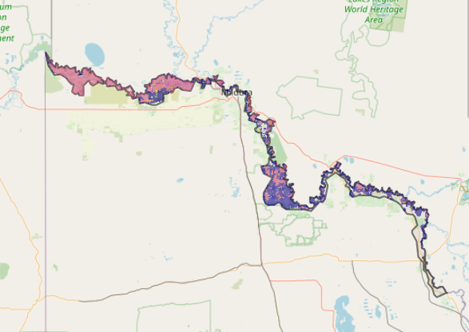
Some areas of this focus landscape (coloured areas on the map) have highly cost-effective actions which provide significant benefit for biodiversity conservation.
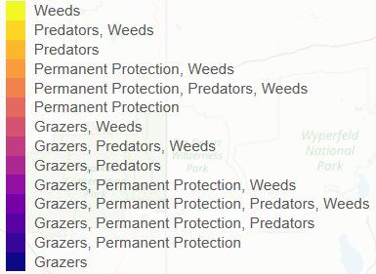
The SMP priority actions which rank among the top 3% for cost-effectiveness of that action across Victoria for much of the area (>25,000ha) are in order:
Control pigs 118,442ha
Control goats 111,684ha
Control weeds 67,078ha
Control overabundant kangaroos 61,317ha
Control rabbits 39,432ha

Of the top 10% of cost-effective actions, control cats and foxes and control weeds provides the most cost-effective biodiversity benefits when considering all flora and fauna.

Actions suggested for this landscape through the nomination process are:
- control of weeds, pig, goat, rabbit, fox, cat and overabundant kangaroos
- revegetation
- cultural flows
- manage off road impacts
- permanent protection
- rubbish dumping
- reintroduce cultural species – dingo
- environmental watering

The most cost-effective actions for flora & fauna
Plants – Control weeds
Mammals, birds, reptiles, amphibians – Combined cat and fox control

For a further in depth look into SMP for this landscape please refer to NatureKit.

