Background / preamble
The Red Gum Plains landscape was recognised during the 2019/20 Gippsland Biodiversity Response Planning (BRP) process as a focus area for future collaborative biodiversity action and investment.
Under the Victorian Government’s Biodiversity 2037: Protecting Victoria’s Biodiversity plan, the BRP process is a long-term area-based planning approach to biodiversity conservation in Victoria. It is designed to strengthen alignment, engagement and participation between government, Traditional Owners, non-government agencies and the community to benefit biodiversity by working together to identify, promote and tackle local biodiversity needs as part of an ongoing collective process.
In 2019/20, significant impacts from the bushfires in East Gippsland and coronavirus (COVID-19) on community, biodiversity stakeholders and agencies, and the environment, resulted in planned engagement with many local stakeholders in Gippsland about BRP being postponed to a future process. In the interim, a multi-agency working group of local staff in Gippsland came together to identify a series of potential strategic priority actions across the region, as well as 13 focus landscapes. Membership of this working group for Gippsland included staff from the Department of Environment, Land, Water and Planning (DELWP) coasts & marine policy and local forest, fire and biodiversity teams, East Gippsland and West Gippsland Catchment Management Authorities (EGCMA & WGCMA), Parks Victoria, Trust for Nature (TfN), the Bunurong Land Council Aboriginal Corporation (BLCAC) and the Gunaikurnai Land and Waters Aboriginal Corporation (GLaWAC).
As part of this process, the Gippsland BRP working group drew upon information available from the DELWP Strategic Management Prospects (SMP) tool as well as their own local knowledge to identify key biodiversity assets, threats and potential management actions across Gippsland. A subset of this information is presented in this Fact Sheet, reflecting a point in time assessment of some of the important biodiversity needs and landscapes for focus across the region.
These BRP Fact Sheets provide useful biodiversity information for the community, non-government and government organisations during project planning and development, including guidance for stakeholders interested to contribute towards some of the strategic priorities identified in these areas to date. Further information and the full list of Fact Sheets is available on the Department’s Environment website.

Landscape description
Landscape context: 324,814ha, 7% public land, 20% native vegetative cover
This landscape includes the majority of the lowland plains between Traralgon and Lakes Entrance, from the edge of the Mitchell and Macalister foothills to the margins of the Gippsland Lakes. This area is predominantly cleared private land used for grazing and some cropping, and includes the floodplains of the Mitchell, Latrobe, Thompson, Macalister and Avon Rivers, including the Macalister Irrigation District.
The remaining native vegetation in this area is predominantly Grassy Woodland with some areas of shrubby dry forest on sandy rises and some very small remnants of native grassland. Major settlements include Rosedale, Glengarry, Sale, Stratford, Heyfield, Munro, Stockdale, Bengworden, Lindenow, Bairnsdale, Nicholson and Swan Reach.

Biodiversity highlights and important places:
The Red Gum Plains landscape forms part of the broader Gippsland Plains bioregion and is home to the Environment Protection and Biodiversity Conservation Act (EPBC) listed Gippsland Red Gum Grassy Woodland and associated grassland community. Despite being heavily cleared, this area has been a key focus area for conservation efforts over the last few decades and many small and isolated reserves and networks of covenanted properties within this landscape support remnant patches of grassy woodland and grasslands and important populations of endangered plants.
Notable areas of remnant grassy woodland and grasslands include Dawson Flora Reserve, Maffra Cemetery, Briagolong Forest Red Gum Reserve, Swallow Lagoon Nature Conservation Reserve, Stratford Highway Park, Fernbank Recreation Reserve, Moormurng Flora and Fauna Reserve, Munro Railway Reserve and The Knob Reserve on public land, and covenanted properties around Strathfieldsaye, Forge Creek Protected Area Network and Briagolong/Newry on private land. Linear strips along rail lines, rail-trails and road reserves also hold some remnant patches of grassland and grassy woodland.
In addition to its grassland values, this landscape is also home to the unique Perry River catchment ‘Chain of Ponds’ wetland formation, home to the endemic Perry River Sandy Flood Scrub Ecological Vegetation Class (EVC). Providence Ponds Nature Conservation Reserve itself also supports one of the few populations of New Holland Mouse.
Important vegetation communities in this landscape include:
*FFG listed | Forest Red Gum Grassy Woodland Community
**EPBC listed | Gippsland Red Gum Grassy Woodland and associated native grassland  Seasonal Herbaceous Wetlands of the Temperate Lowland Plains
*Flora and Fauna Guarantee Act 1988 (Victorian)
**Environment Protection and Biodiversity Conservation Act 1999 (Federal)

Cultural importance
We would like to acknowledge the Traditional Owners and custodians of the land across this landscape, the Gunaikurnai people, particularly the Brabralung and Brayakaulung people. We pay our respects to Country, and to Elders past and present whose knowledge and wisdom has ensured the continuation of culture and traditional practices. We are committed to genuinely partner, and meaningfully engage, with Victoria’s Traditional Owners and Aboriginal communities to support the protection of Country, the maintenance of spiritual and cultural practices and their broader aspirations into the 21st century and beyond in the spirit of self-determination.
The Gunaikurnai Land and Waters Aboriginal Corporation (GLaWAC) are the appointed Registered Aboriginal Party (RAP) and hold a Native Title Determination and current Recognition Settlement Agreement over this area, including Joint Management of The Knob Reserve under Aboriginal Title. GLaWAC are an ongoing member of the local Gippsland BRP working group.

Stakeholder and community interest
Local engagement for BRP in Gippsland in 2019/20 was postponed due to impacts from fire and coronavirus (COVID-19). If you would like to contribute local knowledge about this landscape in the future, find out more about BRP or add your name to the state-wide or Gippsland BRP stakeholder lists, you can find further information on the Department’s Environment website.

Species Summary
An analysis of available Habitat Distribution Models* identify 182 species with more than 5% of their Victorian range falling within the Red Gum Plains BRP landscape, including 36 threatened species and 11 EPBC listed species.
*Note: While version 2.0 of the SMP model utilises HDMs for ~3,200 terrestrial species in its analysis, these models currently exclude aquatic, invertebrate, marine and non-vascular plant species. These HDMs and SMP will continue to be improved upon with ongoing input from species experts and natural resource management practitioners.
Species class | Species with a high proportion of their Victorian distribution in this landscape | Other notable species identified during the BRP process
168 plants, incl. 30 threatened species (8 EPBC) | 6 species with more than 50% of their Victorian range falling within this landscape, notably:  - Blotched Diuris, Diuris sp. aff. dendrobioides (Bairnsdale) (FFG listed, endangered, 76% of Victorian range)  - Gaping Leek-orchid Prasophyllum correctum (EPBC listed, Endangered, 65% of Victorian range)  - Wooly Waterlily Philydrum languinosum (FFG listed, vulnerable, 59% of Victorian range)  - Dwarf Kerrawang, Commersonia prostrata (EPBC listed, Endangered, 50% of Victorian range, Victorian population restricted to swampy land and lake margins around Rosedale-Stradbroke-Providence Ponds areas) | - Drooping Love-grass Eragrostis leptocarpa (72% of Victorian range)  - Rough-grain Love-grass Eragrostis trachycarpa (68% of Victorian range)  - Purple Diuris Diuris punctata (FFG listed, vulnerable, 10% of Victorian range)  - Matted Flax-lily Dianella amoena (EPBC listed, Endangered, 9% of Victorian range)
2 mammals, incl. 2 threatened species (2 EPBC) | Including:  - New Holland Mouse (EPBC listed, Vulnerable, 13% of Victorian range)  - Grey-headed Flying-fox (EPBC listed, Vulnerable, 10% of Victorian range) | - None raised
1 reptile, incl. 1 threatened species (0 EPBC) | Including:  - Glossy Grass Skink (FFG listed, vulnerable, 6% of Victorian range) | - None raised
5 birds, incl. 1 threatened species (0 EPBC) | Including:  - Terek Sandpiper (FFG listed, endangered, 5% of Victorian range)  - Little Tern (FFG listed, vulnerable, 5% of Victorian range) | - Eastern Great Egret (FFG listed, vulnerable, 3% of Victorian range)  - Hardhead (FFG listed, vulnerable, 2% of Victorian range)  - White-bellied Sea-eagle (FFG listed, vulnerable, 1% of Victorian range)
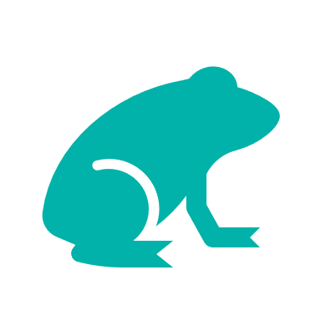  6 frogs, incl. 2 threatened species (1 EPBC) | Notable species include:  - Green and Golden Bell Frog (EPBC listed, Vulnerable, 9% of Victorian range)  - Martin’s Toadlet (FFG listed, critically endangered, 8% of Victorian range). | - Growling Grass Frog (EPBC listed, Vulnerable, 5% of Victorian range)  - Southern Toadlet (FFG listed, vulnerable, 3% of Victorian range)
Other species raised by the working group (e.g. fish, invertebrates etc):
Flinders Pygmy Perch (FFG listed, vulnerable)

Strategic Management Prospects
Strategic Management Prospects (SMP) models species distributions, habitat importance, landscape-scale threats, and management costs. It then compares and highlights those places with the greatest opportunities for cost-effective action state-wide. Learn more about this tool on the SMP webpage.

Which landscape-scale actions are most cost-effective in this landscape?
The maps and information below show those places and actions modelled by SMP to provide the best opportunities for cost-effective action to benefit biodiversity across the state. Coloured areas in the maps below indicate opportunities for highly cost-effective actions that provide significant benefits to biodiversity in those places. If undertaken across Victoria, these collective actions should provide the greatest potential benefit to biodiversity by focusing on undertaking landscape-scale actions in places where they will provide the greatest benefit for cost across all species.
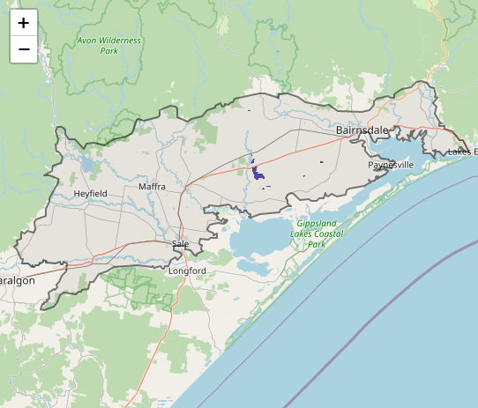
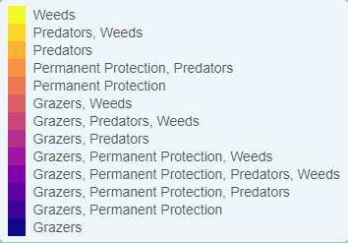
Map a) shows actions in the top 3% cost-effectiveness areas, and Map b) shows actions in the top 10% cost-effective areas.
Map a) – SMP top 3% cost-effective actions
The following landscape-scale actions were ranked among the top 3% cost-effective opportunities for biodiversity action across the state by SMP:

 | Control overabundant kangaroos 724ha
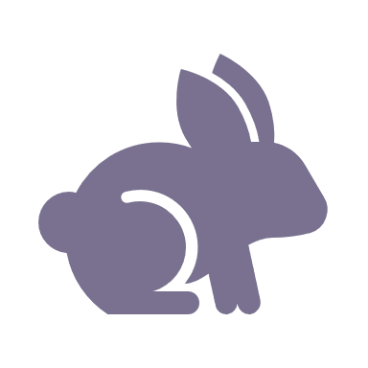 | Control rabbits 76ha
 | Combined overabundant kangaroo control and Permanent Protection 25ha

Control rabbits 76,879ha
Control weeds 52,073ha
Control overabundant kangaroos 19,162ha
Control deer 11,786ha
Combined cat and fox control 10,257ha
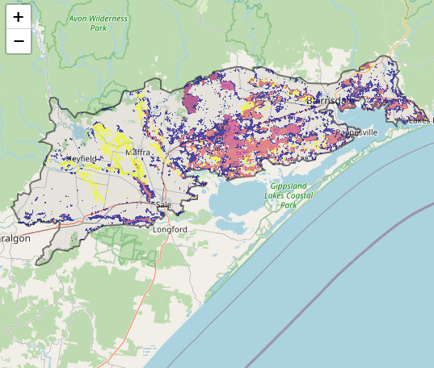
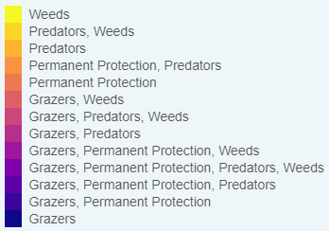
Map b) – SMP top 10% cost-effective actions
The following landscape-scale actions were ranked among the top 10% cost-effective opportunities for biodiversity action across the state by SMP:

The most cost-effective actions for flora & fauna according to SMP
 | Plants – Control rabbits and Control weeds |  | Birds – Combined fox and cat control, Control rabbits and Control weeds
 | Mammals – Combined fox and cat control |  | Amphibians – Control rabbits and Combined fox and cat control
 | Reptiles – Combined fox and cat control
For a further in depth look into SMP for this landscape please refer to NatureKit.

Additional threats raised by the working group
- Incremental land clearing, edge effects & lack of secure tenure (particularly from grassland and grassy woodland remnants and linear reserves)
- Encroachment by native shrubs (e.g. Burgan Kunzea ericoides)
- Changes to natural flow regimes impacting upon wetlands
- Increased sediment and nutrient inflows to waterways/wetlands
- Inconsistent/ineffective management of compounding threats (particularly the need for appropriate fire and grazing regime and management of shrub encroachment, rabbits and weeds)
- Drought (e.g. for particular species like Gaping Leek Orchid and New Holland Mouse, as well as ephemeral wetlands)

Highest priority strategic actions
With consideration of the information available in SMP and local knowledge of this landscape, the Gippsland BRP working group identified the following priority actions for future collaboration and investment in this landscape:
The highest priority actions for the Red Gum Plains landscape include:
- Permanent protection and revegetation/restoration of remnant grassy woodland and wetlands
- Ecological burning and management of Burgan Kunzea ericoides invasion into remnant grassland areas
- Controlling transformer weeds
- Controlling rabbits
- Controlling domestic stock
- Controlling predators (particularly around Providence Ponds)
- Protection of riparian vegetation
Other key actions highlighted by the working group include:
- Controlling overabundant kangaroos & deer (particularly within the Perry River catchment, Providence Ponds and Moormurng Flora and Fauna Reserve)
- Restoration of natural flow regimes and aquatic habitats for priority waterways and wetlands
- Management of sediment and nutrient inflows to priority waterways and wetlands

