Introduction
Biodiversity Response Planning (BRP) is a long-term area-based planning approach to biodiversity conservation in Victoria. It is designed to strengthen alignment, engagement and participation between government, Traditional Owners, non-government agencies and the community.
DELWP Regional staff have been working with stakeholders on actions to conserve biodiversity in specific landscapes, informed by the best available science and local knowledge.
These Fact Sheets capture a point in time, reflecting data and knowledge available in 2020. They provide information for many (but not all) landscapes across Victoria, containing general information on the key values and threats in each area, as well as the priority cost-effective actions that provide the best protection of biodiversity. Fact Sheets are intended to provide useful biodiversity information for the community, non-government and government organisations during project planning and development.
Further information and the full list of Fact Sheets is available on the Department’s Environment website.

Landscape description
This 15,022ha area encompasses the coastal and wetland areas of the western shore of Port Phillip Bay, from the Jawbone in Williamstown, to the Western Treatment Plant and Port Phillip Region’s boundary at Little River. The landscape has 18% native vegetation, and 16% public land.

Cultural importance
We recognise that the entire landscape has high cultural value for Traditional Owners. Some landscapes have notable cultural importance based on knowledge shared by Traditional Owners. This landscape includes lands of the Wadawurrung people and an area where the Traditional Owners have not been formally recognised.
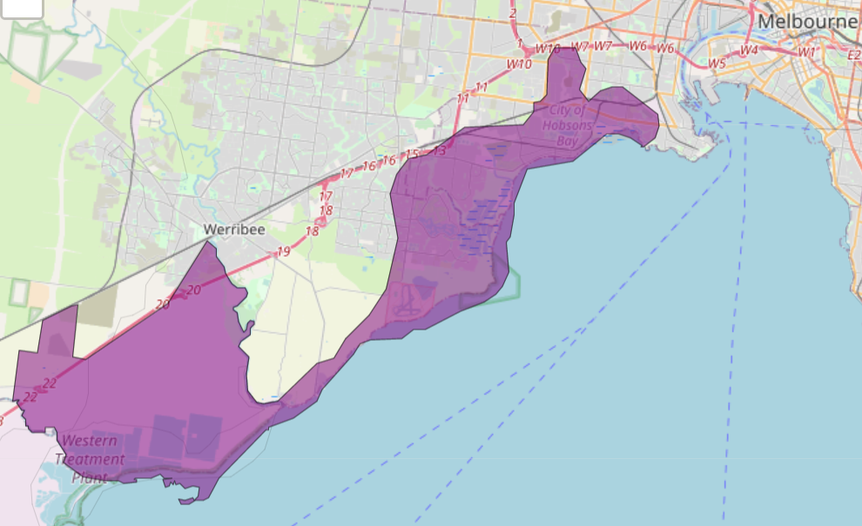

Figure 1: Map showing location of Port Phillip Bay and Western Shoreline Ramsar landscape (purple).

Habitat Distribution Models identify 9 species with more than 5% of their Victorian range in this landscape
- 8 Plant species
- 4 species with more than 10% of statewide range in area
- Notable species: Tasman Grass-wrack (rare, 28% statewide range in area), Coast Saltwort (rare, 21% statewide range in area), Drooping Mistletoe (17% statewide range in area), Sea Water-mat (vulnerable, 16% statewide range in area)
- 0 Mammal species with more than 5% of statewide range in area
- Notable species: Water rat (0.30% statewide range in area), Yellow-bellied Sheathtail Bat (data deficient, 0.26% statewide range in area)
- 0 Reptile species with more than 5% of statewide range in area
- Notable species: Grass skink FORM (P.pag/cry) (1.6% statewide range in area), Grassland Earless Dragon (critically endangered, 1.0% statewide range in area), Four-toed Skink (near threatened, 0.90% statewide range in area)
- 1 Bird species
- 1 species with more than 10% of statewide range in area
- Notable species: Orange-bellied Parrot (critically endangered, 10% statewide range in area), Red Knot (endangered, 3.3% statewide range in area), Lesser Sand Plover (critically endangered, 2.8% statewide range in area), Whimbrel (vulnerable, 2.7% statewide range in area)
- 0 species of amphibians with more than 5% of statewide range in area
- Notable species: Pobblebonk Frog (Limnodynastes dumerilii variegatus, 0.70% statewide range in area), Pobblebonk Frog (Limnodynastes dumerilii insularis, 0.55% statewide range in area), Growling Grass Frog (endangered, 0.46% statewide range in area)

Strategic Management Prospects
Strategic Management Prospects (SMP) models biodiversity values such as species habitat distribution, landscape-scale threats and highlights the most cost-effective actions for specific locations. More information about SMP is available in NatureKit.
Actions with area in the top 3% and top 10%
Specific Action | Area in top 3% (ha) | Area in top 10% (ha)
Control Rabbits | 335 | 5,996
Control Foxes | 20 | 4,459
Control Cats | 20 | 4,387
Control Weeds | 101 | 3,331
Domestic Grazing Control | 10 | 637
Revegetation | 0 | 198
Permanent Protection | 47 | 114
Total Grazing Pressure Control | 0 | 127
Overabundant Kangaroo Control | 0 | 5
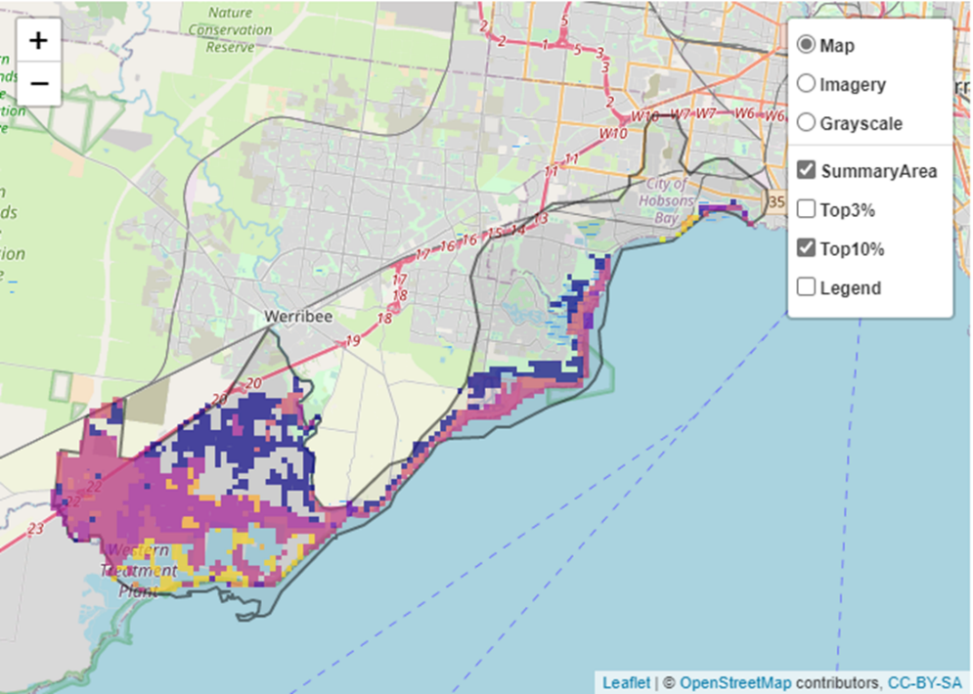
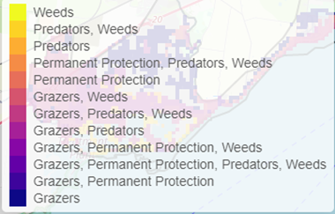
Areas of Port Phillip Bay and Western Shoreline Ramsar shown in Figure 2 have highly cost-effective actions (within the top 10% of cost-effectiveness for that action across the state) that provide significant benefit for biodiversity conservation.
Figure 2: The SMP priority actions which rank among the top 10% for cost-effectiveness of that action across the state. “Grazers” includes deer, domestic grazing, goats, horses, over-abundant kangaroos, pigs, rabbits and total grazing pressure

The most cost-effective action for flora & fauna
Plants – Control rabbits
Birds, Mammals, Amphibians and Reptiles – Combined cat and fox control

For a further in depth look into SMP for this landscape, please refer to NatureKit.

Current actions in Port Phillip Bay and Western Shoreline Ramsar
Specific Actions | Current actions – top 10% (ha) | Current actions – outside top 10% (ha)
Fox Control | 95 | 424
Weed Control | 1 | 5

Current actions – top 10% = The area (ha) of the specific action currently occurring in locations identified by SMP as being in the top 10% for cost-effectiveness for that action across the state
Current actions – outside top 10% = The area (ha) of the specific action currently occurring in locations within this landscape that are not identified by SMP as being in the top 10% for cost-effectiveness for that action across the state

What you told us
SMP is just one tool to use in the process of understanding biodiversity values. Feedback from our stakeholders is also vitally important and forms the basis of our understanding of knowledge gaps.

Port Phillip Bay and Western Shoreline Ramsar was identified by stakeholders as a focus landscape in the ‘medium’ category in Port Phillip region.

Stakeholder interest

Important landscapes
- Western Treatment Plant
- Werribee River
- Ramsar Wetlands
- Truganina Park and Sandy Spit
- Laverton Creek estuary
- Altona Coastal Park
- Emu-foot Grassland Skeleton Creek
- Truganina Explosives Reserve
- Maidstone Street Grassland
- Melbourne Water Sites of Biodiversity Significance Region and Priority Wetlands Region
- Port Phillip Bay western shoreline

Important vegetation communities
- Calcarenite Dune Woodland Ecological Vegetation Class (EVC) 858 – Coastal Alkaline Scrub
- Plains Grassland EVC

Current activities/programs/partnerships
- Living Melbourne – Our Metropolitan Urban Forest
- Port Phillip and Westernport CMA Regional Catchment Strategy – Naturelinks – Kororoit Creek Regional Strategy
- Port Phillip and Westernport CMA Regional Catchment Strategy – Naturelinks – Ramsar Protection Program: Port Phillip Bay western shoreline
- Hobsons Bay Council – various reserves and works
- Melbourne Strategic Assessment
- Friends of groups: Kororoit Creek, Skeleton Creek
- Various Friends of groups, Landcare groups and other community groups focusing on biodiversity conservation
- Historical Friends of Group
- Good Neighbour program
- Trust for Nature land covenanting program

Additional threats
Threats identified through the consultation process (in addition to those modelled in SMP):
- Predation of migratory and resident shorebirds by cats and foxes
- Urban boundary expansion
- Potential contamination from Skeleton Creek and surrounding runoff could affect wetlands like Cheetham
- Toxins from catchment inflows and stormwater
- Recreational water sports, including fishing and associated bait pumping
- Recreational dog walking and dogs off-lead

