Introduction
Biodiversity Response Planning (BRP) is a long-term area-based planning approach to biodiversity conservation in Victoria. It is designed to strengthen alignment, engagement and participation between government, Traditional Owners, non-government agencies and the community.
DELWP Regional staff have been working with stakeholders on actions to conserve biodiversity in specific landscapes, informed by the best available science and local knowledge.
These Fact Sheets capture a point in time, reflecting data and knowledge available in 2020. They provide information for many (but not all) landscapes across Victoria, containing general information on the key values and threats in each area, as well as the priority cost-effective actions that provide the best protection of biodiversity. Fact Sheets are intended to provide useful biodiversity information for the community, non-government and government organisations during project planning and development.
Further information and the full list of Fact Sheets is available on the Department’s Environment website.

Landscape description
This 41,500ha area encompasses Cardinia Reservoir, and extends from Berwick to Bunyip on the southern edge. It excludes Bunyip State Park (which is in the Eastern Yarra Ranges landscape). The landscape has 41% native vegetation, and 10% public land.

Cultural importance
We recognise that the entire landscape has high cultural value for Traditional Owners. Some landscapes have notable cultural importance based on knowledge shared by Traditional Owners. This landscape includes traditional country of the Bunurong people and the Wurundjeri people.
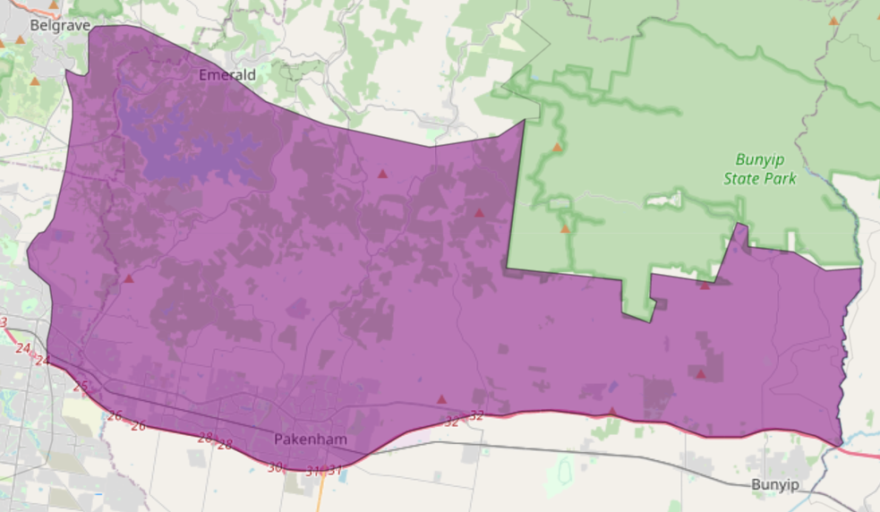
Figure 1: Map showing location of Southern Ranges landscape (purple).

Habitat Distribution Models identify 6 species with more than 5% of their Victorian range in this landscape | Traditional Owners, stakeholders and community groups identified the following species of interest
- 6 Plant species
- 4 species with more than 10% of statewide range in area
- Notable species: White Star-bush (endangered, 16% statewide range in area), Red-tip Greenhood (rare, 12% statewide range in area), Wine-lipped Spider-orchid (vulnerable, 11% statewide range in area), Swamp Bush-pea (rare, 10% statewide range in area)
- 0 Mammal species with more than 5% of their Victorian range in this landscape  - Notable species: Grey-headed Flying-fox (vulnerable, 1.6% statewide range in area), Southern Brown Bandicoot (near threatened, 1.4% statewide range in area) | - Southern Brown Bandicoot  - Platypus
- 0 Reptile species with more than 5% of their Victorian range in this landscape
- Notable species: Metallic Skink (2.1% statewide range in area), Swamp Skink (vulnerable, 1.4% statewide range in area)
- 0 Bird species with more than 5% of their Victorian range in this landscape  - Notable species: Helmeted Honeyeater (critically endangered, 2.6% statewide range in area) | - Powerful Owls and other owl species  - Emu Wrens  - Superb Lyrebirds
- 0 species of amphibians with more than 5% of their Victorian range in this landscape  - Notable species: Pobblebonk Frog (Limnodynastes dumerilii insularis, 1.6% statewide range in area), Haswell’s Froglet (1.3% statewide range in area), Southern Toadlet (vulnerable, 1.2% statewide range in area) | - Growling Grass Frog
Other species | - Dwarf Galaxias  - Spiny Crayfish

Strategic Management Prospects
Strategic Management Prospects (SMP) models biodiversity values such as species habitat distribution, landscape-scale threats and highlights the most cost-effective actions for specific locations. More information about SMP is available in NatureKit.
Areas of Southern Ranges shown in Figure 2 have highly cost-effective actions (within the top 10% of cost-effectiveness for that action across the state) that provide significant benefit for biodiversity conservation.
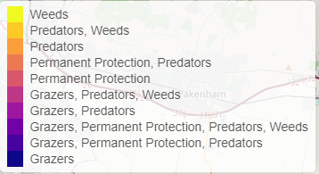
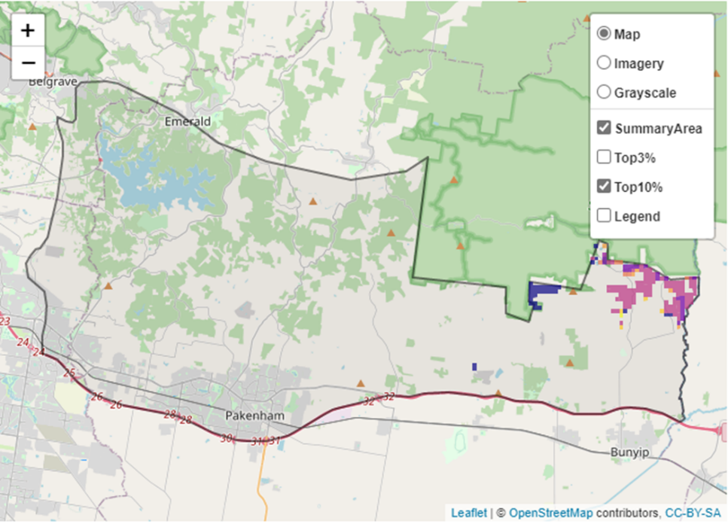
Figure 2: The SMP priority actions which rank among the top 10% for cost-effectiveness of that action across the state. “Grazers” includes deer, domestic grazing, goats, horses, over-abundant kangaroos, pigs, rabbits and total grazing pressure

Actions with area in the top 3% and top 10%
Specific Action | Area in top 3% (ha) | Area in top 10% (ha)
Control Overabundant Kangaroos | 246 | 722
Control Foxes | 338 | 686
Control Weeds | 250 | 647
Control Deer | 53 | 583
Revegetation | n/a | 418
Control Cats | 171 | 258
Permanent Protection | 15 | 133
Domestic Grazing Control | 0 | 37
Total Grazing pressure | 0 | 18
Control Rabbits | 0 | 5

The most cost-effective action for flora & fauna
Plants – Control rabbits
Birds, Mammals, Amphibians and Reptiles – Combined cat and fox control

For a further in depth look into SMP for this landscape, please refer to NatureKit.

Current actions in Southern Ranges
Specific Actions | Current actions – top 10% (ha) | Current actions – outside top 10% (ha)
Deer Control | 158 | 786
Fox Control | 153 | 1,371
Weed Control | 1 | 843
Rabbit Control | 0 | 611
Domestic Grazing Control | 0 | 610
Permanent Protection | 0 | 610
Revegetation | 0 | 45

Current actions – top 10% = The area (ha) of the specific action currently occurring in locations identified by SMP as being in the top 10% for cost-effectiveness for that action across the state
Current actions – outside top 10% = The area (ha) of the specific action currently occurring in locations within this landscape that are not identified by SMP as being in the top 10% for cost-effectiveness for that action across the state

What you told us
SMP is just one tool to use in the process of defining priority landscapes. Feedback from our stakeholders is also vitally important and forms the basis of our understanding of knowledge gaps.

Stakeholder interest

Important landscapes
- Cardinia Reservoir
- Upper Cardinia Creek
- Harkaway Biozone
- Beaconsfield Nature Conservation Reserve
- Cardinia Creek Parklands
- Beaconsfield Nature Conservation Reserve
- Beaconsfield Flora and Fauna Reserve and Cardinia Creek Catchment
- Mt Cannibal Flora and Fauna Reserve and Cannibal Creek Catchment

Current activities/programs/partnerships
- Port Phillip and Westernport CMA Regional Catchment Strategy – Naturelinks – Cardinia Environment Coalition Biolinks Action Plan – Upper Bunyip
- City of Casey Biodiversity Enhancement Strategy
- Living Melbourne – Our Metropolitan Urban Forest
- Council pest management strategies
- Yarra 4 Life – Port Phillip and Westernport CMA
- Cardinia Shire Council – works on various bushland reserves
- Metropolitan Open Space Strategy
- Melbourne Strategic Assessment
- Biodiversity Response Planning project 058 – Cannibal Creek catchment biodiversity project
- High degree of community engagement in Cannibal Creek catchment
- Parks Victoria Native Vegetation Improvement project at Bunyip State Park, and post fire recovery
- Various Friends of groups, Landcare groups and other community groups focusing on biodiversity conservation
- Trust for Nature land covenanting program

Additional threats
Threats identified (in addition to those modelled in SMP) through the consultation process were:
- Post-fire clearing
- Mineral extraction
- Peri-urban development
- Degradation of vegetation
- Stream bank erosion
- Stock access to waterways
- Tourism development
- Loss of connectivity

