Collaboration between the Corangamite Catchment Management Authority and the Department of Sustainability and Environment’s EcoMarkets team has resulted in over 4000 hectares of native vegetation coming under management on private land.

This has been achieved through a series of tenders, including the Victorian Volcanic Plains Tender, Coastal Tender, Wetlands Tender and an EcoTender demonstration project.

Regional Implementation Manager at the Corangamite CMA, Chelsey Langley says the partnership has been highly productive.

“When we first ran the Victorian Volcanic Plains Tender four years ago, we used a simple database to manage the tender process. More recently, we’ve used the EnSym environmental modelling tool developed by the EcoMarkets team which makes the process more streamlined and much easier for the project manager.

“Now we use EnSym’s mapping tools in the site assessment phase and we also use it to develop management plans for landholders,” she said.

“We have access to plenty of data, including the number of hectares of land managed, which catchment they are in, the ecological vegetation classes they represent and the presence of any threatened species.

“We’ve done a few of these tenders now so we’ve got a lot of data to prove what we can achieve.

“In a tender process, landholders put in their bids for managing the native vegetation on their properties and we score those properties using EnSym.

”Properties are then ranked according to which provide the best value in environmental terms. We enter into a contract with successful landholders who carry out management and conservation work, then make payments to the successful landholders,” Chelsey said.

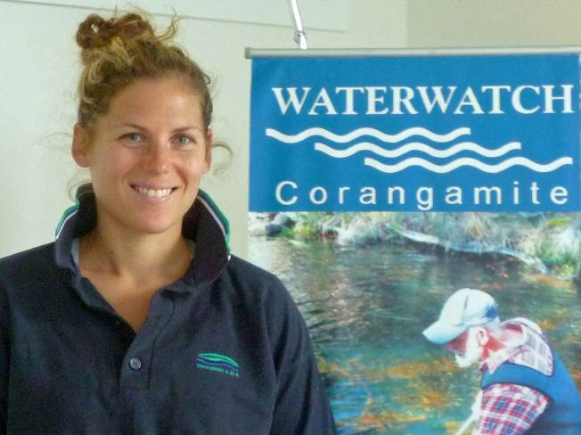

Corangamite Catchment Management Authority’s Chelsey Langley

“We’ve found that EcoMarkets is an efficient way to get natural resource investment delivered while engaging with landholders.

“We’ve been working with the EcoMarkets team for a while now and the improvements to EnSym have been massive.

“Sometimes we brainstorm ways of doing things differently and then put those ideas to the EcoMarkets team to see if they are practical.

“EnSym is widely used in this field now. We can make sure our staff and consultants know EnSym well without it being a costly or expensive process,” she said.

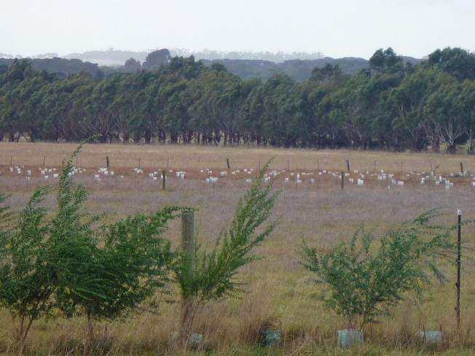

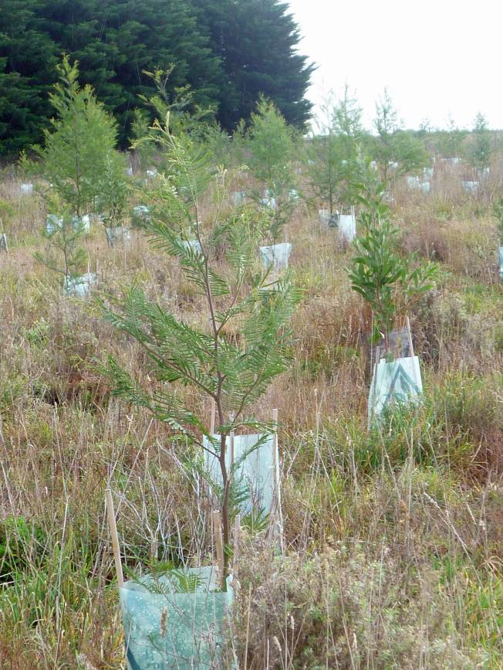

Left and above: Revegetation at a property in Buckley, part of the Corangamite catchment

