|  |
| --- |
| NaturePrint |
| Strategic Management Prospects overview and approach |

Evidence-based decision making is critical to improving outcomes for biodiversity. Strategic Management Prospects (SMP) is a decision support tool that helps biodiversity managers identify and prioritise management options in a transparent, objective and repeatable way. SMP uses a new spatially-explicit, landscape-scale approach to identify the most effective and efficient management actions to benefit biodiversity across Victoria.

# Strategic Management Prospects

## Context

The aim of the Victorian Government’s Biodiversity Plan *Biodiversity 2037 – Protecting Victoria’s Environment* is to “see an overall improvement, where the majority of habitats and threatened species will be improved, and habitat gains will outweigh losses”.

To have the best chance to achieve the greatest outcomes for biodiversity in Victoria we need to compare information about thousands of biodiversity values. There are a range of best-practice methods now available for use.

NaturePrint’s Strategic Management Prospects (SMP) was developed to give Victoria a long-term, strategic approach to identifying cost-effective management actions that deliver an improved outlook for as many species as possible.

SMP is a key element in the Victorian Government’s modernised conservation planning and investment approach. Conservation management is shifting away from planning for threatened species one at a time, instead considering synergies, benefits and potential negative outcomes across multiple species.

|  |
| --- |
| NaturePrint  NaturePrint is a suite of decision-support products and tools designed to help us make choices about what actions to take, and in which places, to protect Victoria’s environment and plan for the future. The tools currently include:   * Habitat Distribution and Importance Models * Threat and Benefit of Action Models* * Strategic Biodiversity Values * Strategic Management Prospects*   *currently focused on terrestrial environment  Further information about NaturePrint, including information sheets, is available at [https://www.environment.vic.gov.au/‌biodiversity/natureprint](https://www.environment.vic.gov.au/biodiversity/natureprint).  NaturePrint products can be viewed using [NatureKit](http://maps.biodiversity.vic.gov.au/viewer/?viewer=NatureKit) – the department's online biodiversity mapping and reporting tool: <https://naturekit.biodiversity.vic.gov.au>. |

## How can SMP be used?

Government and non-government conservation or land managers can use SMP to make informed decisions about how and where we can act to protect and manage biodiversity in Victoria. SMP can be used in a variety of ways, including to:

* provide guidance on how to maximise biodiversity outcomes (by informing on-ground projects and investment decisions)
* facilitate objective comparisons (e.g. between regions, species, threats and management actions)
* provide scope and focus for partnership discussions
* inform and improve the Biodiversity Plan Targets
* inform reporting on progress towards Biodiversity Plan Targets.

## The SMP Approach

SMP integrates and simultaneously compares information on biodiversity values, threats, effectiveness of management actions and indicative costs of management actions for biodiversity across Victoria (Figure 1).

### SMP Inputs

The inputs to the SMP analysis (Table 1) are fine-scale, state-wide spatial models based on extrapolation from different primary datasets. The SMP v1.2 inputs include habitat distribution models, threat models, expert elicited response models for thousands of species to different management actions, and cost estimates for management actions.

Currently, SMP focuses only on terrestrial species and threats that occur at the landscape-scale. Coverage into other environments (e.g. freshwater) and new threats is expected to increase over time.

To consider the likely future prognosis of biodiversity values under different management regimes, we use a time horizon of 50 years. Using an expert elicitation method, we estimate the potential of various types of action (including ‘no action’) to benefit species. Our analysis focuses on the threats for which we can currently generate credible state-wide spatial models, and we will expand this range as opportunities allow. Consequently, the development of the SMP approach is an iterative process and uses a continuous improvement approach.

Table 1: SMP inputs

|  |  |
| --- | --- |
| Inputs to SMP | Relationships modelled |
| Habitat Distribution Models | Known observations of species and characteristics of the environment (e.g. terrain, climate). |
| Threat Models | Known occurrences of threats (e.g. deer or rabbits) and characteristics of the environment (e.g. terrain, climate) |
| Benefit of Action Models | Expert opinion of site-specific and situation-specific settings assessed by multiple experts with a standardised method called expert elicitation. These opinions were extrapolated from sites to landscape. |
| Costs of Actions | Costs of on-ground operations calculated as dollars per hectare, informed by considering temporal (time-related), spatial (place-related), and cost components (site costs; opportunity costs to private landholders; transaction costs; and travel costs). |

Further detail about the inputs and expert elicitation approach used in SMP is in the *Strategic Management Prospects Inputs* information sheet.

### Why use models?

Mapping of natural resource information always requires some form of extrapolation from available primary data. Usually this is done by mathematical modelling where the logic and method is transparent and repeatable, and any comparisons across attributes (e.g. species habitats) can be consistently made. Good modelling practice allows insights into the limitations of inputs and outputs which enables users to be aware of the reliability of the mapping and provides direction for how to drive improvements.

Most importantly for SMP, the use of models and spatial analyses enables for the first time the relative benefit-cost of many value-threat-action-location combinations to be compared simultaneously across Victoria.

### Which actions, where?

The focus of the SMP analysis is to rank management actions across Victoria. This ranking occurs in two steps: identifying the most cost-effective action at each location; then ranking these across Victoria based on their relative contributions to net conservation outcomes across all species.

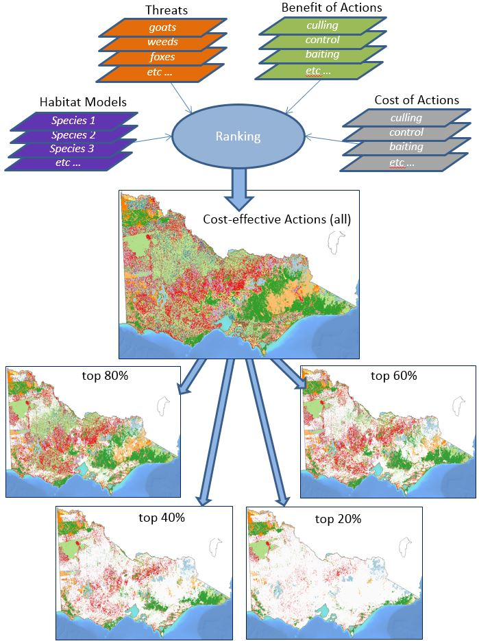

Figure 1: SMP – inputs to the analysis, spatial ranking process, and example outputs

#### Step 1: Finding the cost-effective actions at a location

In the first step of the ranking analysis, spatial models of benefits of management actions for each species are compared to determine the relative cost-effectiveness of options at each location (225 metre x 225 metre grid cell). The result is to identify the most cost-effective action, or set of actions, at each location.

Actions that benefit species most in need or species that are unlikely to benefit from actions elsewhere are weighted more heavily in this part of the analysis (see Dealing with Rarity and Depletion box). This places an emphasis on those local benefits that represent a large proportion of the maximum potential benefit for a species across the state.

For practicality, the local benefit and cost values are ‘smoothed’ by averaging benefit values over what is called a ‘neighbourhood.’ The size of the neighbourhood is determined by the minimum area required to undertake an action. This ensures that the calculation of local benefits accounts for large-scale actions (e.g. fox control), preventing fragmented and unrealistic allocations of actions.

#### Step 2: Ranking cost-effective actions between locations

The second step is a ranking analysis, using conservation planning software called Zonation. This ranks locations based on the potential contribution of the most cost-effective actions at that place to overall species persistence in Victoria.

There are many factors in this analysis, but it essentially seeks to maintain (or create) as much high quality, connected habitat for as many species as possible for a given level of investment. The result is a ranking indicating the relative cost-effectiveness of location-specific actions.

Only two management options are considered at each location; the most cost-effective action (or set of actions), or no action at all. This reduces the complexity of the analysis, allowing the software to produce a hierarchical ranking of spatial priorities for action. It does this by iteratively removing best actions in an order that minimises the marginal loss of return on investment for each iteration. The order of removal provides a ranking of actions in the landscape, with those actions removed last offering the highest conservation return on investment for the state.

|  |
| --- |
| Dealing with rarity and depletion  The prioritisation of management actions in SMP is based on the estimated return on investment of different actions in different locations (e.g. ROI = Total Benefit / Cost). The Total Benefit for a given action (or set of actions) in a particular location is a weighted sum of the estimated benefits of that action to all species. Greater weight is given to actions that improve or maintain important habitat areas for spatially restricted species, including naturally rare species and species that have suffered from past habitat loss. Additional weight is given to actions that benefit species considered most at risk of extinction in the next 50 years (typically species whose distributions have been much reduced since European settlement, or species expected to lose substantial amounts of habitat in the future in the absence of management actions). |

The outputs from this analysis can be represented spatially (Figure 1). The Cost-effective Actions map shows the most cost-effective action(s) at any location. This map has also been divided into five parts based on the state-wide ranking of the actions, resulting in five maps showing the most highly ranked (top 20%) through to the lower ranked (top 80%) and all (100%) cost-effective actions. These maps are a simple way to show the relative ranking of actions in terms of cost-effectiveness across the state, given an overall objective of maintaining wild populations of all native species across the state.

## Additional management considerations

Decision-support tools like Strategic Management Prospects provide valuable information for decision-making, but are not intended to make decisions. For land or project managers, there are a range of other practicalities that influence decision-making. These include:

* the capability and capacity of managers to undertake an action
* the feasibility of the action in the specific terrain or for that particular situation
* relative community support for different projects
* any restrictions associated with funding programs or particular actions.

Depending on these circumstances, SMP information could be used in various ways, for example:

* in a specific area, projects could be chosen from a range of options within a similar ranking
* for a particular species, projects could be chosen just from directly related options but taking account of the overall ranking
* at a location, if the most cost-effective action is not possible, then the next most cost-effective actions may be desirable, but only if close in terms of cost-effectiveness
* where options of similar cost-effectiveness are being compared, if the cost of one option was lower than the indicative cost used in SMP (e.g. due to availability of volunteers), it would be preferred.

## How does SMP compare to other methods?

Conservation scientists have recommended that governments around the world should improve prioritisation of conservation and threatened species management. Assessing the cost-effectiveness of conservation actions is a complex problem, however there is a common set of information that is useful:

* the species that occur at different places (now or in the future)
* the threats that occur at these places, and how sensitive species are to them
* the actions that are required to address the threats
* the cost of actions
* the amount of improvement (benefit) achieved by actions
* the broader context that could influence success at different places (positive or negative, ecological or operational)
* a benefit/cost metric to compare and select across management options.

A number of approaches have been used: some are narrowly focused (e.g. one species or a few high-profile projects at a time) and some are more comprehensive in coverage; some only consider species, threats/actions and places; if benefit is considered, some score it only qualitatively (e.g. high/medium/low) and some score it quantitatively based on estimated outcomes. SMP differs from other common approaches by aiming to consider all the types of inputs in a more comprehensive and more rigorous way.

SMP uses an integrated approach combining techniques in statistical modelling, mathematical optimisation, cost benefit analysis and expert elicitation, in consultation with ecologists, agency managers, policy makers, researchers and stakeholders. We have included up-to-date and available information, methods and expertise in the approach.

SMP uses quantitative spatial modelling to provide a continuous ranking of specific actions in specific places in terms of their capacity to contribute to biodiversity conservation in Victoria.

SMP follows a transparent decision logic and considers the interplay and spatial arrangement of all the biodiversity assets, threats and management actions across Victoria. Rather than simply focusing on places where multiple things occur, or making choices between multiple projects, SMP identifies landscape-scale synergies (e.g. connectivity, efficient arrangements of management actions), and representation of all species is also considered in the overall ranking. This is a significant improvement on other prioritisation methods.

## Continuous Improvement

We are committed to a continuous improvement approach, which enables the NaturePrint products and tools to be updated and refined as further data, computational power, research and modelling methods become available. NaturePrint products have a version number to help identify the currency of each product.

Everyone can contribute to the improvement of the NaturePrint tools. For example, by submitting species records to the Victorian Biodiversity Atlas which is a key source of information for NaturePrint. Visit the [Victorian Biodiversity Atlas](https://www.environment.vic.gov.au/biodiversity/victorian-biodiversity-atlas) web page for more information.

Opportunities for feedback on other data layers will be developed.

## Further reading on the science behind SMP

Carwardine, J., O’Connor, T., Legge, S., Mackey, B., Possingham, H.P. and Martin, T.G. (2012) Prioritizing threat management for biodiversity conservation. *Conservation Letters*, 5(3): 196-204.

Joseph, L.N., Maloney, R.F., and Possingham, H.P. (2009) Optimal allocation of resources among threatened species: a project prioritization protocol. *Conservation Biology,* 23(2): 328-338.

Liu, C., White, M., Newell, G., Griffioen, P. (2013) Species distribution modelling for conservation planning in Victoria, Australia. *Ecological Modelling*, 249(2013): 68-74.

Moilanen, A., Leathwick, J. R. and Quinn, J. M. (2011) Spatial prioritization of conservation management. *Conservation Letters*, 4: 383-393.

Possingham, H. (2013) Five objections to using decision science in conservation and why they’re wrong. *Decision Point*, 74: 14-15.

|  |  |
| --- | --- |
| © The State of Victoria Department of Environment, Land, Water and Planning 2018  LogoThis work is licensed under a Creative Commons Attribution 4.0 International licence. You are free to re-use the work under that licence, on the condition that you credit the State of Victoria as author. The licence does not apply to any images, photographs or branding, including the Victorian Coat of Arms, the Victorian Government logo and the Department of Environment, Land, Water and Planning (DELWP) logo. To view a copy of this licence, visit http://creativecommons.org/licenses/by/4.0/  ISBN 978-1-76047-950-3 (pdf/online)  Disclaimer  This publication may be of assistance to you but the State of Victoria and its employees do not guarantee that the publication is without flaw of any kind or is wholly appropriate for your particular purposes and therefore disclaims all liability for any error, loss or other consequence which may arise from you relying on any information in this publication. | Accessibility  If you would like to receive this publication in an alternative format, please telephone the DELWP Customer Service Centre on 136186, email [customer.service@delwp.vic.gov.au](mailto:customer.service@delwp.vic.gov.au), or via the National Relay Service on 133 677 [www.relayservice.com.au](http://www.relayservice.com.au). This document is also available on the internet at [www.delwp.vic.gov.au](http://www.delwp.vic.gov.au). |