Victorian Deer Control Strategy

Victoria State Government

Aboriginal acknowledgment

The Victorian Government proudly acknowledges Victoria’s Aboriginal community and their rich culture and pays respect to their Elders past and present.

We acknowledge Aboriginal people as Australia’s first peoples, and as the Traditional Owners and custodians of the land on which we work and live.

We recognise the strength of Aboriginal people despite the negative inter-generational impacts of past practice and policies, some of which continue to be experienced today.

We recognise and value the ongoing contribution of Aboriginal people and communities to Victorian life, and how this enriches us all.

We recognise that Aboriginal cultures and communities are diverse, and the value we gain in celebrating these cultures and communities.

We acknowledge that the land is of spiritual, cultural and economic importance to Aboriginal people.

We also recognise the intrinsic connection of Traditional Owners to Country and acknowledge their contribution in the management of land, water and the natural landscape and our built environments.

We embrace the spirit of reconciliation, working towards the equality of outcomes and ensuring an equal voice.

We have distinct legislative obligations to Traditional Owner groups that are paramount in our responsibilities in managing Victoria’s resources.

Accessibility
If you would like to receive this publication in an alternative format, please telephone the DELWP Customer Contact Centre on 136 186, email customer.service@delwp.vic.gov.au, or via the National Relay Service on 133 677 www.relayservice.com.au. This document is also available on the internet at www.delwp.vic.gov.au

Contents
Summary 3
Context for the Victorian Deer Control Strategy 4
Long term vision 4
Goals 4
Objectives 4
Purpose 5
Guiding principles 6
Part 1 7
Introduction 7
Deer in Victoria 7
Impacts of deer 9
Biodiversity 9
Agriculture 13
Disease 13
Melbourne’s water supply 14
Public safety 14
Aboriginal cultural heritage 14
Current legal status of deer 16
Control of deer in Victoria 18
Control methods 18
Private land 21
Public land 21
Recreational hunting 21
Commercial harvesting 22
Current challenges 22
Lack of a strategic and coordinated approach to deer control 22
Regulatory barriers to deer control 22
Risk of other deer populations establishing in the wild 22
Limited control methods 23
Illegal hunting activity 23
Part 2 24
The opportunity for change 24
Long term vision 24
Goals 24
Deer Control Framework 24
Regional Deer Control Partnership Groups 25
Regional Plans 25
Deer Advisory Committee 28
Goals, objectives and actions 28
Implementation 31
Monitoring, evaluation, reporting and improvement 32
Appendices 32
Appendix A, Victoria’s approach to biosecurity 32
Appendix B, Distribution of deer in Victoria* 33
Appendix C, Reduction in biodiversity of native vegetation by Sambar Deer (Cervus unicolor) 35
Appendix D, Diseases that could be carried by wild deer 37
Appendix E, Cost-effective locations for deer control to protect biodiversity 38
Appendix F, Knowledge gaps relating to deer control 38
Endnotes 40
Image credits 41

Summary
The Victorian Deer Control Strategy (the strategy) is an important step toward providing a clear and coordinated approach to deer control in Victoria.
The strategy has been developed by the Victorian Government in response to the rapid increase in wild deer numbers across the state. The strategy recognises that deer pose a significant risk to biodiversity, water quality, public safety, agricultural assets and Aboriginal cultural heritage values. These impacts are increasing, coinciding with an increase in deer distribution and abundance in Victoria.
This strategy recognises that the large numbers of deer and their wide distribution across Victoria, mean that decisions will need to be made to determine where deer control can be most effective in protecting the most important values. The strategy sets out a Deer Control Framework for determining the most important areas for investment in deer control.
The Victorian Government will work with land managers and the community to develop Regional Deer Control Plans. These plans will set priority locations for deer control or other management measures to address current and potential impacts on values.
The strategy describes the process of how the government will work with the community and experts to set deer control priorities. The detail about where the control will take place, in what form and over what time scale will be described in the Regional Plans.
The strategy has been developed under both Protecting Victoria’s Environment – Biodiversity 2037 (Biodiversity 2037) and the Sustainable Hunting Action Plan 2016–2020. It responds to the recommendations of a Parliamentary Inquiry and is consistent with Victoria’s Invasive Plants and Animals Policy Framework.
The approach outlined in the strategy can be summarised below:
- Prevention - Prevent deer from arriving/ establishing
- Eradication - Remove isolated populations
- Containment - Limit spread beyond current geographic range
- Asset protection - Protect and reduce impacts on priority values

Context for the Victorian Deer Control Strategy
Protecting Victoria’s Environment – Biodiversity 2037 and Sustainable Hunting Action Plan 2016–2020 feed into Victorian Deer Control Strategy, Feeds into Regional Deer Control Plans

Long term vision
Deer are no longer significantly impacting on priority environmental, agricultural and Aboriginal cultural heritage values and public safety in Victoria.

Goals
- The impacts of deer on key environmental, agricultural and Aboriginal cultural heritage values and public safety are reduced
- Deer control is more effective through partnerships and community collaboration
- Awareness, understanding and capacity to control deer is increased

Objectives
- Prevent the establishment of new deer species and populations in Victoria
- Implement the deer control framework to guide Victorian Government and partner investment in deer control
- Undertake strategic deer control
- Remove barriers to enable effective deer control
- Facilitate development of a commercial deer harvest industry
- Reduce public safety risks associated with deer
- Provide leadership and coordination through strategic partnerships
- Enhance Traditional Owner involvement in deer control
- Encourage hunters and commercial harvesters to contribute to strategic and cost- effective deer control
- Ensure a consistent and collaborative approach across state borders
- Improve knowledge of current deer distribution
- Enhance knowledge and best practice management of deer
- Increase understanding of the legal framework for deer control options
- Partner with other jurisdictions to share knowledge, co-invest in research and build capacity
- Ensure monitoring and evaluation outcomes continue to inform management
Successful implementation of the strategy will result in a collaborative and coordinated approach to deer control in partnership with the community, a reduction in the impacts of deer, and an increase in the knowledge and capacity to inform effective deer control in the future.

Purpose
The Victorian Deer Control Strategy aims to provide a clear and coordinated approach to deer control in Victoria. It recognises the increasing and significant impacts of deer on biodiversity and the broader environment, Aboriginal cultural heritage, agriculture and public safety, and community expectations regarding deer control in Victoria.
This strategy has been developed in recognition of the growing impacts of deer in Victoria. A draft of the strategy was developed by the Department of Environment, Land, Water and Planning (DELWP) and the previous Department of Economic Development, Jobs, Transport and Resources (DEDJTR), now the Department of Jobs, Precincts and Regions (DJPR). Assistance was provided by an Advisory Group comprised of representatives from DJPR, DELWP, Parks Victoria and the Game Management Authority (GMA).
Targeted stakeholder consultation assisted in the development of the draft strategy. The draft strategy was released for public consultation for a four-week period in October 2018 via the Engage Victoria website. Readers were invited to complete a survey on the draft strategy and written submissions were also received. A summary of the feedback is available at engage.vic.gov.au.
Feedback on the draft strategy overwhelmingly showed growing community concern about the impacts of deer. More specifically, the community feedback requested a greater focus on managing the impacts of deer, that deer should be declared pest animals, support for a reduction in regulation concerning deer control, and greater clarity about the proposed deer management zones that were proposed in the draft strategy.
The final deer strategy responds to this feedback by better articulating the impacts of deer and clarifying that the intent of the strategy is primarily to reduce the impacts of deer on a range of values important to Victorians. It proposes to review the legal status of some deer species and replaces the proposed deer management zones with a Deer Control Framework. The Deer Control Framework will identify priority areas and control actions that provide the highest potential return on investment. It will also maximise outcomes for biodiversity and other values, in line with the Biodiversity Response Planning approach under Biodiversity 2037 (Biodiversity Response Planning is a new area-based planning approach to biodiversity conservation in Victoria. For more information, visit www.environment.vic.gov.au/ biodiversity/biodiversity-response-planning) The framework is also consistent with the approach used to manage invasive species outlined in Victoria’s Invasive Plants and Animals Policy Framework.
The goal to reduce illegal hunting proposed in the draft strategy has been removed from the final version. This is to give the strategy a clear focus on reducing the impacts of deer. The Victorian Government remains committed to reducing illegal and anti-social hunting behaviour associated with the hunting of deer, by promoting legal and ethical hunting practices and improving hunting compliance. These actions will continue to be led by the GMA and Victoria Police.

Guiding principles
The strategy has been developed to align with the following principles:
- Recognition that deer populations and their impacts have significantly increased in recent years.
- Recognition that deer management is a shared responsibility involving: Traditional Owners, public and private land managers, conservation and community groups, the agricultural sector, Landcare, water authorities, Catchment Management Authorities, the commercial deer industry, hunting organisations, hunters, the community and all levels of government.
- Victoria’s biodiversity is highly valued and the highest priority will be given to actions that provide the greatest net benefit to biodiversity across all land tenures.
- Stakeholders share many values in relation to deer management and divergent stakeholder views are acknowledged and respected.
- Deer control requires a coordinated and integrated approach that is supported by scientific research, collaboration, information sharing, evidence‑based planning and on‑ground action.
- Deer control is targeted and managed to ensure human safety and compliance with relevant laws, and to minimise adverse animal welfare outcomes.
- Deer control will be guided by Victoria’s existing approach to investment in biodiversity (i.e. Biodiversity Response Planning, Biodiversity 2037) and biosecurity (i.e. the invasive species curve – see Appendix A).
- Deer control is strategic, cost-effective and adaptive.
- There is sufficient evidence on the impacts of deer to act now.

Part 1

Introduction
Deer were introduced into Australia by acclimatisation societies in the nineteenth century for game hunting purposes. In Victoria, deer releases occurred predominantly between 1860 and 1880, with introductions occurring in various locations around Melbourne.

Deer in Victoria
Four species have established populations in the wild in Victoria: Fallow Deer (Dama dama), Hog Deer (Axis porcinus), Red Deer (Cervus elaphus) and Sambar Deer (Cervus unicolor) are present throughout large areas of the state (see Appendix B for the distribution of each species). It is unknown how many wild deer there are in Victoria, however, some estimate that combined, the four species number between several hundred thousand up to one million wild animals or more.
Another two deer species, Chital Deer (Axis axis) and Rusa Deer (Cervus timorensis), were also released in Victoria but are mostly found on farms. Given their successful establishment in other Australian states, including New South Wales, it is a priority to prevent these species from establishing in Victoria.
Sambar Deer is the most common and widespread species of deer in Victoria, occurring over most of eastern Victoria, French Island and at Timboon in the south west with recent reports in and around the Grampians (e.g. Moyston).
Fallow and Red Deer have a patchy distribution across Victoria and have historically existed in low numbers within most occupied areas. For example, the largest population of Red Deer in Victoria is located within the Grampians National Park, and currently consists of between 300 and 500 individuals. For these deer species, public land managers use site and species-specific monitoring techniques to account for deer numbers as part of strategic and targeted control programs.
Hog Deer have a limited distribution and are found in coastal areas of Gippsland, including Wilsons Promontory National Park and Nooramunga Marine and Coastal Reserve.
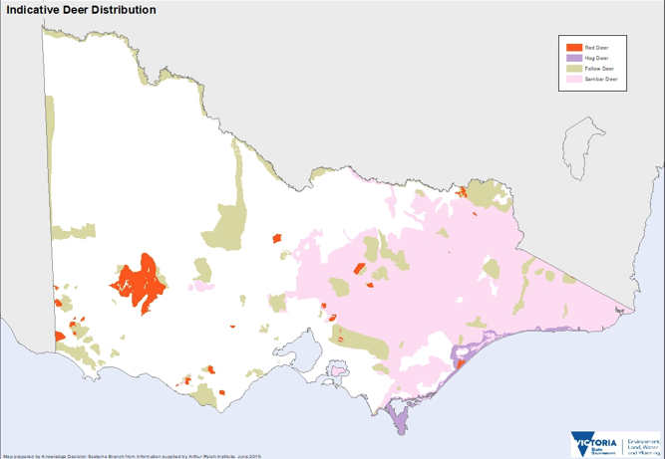

Figure 1: Estimated breeding distribution of deer (combined) in Victoria
Up until the end of the last century, it was considered rare to see deer in the wild. However, reports suggest that deer distribution and abundance, particularly of Sambar and Fallow Deer, have rapidly increased in recent years and are consequently having an increased impact on a range of values. There is also evidence deer are spreading to new areas across Victoria at a rapid rate. While the exact number of wild deer is unknown, there are a number of theories that explain their relatively rapid spread. Increases in deer have been, in part, attributed to fire, natural dispersal, deliberate releases and farm escapes, while urbanisation has led to a greater number of human observations and interactions with deer.
Sambar, Red, Fallow and Hog Deer are well established in the Victorian environment and occur in densities that rule out eradication as a feasible statewide goal for Victoria. There is, however, potential for their further spread, with estimates suggesting that Sambar Deer had only occupied approximately 74% of suitable habitat by 2009. Further work is required to determine how much habitat is occupied by established deer species now and into the future.
It is unknown how climate change will affect the distribution and abundance of deer in Victoria.
Modelling suggests that Red and Fallow Deer have an extremely wide predicted distribution in Victoria. Dispersal of deer in the landscape is contiguous across the state borders with South Australia and New South Wales.
Deer can inhabit many different habitat types from dense forest, rough mountainous terrain and alpine environments to more open-country including semi- open scrublands, pine plantations and open grazing land. As deer populations increase and expand, and Victoria’s human population, urban expansion and associated infrastructure continues to grow, deer are being seen more commonly in peri-urban and urban areas. Deer presence in such areas brings a unique set of management challenges.

Impacts of deer
A wide range of environmental, economic and social impacts have been attributed to wild deer. Deer impact natural and agricultural systems through browsing and grazing on a wide range of vegetation, antler rubbing, trampling, trail creation and wallowing. During the breeding period (rut) these impacts are more prevalent. Sambar, Red, Fallow and Hog Deer have slightly different impacts due to differences in diet, size and habitat preference.
The environmental, economic and social impacts of wild deer in Victoria have not been quantified, however, they are believed to be significant and increasing in their extent and severity.

Biodiversity
Deer pose a significant risk to biodiversity, having both direct and indirect impacts on native flora and fauna. Occurrences and severity of impacts on areas of high value biodiversity have increased over the last decade, placing increasing pressure on threatened species and ecological communities.
Deer reduce and destroy native vegetation and compete with native wildlife for food sources. As deer densities increase in an area, the abundance and diversity of plant species is reduced.
Sambar Deer were listed as a potentially threatening process to native vegetation under Victoria’s Flora and Fauna Guarantee Act 1988 (FFG Act) in 2007. At this time, the species was considered a threat to at least 13 threatened flora species and 12 ecological communities, some of which are threatened, including Alpine Sphagnum Bogs and associated fens (see Appendix C for the full list).
Current DELWP data and analysis from the Strategic Management Prospects tool (designed to help biodiversity managers consider and compare which actions to do where to achieve the most cost-effective benefits for the most species in line with the targets in Biodiversity 2037. www.environment.vic.gov.au/biodiversity/natureprint) also suggests that over a thousand species of flora and fauna would benefit from deer control efforts across the state.
Deer populations can significantly reduce the health of natural ecosystems. Deer contribute to shrub and ground layer disturbance, plant and habitat destruction through grazing, localised soil compaction and erosion, degradation of waterways and the spread of weeds into new areas.
These impacts collectively disrupt the overall viability and function of ecosystems and landscapes in which deer are present.
At some rainforest sites in Victoria, deer threaten ‘key structural species’, such as Yellow-wood (Acronychia oblongifolia) and Mutton-wood (Rapanea howittiana). Reduction in these individual plants implies a much broader environmental impact. Seedlings and plants with new shoots are particularly attractive to deer, and their reduction will result in changed vegetation structures and reduced species diversity.
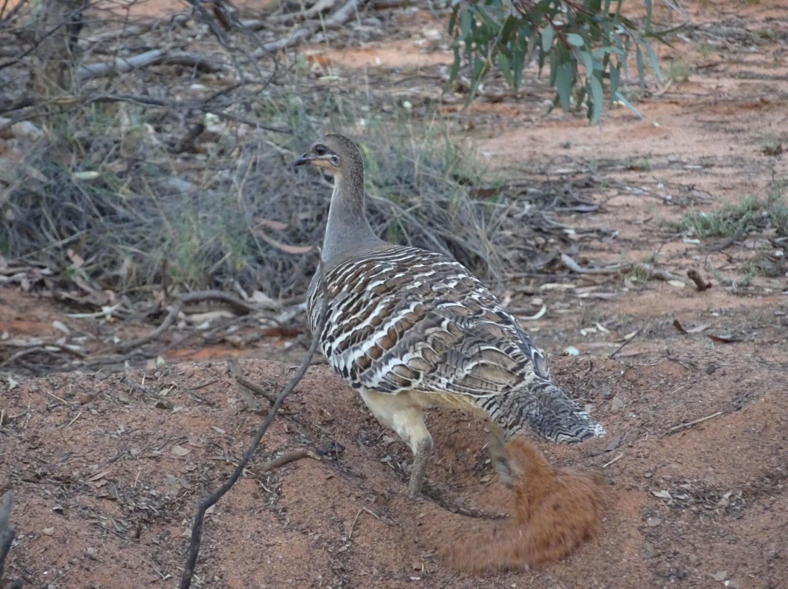

Image: Malleefowl in Little Desert National Park
Malleefowl are listed as vulnerable under the Commonwealth’s Environment Protection and Biodiversity Conservation Act 1999 (EPBC Act) and threatened under the FFG Act. In Victoria’s Little Desert area, Fallow Deer impact the threatened Malleefowl by competing for available food and damaging habitat through trampling, grazing and ring-barking vegetation. It is suspected that the deer may also trample Malleefowl mounds that are used as nesting sites.
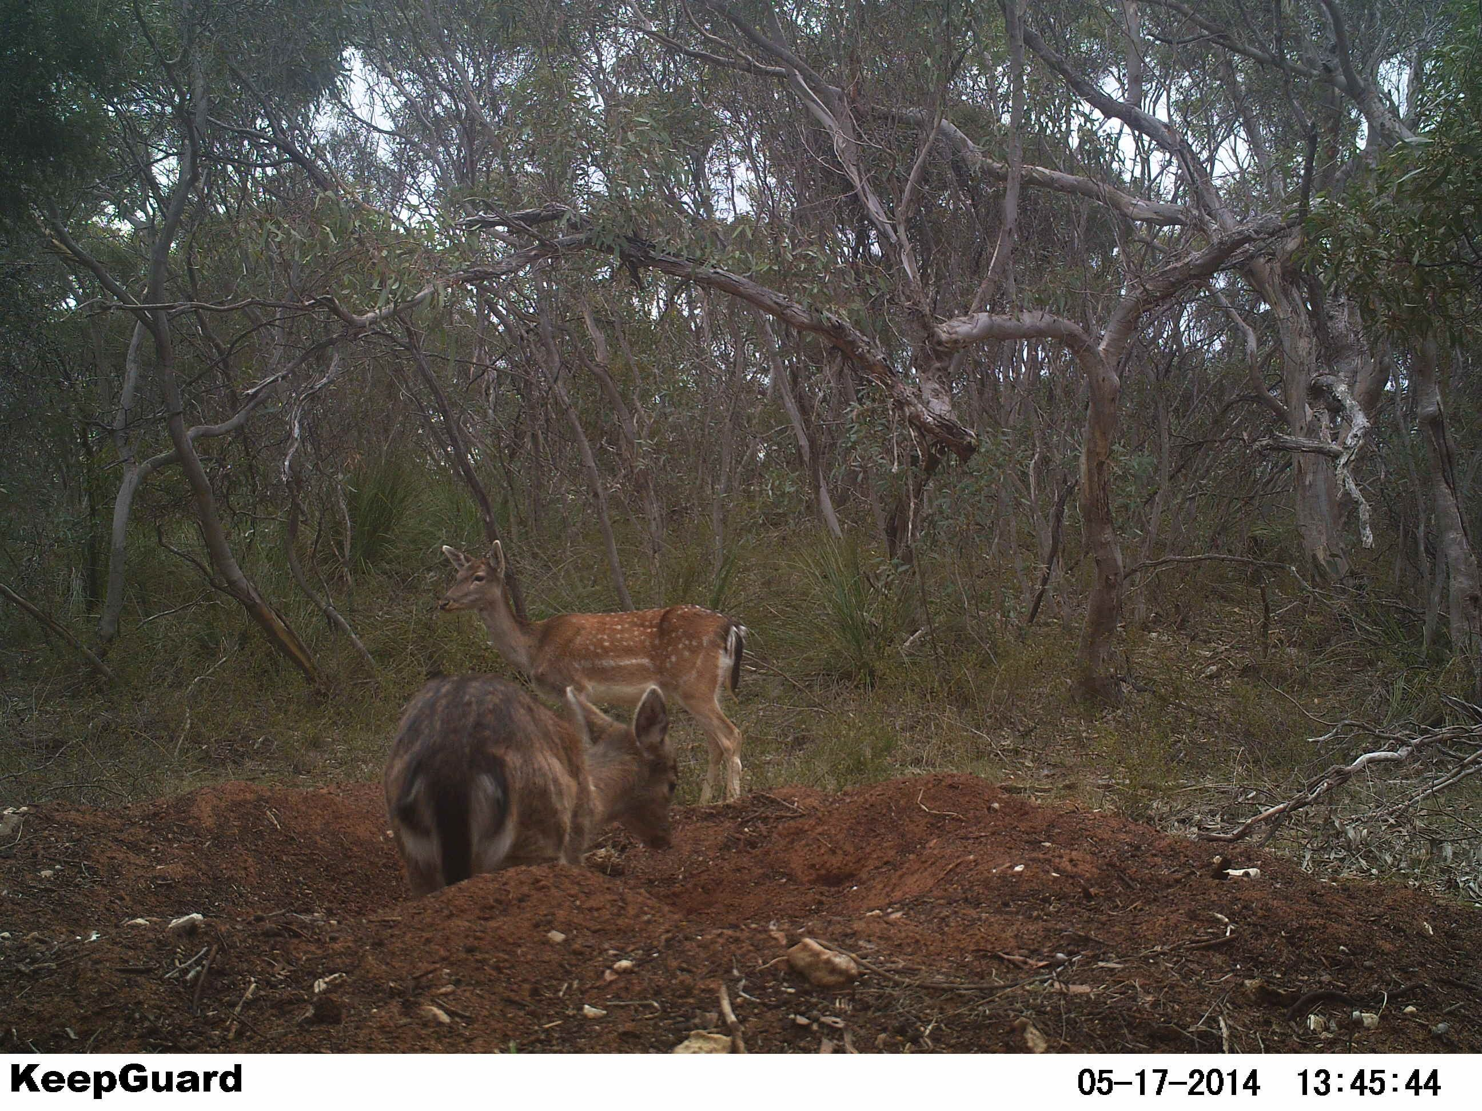

Image: Fallow Deer in Malleefowl mounds
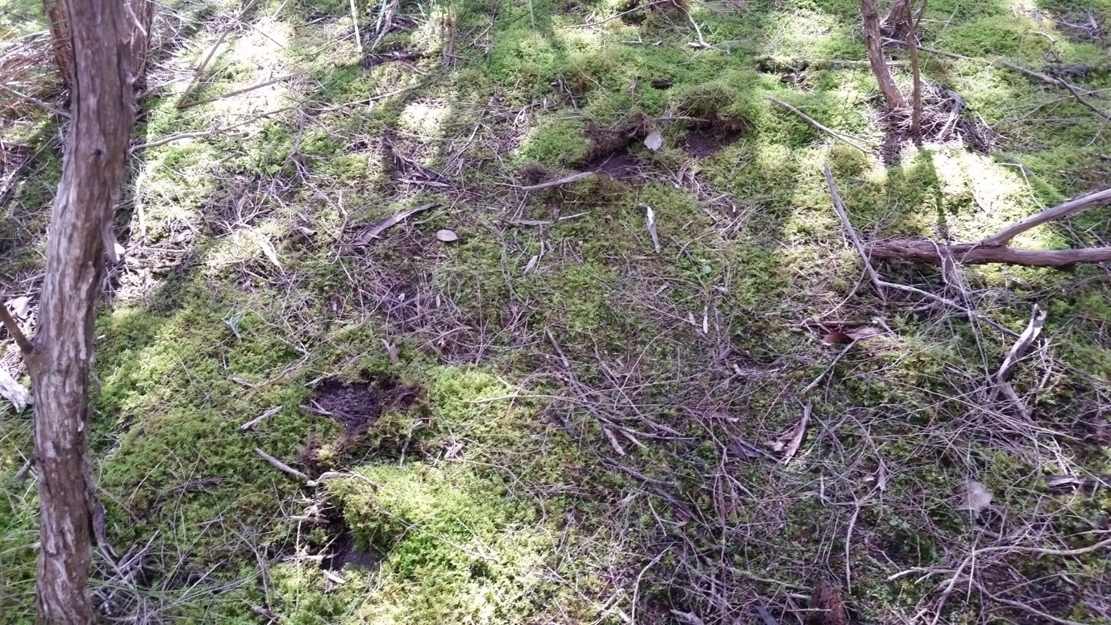

Image: Sambar tracks through moss bed in Warrandyte State Park
Conservation groups that have dedicated significant time to rehabilitate and revegetate areas, such as the Warrandyte State Park, to restore biodiversity have advised that their efforts over many years are now being undone by wild deer. These community-based groups have reported that deer over browse and damage saplings, trample small delicate plant species, and destroy moss beds through wallowing and spread weeds.
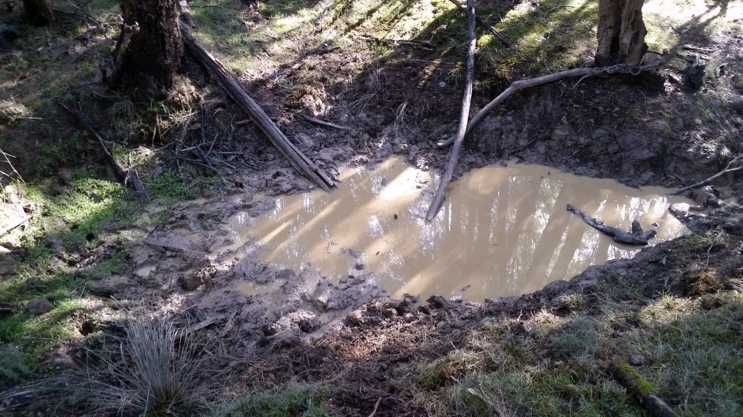

Image: Sambar wallow in Warrandyte State Park with Callitriche weed (light green herb at left hand side) introduced by the deer
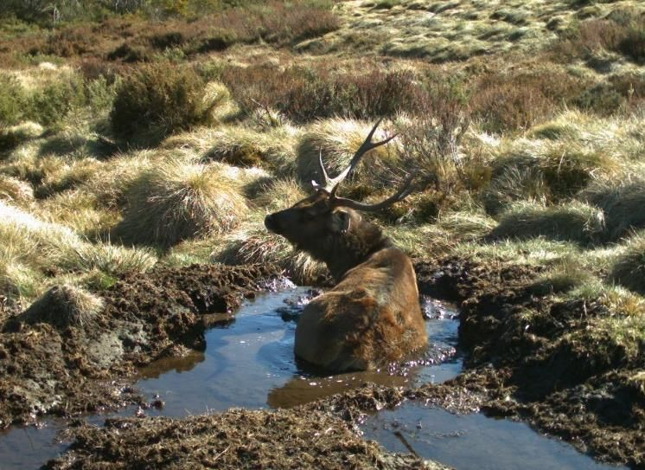

Image: Sambar stag in wallow, Bogong High Plains, Alpine National Park
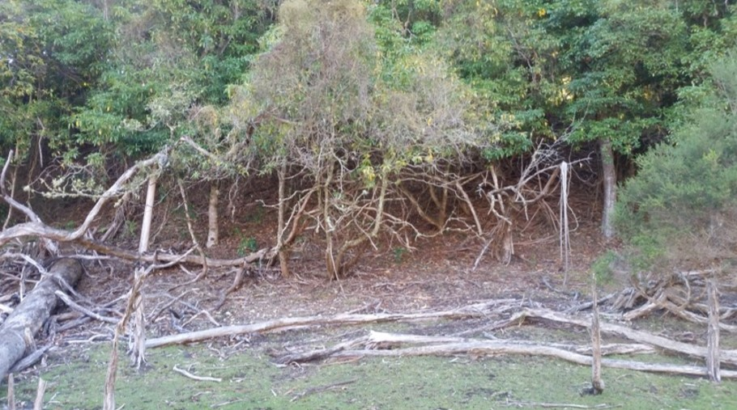

Image: Deer have eaten all accessible leaf matter marked by the browse line at this Littoral Rainforest site in east Gippsland
The Littoral Rainforest and Coastal Vine Thickets of Eastern Australia are listed as critically endangered ecological communities under the EPBC Act. In east Gippsland, the majority of Littoral Rainforest sites are threatened by Sambar and Hog Deer through their browsing and tree rubbing habits. Deer have the capacity to significantly change the structure and composition of these sites,s predominantly through disturbance to the vine and canopy plants.

Agriculture
While the total economic impact of wild deer on agriculture has not been quantified, deer have been reported to cause damage to a wide variety of agricultural crops (including cereal, nut, fruit and vegetables), vineyards and plantations.
Other impacts on primary production include fouling of pasture, crops and water, the spread of weed and soil borne disease and damage to infrastructure including fences and nets. There are also reports that deer compete with livestock for feed and during the mating season. Sambar stags are also known to harass cattle.

Disease
Deer are potential vectors of a range of animal diseases that may transmit to humans, livestock and other animals and can lead to serious economic and social impacts. Exotic diseases of concern include livestock diseases such as foot-and-mouth disease and surra. Endemic diseases spread by deer include cryptosporidiosis, neosporosis and leptospirosis. Some of these diseases are notifiable under state animal disease legislation and may initiate an emergency response should an outbreak occur. See Appendix D for a summarised list of diseases of which deer could be carriers.
Victoria is contributing to a national study led by the Centre for Invasive Species Solutions that investigates the role of wild deer in the transmission of diseases to livestock.

Melbourne’s water supply
Melbourne’s water supply relies on protected water supply catchments. Protecting these reservoirs and catchments from contamination is critical to maintaining a safe and relatively inexpensive drinking water supply without the need for Ultra Violet (UV) treatment. The quality of water these catchments supply is very rare for a large city like Melbourne and avoids considerable water treatment costs commonly required for most comparable cities.
While other animals are known carriers of the parasite, Cryptosporidium spp., deer carry an increased risk as they appear in greater abundance than other host species near these protected catchments. This parasite can contaminate drinking water reservoirs and cause infection in humans (cryptosporidiosis).
The protected catchment areas do not have drinking water treatment systems designed to manage Cryptosporidium. Melbourne Water suggests that failure to adequately control deer in these catchments could result in the need to build a UV plant to meet drinking water quality standards. Building UV treatment plants is a significant cost and would considerably increase the price of supplying water to Melbourne.

Public safety
As deer distribution and abundance increases, deer sightings and reports of public safety risk are becoming more common, particularly in peri-urban areas. Impacts that have been observed include deer-vehicle collisions and damage to infrastructure. In densely populated areas, deer are a growing public concern, appearing in backyards, schools and other public places. Deer may charge or kick people if they feel threatened and given their size they can cause significant and even fatal injuries if they are struck by a vehicle.

Aboriginal cultural heritage
There is concern over the risks posed by deer populations to cultural heritage sites and values.
For example, the Gunaikurnai Land and Water Aboriginal Corporation and the Dja Dja Wurrung Clans Aboriginal Corporation are both seeking to tackle the impacts of deer (and other large invasive herbivores) at ten sites in Gippsland and six sites in Central Victoria, respectively. The identified impacts of deer at these sites include soil compaction and erosion, damage to native plant species and competition with native species for grazing in grassy, shrubby and herb-rich woodlands.
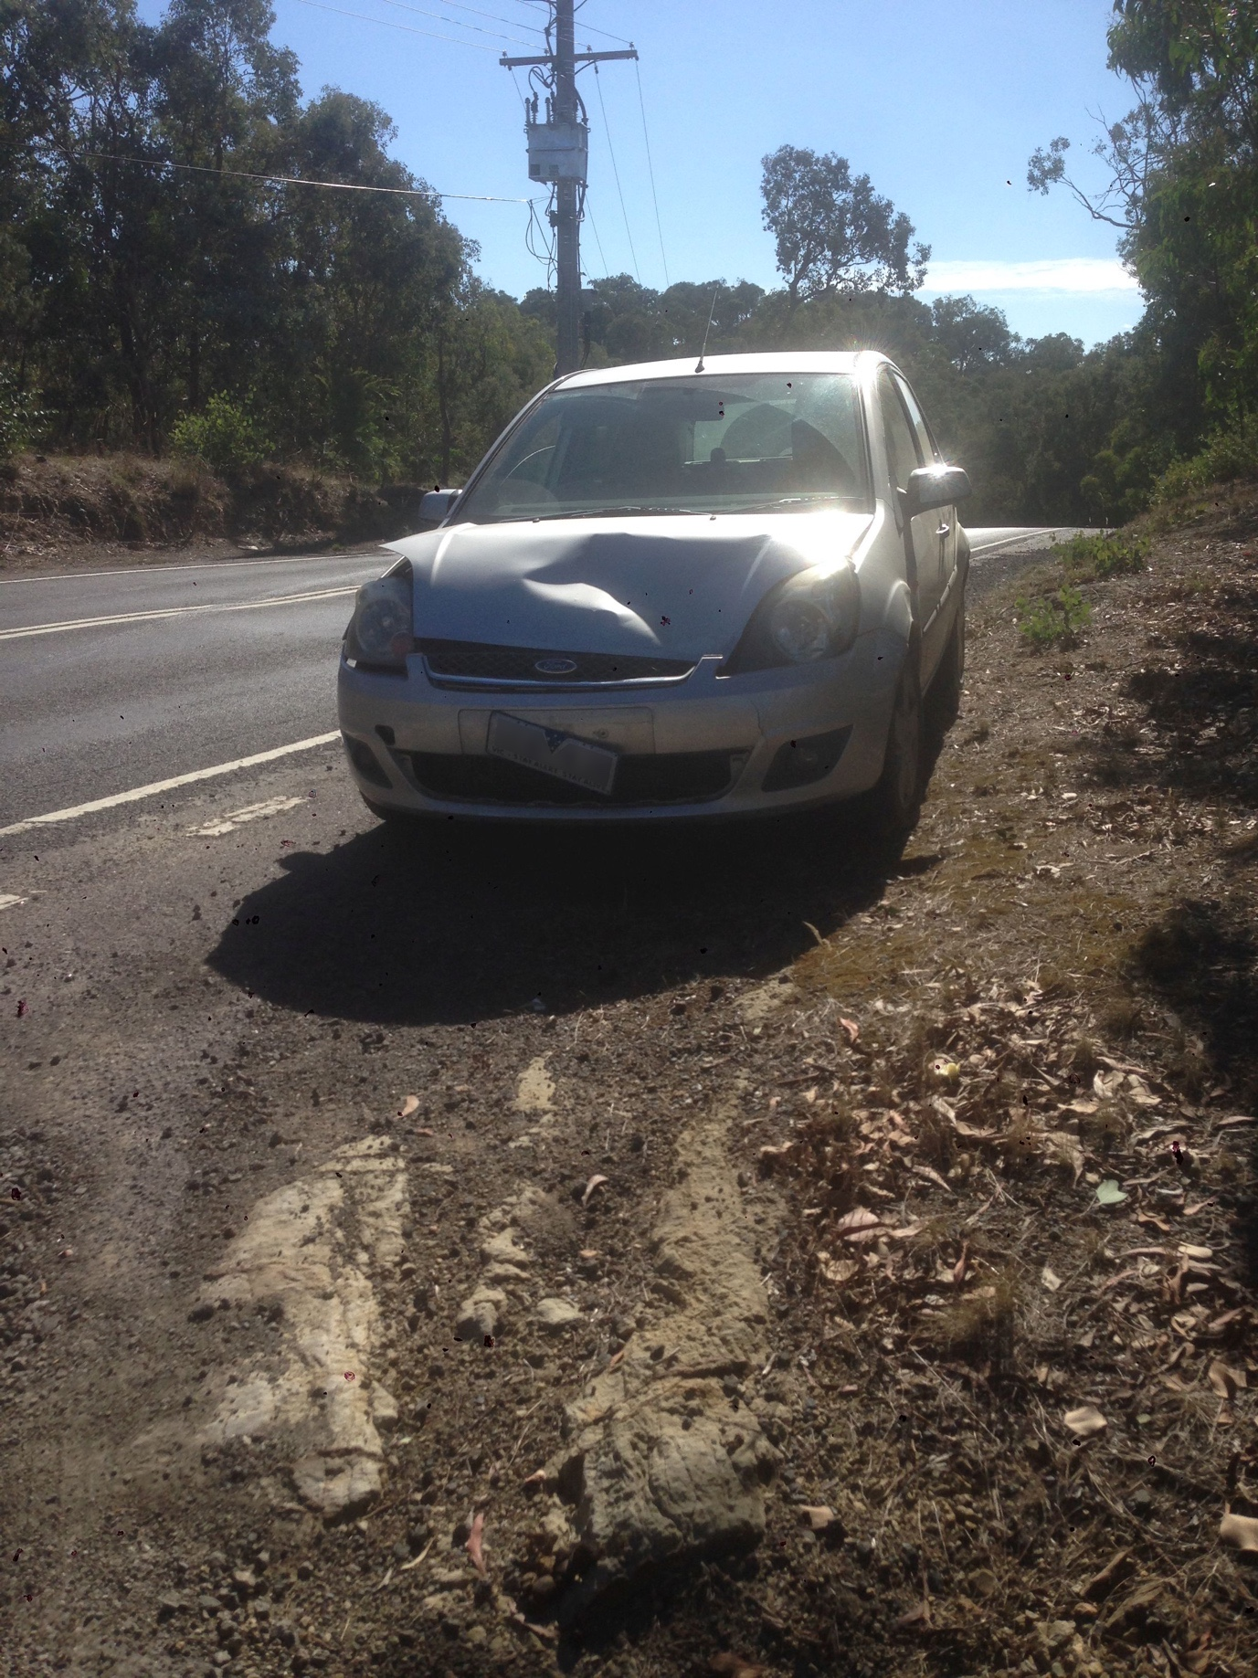

Image: Car damaged by deer collision
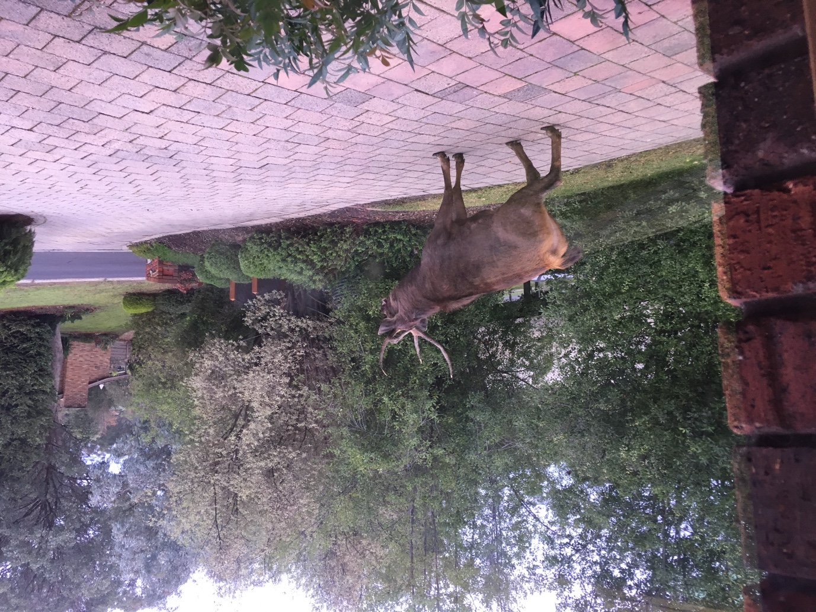

Image: A Sambar Deer in an Eltham driveway

Current legal status of deer
Hog, Red, Sambar, Fallow, Rusa, Chital, Sika and Wapiti Deer are defined as protected wildlife under the Wildlife Act 1975 (Wildlife Act). Hog, Red, Sambar, Fallow, Rusa and Chital Deer are further defined as game, which means they can be hunted by licensed game hunters. All other species of deer are declared as prohibited pest animals under the Catchment and Land Protection Act 1994 (CaLP Act).
All deer species, except Hog Deer, are currently unprotected on private property and can be controlled by the property owner where they are causing damage. This means deer on private property can be controlled without a licence or permit, allowing landowners to destroy problem deer at their convenience. Deer control on public land, however currently requires authorisation by DELWP under the Wildlife Act.
Deer are farmed in Victoria for a range of products including venison and velvet and these products are sold domestically and internationally.
Deer farming does not currently require a permit or licence under the Wildlife Regulations 2013, however it is regulated under other legislation including the Livestock Management Act 2010 and the Impoundment of Livestock Act 1994.
In Victoria, the commercial processing of wild deer for human or pet food consumption is regulated by PrimeSafe according to national food safety standards. This is a relatively new industry, facilitated by legislative changes by the Victorian Government in 2018.
Commercial deer harvesting on private land requires the permission of the landholder but does not require authorisation under the Wildlife Act, given deer are unprotected on private land.
Authorisation is currently required under the Wildlife Act for commercial deer harvesting on public land.
Hunting laws like the Wildlife (Game) Regulations 2012 and the Code of Practice for the Welfare of Animals in Hunting, set out minimum standards and practices to prevent cruelty and ensure hunting is undertaken humanely.

Status: Protected wildlife
- Legislation-Wildlife Act 1975
- Deer Species- Chital, Fallow, Hog, Red, Rusa, Sambar, Sika, Sika-Red hybrids and Wapiti
- Intent/Obligation-Offence to hunt, take, or destroy protected wildlife unless authorised

Status: Game Species
- Legislation-Wildlife Act 1975
- Deer Species- Chital, Fallow, Hog, Red, Rusa and Sambar
- Intent/Obligation- Can be hunted by licensed game hunters according to prescribed methods, seasons (Hog Deer only) and time of day

Status: Problem deer on private land (unprotected species)
- Legislation- Governor in Council Order under the Wildlife Act 1975
- Deer Species- All deer species, except Hog Deer
- Intent/Obligation- Problem deer on private property can be controlled without a licence or permit

Status: Prohibited pest animal
- Legislation- Catchment and Land Protection Act 1994
- Deer Species- All species except: Chital, Fallow, Hog, Red, Rusa, Sambar, Sika, Sika-Red hybrids and Wapiti
- Intent/Obligation-This declaration prohibits the bringing into Victoria, keeping, selling, or releasing of these animals without a permit. Government has a responsibility to take all reasonable steps to control prohibited pest animals on any land in the State.

Status: Exotic fauna
- Legislation- National Parks Act 1975
- Deer Species- All species of deer
- Intent/Obligation-The National Parks Act 1975 requires the extermination or control of exotic fauna (including deer) in National and State parks, Wilderness Parks and other reserves

Status: Potentially threatening process
- Legislation- Flora and Fauna Guarantee Act 1988
- Deer Species-Sambar Deer
- Intent/Obligation-Recognises that Sambar Deer pose a significant threat to the survival and evolutionary development of numerous plant taxa and ecological communities

Control of deer in Victoria

Control methods
The primary control method for deer is shooting, which is carried out by professional shooters, accredited volunteer hunters, commercial harvesters and recreational hunters.
Deer control using professional contractors and agency staff is targeted and measured to achieve specific habitat protection outcomes over defined periods of time. This can help in minimising the impacts of deer control on other public land users and achieving focussed protection of species and habitats at risk from deer.
While providing some benefit, it is recognised that recreational hunting on its own is not an effective means of controlling deer numbers. However, volunteer recreational hunters have been part of the success of some targeted control works and are a significant skills base to draw on where coordinated hunting is required, particularly in partnership with public land managers.
Ground shooting is commonly used to control deer, with aerial shooting now being used in Victoria to deliver deer control in inaccessible and remote terrain where ground shooting is impractical. An integrated approach that utilises professional ground and aerial shooting is required to deliver effective deer control over varied landscapes.
In some small areas, including habitats with limited distribution, it may be necessary to totally exclude deer. Exclusion fencing is currently used by farmers to exclude deer and to protect some specific environmental values, for example at Mount Bullfight to protect Alpine Tree Frog (threatened under the FFG Act) habitat and at McMahons Creek.
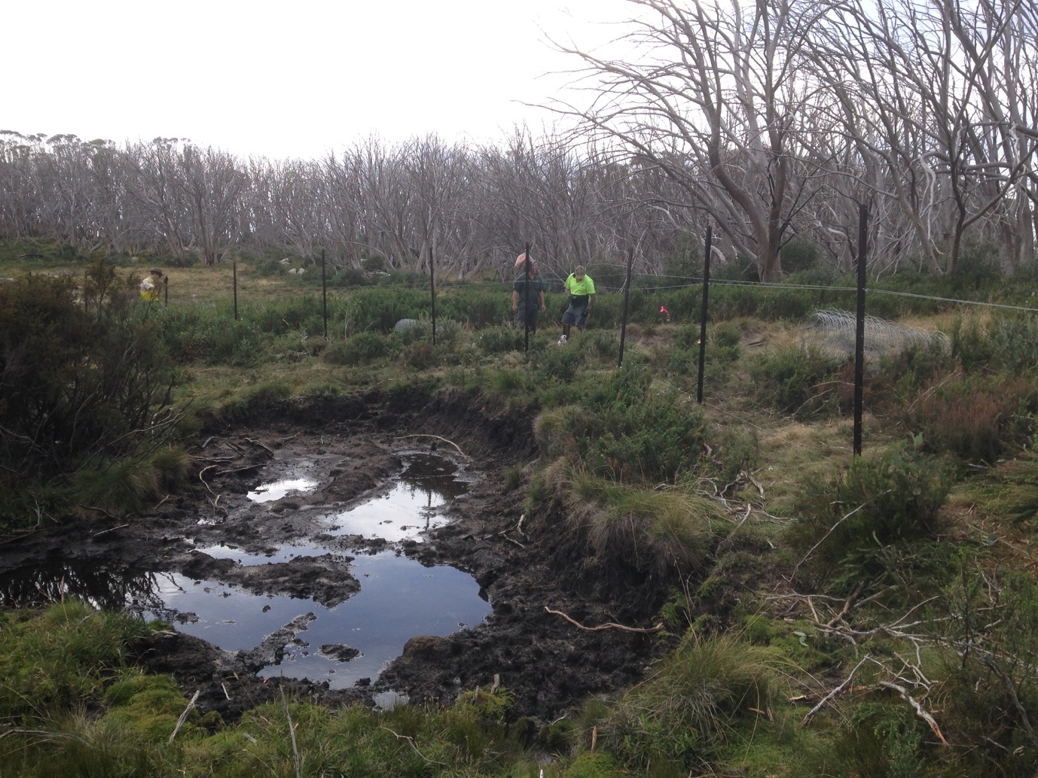

Image: Exclusion fencing being erected at Mount Bullfight
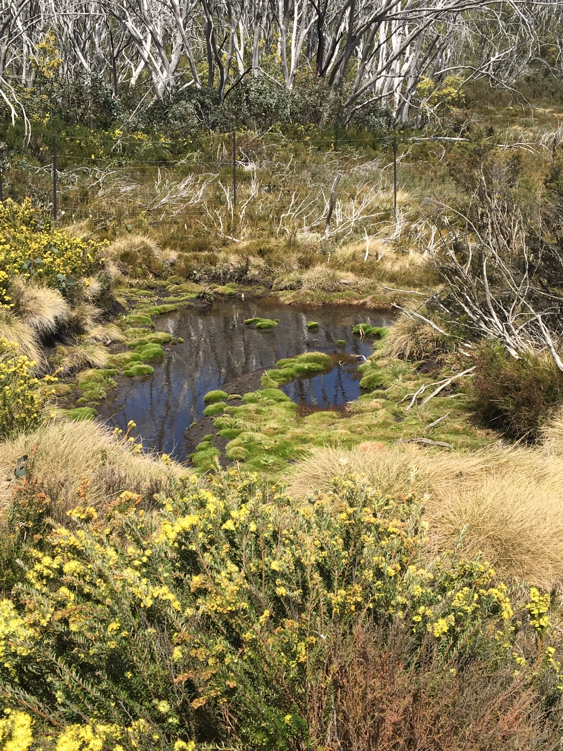

Image: Two years after exclusion fencing was installed at Mount Bullfight
While deer fencing provides a long-term solution, it is only applicable to relatively small areas. Trapping is not commonly adopted for deer control in preference for suitably scaled, integrated shooting programs.
Parks Victoria is currently trialling deer repellents at Lake Mountain. Broad scale control tools commonly used for several other invasive animals, such as baiting and biological control methods are not currently available, although research to investigate these methods is underway in other states. The Victorian Government will monitor the results of these trials for consideration of their applicability in Victoria.

Private land
On private land, deer are unprotected (except for Hog Deer). This means deer on private property can be controlled using a firearm, allowing landowners to destroy problem deer without the need for a game licence or permit.
With the development of a commercial deer harvest industry, landowners can also utilise the services of commercial harvesters to control and remove problem deer which will reduce or eliminate the costs of deer control.

Public land
Deer control on public land is primarily managed using professional shooters or accredited volunteer hunters under the instruction and guidance of the land manager, as part of a strategic control program. Such programs currently focus on protecting key biodiversity values from the impacts of deer.
Public land managers, such as Parks Victoria and local government, are currently required to apply for authorisation under the Wildlife Act to manage deer on public land.

Recreational hunting
Deer hunting is a valued recreational activity undertaken by more than 38,000 licensed hunters.
An estimated 173,800 deer were harvested by recreational hunters in 2019, which is a significant increase from previous years in line with the increasing deer population.
Chital, Fallow, Hog, Red, Rusa and Sambar Deer are currently declared as ‘game’ under the Wildlife Act which allows them to be hunted by licensed recreational hunters. There are no limits on the number of deer that can be taken by a hunter, except for Hog Deer where one male and one female can be shot during the one-month hunting season in April each year. Other game deer can be hunted year-round except for Sambar Deer hunting with hounds. Some seasonal restrictions for hunting deer in National Parks also apply.
Deer can be hunted in State forest, certain forest parks (Cobboboonee and Otway) and other unoccupied Crown land (such as Crown land that is not leased or licensed), leased Crown land (with permission of the lessee), licensed Crown land, some state game reserves and private land (with permission of the landowner/manager). Deer can also be hunted in some National, State, Coastal and Wilderness Parks, subject to varying conditions.

Commercial harvesting
Regulatory changes to allow the commercial processing and use of wild deer were made under the Meat Industry Act 1993 and the Wildlife Act in 2018. The changes enable commercially harvested wild deer to be processed for human and pet consumption.
The commercial harvesting and processing of wild deer is regulated by PrimeSafe according to national food safety standards. A commercial deer harvesting industry may assist land owners and managers to reduce the impacts of deer on their land and generate new employment and economic opportunities in Regional Victoria.
Further legislative changes have allowed recreational deer hunters to have wild deer processed (butchered) for personal use.

Current challenges

Lack of a strategic and coordinated approach to deer control
The current approach to deer control and management is currently ad hoc and largely done to address specific issues in localised areas. To be effective, a more strategic, landscape-scale approach is required.
There is a need to understand the highest priority and most cost- effective areas for deer control in the state that benefit multiple environmental, agricultural and Aboriginal cultural values and public safety. This information will ensure that government investment in deer control is happening in the most important and cost- effective locations. Partnerships and a collaborative approach between stakeholders is important in the current and future control of wild deer.

Regulatory barriers to deer control
Under the current legislative framework, authorisation under the Wildlife Act is required to control deer on Crown land each time it is undertaken. This is an unnecessary administrative obligation for public land agencies such as Parks Victoria, local government and water authorities. An action in this strategy is to remove this regulatory barrier under the Wildlife Act.

Risk of other deer populations establishing in the wild
Sambar, Hog, Fallow and Red Deer are well established in the wild in Victoria. There are however, other deer species that are present in Victoria (in farms and kept as pets) that have not established in the wild. There is a need to prevent incursions of new populations of both established and unestablished species in the wild.
The legislative and regulatory framework needs to provide adequate measures to minimise risks associated with the establishment of new deer species and populations, in line with Victorian Government’s approach to biosecurity (see Appendix A). An action in this strategy is to undertake a review of the classification of deer species not established in the wild.
The regulatory framework for the farming and keeping of deer will also be reviewed to ensure that risks associated with their escape from captivity are being effectively managed.

Limited control methods
The control of deer is restricted by the limited number of control options available.
Information on options and the cost of each is also limited. Public safety risks can limit the use of firearms in some situations. Fencing is costly and can cause other problems, such as preventing the movement of native wildlife in the landscape.
Management of problem deer in urban and peri-urban areas can be challenging, due to restrictions on firearm use, limited availability of other control methods and a wide range of land tenures that make coordinated control difficult.
Increased research and trialling of alternative methods of deer control is required. In developing and trialling new control methods, consideration must be given to the impacts on any off-target species, animal welfare and farmed deer. A collaborative research project is currently underway led by the Centre for Invasive Species Solutions that investigates cost-effective control tools for wild deer control. Trials involving baiting and trapping of deer are also underway in New South Wales. The outcomes from this research will be monitored to determine the effectiveness and suitability of these control methods within Victoria.

Illegal hunting activity
Illegal hunting activity is a significant issue, particularly in rural and regional communities, with reports of illegal spotlighting, trespass, firearm offences, illegal use of dogs, damage to infrastructure such as fences and gates and loss of stock. This illegal activity affects the reputation of lawful recreational hunting and reduces the likelihood of private landowners utilising the services of hunters to reduce the impacts of deer.
Victoria Police is responsible for enforcing the ownership and use of firearms and the GMA is responsible for enforcing game hunting laws and educating and informing hunters on how to hunt legally. The GMA is delivering several key actions under the Sustainable Hunting Action Plan to promote responsible hunting. Further information can be found at www.gma.vic.gov.au.

Part 2

The opportunity for change
The Victorian Deer Control Strategy outlines a partnership approach between all levels of government, Traditional Owners, public and private land managers, conservation and community groups, the agricultural sector, Landcare, water authorities, Catchment Management Authorities, the commercial deer industry, hunting organisations, hunters, and the community.

Long term vision
Deer are no longer significantly impacting on priority environmental, agricultural and Aboriginal cultural heritage values and public safety in Victoria

Goals
- The impacts of deer on key environmental, agricultural and Aboriginal cultural heritage values and public safety are reduced
- Deer control is more effective through partnerships and community collaboration
- Awareness, understanding and capacity to control deer is increased

Deer Control Framework
The strategy is underpinned by a Deer Control Framework to provide a coordinated, strategic and adaptive approach to managing the impacts of deer.
It will identify the most cost- effective actions and locations for undertaking deer control or management to benefit multiple high priority values, and guide investment and onground action.
The objectives of the framework are to:
- Prevent new deer populations from establishing in Victoria (prevention);
- Remove isolated populations of deer (eradication);
- Limit the spread of deer beyond their current geographic range (containment); and
- Protect and reduce the impacts of deer on priority values (asset protection).
The framework comprises:
- Deer Advisory Committee who provides information and expert advice to support development of Regional Plans and advocates for implementation of the strategy
- DELWP who oversees a consistent approach to the development and operation of Regional Plans
- Regional Deer Control Partnership Groups who input into the Regional Plans
- Local land managers and partners who input into Local control/operational plans. Regional Plans also input into the Local control/operational plans and projects.

Regional Deer Control Partnership Groups
The Victorian Government will establish and lead the delivery of the framework with the establishment of Regional Deer Control Partnership Groups (partnership groups) to develop and implement Regional Plans.
Partnership groups will be comprised of local stakeholders involved and interested in managing deer impacts and may include land managers, local government, Traditional Owners, conservation, industry and community groups.

Regional Plans
Regional Plans will be developed with input from each partnership group. The Regional Plans will be five-year plans however, they will be adaptive to respond to new information and enable continuous improvement.
The Regional Plans will outline
- the values being significantly impacted by deer and those at future risk based on current and projected deer distribution;
- current deer control efforts;
- the most cost-effective and strategic locations to undertake deer control, surveillance or other management measures, in line with the management approaches described below, to address impacts and risks and provide the greatest net benefit;
- a delivery plan including most appropriate control methods, funding options, partners, accountability, information requirements; and
- monitoring and evaluation plans.
A description of each management approach and their respective actions are provided in the following table.

Approach: Prevention
- Management objective
  - Prevent new deer populations from arriving and/or establishing
- Description
  - Areas where deer are not yet present or established in the wild in Victoria
- Example management actions
  - Regulate the bringing into Victoria, keeping and farming of deer
  - Prohibit the release of deer into the wild
  - Surveillance to detect new incursions of both existing species and species not yet present in Victoria
  - Immediate removal of new populations if detected
- Land tenure
  - Public and private land

Approach: Eradication
- Management objective
  - Eliminate all deer from a defined area
- Description
  - Areas where small, isolated populations are present, densities are low, eradication is feasible, and the likelihood of re- establishment is low
- Example management actions
  - Intensive, targeted control program to remove deer where cost-effective and the risk of re-invasion is low
  - Surveillance and monitoring
- Land tenure
  - Public and private land (at landholder’s discretion)

Approach: Containment
- Management objective
  - Limit the spread of deer beyond their current geographic range
- Description
  - Areas where eradication may not be feasible, but the expansion of populations and any increase in density is undesirable
- Example management actions
  - Reduce/maintain low deer densities within current range through integrated management (e.g. targeted deer control programs, hunting, commercial harvesting etc)
  - Surveillance in priority locations outside current range to detect any incursions or spread
  - Targeted control program to remove deer where cost- effective
- Land tenure
  - Public and private land (at landholder’s discretion)

Approach: Asset Protection
- Management objective
  - Protect and reduce the impacts of deer on priority values
- Description
  - Areas where deer are well established and eradication is not feasible. Control efforts are focused on protecting priority environmental, agricultural, social, economic or cultural values
  - Control areas must be practical and feasible for real reductions to be achieved
- Example management actions
  - Identify values significantly impacted by deer
  - Lower deer densities in strategic, priority locations to benefit multiple values through intensive and targeted control
  - Monitoring and evaluation to determine effectiveness of approach
  - Control tools include ground and aerial control programs, commercial harvesting, accredited volunteer hunters, fencing of sensitive sites etc
- Land tenure
  - Public and private land (at landholder’s discretion)
DELWP’s Strategic Management Prospects will be a key decision- support tool. It will inform where deer control is most cost-effective to protect biodiversity values, where the control of other introduced herbivores is occurring and the benefits of aligning deer control with these programs. The map in Appendix E shows, based on current data, where it is most cost- effective to manage the impacts of deer to benefit biodiversity. There will be a need to overlay the other values identified in Regional Plans to identify locations where benefits to multiple values can be realised.
Priorities for Victorian Government investment will include:
- where benefits to multiple values can be realised;
- protecting threatened species and ecological communities under imminent risk from the impacts of deer;
- protecting drinking water supplies;
- responding to incursions of new species and populations;
- protecting significant Aboriginal cultural heritage sites and values; and
- where return for effort can be maximised, such as through integration of deer control with other pest animal control e.g. other pest herbivores.
Once Regional Plans are finalised, they will guide Victorian Government and partner investment and action in deer control, surveillance and management. Land owners/ managers will also be encouraged to use these plans to guide and coordinate on-ground efforts.
Regional plans will assist in the coordination between stakeholders to strengthen alignment in control activities.

Deer Advisory Committee
A Deer Advisory Committee will be established comprising of government and non-government members. The Committee will be responsible for providing information and expert advice to support development of Regional Plans and advocating for implementation of the strategy.

Goals, objectives and actions

Goal 1 The impacts of deer on key environmental, agricultural and Aboriginal cultural heritage values and public safety are reduced
This goal seeks to reduce the impact of deer on key values by limiting further range expansion, eradicating isolated populations where cost-effective and feasible, preventing the establishment of new populations and species and reducing the population of deer in the most important locations. To achieve this goal, the legal classification of deer not present or established in the wild will be reviewed to reduce the risk of their establishment, thereby preventing their impact on key values. Other measures aim to improve public safety and the facilitation of a commercial deer harvesting industry to assist in reducing deer populations.

Objective 1.1 Prevent the establishment of new deer species and populations in Victoria

Actions
- 1.1.1, Review the classification of deer species not present or established in the wild in Victoria (e.g. Chital, Rusa, Wapiti, Sika and any hybrids) and investigate their transition to pest animals under the Catchment and Land Protection Act 1994.
- 1.1.2, Review the current regulatory framework that applies to the keeping and farming of all deer species in Victoria to ensure that risks relating to their escape and establishment are being effectively managed. The impact of any necessary changes on deer farmers and keepers will be considered as part of this review.
- 1.1.3, Develop and publish education material to reinforce that the release and translocation of deer is illegal.
Objective 1.2 Implement the Deer Control Framework to guide Victorian Government and partner investment in deer control

Actions
- 1.2.1, Implement the Deer Control Framework, including establishment of regional deer control partnership groups, the Deer Advisory Committee and development of Regional Plans.
- 1.2.2, Communicate and promote the use of Regional Plans.
- 1.2.3, Use the Regional Plans to guide investment in deer control and other management measures.
Objective 1.3 Undertake strategic deer control

Actions
- 1.3.1, Invest in and undertake deer control and management activities, as guided by the Regional Plans.
Objective 1.4 Remove barriers to enable effective deer control

Actions
- 1.4.1, Authorise public land managers to undertake deer control as required without the need to obtain individual authorisations under the Wildlife Act.
Objective 1.5 Facilitate development of a commercial deer harvesting industry

Actions
- 1.5.1, Facilitate the utilisation of wild deer carcasses for economic benefit, by working with commercial entities to:
  - facilitate commercial utilisation of wild deer from private and public land to reduce deer densities
  - improve utilisation of wild harvested carcasses from deer control programs, including pilot projects.
Objective 1.6 Reduce public safety risks associated with deer

Actions
- 1.6.1, Identify hot spots for deer/vehicle accidents through the establishment of a collision register.
- 1.6.2, In consultation with local government and Victoria Police, develop peri- urban/public place deer control guidelines for inclusion in the Standard Operating Procedure for the control of deer outlined in Goal 3.

Goal 2 Deer control is more effective through partnerships and community collaboration
A partnership approach is integral to the delivery of the strategy and this goal focuses on the establishment of partnerships between all key stakeholders.
Objective 2.1 Provide leadership and coordination through strategic partnerships

Actions
- 2.1.1, Coordinate an annual forum for land managers and other key stakeholders involved in Regional Plans to share information regarding deer behaviour, distribution, abundance, effectiveness of control programs, impacts and management approaches to inform planning and control programs.
Objective 2.2 Enhance Traditional Owner involvement in deer control

Actions
- 2.2.1, Engage with Traditional Owner groups to:
  - determine Aboriginal cultural and natural heritage values requiring protection from the impacts of deer
  - ensure the protection of Aboriginal cultural and natural heritage values are considered in the determination of priority locations for deer control in the development of Regional Plans.
- 2.2.2, Engage Traditional Owners in strategic deer control, including assessment, monitoring, planning and management.
Objective 2.3 Encourage hunters and commercial harvesters to contribute to strategic and cost-effective control programs

Actions
- 2.3.1, Provide advice to hunters on how they can effectively contribute to reducing deer densities (e.g. targeting female deer when hunting).
- 2.3.2, Provide advice to private and public land managers on the options available to them to control deer on their land, including cost-effective options such as engaging commercial deer harvesters or farm assistance programs run by hunting organisations.
- 2.3.3, Support opportunities to increase the involvement of recreational hunters in control programs on public land.
Objective 2.4 Ensure a consistent and collaborative approach across state borders

Actions
- 2.4.1, Work with NSW and SA to ensure a consistent, landscape approach to deer control is adopted across borders.

Goal 3 Awareness, understanding and capacity to control deer is increased
This goal promotes the improvement of our knowledge base through applied research, trials, and the establishment of a monitoring, evaluation, reporting and improvement framework. It also focuses on education and awareness-raising through information kits and other resources.

Objective 3.1 Improve knowledge of current deer distribution

Actions
3.1.1, Undertake a deer distribution survey in Victoria on all present species.
Objective 3.2 Enhance knowledge and best practice management of deer

Actions
- 3.2.1, Initiate and support research opportunities that progress implementation of the strategy. Priority research themes include the establishment of deer density targets to protect key values, further information on deer distribution and abundance, management efficacy, humane control measures, monitoring and disease risk and cost. Refer to Appendix F for a list of current research needs.
- 3.2.2, Through research and trials, improve the efficiency of existing deer management and investigate new management or control methods, ensuring consideration of animal welfare impacts.
- 3.2.3, Develop a Standard Operating Procedure and Code of Practice for the control of deer to assist land managers.
- 3.2.4, Encourage the community to contribute to improving our knowledge of deer by:
  - reporting deer sightings
  - reporting car accidents and other public safety issues via the reporting tool discussed under Goal 1
  - being involved in community forums and sessions for informing Regional Plans.
Objective 3.3 Increase understanding of the legal framework for deer control options

Actions
- 3.3.1, Develop a deer control information pack for the public, explaining:
  - why deer control is necessary (deer impacts)
  - the legislative framework for deer control (including land owner/ manager legal requirements and animal welfare requirements) in plain language
  - options and opportunities for controlling deer
  - best practice standards and codes of practice for humane destruction of deer.
Objective 3.4 Partner with other jurisdictions to share knowledge, co-invest in research and build capacity

Actions
- 3.4.1, Work with other states to share knowledge about deer management and control, improve practices, co-invest in research and develop cooperative management strategies across borders.
Objective 3.5 Ensure monitoring and evaluation outcomes continue to inform management

Actions
- 3.5.1, Develop and implement a Monitoring, Evaluation, Reporting and Improvement Framework for deer management effectiveness, value and success.

Implementation
Delivery of the actions in this strategy is the responsibility of the Victorian Government in partnership with Traditional Owners, public and private land managers, conservation and community groups, the agricultural sector, Landcare, water authorities, Catchment Management Authorities, Local Government, the Commonwealth Government and other states and territories, the commercial deer industry, hunting organisations, hunters, and the community.
DELWP will establish Regional Deer Control Partnership Groups which will inform the development of the Regional Plans and play a key role in coordinating implementation of the Regional Plans at a local level.

Monitoring, evaluation, reporting and improvement
A monitoring, evaluation, reporting and improvement (MERI) framework will be developed to measure the effectiveness of the strategy in its progress towards the long- term vision and its performance against the goals. The MERI framework will be flexible in its approach to enable adaptive, effective and transparent management.
The MERI will:
- Outline the framework for collection and analysis of the information needed to assess whether the strategy is meeting its goals;
- Coordinate provision of information for deer control program reporting and strategy evaluation reporting five years after its release;
- Ensure that reporting on objectives and actions in the strategy is transparent and identifies learnings and opportunities for improvement;
- Provide the key mechanisms to reinforce, review and refine activities as part of a continual improvement process.
The MERI activities will include monitoring and evaluation of individual deer control programs, the deer control framework and the strategy as a whole. Included in the MERI Framework will be an evaluation of this strategy undertaken within five years from its date of release. The evaluation will assess progress in delivering on the strategy’s vision, goals, objectives and actions.
It will inform future direction of deer control in Victoria and reporting against the targets under Biodiversity 2037.

Appendices

Appendix A, Victoria’s approach to biosecurity
The Victorian Government’s approach to biosecurity is based on the return on investment principle, whereby the greatest return on investment is realised through activities that prevent the entry and establishment of a species. The benefit–cost ratio decreases as a species becomes more widespread. This is commonly represented in an invasion curve (see below).
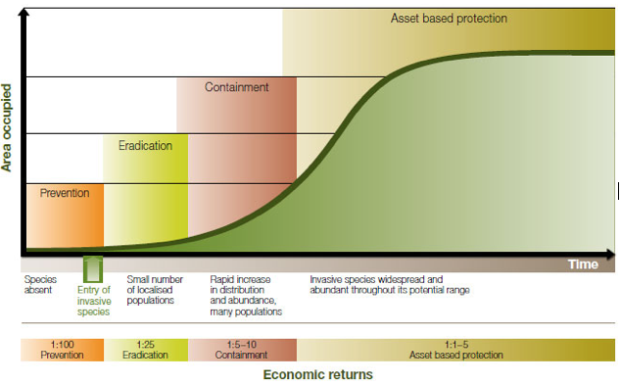

Figure 2 Generalised invasion curve showing actions appropriate to each stage

Appendix B, Distribution of deer in Victoria*

Sambar Deer
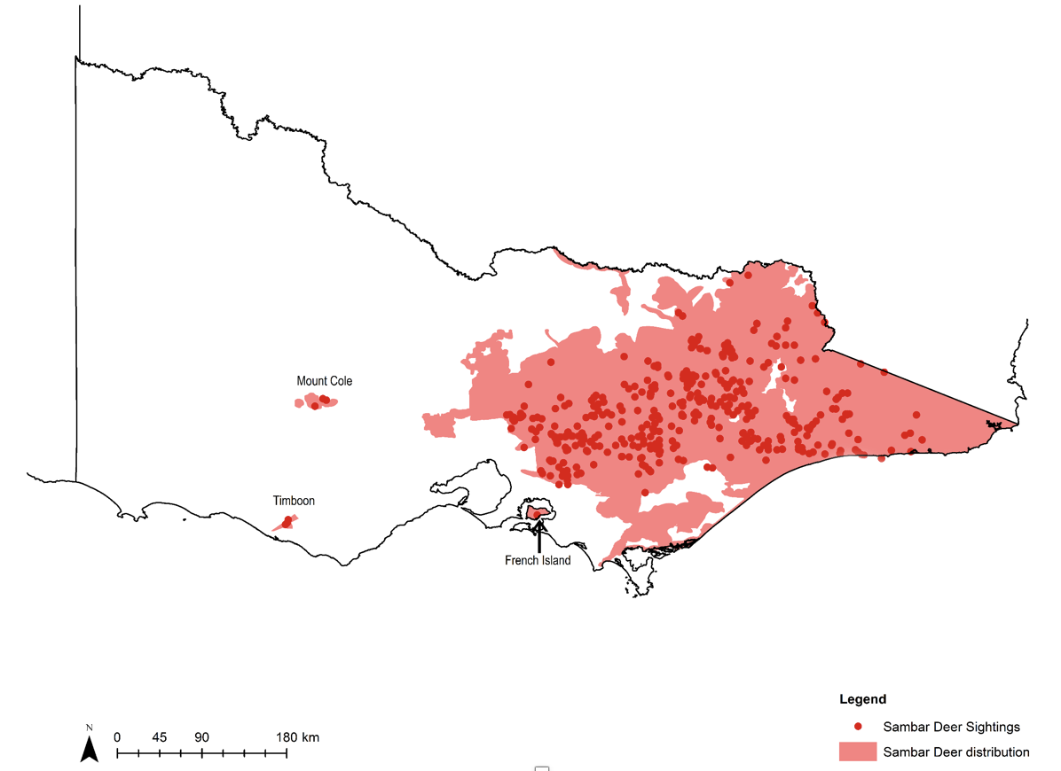

Figure 3 Estimated breeding distributions of Sambar Deer

Hog Deer
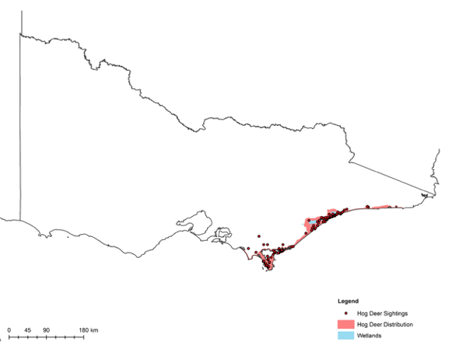

Figure 4 Estimated breeding distributions of Hog Deer

Red Deer
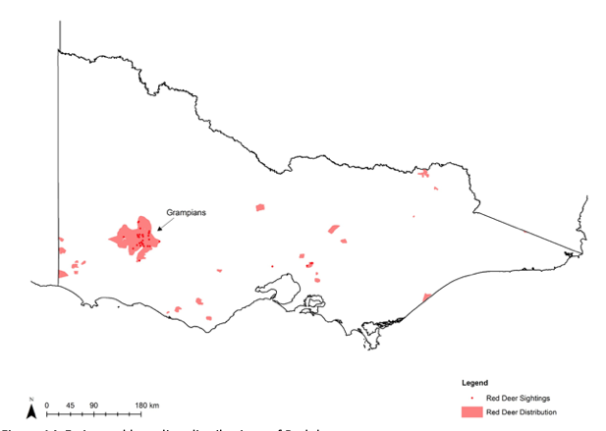

Figure 5 Estimated breeding distributions of Red Deer

Fallow Deer
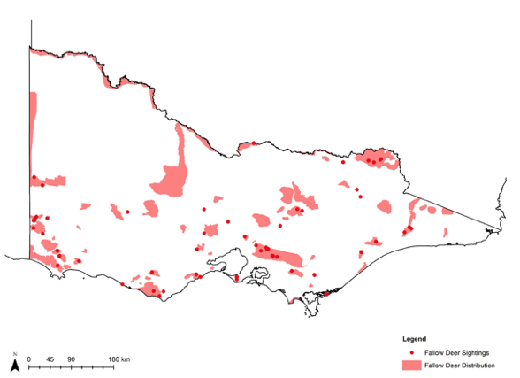

Figure 6 Estimated breeding distributions of Fallow Deer
*These maps were current as of 2015/2016. They represent the breeding distributions of deer defined as observations of breeding activity (i.e. juveniles and/or mother/offspring)

Appendix C, Reduction in biodiversity of native vegetation by Sambar Deer (Cervus unicolor)
The following two tables summarise the threatened flora species (Table 1) and plant communities (Table 2) adversely affected by Sambar Deer in Victoria, as at 13 March 2007, when Sambar Deer were declared as a potentially threatening process under the FFG Act 1988.

Table 1 Threatened flora species affected by Sambar in Victoria
Status under FFG ACT Listed, Status in DELWP (2014) Endangered
- Symplocos thwaitesii Buff Hazelwood
- Acacia maidenii Maiden’s Wattle
- Muehlenbeckia gracillima Slender Lignum
Status under FFG ACT Listed, Status in DELWP (2014) Vulnerable
- Nematolepis wilsonii Shiny Phebalium
- Cyathea leichardtiana Prickly Tree-fern
- Acacia daviesii Timbertop Wattle
- Sambucus australasica Yellow Elderberry
Status under FFG ACT Nil, Status in DELWP (2014) Vulnerable
- Adiantum formosum Black-stemmed Maidenhair
- Lysimachia japonica Creeping Loosestrife
Status under FFG ACT Listed, Status in DELWP (2014) Rare
- Acronychia oblongifolia Yellow-wood
Status under FFG ACT Nil, Status in DELWP (2014) Rare
- Gynatrix macrophylla Gippsland Hemp Bush
- Marsdenia flavescens Yellow Milk-Vine
- Zieria smihii Sandfly Zieria

Table 2 Plant communities that appear to be adversely affected by Sambar in East Gippsland

Floristic community of ecological vegetation class
Warm Temperate Rainforest (East Gippsland Alluvial Terraces) Community
- Observed consequences, Loss of species, loss of structure, loss of vegetation, loss of fauna, refuges from predation
- Status under FFG Act 1988, Listed
Warm Temperate Rainforest (Coastal East Gippsland) Community
- Observed consequences, Loss of species, loss of structure, loss of vegetation, loss of fauna, refuges from predation
- Status under FFG Act 1988, Listed
Warm Temperate Rainforest (Far East Gippsland) Community
- Observed consequences, Loss of species, loss of structure, loss of vegetation, loss of fauna, refuges from predation
- Status under FFG Act 1988, Listed
Littoral Rainforest
- Observed consequences, Loss of species, loss of structure, loss of vegetation, loss of fauna, refuges from predation
- Status under FFG Act 1988, Nil
Alpine Bog Community
- Observed consequences, Loss of species, erosion, loss of vegetation cover, loss of structure
- Status under FFG Act 1988, Listed
Fen (Bog Pool) Community
- Observed consequences, Loss of species, erosion, loss of vegetation cover, loss of structure
- Status under FFG Act 1988, Listed
Riparian Shrubland
- Observed consequences, Loss of species, loss of structure, loss of vegetation
- Status under FFG Act 1988, Nil
Riparian Forest
- Observed consequences, Loss of species, loss of structure, loss of vegetation, loss of fauna, refuges from predation, erosion
- Status under FFG Act 1988, Nil
Estuarine Wetland
- Observed consequences, Loss of species, loss of structure, loss of vegetation, loss of fauna, refuges from predation, erosion
- Status under FFG Act 1988, Nil
Salt Marsh
- Observed consequences, Loss of species, loss of structure, loss of vegetation, loss of fauna, refuges from predation, erosion
- Status under FFG Act 1988, Nil
Sand Sheet Grassland
- Observed consequences, Loss of species, loss of structure, loss of vegetation, loss of fauna, refuges from predation
- Status under FFG Act 1988, Nil
Swamp Scrub
- Observed consequences, Heavy browsing of species including shrubs, tree-ferns, herbs and grasses; wallows leading to loss of ground- layer plants; alteration of drainage patterns; and loss of predator refuges for ground mammals
- Status under FFG Act 1988, Nil

Appendix D, Diseases that could be carried by wild deer
Table 3 is informed by Animal Health Australia (2011) and Davis et. al (2016).

Table 3 Emergency diseases and other endemic diseases that could be carried by wild deer in Australia
Major emergency disease
- Anthrax, Aujeszky’s disease, bluetongue, brucellosis, foot-and-mouth disease, Japanese encephalitis, peste des petits ruminants, rabies, screw-worm fly, surra, vesicular stomatitis
Other endemic disease
- Parasite, Protozoan parasites (Cryptosporidium spp. and Giardia spp.), cattle tick (Rhipicephalus microplus), other tick species (e.g. Ixodes spp.), gastrointestinal helminths, Neospora caninum
- Bacterial disease hosted by ticks, Anaplasmosis (caused by Anaplasma phagocytophilum), dermatophilosis (caused by Dermatophilus congolensis)
- Other bacterial disease, Leptospirosis (caused by sprirochaete Leptospira spp.), Johne’s disease (caused by bacterium Mycobacterium paratuberculosis), Q fever (caused by Coxiella burnetti)
- Virus, Akabane virus, bovine ephemeral fever virus, malignant catarrhal fever

Appendix E, Cost-effective locations for deer control to protect biodiversity
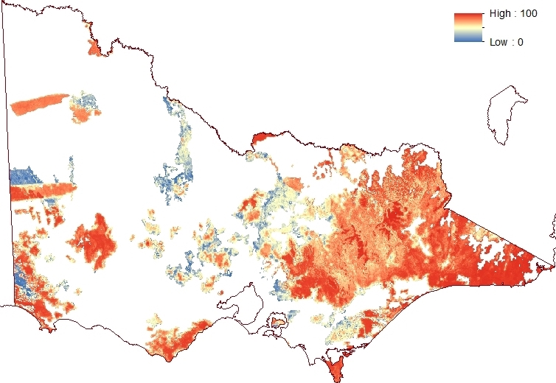

Figure 7 Cost-effective areas in Victoria to protect biodiversity values from the impacts of deer
Red shows the locations where deer control has a relatively high cost-effectiveness, while blue shows areas where deer control has a relatively low cost-effectiveness. Cost-effectiveness is calculated as the benefit to biodiversity from managing the impact of deer at a certain location, divided by the indicative cost of deer control.

Appendix F, Knowledge gaps relating to deer control
The ability to control deer effectively is impeded by gaps in current knowledge. These gaps can be broadly grouped into the below areas. This list is not exhaustive.

Impacts
- Quantify the environmental, social and economic impacts of deer in Victoria.
- Review the impacts of deer on priority values and the metrics for monitoring those impacts.
- Improve understanding of damage/density relationships and control thresholds required to protect values.
- Improve understanding of how burning regimes, bushfire and drought affect deer distribution and abundance
- Improve understanding of how deer carcasses affect predators (wild dogs) and disease (transfer) risks.
- Determine rate of human injury/ fatality in car collisions from with deer relative to macropods (perceptions v. data).

Management tools and systems
- Assess alternative deer control or management options and their cost-effectiveness, impact on other species, and humaneness, e.g. guardian dogs, exclusion fencing, poisons, odour repellents, fertility control, use of disease as a biological control method.
- Assess animal welfare outcomes of aerial shooting.
- Assess the effectiveness of hunting in integrated control programs to reduce deer density.
- Improve understanding of lures and options for baiting deer.
- Build capacity and training of contractors to control deer with dogs and ground shooting.
- Assess the cost-effectiveness of guardian dogs and exclusion fences at protecting crops.
- Assess the commercial use of deer products to reduce deer numbers.
- Understand motivations of recreational hunters and the effectiveness of incentives to shoot more females/more deer.
- Develop a best-practice guide for monitoring and controlling deer and their impacts which includes a review of effectiveness of existing techniques for different scenarios, species, habitats, costs, how to control deer and monitor deer and their impacts.
- Improve trapping techniques.

Monitoring deer distribution and abundance
- Undertake a survey on deer distribution and abundance in Victoria.
- Assess and validate emerging techniques (e.g. thermal imaging, drones, species recognition algorithms) for monitoring distribution and abundance.
- Improve understanding of the rate and locations of where deer will spread, including under climate change scenarios.
- Undertake a pilot study to assess the potential of molecular techniques for identifying the sources of new deer populations and for helping managers understand the potential for reinvasion if eradication of a new population is attempted.

Endnotes
- Animal Health Australia (2011). Wild Animal Response Strategy (Version 3.3). Australian Veterinary Emergency Plan (AUSVETPLAN), Edition 3, Primary Industries Ministerial Council, Canberra, ACT
- Davis, N.E., Bennett, A., Forsyth, D.M., Bowman, D.M.J.S., Lefroy, E.C., Wood, S.W., Woolnough, A.P., West, P., Hampton, J.O., and Johnson, C.N. (2016). A systematic review of the impacts and management of introduced deer (family Cervidae) in Australia. Wildlife Research 43 pp.515–532.
- Forsyth, D.M., Stamation, K. and Woodford, L. (2015). Distributions of Sambar Deer, Rusa Deer and Sika Deer in Victoria. Arthur Rylah Institute for Environmental Research. Unpublished Client Report for the Biosecurity Branch, Department of Economic Development, Jobs, Transport and Resources. Department of Environment, Land, Water and Planning, Heidelberg, Victoria.
- Forsyth, D.M., Stamation, K. and Woodford, L. (2016). Distributions of Fallow Deer, Red Deer, Hog Deer and Chital Deer in Victoria. Arthur Rylah Institute for Environmental Research Unpublished Client Report for the Biosecurity Branch, Department of Economic Development, Jobs, Transport and Resources. Arthur Rylah Institute for Environmental Research, Department of Environment, Land, Water and Planning, Heidelberg, Victoria.
- Flora and Fauna Guarantee, Scientific Advisory Committee (2007). Final recommendation on a nomination for listing – Reduction in biodiversity of native vegetation by Sambar. (Nomination no. 756).
- Gormley, A.M., Forsyth, D.M., Griffioen, P., Lindeman, M., Ramsey, D.S., Scroggie, M.P., and Woodford, L. (2011). Using presence-only and presence– absence data to estimate the current and potential distributions of established invasive species. Journal of Applied Ecology 48(1), pp.25-34.
- Lindeman, M.J. and Forsyth, D.M. (2008) Agricultural impacts of wild deer in Victoria. Arthur Rylah Institute for Environmental Research Technical Report Series No. 182. Department of Sustainability and Environment, Heidelberg, Victoria.
- Parliament of Victoria, Environment, Natural Resources and Regional Development Committee (2017). Inquiry into the control of invasive animals on Crown land. Victorian Government Printer. June 2017. PP No 297, Session 2014-17.
- Parks Victoria (2019). Deer control program to protect native vegetation and habitat. Accessed February 2019. Available at; parkweb.vic.gov.au/about-us/news/deer- control-program-to-protect- native-vegetation-and-habitat
- Phillipson, E. (2014). Littoral Rainforests of East Gippsland: Priorities for Action – 2014–2019. Ethos NRM Pty Ltd for the Department of Environment and Primary Industries.
- State of Victoria (2017). Government response to the Environment, Natural Resources and Regional Development Committee’s Inquiry into the control of invasive animals on Crown land. Victorian Government Printer. December 2017.
- Zahed,i A., Paparini, A., Fuchan, J., Robertson, I., and Ryan, A. (2016). Public health significance of zoonotic Cryptosporidium species in wildlife: Critical insights into better drinking water management. International Journal for Parasitology: Parasites and Wildlife 5, pp. 88–109.

Image credits
By page number, page description and photographer/
- Cover, Sambar Deer grazing in the landscape, Reg Gordon
- 7, Sambar Deer in rainforest, Ron Waters
- 8, Red Deer, Ron Waters
- 11, Malleefowl in Little Desert National Park, Fiona Murdoch
- 11, Fallow Deer in Malleefowl mounds, Lee Williams
- 12, Sambar tracks through moss bed in Warrandyte State Park, Cathy Willis, Manningham Council
- 12, Sambar wallow in Warrandyte State Park with Callitriche weed (light green herb at left hand side) introduced by the deer, Cathy Willis, Manningham Council
- 13, Sambar stag in wallow, Bogong High Plains, Alpine National Park, Parks Victoria
- 13, Deer have eaten all accessible leaf matter marked by the browse line at this Littoral Rainforest site in east Gippsland, Tom Crook
- 15, Car damaged by deer collision, Manningham Council
- 15, A Sambar Deer in an Eltham driveway, Eltham resident
- 17, Exclusion fencing being erected at Mount Bullfight, Parks Victoria
- 17, Two years after exclusion fencing was installed at Mount Bullfight, Parks Victoria
- 20, Sambar Deer, Reg Gordon
- 30, Sambar Deer, Reg Gordon
ISBN 978-1-76077-911-5 (Print) 978-1-76077-912-2 (PDF)
© The State of Victoria Department of Environment, Land, Water and Planning 2020
This work is licensed under a Creative Commons Attribution 4.0 International licence. You are free to re-use the work under that licence, on the condition that you credit the State of Victoria as author. The licence does not apply to any images, photographs or branding, including the Victorian Coat of Arms, the Victorian Government logo and the Department of Environment, Land, Water and Planning (DELWP) logo. To view a copy of this licence, visit creativecommons.org/licenses/by/4.0/

Disclaimer
This publication may be of assistance to you, but the State of Victoria and its employees do not guarantee that the publication is without flaw of any kind or is wholly appropriate for your particular purposes and therefore disclaims all liability for any error, loss or other consequence which may arise from you relying on any information in this publication.

