Introduction
Biodiversity Response Planning (BRP) is a long-term area-based planning approach to biodiversity conservation in Victoria. It is designed to strengthen alignment, engagement and participation between government, Traditional Owners, non-government agencies and the community.
DELWP Regional staff have been working with stakeholders on actions to conserve biodiversity in specific landscapes, informed by the best available science and local knowledge.
These Fact Sheets capture a point in time, reflecting data and knowledge available in 2020. They provide information for many (but not all) landscapes across Victoria, containing general information on the key values and threats in each area, as well as the priority cost-effective actions that provide the best protection of biodiversity. Fact Sheets are intended to provide useful biodiversity information for the community, non-government and government organisations during project planning and development.
Further information and the full list of Fact Sheets is available on the Department’s Environment website.

Landscape description
The Burrowa - Pine Mountain focus landscape is 70,554ha in size. Over 50% of the area is covered in native vegetation and public land makes up 42% of the landscape. This includes several parcels of Burrowa-Pine Mountain National Park and Mount Lawson State Park. Approximately 50% of the area, including Burrowa-Pine Mountain National Park, was impacted by bushfire in 2019/2020. For area context, refer to the map at the end of this Fact Sheet.

Cultural importance
We recognise that the entire landscape has high cultural value for Traditional Owners. Landscapes identified as having “notable” cultural importance are based on the density of recorded cultural heritage sites and knowledge shared by Traditional Owners. We also recognise that there are locations important to Traditional Owners that are not within these focus landscapes.

Stakeholder interest
As part of the Biodiversity Response Planning process, in October 2020 stakeholders were asked to nominate focus landscapes and actions of interest. Representatives from DELWP, Parks Victoria, Trust for Nature, Goulburn Broken Catchment Management Authority, North East Catchment Management Authority, Taungurung Land and Waters Council, Yorta Yorta Nation Aboriginal Corporation and the Alpine Resorts agreed on the boundaries and issues of interest in the nominated area.
This focus landscape covers both National Park and Regional Park, therefore Parks Victoria is the representative stakeholder for this landscape.

Habitat Distribution Models identified 38 species with more than 5% of their Victorian range in this landscape
35 Plants species, including:
- Green Grevillea (Grevillea jephcottii), Rare, with 40% Victorian range in area;
- Summer Leek-orchid (Prasophyllum uvidulum), Endangered, 19% Victorian range in area;
- Phantom Wattle (Acacia phasmoides), Vulnerable, 23% of Victorian range in area
Other Species identified by stakeholders include: Grasslands for Leek-orchids and Striated Sun Moths
1 Mammal species:
- Eastern Wallaroo (Macropus robustus robustus) Endangered, 9% Victorian range in area
Additional species of interest: Greater Glider
1 Reptile species:
- Red-throated Skink (Acritoscinus platynotus) 7.56% Victorian range in area
1 amphibian species:
- Booroolong Frog (Litoria booroolongensis) Critically Endangered, 27% Victorian range in area
Additional species of interest: Spotted Tree Frog, Smooth Toadlet

Strategic Management Prospects
Strategic Management Prospects (SMP) models biodiversity values such as species habitat distribution, landscape-scale threats and highlights the most cost-effective actions for specific locations. More information about SMP is available in NatureKit.

Additional threats and management
In addition to the threats modelled in SMP, the BRP stakeholder consultation process identified the following threats:
- Weeds, which can have a negative impact on the biodiversity values and, through competition with native vegetation, can alter natural ecosystems. Endangered species such as the Summer Leek-orchid and Striated Sun-moth require open grassland areas (including roadside areas) which are often favourable sites for weeds and can be susceptible to impact where weed control practices are implemented. Controlling the emergence of weeds after bushfires is considered a high priority in this landscape.
- Deer control is a high priority and subject to considerable investment post-fire. Goat control and monitoring has been undertaken in the Mt Mittamatite area and has been successful.
- Pigs are not currently identified in the landscape however are likely to emerge (recreational interests) and surveillance will be required.
- Rabbit control is not considered as a priority and the impact of overabundant kangaroos is unknown.
- Populations of wild dogs have been problematic in the past and can impact on the natural environment and agricultural operations; monitoring of this threat is also a priority.
From the BRP consultation process, the following additional actions were suggested for this landscape:
- Habitat protection activities (weed control) for Booroolong Frog in the Koetong Creek area.
- Habitat modification works (grassland slashing regime) for Summer Leek-orchid and Striated Sun-moth.
- Surveillance for pest species to determine presence in landscape and continuation of eradication programs.

Which landscape-scale actions are most cost-effective in this landscape?
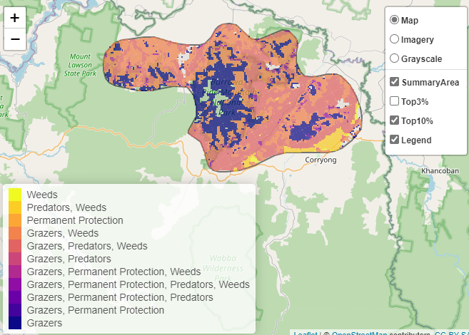
Some areas of this focus landscape (coloured areas on the map) have highly cost-effective actions which provide significant benefit for biodiversity conservation.
The SMP priority action which ranks among the top 3% for cost-effectiveness of that action across the state for much of the area (>1,000ha) is to Control pigs.

Control rabbits 39,817ha
Control weeds 48,691ha

Of the top 10% of cost-effective actions, controlling weeds and rabbits provide the most cost-effective biodiversity benefits when considering all flora and fauna values.

The most cost-effective actions for flora and fauna
Plants, Birds - Control weeds
Reptiles, Mammals - Control pigs
Amphibians - Control rabbits

For a further in depth look into SMP for this landscape, please refer to NatureKit.

