Introduction
Biodiversity Response Planning (BRP) is a long-term area-based planning approach to biodiversity conservation in Victoria. It is designed to strengthen alignment, engagement and participation between government, Traditional Owners, non-government agencies and the community.
DELWP Regional staff have been working with stakeholders on actions to conserve biodiversity in specific landscapes, informed by the best available science and local knowledge.
These Fact Sheets capture a point in time, reflecting data and knowledge available in 2020. They provide information for many (but not all) landscapes across Victoria, containing general information on the key values and threats in each area, as well as the priority cost-effective actions that provide the best protection of biodiversity. Fact Sheets are intended to provide useful biodiversity information for the community, non-government and government organisations during project planning and development.
Further information and the full list of Fact Sheets is available on the Department’s Environment website.

Landscape description
The Upper Loddon landscape covers 32,454ha with a significant amount of native vegetation cover of 72%. Public land makes up 49% of the landscape and includes Upper Loddon State Forest (SF), Fryers Range SF and Castlemaine Diggings National Heritage Park. Refer to the map at the end of this Fact Sheet.
This landscape has an overlap with the Dja Dja Wurrung Clans Aboriginal Corporation RSA landscape. For more information, please refer to this Fact Sheet in the full list of Fact Sheets.

Cultural importance
We recognise that the entire landscape has high cultural value for Traditional Owners. Landscapes identified as having “notable” cultural importance is based on the density of recorded cultural heritage sites and knowledge shared by Traditional Owners. We also recognise that there are locations important to Traditional Owners not within these landscapes.

Stakeholder interest
As part of the BRP process, in October 2020 stakeholders were asked to nominate focus landscapes and actions of interest. Mount Alexander Shire Council, Connecting Country, Hepburn Shire Council, DELWP (Public Land), Coliban Water, Parks Victoria, and Dja Dja Wurrung all nominated Upper Loddon.
Possible future investment/project development in this landscape will be available to any interested stakeholders in addition to those who nominated this landscape.

0BEcological values identified by Traditional Owners, partners and community within this landscape
Revegetation of Djandak with:
- Buwatji (grasses used for grain)
- Witji (weaving grasses)
- Gatjawil Matorm (tuberous plants with scented flowers)
- Murnang (Yam Daisies) including Kangaroo grass, Lomandra and Dianella species, Chocolate Lily, Vanilla Lily, Bulbine Lily and Yam Daisy
Woodland bird community
Wi (cultural fire) authorised and led by Dja Dja Wurrung on Djandak (Country); Castlemaine – Kalimna Park Dja Dja Wurrung

 | Habitat Distribution Models identify 8 species with more than 5% of their Victorian range in this landscape area | Traditional Owners, stakeholders and community groups identified the following species of interest within this landscape
 | 8 Plants, including:  - Fryerstown Grevillea (Grevillea obtecta), rare with 43% of its Victorian range in area  - Fryers Range Scentbark (Eucalyptus conferta), endangered with 35% of its Victorian range in area  - Midlands Spider-orchid (Caladenia sp. aff. concolor (Midlands), vulnerable with 22% of its Victorian range in area | - Matted Flax-lily  - Wimmera Scentbark  - Rosemary Grevillea
 | Mammals | - Gal Gal (Dingo) at Gal Gal Gundith – approximately in south east of Recognition and Settlement Agreement (RSA) area, which is more heavily populated  - Brush-tailed Phascogale  - Eastern-barred Bandicoot  - Fat-tailed Dunnart  - Greater Glider
 | Reptiles | - Tree Goanna  - Striped Legless Lizard
 | Birds | - Australasian Bittern  - Brolga  - Bush Stone-curlew  - Swift Parrot  - Powerful Owl
 | Amphibians | - Growling Grass Frog  - Bibron’s Toadlet
Other | Eltham Copper Butterfly

Traditional Owners, stakeholders and community groups identified the following threats within this landscape
Exclusion of Dja Dja Wurrung leadership (governance)
Lack of enquiry and understanding of Dja Dja Wurrung customs and practice that provide an enabling and supportive environment so that Djaara can reconnect to land and reconnect stories and knowledge to place. Ask “How?” not “Why?”
Weeds including Bridal Creeper, Soursob spread via road and track grading
Overabundant Kangaroos
Change of land use, parcelling up of land for residential estates in areas adjacent to the bushland
Degradation and clearance of existing vegetation from human use associated with residential development
Mining operations – mining exploration rights
Prescribed burning
Lack of listening, hearing and respect for Dja Dja Wurrung ability to talk to Country – bias toward western science-based decision support tools and not Dja Dja Wurrung knowledge-based tools
Utilising past learnings and achievement to guide future effort – Dja Dja Wurrung participation in past and future biodiversity planning and delivery below the International Association of Public Participation (IAP2) level of ‘involve’ does not support Dja Dja Wurrung aspirations
Pest animals including rabbits, deer, foxes, hares, cats
Clearance of native vegetation for farming activities
Firewood collection
Uncontrolled livestock access to areas of intact native vegetation, waterways and riparian areas
Climate change

Strategic Management Prospects
Strategic Management Prospects (SMP) models biodiversity values such as species habitat distribution, landscape-scale threats and highlights the most cost-effective actions for specific locations. More information about SMP is available in NatureKit.

Additional threats
Threats identified (in addition to those modelled in SMP) through the consultation process were:
- alterations to hydrology
- land salinisation
- soil erosion
- habitat degradation due to extremes of climate and weather, and lack of regeneration in some vegetation classes
- recreational activities causing fragmentation
- loss of vegetation, and erosion
- legacy use of public land
- private land use impacting biodiversity
- inappropriate land use planning
- inappropriate fire regimes (planned burning and bushfires)
Some individual threatened species may also require targeted intervention, beyond actions to manage landscape-scale threats, to improve their future prospects.

Which landscape-scale actions are most cost-effective in this landscape?
The coloured areas indicate where the identified landscape-scale actions and locations are most cost-effective and will maximise biodiversity benefit across Victoria for multiple species.
 | Control goats 20,296ha
 | Control pigs 17,081ha
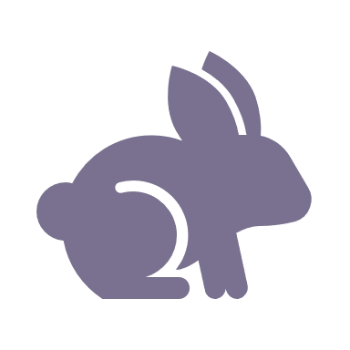 | Control rabbits 8,672ha
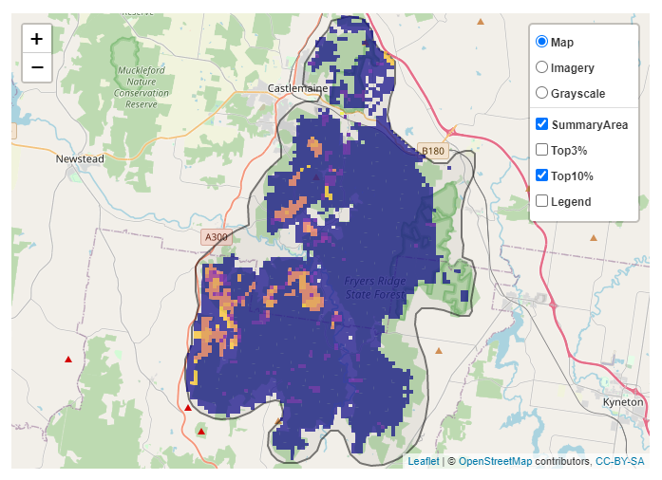
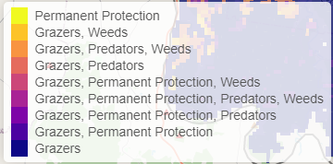
The SMP priority actions which rank among the top 10% for cost-effectiveness of that action across Victoria for much of the landscape are in order of the top 3 actions, see map and list below:

Of the top 10% of cost-effective actions, controlling goats provides the most cost-effective biodiversity benefits when considering all flora and fauna.

From the nomination process the following additional actions were also suggested for this landscape:
- revegetation
- weed control
- fox control
- permanent protection
- control overabundant kangaroos
- cultural/ecological burning

The most cost-effective action for flora and fauna
Plants, birds, mammals, amphibians - Control goats
Reptiles - Control pigs

For a further in depth look into SMP for this landscape please refer to NatureKit.
.
