Introduction
Biodiversity Response Planning (BRP) is a long-term area-based planning approach to biodiversity conservation in Victoria. It is designed to strengthen alignment, engagement and participation between government, Traditional Owners, non-government agencies and the community.
DELWP Regional staff have been working with stakeholders on actions to conserve biodiversity in specific landscapes, informed by the best available science and local knowledge.
These Fact Sheets capture a point in time, reflecting data and knowledge available in 2020. They provide information for many (but not all) landscapes across Victoria, containing general information on the key values and threats in each area, as well as the priority cost-effective actions that provide the best protection of biodiversity. Fact Sheets are intended to provide useful biodiversity information for the community, non-government and government organisations during project planning and development.
Further information and the full list of Fact Sheets is available on the Department’s Environment website.

Landscape description
This 19,200ha area is a mostly cleared landscape (23% native vegetation cover) and is mostly private land (96%). The landscape is bordered by the Meereek State Forest, Kanawinka State Forest and the South Australian border.

Habitat Distribution Models identify 0 species with more than 5% of their Victorian range in this landscape

Strategic Management Prospects
Strategic Management Prospects (SMP) models biodiversity values such as species habitat distribution, landscape-scale threats and highlights the most cost-effective actions for specific locations. More information about SMP is available in NatureKit.

Which landscape-scale actions are most cost-effective in this landscape?
Some areas of this focus landscape (coloured areas on the map) have highly cost-effective actions which provide significant benefit for biodiversity conservation.
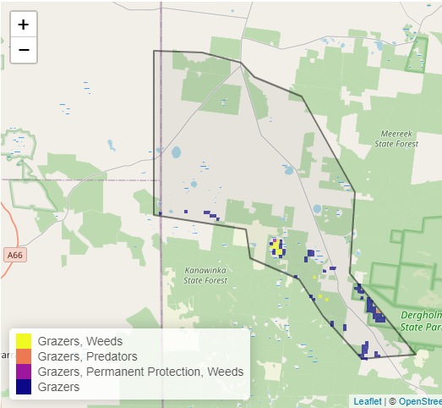
The SMP priority actions which rank among the top 10% for cost-effectiveness of that action across the state are in order:
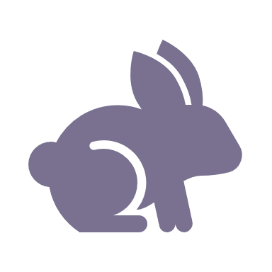 | Control rabbits 386ha
 | Control overabundant kangaroos 260ha
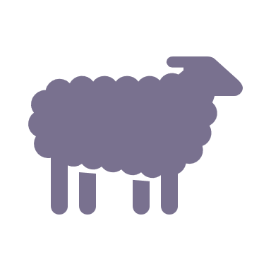 | Control domestic stock grazing 80ha
 | Control weeds 51ha

The most cost-effective actions for flora & fauna
Plants - Control rabbits, kangaroos, control domestic stock grazing
Birds - Control rabbits, kangaroos, control domestic stock grazing, control weeds
Mammals, Reptiles - Control kangaroos, control rabbits
Amphibians - Control kangaroos, control rabbits

For a further in depth look into SMP for this landscape please refer to NatureKit.

