Introduction
Biodiversity Response Planning (BRP) is a long-term area-based planning approach to biodiversity conservation in Victoria. It is designed to strengthen alignment, engagement and participation between government, Traditional Owners, non-government agencies and the community.
DELWP Regional staff have been working with stakeholders on actions to conserve biodiversity in specific landscapes, informed by the best available science and local knowledge.
These Fact Sheets capture a point in time, reflecting data and knowledge available in 2020. They provide information for many (but not all) landscapes across Victoria, containing general information on the key values and threats in each area, as well as the priority cost-effective actions that provide the best protection of biodiversity. Fact Sheets are intended to provide useful biodiversity information for the community, non-government and government organisations during project planning and development.
Further information and the full list of Fact Sheets is available on the Department’s Environment website.

Landscape description
This 411,451ha area is a mostly cleared landscape (16% native vegetation cover) and is mostly private land (98%). The landscape is bordered by the Little Desert in the south and the Big Desert and Wyperfeld National Parks in the north.

Habitat Distribution Models identify 265 species with more than 5% of their Victorian range in this landscape
254 Plants
- Of these, 18 species have more than 20% of Victorian range in area.
- Notably Jumping-jack Wattle (56% of Victorian range is within landscape, EPBC*-listed Vulnerable) and Broad-leaf Mallee-box (57% of Victorian range is within landscape, endangered)
1 Mammal
- Silky Mouse (5% of Victorian range within this landscape, EPBC*-listed Near Threatened)
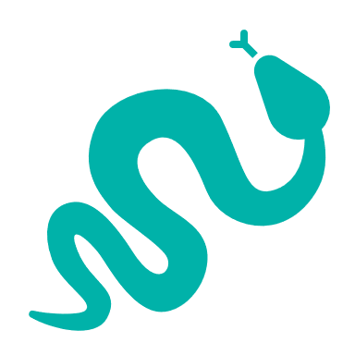
7 Reptiles
- Notably Rosenberg’s Goanna (12% of Victorian range within this landscape, EPBC*-listed Endangered) and Port Lincoln Snake (9% of Victorian range within this landscape, EPBC*-listed Endangered)
3 Birds
- Notably Australian Bustard (15% of Victorian range within this landscape, EPBC*-listed Critically Endangered) and Slender-billed Thornbill (9% of Victorian range within this landscape, EPBC*-listed Near Threatened)
*Environment Protection and Biodiversity Conservation Act 1999 (Federal)

Strategic Management Prospects
Strategic Management Prospects (SMP) models biodiversity values such as species habitat distribution, landscape-scale threats and highlights the most cost-effective actions for specific locations. More information about SMP is available in NatureKit.

Which landscape-scale actions are most cost-effective in this landscape?
Some areas of this focus landscape (coloured areas on the map) have highly cost-effective actions which provide significant benefit for biodiversity conservation.
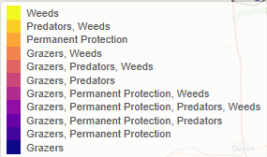
The SMP priority actions which rank among the top 10% for cost-effectiveness of that action across the state are in order:
Control rabbits 44,811ha
Control overabundant kangaroos 42,038ha
Control goats 29,374ha
Control weeds 14,811ha
Revegetation 1,256ha
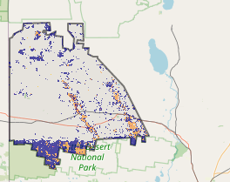

Of the top 3% of actions, kangaroo control, rabbit control and weed control rank highest.

The most cost-effective actions for flora & fauna
Plants - Control rabbits, control kangaroos, control weeds
Birds - Control foxes, control kangaroos, control rabbits, control weeds
Mammals, Reptiles - Control rabbits, control goats, control kangaroos
Amphibians - Control kangaroos
For a further in depth look into SMP for this landscape, please refer to NatureKit.

