Introduction
Biodiversity Response Planning (BRP) is a long-term area-based planning approach to biodiversity conservation in Victoria. It is designed to strengthen alignment, engagement and participation between government, Traditional Owners, non-government agencies and the community.
DELWP Regional staff have been working with stakeholders on actions to conserve biodiversity in specific landscapes, informed by the best available science and local knowledge.
These Fact Sheets capture a point in time, reflecting data and knowledge available in 2020. They provide information for many (but not all) landscapes across Victoria, containing general information on the key values and threats in each area, as well as the priority cost-effective actions that provide the best protection of biodiversity. Fact Sheets are intended to provide useful biodiversity information for the community, non-government and government organisations during project planning and development.
Further information and the full list of Fact Sheets is available on the Department’s Environment website.

Landscape description
This 37,000ha area has a moderate amount of native vegetation (30% cover) and a moderate amount of public land (31%). It includes the general area around the Cardross Koorlong State Forest, Wargan Basins and reserves such as Yatpool Bushland Reserve. It does not overlap with any other landscape.

Cultural importance
We recognise that the entire landscape has high cultural value for Traditional Owners. Landscapes identified as having “notable” cultural importance is based on the density of recorded cultural heritage sites and knowledge shared by Traditional Owners. We also recognise that there are locations important to Traditional Owners not within these landscapes.
Cultural importance for the First People of the Millewa Mallee Aboriginal Corporation.

Stakeholder interest
As part of the Biodiversity Response Planning process, in October 2020 stakeholders were asked to nominate focus landscapes and actions of interest. First People of the Millewa Mallee, Lower Murray Water and Mildura Rural City Council nominated Cardross - Koorlong.
Possible future investment/project development in this landscape will be available to any interested stakeholders in addition to those who nominated this landscape.
Specific stakeholder interests identified through the engagement process within this landscape include:
- Mallee Catchment Management Authority, Regional Catchment Strategy priority landscape – 3. Cardross Lakes / Koorlong SF; Climate Change priority corridor 2: East Millewa
- Department of Environment, Land, Water and Planning, large area of public land – Cardross Koorlong State Forest
- Mildura Rural City Council, opportunity for Semi Arid Woodland regeneration and increased fauna species population relating to this Ecological Vegetation Class

Community interest
There is high community interest in biodiversity conservation in this area due to the proximity to Mildura.

 | Habitat Distribution Models identify 14 species more than 5% of their Victorian range in this landscape area | Traditional Owners, stakeholders and community groups identified the following species of interest
 | 13 Plants with more than 5% of Victorian range in area. Notably:  - Limestone Sida (vulnerable, 15% of Victorian range in area)  - Dwarf Lantern Flower (endangered, 12% of Victorian range in area) | - Semi-arid Woodlands
 |  | - Red Kangaroo
1 Reptile with more than 5% of Victorian range in area. Notably:
- Dwarf Burrowing Skink (endangered 6% of Victorian range in area)

Strategic Management Prospects
Strategic Management Prospects (SMP) models biodiversity values such as species habitat distribution, landscape-scale threats and highlights the most cost-effective actions for specific locations. More information about SMP is available in NatureKit.

Additional threats
Threats identified (in addition to those modelled in SMP) through the consultation process were:
- alterations to hydrology
- land salinisation
- soil erosion
- habitat degradation due to extremes of climate and weather
- lack of regeneration in some vegetation communities
- recreational activities causing fragmentation
- loss of vegetation, and erosion
- legacy use of public land
- private land use impacting biodiversity
- inappropriate land use planning
- inappropriate fire regimes (planned burning and bushfires)

Which landscape-scale actions are most cost-effective in this landscape?
Some areas of this landscape (coloured areas on the map) have highly cost-effective actions which provide significant benefit for biodiversity conservation.
Control goats 7,513ha
Control rabbits 1,635ha
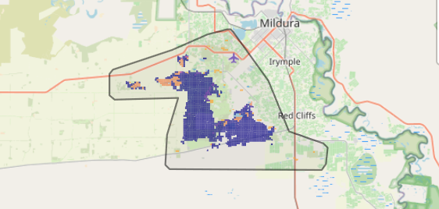
The SMP priority actions which rank among the top 3% for cost-effectiveness of that action across Victoria cover more than 1,000ha of the area in order:
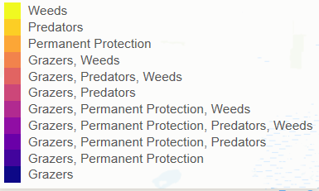

Of the top 10% of cost-effective actions, control rabbits provides the most cost-effective biodiversity benefits when considering all flora and fauna.

Actions suggested for this landscape through the nomination process are:
- control weeds, foxes, rabbits and cats
- revegetation
- prevent rubbish dumping

The most cost-effective actions for flora and fauna
Plants - Control rabbits
Mammals, reptiles - Combined cat and fox control
Birds - Combined cat and fox control, control goats, control rabbits

For a further in depth look into SMP for this landscape please refer to NatureKit.

