Background / preamble
The Lake Tyers Corringle landscape was recognised during the 2019/20 Gippsland Biodiversity Response Planning (BRP) process as a focus area for future collaborative biodiversity action and investment.
Under the Victorian Government’s Biodiversity 2037: Protecting Victoria’s Biodiversity plan, the BRP process is a long-term area-based planning approach to biodiversity conservation in Victoria. It is designed to strengthen alignment, engagement and participation between government, Traditional Owners, non-government agencies and the community to benefit biodiversity by working together to identify, promote and tackle local biodiversity needs as part of an ongoing collective process.
In 2019/20, significant impacts from the bushfires in East Gippsland and coronavirus (COVID-19) on community, biodiversity stakeholders and agencies, and the environment, resulted in planned engagement with many local stakeholders in Gippsland about BRP being postponed to a future process. In the interim, a multi-agency working group of local staff in Gippsland came together to identify a series of potential strategic priority actions across the region, as well as 13 focus landscapes. Membership of this working group for Gippsland included staff from the Department of Environment, Land, Water and Planning (DELWP) coasts & marine policy and local forest, fire and biodiversity teams, East Gippsland and West Gippsland Catchment Management Authorities (EGCMA & WGCMA), Parks Victoria, Trust for Nature (TfN), the Bunurong Land Council Aboriginal Corporation (BLCAC) and the Gunaikurnai Land and Waters Aboriginal Corporation (GLaWAC).
As part of this process, the Gippsland BRP working group drew upon information available from the DELWP Strategic Management Prospects (SMP) tool as well as their own local knowledge to identify key biodiversity assets, threats and potential management actions across Gippsland. A subset of this information is presented in this Fact Sheet, reflecting a point in time assessment of some of the important biodiversity needs and landscapes for focus across the region.
These BRP Fact Sheets provide useful biodiversity information for the community, non-government and government organisations during project planning and development, including guidance for stakeholders interested to contribute towards some of the strategic priorities identified in these areas to date. Further information and the full list of Fact Sheets is available on the Department’s Environment website.

Landscape description
Landscape context: 131,955ha, 68% public land, 67% native vegetation cover
The Lake Tyers Corringle landscape generally includes the coastal lowlands bounded by the western edge of Colquhuon State Forest, the edge of the coastal plain to Cabbage Tree Creek and the coast. This area features undulating foothill and coastal landforms and includes the Snowy River Flats, lower sections of Boggy Creek, Hospital Creek and the Snowy and Brodribb Rivers, Lake Tyers State Park, Ewings Morass, Nowa Nowa, Tostaree, Orbost and Marlo. Livestock grazing occurs predominantly around Newmerella, Simpsons Creek and Marlo Plains, with intensive agriculture supported on the Snowy River Flats and around Wairewa (Hospital Creek flats).
The predominant vegetation types here include foothill and coastal communities with extensive tracts of Lowland Forest, Banksia Woodland, Limestone Box and Damp Forest in gullies and on sheltered slopes, and patches of rainforest and riparian forest along rivers and gullies.

Biodiversity highlights and important places:
Coastal forests, shrublands, dunes and ocean beach are continuous with the neighbouring Gippsland Lakes and Far East Coast landscapes. This landscape is home to approximately 30% of all mapped stands of Littoral Rainforest in Victoria and some areas of coastal heathland. Ewings Morass between Lake Tyers and the lower Snowy River estuary at Marlo is an intact ephemeral coastal lagoon and wetland system, and the estuarine inlets at Lake Tyers and Marlo and large estuarine lake system at the bottom of the Snowy River provide a system of interconnected wetlands.
Important vegetation communities in this landscape include:
*FFG listed | Warm Temperate Rainforest - East Gippsland Alluvial Terraces
**EPBC listed | Littoral Rainforest and Coastal Vine Thicket  Subtropical and Temperate Coastal Saltmarsh
*Flora and Fauna Guarantee Act 1988 (Victorian)
**Environment Protection and Biodiversity Conservation Act 1999 (Federal)

Cultural importance
We would like to acknowledge the Traditional Owners and custodians of the land across this landscape, including the Gunaikurnai, particularly the Krowathunkooloong people. We pay our respects to Country, and to Elders past and present whose knowledge and wisdom has ensured the continuation of culture and traditional practices. We are committed to genuinely partner, and meaningfully engage, with Victoria’s Traditional Owners and Aboriginal communities to support the protection of Country, the maintenance of spiritual and cultural practices and their broader aspirations into the 21st century and beyond in the spirit of self-determination. The Gippsland BRP project team are seeking interest from traditional owners in this area to contribute towards biodiversity planning and conservation processes, including Biodiversity Response Planning.
The Gunaikurnai Land and Waters Aboriginal Corporation (GLaWAC) are the appointed Registered Aboriginal Party (RAP) for the area west of Marlo and Orbost and hold a Native Title Determination and Traditional Owner Recognition Settlement Agreement over this area, including Joint Management of Lake Tyers State Park. GLaWAC are an ongoing member of the local Gippsland BRP working group.

Stakeholder and community interest
Local engagement for BRP in Gippsland in 2019/20 was postponed due to impacts from fire and coronavirus (COVID-19). If you would like to contribute local knowledge about this landscape in the future, find out more about BRP or add your name to the state-wide or Gippsland BRP stakeholder lists, you can find further information on the Department’s Environment website.

Species summary
An analysis of available Habitat Distribution Models* identify 157 species with more than 5% of their Victorian range falling within the Lake Tyers Corringle BRP landscape, including 40 threatened species and 10 EPBC listed species.
*Note: While version 2.0 of the SMP model utilises HDMs for ~3,200 terrestrial species in its analysis, these models currently exclude aquatic, invertebrate, marine and non-vascular plant species. These HDMs and SMP will continue to be improved upon with ongoing input from species experts and natural resource management practitioners.
Species class | Species with a high proportion of their Victorian distribution in this landscape | Other notable species identified during the BRP process
129 plants, incl. 27 threatened species (5 EPBC) | 11 species with greater than 35% of their Victorian range within this landscape, notably:  - Maiden’s Wattle Acacia maidenii (FFG listed, endangered, 95% of Victorian range)  - Dainty Bitter-cress Cardamine tryssa (FFG listed, endangered, 94% of Victorian range)  - Buff Hazelwood Symplocos thwaitesii (FFG listed, endangered, 64% of Victorian range)  - Viscid Daisy-bush Oleria viscosa (FFG listed, vulnerable, 64% of Victorian range)  - Heath Spider-orchid Caladenia peisleyi (FFG listed, vulnerable, 62% of Victorian range)  - Colquhoun Grevillea Grevillea celata (EPBC listed, Vulnerable, 48% of Victorian range)  - Limestone Pomaderris Pomaderris oraria subsp. calcicole (47% of Victorian range)  - Cabbage Fan-palm Livistona australis (FFG listed, vulnerable, 38% of Victorian range)  - Gippsland Stringybark Eucalyptus mackintii (36% of Victorian range) | - Boggy Creek Bottlebrush Callistemon nyallingensis (FFG listed, vulnerable, restricted to Boggy Creek gorge)  - Thick-lip Spider-orchid Caladenia tessallata (EPBC listed, Vulnerable, 29% of Victorian range)  - Limestone Blue Wattle Acacia caerulescens (EPBC listed, Vulnerable, 14% of Victorian range, restricted to Gippsland predominantly around Upper Tambo and Lake Tyers)  - Bonnet orchid Cryptostylis erecta (FFG listed, endangered, 11% of Victorian range)
4 mammals, incl. 4 threatened species (3 EPBC) | Including:  - Grey-headed Flying-fox (EPBC listed, Vulnerable, 10% of Victorian range)  - Long-nosed Potoroo (EPBC listed, Vulnerable, 8% of Victorian range)  - Southern Brown Bandicoot (EPBC listed, Endangered, 7% of Victorian range)  - Eastern Horseshoe Bat (FFG listed, vulnerable, 6% of Victorian range) | - None raised
2 reptiles, incl. 0 threatened species (0 EPBC) | Including:  - Swamp Skink (FFG listed, vulnerable, 7% of Victorian range)  - Gippsland Water Dragon (5% of Victorian range) | - Lace Monitor (FFG listed, endangered, 2% of Victorian range)
14 birds, incl. 4 threatened species (0 EPBC) | Notable species include:  - Glossy Black-Cockatoo (FFG listed, vulnerable, 28% of Victorian range)  - Masked Owl (FFG listed, endangered, 12% of Victorian range)  - Ground Parrot (FFG listed, endangered, 6% of Victorian range)  - Sooty Owl (FFG listed, vulnerable, 5% of Victorian range) | - Powerful Owl (FFG listed, vulnerable, 4% of Victorian range)  - Little Tern (FFG listed, vulnerable, 3% of Victorian range)  - Fairy Tern (FFG listed, vulnerable)
8 frogs, incl. 4 threatened species (2 EPBC) | Notable species include:  - Green and Golden Bell Frog (EPBC listed, Vulnerable, 22% of Victorian range)  - Martin’s Toadlet (FFG listed, critically endangered, 16% of Victorian range)  - Giant Burrowing Frog (EPBC listed, Vulnerable, 8% of Victorian range)  - Southern Toadlet (FFG listed, vulnerable, 6% of Victorian range) | - None raised
Other species raised by the working group (e.g. fish, invertebrates etc):
None raised

Strategic Management Prospects
Strategic Management Prospects (SMP) models species distributions, habitat importance, landscape-scale threats, and management costs. It then compares and highlights those places with the greatest opportunities for cost-effective action state-wide. Learn more about this tool on the SMP webpage.

Which landscape-scale actions are most cost-effective in this landscape?
The maps and information below show those places and actions modelled by SMP to provide the best opportunities for cost-effective action to benefit biodiversity across the state. Coloured areas in the maps below indicate opportunities for highly cost-effective actions that provide significant benefits to biodiversity in those places. If undertaken across Victoria, these collective actions should provide the greatest potential benefit to biodiversity by focusing on undertaking landscape-scale actions in places where they will provide the greatest benefit for cost across all species.
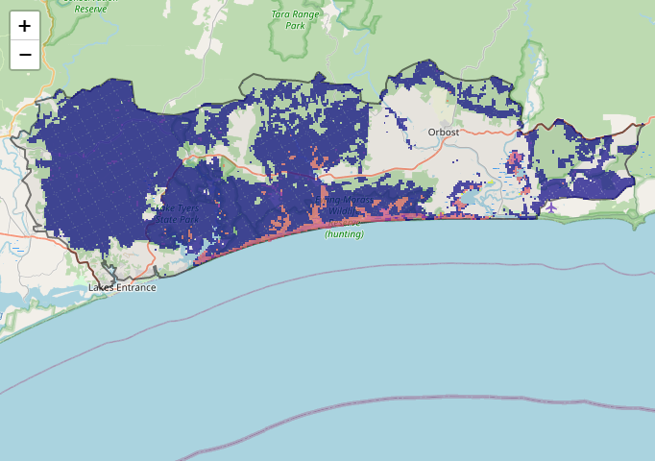
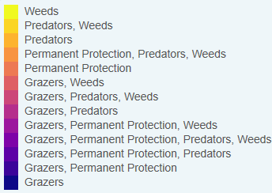
Map a) shows actions in the top 3% cost-effectiveness areas, and Map b) shows actions in the top 10% cost-effective areas.
The following landscape-scale actions were ranked among the top 3% cost-effective opportunities for biodiversity action across the state by SMP:
Map a) – SMP top 3% cost-effective actions

Control pigs 43,219ha
Control deer 34,886ha
Control overabundant kangaroos* 16,023ha
Control rabbits 4,475ha

*The Gippsland BRP working group advised overabundant kangaroos are generally not a critical issue in east Gippsland.

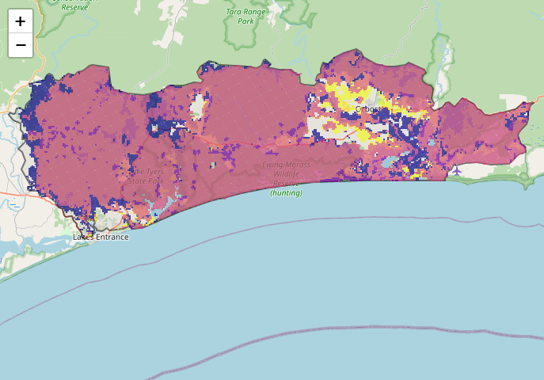
The following landscape-scale actions were ranked among the top 10% cost-effective opportunities for biodiversity action across the state by SMP:
Map b) – SMP top 10% cost-effective actions

Control weeds 101,640ha
Control deer 98,197ha
Combined cat and fox control 88,224ha
Control cats 81,228ha
Control foxes 80,995ha

The most cost-effective actions for flora & fauna according to SMP
 | Plants – Control deer, Control weeds and Combined fox and cat control |  | Birds – Combined fox and cat control
 | Mammals – Combined fox and cat control |  | Amphibians – Combined fox and cat control (particularly cats) and Control deer
 | Reptiles – Combined fox and cat control (particularly cats)
For a further in depth look into SMP for this landscape please refer to NatureKit.

Additional threats raised by the working group
- None raised

Highest priority strategic actions
With consideration of the information available in SMP and local knowledge of this landscape, the Gippsland BRP working group identified the following priority actions for future collaboration and investment in this landscape:
The highest priority actions for the Lake Tyers Corringle landscape include:
- Controlling deer (including in littoral rainforest)
- Controlling transformer weeds (including in littoral rainforest)
- Integrated predator control (including the continuation and expansion of the Southern Ark fox-baiting program plus cat control around key biodiversity assets)
Other key actions highlighted by the working group include:
- Permanent protection and revegetation along riparian corridors

