Introduction
Biodiversity Response Planning (BRP) is a long-term area-based planning approach to biodiversity conservation in Victoria. It is designed to strengthen alignment, engagement and participation between government, Traditional Owners, non-government agencies and the community.
DELWP Regional staff have been working with stakeholders on actions to conserve biodiversity in specific landscapes, informed by the best available science and local knowledge.
These Fact Sheets capture a point in time, reflecting data and knowledge available in 2020. They provide information for many (but not all) landscapes across Victoria, containing general information on the key values and threats in each area, as well as the priority cost-effective actions that provide the best protection of biodiversity. Fact Sheets are intended to provide useful biodiversity information for the community, non-government and government organisations during project planning and development.
Further information and the full list of Fact Sheets is available on the Department’s Environment website.

Landscape description
This 158,351ha, mostly forested area, extends to the north east along the boundary of the Shire of Yarra Ranges, down through Powelltown to the western side of Bunyip State Park. It incorporates the subalpine environment around Mt Donna Buang and includes the Yarra Ranges National Park and Upper Yarra Reservoir. The landscape has 80% native vegetation, and 98% public land.
This landscape has a partial overlap with the Mountain Ash Forest – Marysville landscape. For more information please refer to the Mountain Ash Forest – Marysville Fact Sheet in the full list of Fact Sheets.

Cultural importance
We recognise that the entire landscape has high cultural value for Traditional Owners. Some landscapes have notable cultural importance based on knowledge shared by Traditional Owners.
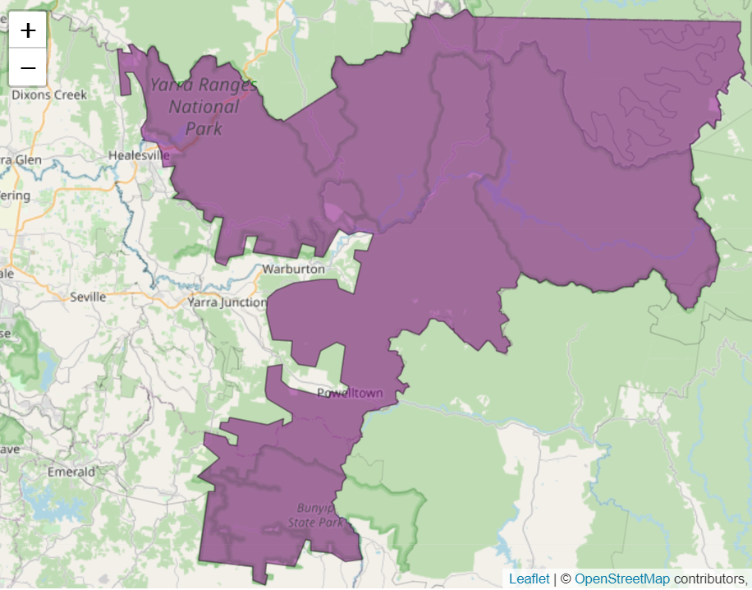
This landscape includes lands of the Taungurung people, the Wurundjeri people, the Bunurong people and an area where the Traditional Owners have not been formally recognised.
Figure 1: Map showing location of Eastern Yarra Ranges (purple).

Habitat Distribution Models identify 107 species with more than 5% of their Victorian range in this landscape
- 92 Plant species
- 40 species with more than 10% of statewide range in area
- Notable species: Shiny Nematolepis (vulnerable, 93% statewide range in area), Upper Yarra Swamp-gum (endangered, 58% statewide range in area), Long Pink-bells (rare, 57% statewide range in area), Christmas Spider-orchid (rare, 50% statewide range in area)
- 4 Mammal species
- 2 species with more than 10% of statewide range in area
- Notable species: Leadbeater’s Possum (endangered, 36% statewide range in area), Smoky Mouse (endangered, 10% statewide range in area)
- 2 Reptile species
- 0 species with more than 10% of statewide range in area
- Notable species: Metallic Skink (9.4% statewide range in area), Coventry’s Skink (5.4% statewide range in area)
- 9 Bird species
- 0 species with more than 10% of statewide range in area
- Notable species: Large-billed Scrubwren (10% statewide range in area), Helmeted Honeyeater (critically endangered, 9.8% statewide range in area), Sooty Owl (vulnerable, 9.3% statewide range in area), Pilotbird (9.2% statewide range in area)
- 0 species of amphibians with more than 5% of their Victorian range in this landscape
- Notable species: Victorian Smooth Froglet (3.9% statewide range in area)

Strategic Management Prospects
Strategic Management Prospects (SMP) models biodiversity values such as species habitat distribution, landscape-scale threats and highlights the most cost-effective actions for specific locations. More information about SMP is available in NatureKit.
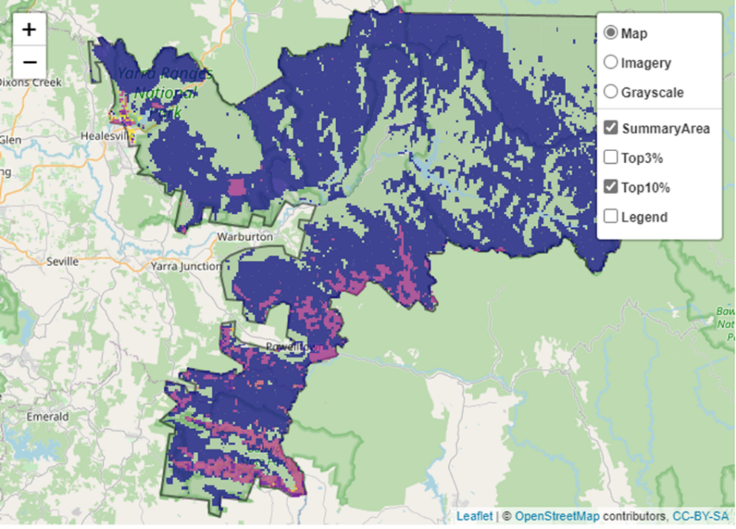
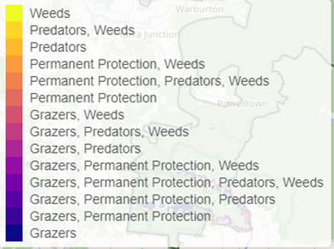
Areas of Eastern Yarra Ranges shown in Figure 2 have highly cost-effective actions (within the top 10% of cost-effectiveness for that action across the state) that provide significant benefit for biodiversity conservation.
Figure 2: The SMP priority actions which rank among the top 10% for cost-effectiveness of that action across the state. “Grazers” includes deer, domestic grazing, goats, horses, over-abundant kangaroos, pigs, rabbits and total grazing pressure

Actions with area in the top 3% and top 10%
Specific Action | Area in top 3% (ha) | Area in top 10% (ha)
Control Deer | 1,996 | 89,624
Control Goats | 7,394 | 14,715
Control Foxes | 1,087 | 5,786
Control Cats | 1,109 | 5,702
Domestic Grazing Control | 603 | 4,532
Overabundant Kangaroo Control | 1,481 | 4,375
Total Grazing Pressure | 281 | 3,434
Control Weeds | 484 | 2,574
Permanent Protection | 275 | 1,403
Control Pigs | 241 | 357
Control Rabbits | 15 | 170
Revegetation | 0 | 69

The most cost-effective action for flora & fauna
Plants, Birds, Mammals, Amphibians and Reptiles - Control deer

For a further in depth look into SMP for this landscape, please refer to NatureKit.

Current actions in the Eastern Yarra Ranges
Specific Actions | Current actions – top 10% (ha) | Current actions – outside top 10% (ha)
Weed Control | 16 | 2,098
Deer Control | 32 | 33
Fox Control | 15 | 93
Pig Control | 0 | 45
Rabbit Control | 0 | 45
Domestic Grazing Control | 9 | 35
Permanent Protection | 5 | 4

Current actions – top 10% = The area (ha) of the specific action currently occurring in locations identified by SMP as being in the top 10% for cost-effectiveness for that action across the state
Current actions – outside top 10% = The area (ha) of the specific action currently occurring in locations within this landscape that are not identified by SMP as being in the top 10% for cost-effectiveness for that action across the state

What you told us
SMP is just one tool to use in the process of understanding biodiversity values. Feedback from our stakeholders is also vitally important and forms the basis of our understanding of knowledge gaps.
Eastern Yarra Ranges was identified by stakeholders as a focus landscape in the ‘large’ category in Port Phillip region.

Stakeholder interest

Important landscapes
- The Yarra River
- Yarra Ranges National Park
- Bunyip State Park
- Melbourne Water priority waterways for biodiversity

Additional important communities
- Cool temperate rainforest Ecological Vegetation Classes

Current activities/programs/partnerships
- Central Highlands Eden Program
- Cardinia Shire Council – works on Bushland reserves
- Forest Management Planning – Special Protection Zones
- Eastern Region Pest Animal Strategy
- Port Phillip and Westernport CMA
- Trust for Nature land covenanting program

Additional threats
Threats identified through the consultation process (in addition to those modelled in SMP):
- Fire regimes and management – too frequent/infrequent, wrong season, severity

