Introduction
Biodiversity Response Planning (BRP) is a long-term area-based planning approach to biodiversity conservation in Victoria. It is designed to strengthen alignment, engagement and participation between government, Traditional Owners, non-government agencies and the community.
DELWP Regional staff have been working with stakeholders on actions to conserve biodiversity in specific landscapes, informed by the best available science and local knowledge.
These Fact Sheets capture a point in time, reflecting data and knowledge available in 2020. They provide information for many (but not all) landscapes across Victoria, containing general information on the key values and threats in each area, as well as the priority cost-effective actions that provide the best protection of biodiversity. Fact Sheets are intended to provide useful biodiversity information for the community, non-government and government organisations during project planning and development.
Further information and the full list of Fact Sheets is available on the Department’s Environment website.

Landscape description
This 84,607ha area stretches from the northern coastline of Western Port Bay to the Princes Freeway. It includes some of the south eastern suburbs in the growth area around Clyde and part of the Royal Botanic Gardens Cranbourne. There is some overlap with the Westernport Ramsar landscape around the coastline. The landscape has 11% native vegetation, and 4% public land.
This landscape has a minor overlap with the Westernport Bay Ramsar landscape along the coast. For more information, please refer to the Westernport Bay Ramsar Fact Sheet in the full list of Fact Sheets.

Cultural importance
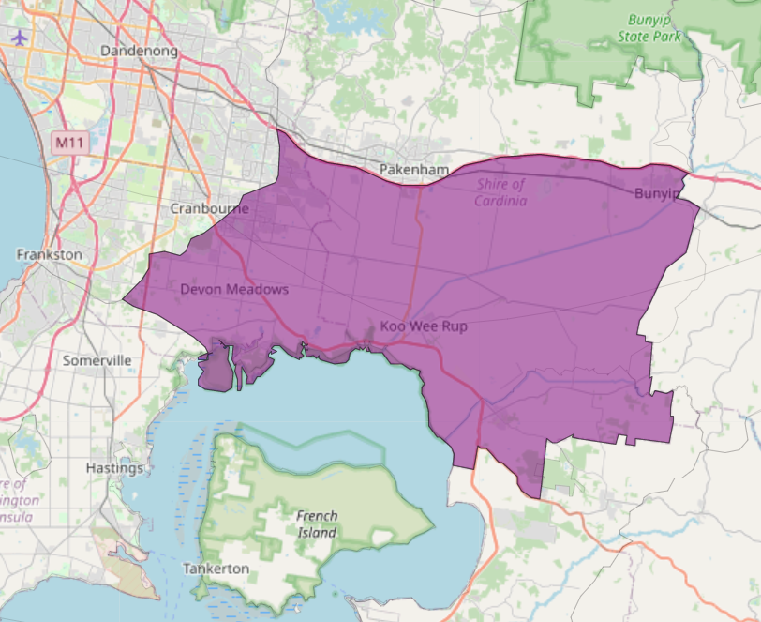
We recognise that the entire landscape has high cultural value for Traditional Owners. Some landscapes have notable cultural importance based on knowledge shared by Traditional Owners.

This landscape includes traditional country of the Bunurong people.
Figure 1: Map showing location of Westernport Flats landscape (purple).
Habitat Distribution Models identify 9 species with more than 5% of their Victorian range in this landscape | Traditional Owners, stakeholders and community groups identified the following species of interest
- 8 Plant species  - 2 species with more than 10% of statewide range in area  - Notable species: Swamp Plantain (19% statewide range in area), Grey Billy-buttons (endangered, 12% statewide range in area) | - Entolasia stricta  - Many orchids including: Pterostylis tasmanica, Corybas aconitiflorus, Pterostylis grandiflora, Caladenia oenochila, Prasophyllum lindleyanum
- 0 Mammal species with more than 5% of their Victorian range in this landscape  - Notable species: Southern Brown Bandicoot (near threatened, 2.1% statewide range in area), Water Rat (1.4% statewide range in area), Yellow-bellied Sheathtail-bat (data deficient, 1.4% statewide range in area) | - Southern Brown Bandicoot
- 0 Reptile species with more than 5% of their Victorian range in this landscape  - Notable species: Glossy Grass Skink (vulnerable, 3.8% statewide range in area), Metallic Skink (3.1% statewide range in area), Swamp Skink (vulnerable, 1.5% statewide range in area), Four-toed Skink (near threatened, 1.4% statewide range in area) | - Swamp Skink
- 1 Bird species  - Notable species: Terek Sandpiper (endangered, 7.6% statewide range in area), Little Tern (vulnerable, 4.7% statewide range in area), Magpie Goose (near threatened, 3.8% statewide range in area), Lesser Sand Plover (critically endangered, 3.1% statewide range in area) | - White bellied Sea-Eagle  - Powerful Owl  - Latham's Snipe  - Barn Owl
- 0 species of amphibians with more than 5% of their Victorian range in this landscape  - Notable species: Pobblebonk Frog (Limnodynastes dumerilii insularis, 4.5% statewide range in area), Growling Grass Frog (endangered, 2.3% statewide range in area) | - Growling Grass Frog  - Victorian Smooth Froglet  - Southern Toadlet
Other species | - Dwarf Galaxias

Strategic Management Prospects
Strategic Management Prospects (SMP) models biodiversity values such as species habitat distribution, landscape-scale threats and highlights the most cost-effective actions for specific locations. More information about SMP is available in NatureKit.
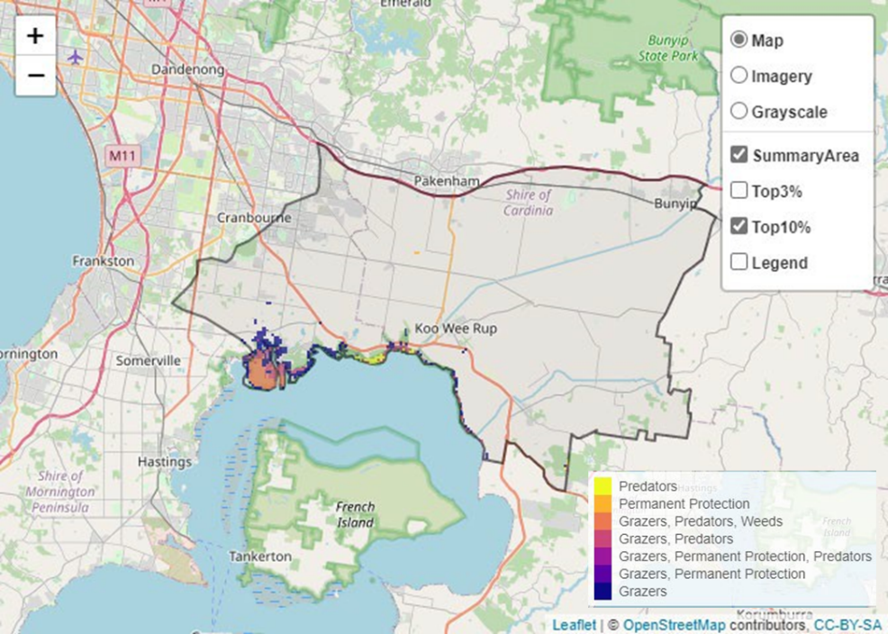
Areas of Westernport Flats shown in Figure 2 have highly cost-effective actions (within the top 10% of cost-effectiveness for that action across the state) that provide significant benefit for biodiversity conservation.
Figure 2: The SMP priority actions which rank among the top 10% for cost-effectiveness of that action across the state. “Grazers” includes deer, domestic grazing, goats, horses, over-abundant kangaroos, pigs, rabbits and total grazing pressure

Actions with area in the top 3% and top 10%
Specific Action | Area in top 3% (ha) | Area in top 10% (ha)
Control Pigs | 747 | 1,685
Control Rabbits | 0 | 1,230
Control Cats | 0 | 1,091
Control Foxes | 0 | 1,086
Control Overabundant Kangaroos | 20 | 357
Control Weeds | 0 | 317
Revegetation | 0 | 137
Total Grazing Pressure | 25 | 121
Domestic Grazing Control | 0 | 121
Permanent Protection | 5 | 47

The most cost-effective actions for flora & fauna
Plants - Control rabbits
Birds, Mammals, Amphibians and Reptiles - Combined cat and fox control

For a further in depth look into SMP for this landscape, please refer to NatureKit.

Current actions in Westernport Flats
Specific Actions | Current actions – top 10% (ha) | Current actions – outside top 10% (ha)
Control Pigs | 632 | 19
Control Foxes | 116 | 138
Control Weeds | 21 | 195
Permanent Protection | 0 | 13
Control Rabbits | 0 | 13
Domestic Grazing Control | 0 | 13

Current actions – top 10% = The area (ha) of the specific action currently occurring in locations identified by SMP as being in the top 10% for cost-effectiveness for that action across the state
Current actions – outside top 10% = The area (ha) of the specific action currently occurring in locations within this landscape that are not identified by SMP as being in the top 10% for cost-effectiveness for that action across the state

What you told us
SMP is just one tool to use in the process of understanding biodiversity values. Feedback from our stakeholders is also vitally important and forms the basis of our understanding of knowledge gaps.

Stakeholder interest

Important landscapes
- Significant number of parks, waterways and biozones were identified by stakeholders
- Cardinia foothills (Cardinia Creek)
- City of Casey Coastal Biozone
- Cranbourne South and Pearcedale
- Cannons Creek
- Warneet
- Blind Bight
- Westernport and Koo Wee Rup Swamps
- Bunyip Creek
- Strategic corridor for Southern Brown Bandicoot
- Various Friends of groups, Landcare groups and other community groups focusing on biodiversity conservation

Current activities/programs/partnerships
- Living Melbourne - Our Metropolitan Urban Forest
- Ramsar Protection program in the Port Phillip and Westernport CMA Region
- City of Casey activities (incl. pest animal control)
- Cardinia Shire Council – works on various reserves
- City of Casey Biodiversity Enhancement Strategy
- Two Great Ramsar Wetlands (Port Phillip and Westernport CMA) (Delivered by Parks Victoria)
- Southern Brown Bandicoot overlay being developed by Cardinia Shire Council
- Metropolitan Open Space Strategy
- Melbourne Strategic Assessment Program
- Biodiversity Response Planning project 020 – Building the Bass Coast biolinks
- Trust for Nature land covenanting program

Additional threats
Threats identified through the consultation process (in addition to those modelled in SMP):
- Weeds
- Invasive predators
- Deer
- Rabbits
- Agricultural and peri urban development
- Pesticide impact on pollinators
- Nutrient loads
- Erosion and turbidity of waterways
- Lack of connectivity
- Genetic isolation of flora and fauna populations

