Leongatha South farmer Jim Seabrook says he loves what he’s doing: adding to the biodiversity of his property to support a healthy landscape and healthy animals. This has been assisted by funding through the West Gippsland EcoTender which was delivered by the ecoMarkets team in the Department of Sustainability and Environment with its CMA and Landcare partners.

Jim said he has four areas at the property which are being conserved and managed with funding from the EcoTender. “Two of the areas are being revegetated; another will link a bush corridor to a creek. The last area has vegetation that’s been dying but will be revegetated and we’ll expand the fencing to keep stock and kangaroos out,” he explained.

Under the EcoTender program, landholders submit bids for funding to manage and conserve the native vegetation on their properties through work such as planting native trees, fencing and weed control.

Successful bids are those which offer the best value for money based on a range of ecosystem outcomes such as biodiversity, improvements in salinity, carbon sequestration and water quality. Successful landholders complete the works in their management plans and receive payments over five years.

Jim says, “It will help us to advance the whole cell grazing system. We’ll have better fencing and are looking to building soil and building animal health.
“In time, I expect to see productivity gains with more shelter and biodiversity. Already, we’re seeing a lot more birdlife feeding in the grass and on the soil.

“This property has been in the family since 1959 and over the last 20 to 30 years we’ve been working hard to improve the place. I just love seeing a plan come together, building on a dream that I’ve had for many years.



Jim Seabrook

“My aim is for this place to be a demonstration of how we can farm without chemicals and have healthy animals and healthy people.

“My mother and I had long talks about this place and our plans. We’ve got five years to do the work we’re doing with the EcoTender, but plan to do most of it in two.
“The trees are already growing and the first area is already fenced. As soon as it’s dry enough we’ll do the other two areas. It is part of a whole farm program, adding to the biodiversity and bringing a whole range of benefits, he said.

Jim is one of 80 landholders who received total funding of $2.5 million through the West Gippsland EcoTender. As a result, over 1100 hectares of native vegetation, wetlands and river frontage are being managed, conserved and protected for the future.

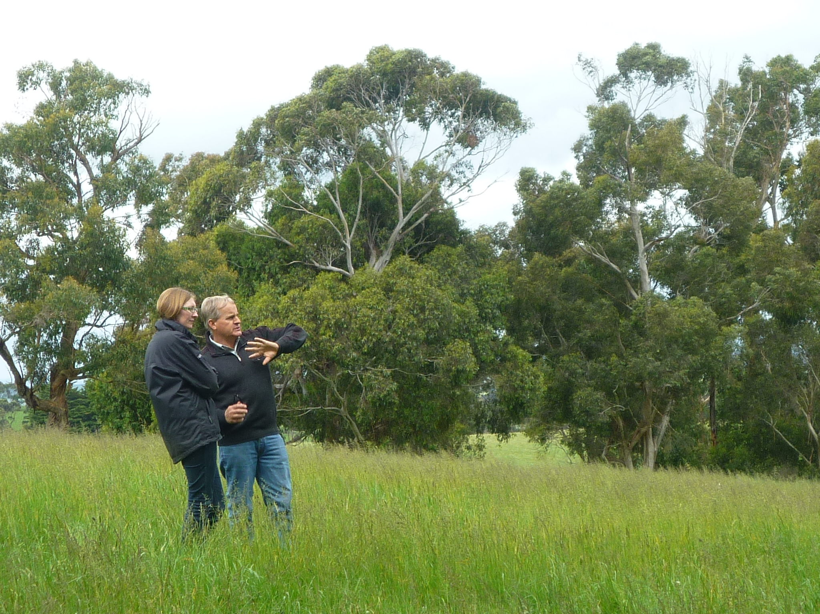

Jim at his property in Leongatha South, with Michelle Butler from the Department of Sustainability and Environment

