Biodiversity 2037: Manual for the identification and prioritisation of biodiversity actions and knowledge gaps

Matthew Bruce, Billy Geary, Ella Kelly, Terry Walshe, Libby Rumpff, Canran Liu, Jim Thomson, Anne Buchan, Ella Loeffler and Angela Muscatello

June 2020
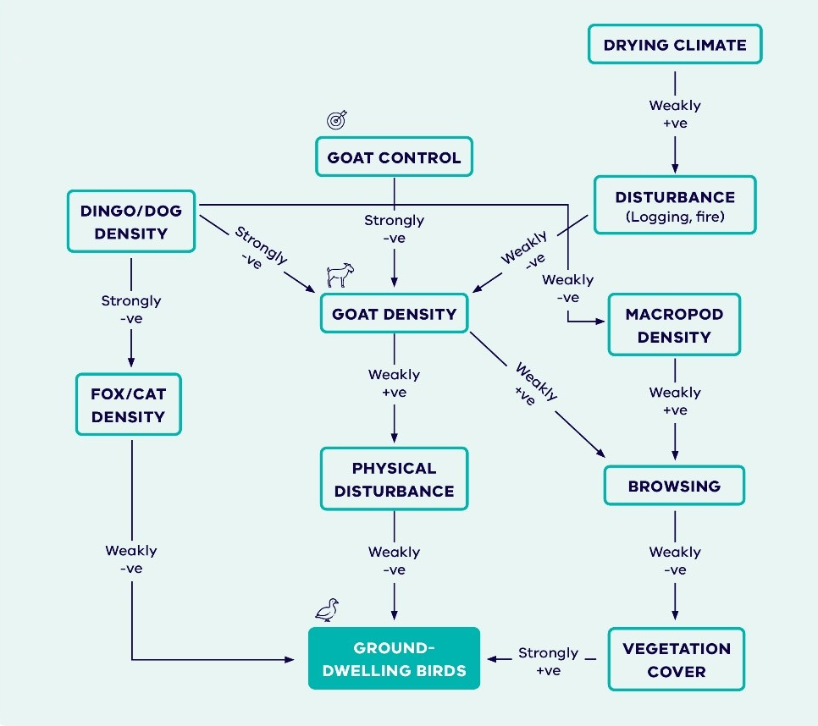

Biodiversity 2037

Biodiversity 2037: Manual for the identification and prioritisation of biodiversity actions and knowledge gaps

Matthew Bruce¹, Billy Geary², Ella Kelly²,Terry Walshe³, Libby Rumpff³, Canran Liu¹, Jim Thomson¹, Anne Buchan², Ella Loeffler² and Angela Muscatello².
¹ Arthur Rylah Institute for Environmental Research, Department of Environment, Land, Water and Planning, 123 Brown St, Heidelberg, VIC 3084
² Biodiversity Strategy and Knowledge, Biodiversity Division, Department of Environment, Land, Water and Planning, 8 Nicholson Street, East Melbourne, VIC 3002
³ School of BioSciences, The University of Melbourne, Parkville, VIC 3052

Citation: Bruce, M., Geary, B., Kelly, E., Walshe, T., Rumpff, L., Liu, C., Thomson, J., Buchan, A., Loeffler, E., Muscatello, A. 2020. Biodiversity 2037: Manual for the identification and prioritisation of biodiversity actions and knowledge gaps. Department of Environment, Land, Water and Planning. East Melbourne.

Front cover picture
Detail of stylised fuzzy cognitive map for goat control

© The State of Victoria Department of Environment, Land, Water and Planning 2020
Disclaimer
This publication may be of assistance to you but the State of Victoria and its employees do not guarantee that the publication is without flaw of any kind or is wholly appropriate for your particular purposes and therefore disclaims all liability for any error, loss or other consequence which may arise from you relying on any information in this publication.

Contents
Aboriginal acknowledgement 1
Figures 2
Figures 2
Glossary 3
Summary 4
1 Improving decision-making 5
1.1 Measuring benefits and uncertainty of a management action, intervention or policy 5
1.2 Identifying the most cost-effective biodiversity actions 6
1.3 Improving the effectiveness of actions through prioritized knowledge acquisition 6
2 Problem-response scenarios 8
3 Identifying and prioritizing actions in a threat-action scenario (via Strategic Management Prospects) 0
4 Identifying and prioritizing actions in a single species – multi action or ecosystem – multi action scenario (Specific Needs Analysis) 0
4.1 Define problem response scenario and objectives 2
4.2 Identify potential action 3
4.3 Develop best and worst-case scenario causal model 3
4.4 Estimate the benefit of each management action 3
4.5 Estimate the costs of each action 7
4.6 Calculate the cost-efficiency of each management action 7
4.7 Rank the most cost-effective action(s) 7
4.8 Comparing cost-efficiency with Strategic Management Prospects 7
5 Identifying and prioritising knowledge gaps 9
5.1 Relative Benefit of Knowledge 9
5.2 Expected gain 10
5.3 Proportional reduction in uncertainty 10
6 Developing causal models 12
6.1 Introduction 12
6.2 Causal model development 12
6.3 Creating best- and worst-case scenarios 14
7 Updating models 14
8 References 15
Appendix 1. Expected gain from resolving all uncertain elements calculated in SMP 17
Appendix 2. Standard terminology 19
Appendix 3. Steps for creating FCMs in Mental Modeler 20
Appendix 4. R code for the automated comparison of best- and worst-case models 26

Aboriginal acknowledgement
The Victorian Government proudly acknowledges Victoria’s Aboriginal community and their rich culture and pays respect to their Elders past and present.
We acknowledge Aboriginal people as Australia’s first peoples, and as the Traditional Owners and custodians of the land on which we work and live.
We recognise the strength of Aboriginal people despite the negative inter-generational impacts of past practices and policies, some of which continue to be experienced today.
We recognise and value the ongoing contribution of Aboriginal people and communities to Victorian life, and how this enriches us all.
We recognise that Aboriginal cultures and communities are diverse, and the value we gain in celebrating these cultures and communities. We acknowledge that the land is of spiritual, cultural and economic importance to Aboriginal people.
We also recognise the intrinsic connection of Traditional Owners to Country and acknowledge their contribution in the management of land, water, the natural landscape and our built environments.
We embrace the spirit of reconciliation, working towards the equality of outcomes and ensuring an equal voice.
We have distinct legislative obligations to Traditional Land Owner groups that are paramount in our responsibilities in managing Victoria’s resources.

Figures

Figures
Figure 1. A systematic approach to improving the rigour of decision making and the effectiveness of actions. 9
Figure 2. Steps for developing problem-response scenarios, identifying actions and knowledge gaps. 10
Figure 3. Pyramid outlining complexity of Specific Needs (SN). Less complex scenarios at the bottom of the pyramid will require less time and fewer resources, and so it may be possible to explore a number of these scenarios. In comparison, it may only be possible to conduct SN analyses on a small number of complex scenarios. 1
Figure 4. The seven steps of the Specific Needs Analysis 2
Figure 5. Conceptual illustration of the values (x and y) elicited from species experts during the Specific Needs approach. 4
Figure 6. Calculating the Relative Benefit of Knowledge. 9
Figure 7. Example best- and worst-case models outlining the effects of fox control on terrestrial mammal density. Dashed lines indicate no influence. Negative links indicate an inverse relationship between parent and child nodes. 11
Figure 8. The process for calculating expected gain using SMP. 18
Figure 9. Steps to open the Mental Modeler model builder. 20
Figure 10. Node types as they appear in Mental Modeler. 21
Figure 11. The model builder screen. 22
Figure 12. Example model from Mental Modeler. 24
Figure 13. Example matrix produced from the Button Wrinklewort model. 25
Figure 14. The relationship between the three output files needed to determine the proportional reduction in distance. 31

Glossary
Causal models – Conceptual models which describe the relationship between biodiversity values and management or intervention. There are a number of different extensions to conceptual models, such as fuzzy cognitive mapping and Bayesian models. The method used in this document is fuzzy cognitive mapping.
Change in Suitable Habitat – The increase in likelihood that a species will still be found at a location in 50 years if given sustained management, compared to no management. The measure is used to quantify the benefit of management actions in Biodiversity 2037—Protecting Victoria’s Environment.
Disbenefits – The potential negative benefits of undertaking management actions for some species. For example, rabbit control can have a disbenefit for raptors due to the loss of a key food source. Disbenefits in the context of this manual are measured by Change in Suitable Habitat.
Fuzzy Cognitive Maps – a type of conceptual model whereby the strength and direction of the relationships between the elements (e.g. species abundance) is specified and can be used to coarsely infer the strength of the impact of these elements.
Knowledge gaps – Uncertain relationships within a modelled system that may be resolved through research or monitoring.
Problem-response scenarios – Particular biodiversity management scenarios.
Relative Benefit of Knowledge – A metric of how much benefit we may get from investing in one piece of research over another.
Specific Needs – A decision-making tool that supports conservation managers to make evidence-based decisions for bespoke (e.g. species-specific or narrow-focused) conservation scenarios.
Strategic Management Prospects – A spatially explicit decision-making tool that supports biodiversity managers to make evidence-based decisions.

Summary
Protecting Victoria’s Environment – Biodiversity 2037 is Victoria’s 20-year plan to tackle declining biodiversity across the state. Despite on-going management and concentrated efforts to protect Victoria’s environment, our state’s biodiversity continues to decline. In order to make good decisions for biodiversity response planning, we first need to identify the most cost-effective conservation actions. This ensures optimal allocation of resources, and the greatest benefit to biodiversity across Victoria. Decision-support tools will help to inform how and where to focus our collective efforts, alongside a knowledge framework that establishes processes to identify, prioritise and fill knowledge gaps and address uncertainties.
This manual provides guidance on how to identify and prioritise biodiversity actions and knowledge gaps using some of DELWP’s decision-support tools and frameworks. These include Strategic Management Prospects, which currently assesses the cost-effectiveness of 17 landscape-scale terrestrial conservation actions, and Specific Needs, which compares a range of actions for a single species or location to help choose the most cost-effective bespoke action for species (or population) combinations.
Conceptual models can be used to describe the relationship between the important biodiversity values and management or intervention components (e.g. control method, effect of disturbance) within different scenarios. The manual outlines the process for creating these models. In this instance we have chosen Fuzzy Cognitive Mapping as the method for visualising the conceptual model.
This manual will be useful for biodiversity practitioners and conservation managers in determining the most-effective management actions for different conservation scenarios and identifying knowledge gaps and uncertainties.

- Improving decision-making
Protecting Victoria’s Environment – Biodiversity 2037 (DELWP 2017) is Victoria’s 20-year plan to tackle declining biodiversity across the state. Acknowledging that the personal wellbeing of every Victorian and the economic wellbeing of the state are dependent on the health of the natural environment, Protecting Victoria’s Environment - Biodiversity 2037 articulates a new vision: Victoria’s biodiversity is healthy, valued and actively cared for. This vision can only be achieved through collective action. Together, we can ensure Victoria’s natural environment is healthy, has functioning plants and animal populations, improved habitats and resilient ecosystems, even under climate change. This will be achieved by stopping the overall decline of threatened species, securing the greatest possible number of species in the wild, and improving the overall extent and condition of habitat.
Conservation management is shifting away from planning for threatened species one at a time. While it will always be necessary to understand each species’ specific circumstances and needs, species are embedded in ecosystems and are collectively subject to threats and management responses. Biodiversity management is more effective if synergies and potential negative outcomes are considered.
Despite on-going management and concentrated efforts to protect Victoria’s environment, our state’s biodiversity continues to decline. The current level of remedial effort is not sufficient and needs to be more targeted to ensure that everyone’s contribution is focused on delivering the most beneficial actions in the relevant places, particularly under the game changing influence of climate change. Decision-support tools will help to inform how and where to focus our collective efforts alongside a knowledge framework that establishes processes to identify, prioritise and fill knowledge gaps and address uncertainties. This ensures that our decision-support tools, data and data management systems are continually improved, so that people’s contributions to the targets can be measured and their knowledge reflected through the tools.
The purpose of this manual is to provide guidance to biodiversity practitioners on how to identify and prioritise biodiversity actions and knowledge gaps using some of DELWP’s decision-support tools and frameworks.

  - Measuring benefits and uncertainty of a management action, intervention or policy
Interventions under Biodiversity 2037 seek to deliver a particular outcome, given the available budget. This may be to increase the ability of a species to persist in the wild or an increased connection to nature. To plan and prioritise which management actions, behaviour change activities or policy interventions we will do, and where, we want to know how a particular response activity could impact the desired outcome.
While a measure to quantify the benefits of activities to encourage people to connect and value nature is yet to be developed, a new measure – Change in Suitable Habitat - was developed under Biodiversity 2037 and is used for looking at biodiversity (species) benefits. In the case of biodiversity, we want to know how particular management actions benefit different species of plants and animals in different locations, and how that benefit may vary across species and locations.
Change in Suitable Habitat was developed to provide a consistent measure of the relative contribution of management actions to habitat quality and populations’ persistence across many different species. It provides a transparent, comparable and consistent measure of the benefit of different conservation actions for individual or groups of species. The anticipated Change in Suitable Habitat gained by a species from an action is calculated using elicited expert judgments of a species’ likelihood of persistence at a location under management and under no management, and then extrapolated spatially using a model of the species’ distribution. The magnitude of anticipated Change in Suitable habitat can be highly uncertain. Uncertainty implies both upside and downside risk, so there may be better than expected outcomes for conservation, alongside the possibility of failure. The Biodiversity Knowledge Framework seeks to identify key elements of uncertainty that improve prospects for success and limit exposure to failure.
In estimating anticipated Change in Suitable Habitat, uncertainty is also explicitly captured (e.g. where experts have provided plausible lower and upper bounds of changes in persistence probability for a species and action, or uncertainty around the increase in the probability of occupancy of a species following a management action). Quantifying the benefits and uncertainty of each action allows us to identify which actions we can be relatively more certain about having a positive outcome for biodiversity and actions for which the consequences are uncertain.
To quantify the benefits and uncertainty of management actions appropriately a standard set of information is required. Where do the biodiversity assets occur across the state? What are the threats or disturbance processes operating at those locations? Which of these threats can be addressed directly through management and what are the potential benefits of those management actions for the biodiversity assets?
  - Identifying the most cost-effective biodiversity actions
To achieve the vision of Biodiversity 2037 we need to re-balance efforts and investment to increase the focus on prevention as well as the critical care of biodiversity. Evidence-based decision making is critical to improving outcomes for biodiversity. To help us protect and manage biodiversity, we need the best information possible, and decision-support tools which can deal with the complexity of nature in a way that is accessible to managers and stakeholders.
In order to make good decisions for biodiversity response planning, we first need to identify the most cost-effective conservation actions. This ensures optimal allocation of resources, and the greatest benefit to biodiversity across Victoria.
Over the past few years DELWP has invested in a number of decision-support tools for quantifying the benefits, cost-effectiveness and uncertainties of an action in order to secure the greatest overall benefit for biodiversity, for both broad-scale and more specific, bespoke management actions.
Strategic Management Prospects (SMP) (Thomson et al. 2017) is a decision-making tool that supports biodiversity managers to make evidence-based decisions, including which actions to undertake, in which places, in order to achieve the most benefits across hundreds of species, for the least cost. The tool is designed to capture uncertainty about the effectiveness of an action (in response to a threat) and the outcome for species (a change in site-specific persistence probability).
SMP currently assesses the cost-effectiveness of 17 landscape-scale terrestrial conservation actions (such as pest control, ecological burning or revegetation) across the state, plus combinations of actions, for all vertebrate fauna and most vascular flora in Victoria. SMP was developed to determine which conservation actions will have the maximum benefit for the maximum number of species. This helps biodiversity managers make the most of effort and investment to benefit the greatest number of species. SMP can be used to determine the relative cost-effectiveness of actions across different locations.
SMP does not, however, currently cover all possible species and actions in the conservation toolkit. So how do we make decisions about the conservation of species for which landscape scale actions are not enough to sufficiently increase persistence? What about projects that employ novel or unique conservation actions yet to be included in SMP? To fill these gaps, we required a method that can rapidly evaluate projects like this in a framework compatible with SMP. This can be done using a process called Specific Needs, which compares a range of actions for a single species or location to help choose the most cost-effective bespoke action for species (or population) combinations (DELWP in prep.).
Biodiversity 2037 recognises that under the game-changing influence of climate change, new types of intervention and projects that maintain a single species focus will still be needed, particularly for those at risk of population failure or vulnerable to episodic events. However, such single-species conservation actions often come at a high cost, and generally only benefit the species in question. It is important to be strategic when planning conservation investment and recognise that there is a trade-off between multiple and single species actions. Estimates from Specific Needs can be compared with SMP actions to identify the most cost-effective conservation investment more generally.
  - Improving the effectiveness of actions through prioritized knowledge acquisition
Biodiversity 2037 emphasises the need for an increase in targeted data collection for evidence-based decision-making of management actions. This includes progressively filling critical knowledge gaps, through targeted research and data gathering and ensuring that information is integrated across all environments (marine, waterway and terrestrial). This is reinforced through the State of the Environment 2018 report which notes that Victoria’s science and data capability is diminished by a lack of coordination and a strategic approach to investing in the critical research that will enable better, and timelier, decision making and policy interventions.
The changing nature and scale of both private and public investment in biodiversity conservation requires a systematic approach to improving our understanding of the potential benefits of a management action, intervention or policy approach. Identifying uncertainty in the effectiveness of actions and reducing this uncertainty by obtaining more information about management effectiveness will lead to better decisions, greatly improving the impact of current management actions (Nicol et al 2019).
Biodiversity 2037 identifies the need for conservation actions to be more strategic, deliver better value for money and be underpinned by the best available information and science. This will ensure conservation efforts deliver the most benefit for the most species. To achieve this, a consistent, quantifiable and systematic approach is required to a) identify knowledge gaps and b) prioritise research investment to ensure that the research being invested in is strongly linked to policy and decision-making with a focus on strengthening Victoria’s ability to deliver on the vision of Biodiversity 2037.
The Biodiversity 2037 Monitoring Evaluation and Reporting Framework V2 (Biodiversity 2037 MERF; DELWP 2019a) has been developed to demonstrate the progress of the collaborative efforts to deliver the outcomes and targets and underpin adaptive management to ensure the vision that Victoria’s biodiversity is healthy, valued and actively cared for, and is delivered in the most cost effective and efficient way. The Biodiversity 2037 MERF provides an overarching framework to embed continuous improvement in Biodiversity 2037, biodiversity conservation and management and the tools we use for modelling, mapping, making decisions and reporting.
Biodiversity 2037 MERF also outlines the need for a consistent and transparent approach for prioritising and selecting knowledge acquisition projects. This has resulted in the development of the Biodiversity Knowledge Framework. The approach to identify and fill priority knowledge gaps and uncertainties is detailed in the Biodiversity Knowledge Framework V1 (DELWP 2019b), which has been developed to:
- Describe our shared understanding through causal models of a threat or disturbance process to a species or ecosystem, or barriers to human behavioural change; identify options for intervention, policy or management and predicted benefit or impact of those options. New models can be added as they are developed.
- Identify, compare and prioritise knowledge gaps across management actions/ interventions, environments (marine, freshwater and terrestrial) and systems (through an index describing the Relative Benefit of Knowledge). The prioritisation approach can also be used to assess proposals and project concepts for knowledge gaps for which the relative benefit hasn’t yet been calculated.
- Provide a platform for partners and stakeholders to identify and include projects that are helping to address knowledge gaps and a process to update our understanding and causal models; and provide standards and tools as new knowledge is acquired that verifies or refutes assumptions and resolves uncertainty.
One of the outputs of Biodiversity 2037 is the identification of priority knowledge gaps to continually improve decision-making. Here, the Key Performance Indicator is the number of causal models developed and parametrised to identify knowledge gaps, with the aim of improving decision support tools and ensuring they are used by more people.
As SMP and Specific Needs are designed to directly calculate the predicted impact of an action on a species, the sources of uncertainly aren’t clear (e.g. are we uncertain about fox control because of uncertainty surrounding the effectiveness of control methods on fox density or because of uncertainty around the impact of reduced fox density on the target species?). Furthermore, some actions may have disbenefits for species. For us to learn more about the effectiveness of actions we need to better understand the sources of uncertainty in the link between actions and conservation outcomes. This means we need to understand for which key uncertainties additional information should be collected, and how to best collect this information (Canessa et al 2015). After identifying the broad actions and species for which we are most uncertain (e.g. the benefit of fox control on small and medium sized mammals), a deeper dive into the ecological and human mechanisms influencing this uncertainty is required to identify knowledge gaps and therefore research questions.

- Problem-response scenarios
A systematic approach has been developed to work through the identification and prioritisation of actions and knowledge gaps (Figure 1). Under this approach, problem-response scenarios describe particular biodiversity management scenarios that may benefit from knowledge acquisition. These scenarios inform the development of causal models. Causal models describe the relationship between the important biodiversity values and management or intervention components (e.g. control method, effect of disturbance) within the scenario. Developing causal models for each scenario ensures that a whole-of-system view of the management problem is used.
We define below three broad problem-response scenarios: landscape-scale threat-action, multi-action single species (or species guild) and ecosystem. Priorities for developing threat-action scenarios are derived from uncertainty analysis in SMP, priorities for the other two scenarios will arise where there is a particular need. Figure 2 outlines the steps for each scenario described in this document.

Threat - action scenarios at broad landscape scale
Threat-action scenarios are used to understand the impact of a threat and the effectiveness of an associated management intervention (e.g. fox predation and fox control) on one or more individual species, or groups of species with similar traits (species guilds). These types of models are linked most closely to SMP and are developed to understand and prioritise uncertainties related to broad-scale management interventions such as predator control. They are not necessarily linked to specific locations. SMP can provide information about the benefits of different management actions as well as the uncertainty around those benefits. Actions with significant benefits and high uncertainty are good candidates for knowledge acquisition projects. Since SMP does not provide any information on why we are uncertain about the benefits of an action, there is a need to develop models to understand those sources of uncertainty.

Single species - multi action scenarios
Single species – multi action scenarios are used to understand how different candidate actions affect a single species (or in some cases a species guild). This is most closely aligned to the Specific Needs approach and can be developed where there are uncertainties around the impact of a bespoke set of actions under consideration and that aren’t captured in SMP. These models may be generic (not tied to a particular location) or specific in that they are built considering the characteristics of a particular population or populations. Such models are most appropriate for threatened or range-restricted species.

Ecosystem - multi action scenarios
Ecosystem – multi action scenarios models attempt to capture the important elements of a particular (spatially defined) ecosystem. Objectives in these models are generally broader than those for the first two model types and can include non-biodiversity values such as Traditional Owner cultural values. Working in partnership with Traditional Owners, we have used these types of models to describe Traditional Owner ecological knowledge and objectives, and how actions can contribute to both biodiversity and cultural outcomes. This model type is dealt with in the same way as multi-action single species models (i.e. though the Specific Needs approach).

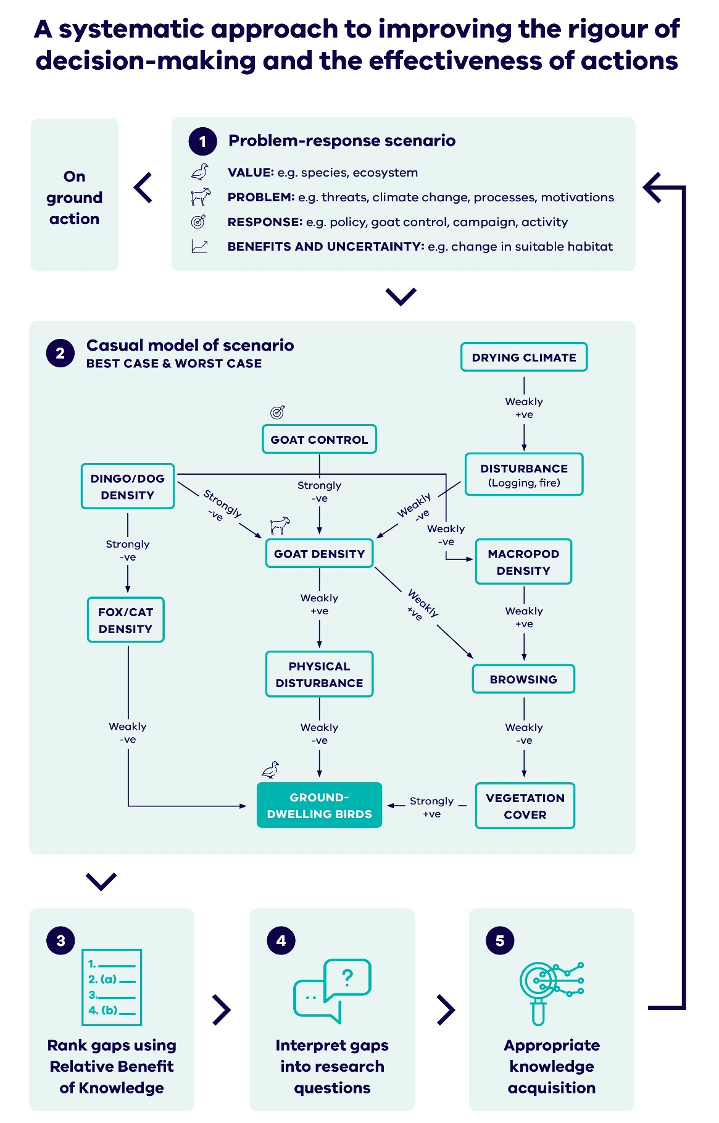
Figure 1. A systematic approach to improving the rigour of decision making and the effectiveness of actions.

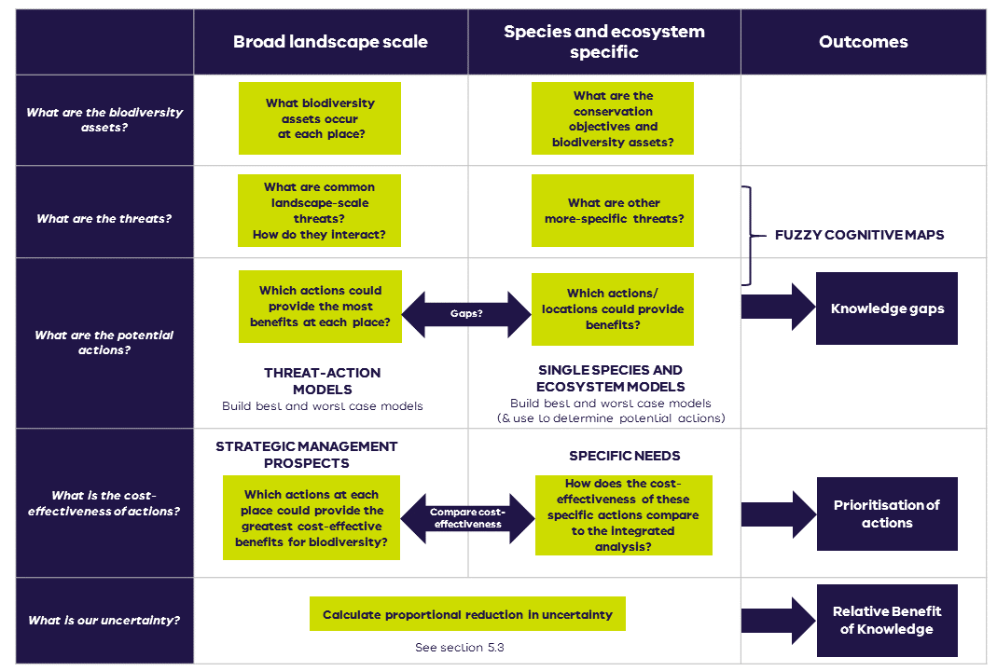
Figure 2. Steps for developing problem-response scenarios, identifying actions and knowledge gaps.

- Identifying and prioritizing actions in a threat-action scenario (via Strategic Management Prospects)
Strategic management actions that focus on benefits to multiple species can prevent many of the state’s vulnerable and common species (of native vascular plants and terrestrial vertebrate animals) from entering the endangered category. In some cases broadscale actions may need to be complemented with species specific actions to leverage the benefits. Because they provide benefit to multiple species, these actions can be highly cost effective. For investment in actions to secure the best conservation outcomes from finite resources, we need to understand and compare the relative benefits that can be expected for different species from under this increasingly wide range of interventions. For example, for a given amount of investment, how many species benefit more from an area of revegetation compared to, say, invasive species control across the same area?
Strategic Management Prospects (SMP) uses a spatially explicit, landscape-scale approach to identify the most effective and efficient management actions to benefit species across Victoria. The SMP tool can help to identify priority areas and management actions that provide the highest potential return on investment and contribution to state-wide targets. SMP is based on expert estimates of the benefits of different management actions under climate change, consideration of the connections and spatial arrangement of different species and relevant actions, and for each species in a strategic ranking. In this way, SMP strategically identifies a cost-effective suite of actions that benefit the most species. Table 1 outlines the threats and actions included in SMP.

Table 1. Threats and actions included in SMP v2.0.
Threat | Action
Feral cats | Cat control
Feral deer | Deer control
Red foxes | Fox control
Feral goats | Goat control
Feral pigs | Pig control
Rabbits | Rabbit control
Feral horses | Horse control
Grazing by domestic stock | Domestic stock control
Overabundant kangaroos | Kangaroo control
Land clearing | Permanent protection
Lack of fire | Ecological burning
Weed invasion | Weed control
Historical land clearing | Revegetation

To identify the most cost-effective actions to do at a location, use the SMP v2.0 layers on NatureKit. The purple benefit-cost layers for each individual action identify where in the landscape it is most cost-effective to undertake that action, compared with other possible actions. Use the Summary Area reports to get an indication of the Change in Suitable Habitat that can be achieved for individual assets or groups of assets by managing a particular threat using the actions in Table 1. For more information, go to the NaturePrint website to learn more about using SMP.

- Identifying and prioritizing actions in a single species – multi action or ecosystem – multi action scenario (Specific Needs Analysis)
There are unique biodiversity management situations where species or locations will not benefit sufficiently from SMP landscape-scale actions, and therefore need further consideration. For example, we still need to make decisions about the conservation of critically endangered species for which landscape scale actions alone are not enough to ensure persistence. This also includes novel or unique conservation actions not considered by SMP. Management actions that are not currently considered in Strategic Management Prospects (e.g. genetic rescue, translocation) will also need to be ranked in terms of cost-effectiveness and considered in the portfolio of possible research questions and knowledge gaps.
One of the targets of Biodiversity 2037 is to ensure all critically endangered and endangered species have at have least one option to be conserved ex situ or re-established in the wild, which means DELWP needs to consider potential translocation and ex situ conservation actions for Victoria’s most threatened species. This can be done using the Specific Needs process, which is an important process for considering these ‘gaps’ in SMP.
The Specific Needs process follows the same method used to collect expert judgements for the landscape-scale actions in SMP but focuses on bespoke actions and how they benefit a particular species in specific locations. This process identifies the most cost-effective actions for unique biodiversity management situations. As it uses the same method and quantifies benefit in the same manner as SMP, the Specific Needs estimates can also be used to compare those actions against the cost-efficiency of all SMP actions to identify where conservation investment should go more generally. This process also incorporates uncertainty in the same way as SMP and therefore can also provide the inputs for uncertainty analysis.
The Specific Needs approach was developed for assessments of the cost-effectiveness of bespoke conservation actions. In combination with a library of benefit information for landscape-scale actions, Specific Needs also allows for comparison with SMP outputs under a cost-effectiveness framework. Such an approach is valuable as it balances the need to consider both species-focused and threat-focused approaches to providing conservation resources (McDonald et al. 2015). This framework is adaptable, portable and applies decision theory principles to bespoke conservation actions by explicitly considering the expected benefits of each management strategy, as well as costs and associated uncertainties. Specific Needs can be extended to include ecosystem models or single threats and actions that aren’t included in SMP. Assessing the relative cost-effectiveness of different management strategies for conservation values with Specific Needs follows the typical structured decision-making framework as described in Gregory et al. (2012).
In the decision context and aligning with the Strategic Management Prospects tool, the objective of each Specific Needs analysis is to identify the management strategy that maximizes the summed (i.e. state-wide) probability of persistence for the species of concern. This is represented mathematically as:
$$\operatorname{maximize}{\sum_{s}{P_{s}\left(A\right)}} (1)$$
Where P_{s}(A) represents the likelihood (0 being no chance, 1 being certain) that a species persists in Victoria (e.g. in at least one location or management unit) in 50 years time for species s given a set of management actions A, and the location’s overall context (e.g. habitat, threats etc.). The overall equation is equivalent to maximizing the expected number of extant species at the end of the time horizon (50 years), or minimizing the number of extinctions. Persistence probability can be estimated using a number of methods, ranging from expert judgements to more complex approaches such as population viability analyses.
Specific Needs assessments can vary in their level of complexity due to a range of factors. The level of complexity will determine the resource requirements, time needed to complete, and type of output. Complexity of Specific Needs varies based on the number of scenarios being explored, determined by:
- Number of threat/actions for consideration (including combinations of actions) for a given species
- Number of species being assessed
- Number of locations being assessed
For example, a scenario for one individual species might be very complex because it contains many threats and actions for consideration, across a number of locations, whereas a simpler scenario might be limited to an individual threat/action at one location for a handful of species. The complexity of each scenario will affect the number of scenarios for which Specific Needs analyses can be carried out, given limited resources (see Figure 3).
Additional considerations which may make a Specific Needs assessment more complex by impacting the numbers of species/actions/locations include:
- Status of the species (including conservation status, feasibility of undertaking management for that species)
- Uncertainty (unknowns regarding the species and it’s threats, as well as the benefit/feasibility of actions)
- Whether we can group similar species into one assessment (i.e. guild assessments)
- Complexity of actions (e.g. if an action is untested, or bespoke)
- If the assessment is for the whole species, or single project (across range, single location)
It is also necessary to consider feasibility of undertaking the assessment, including timing constraints (e.g. whether there is sufficient time to do a large, in-depth workshop), availability of experts or other data sources, and requirements of different projects and their stakeholders.
Figure 3. Pyramid outlining complexity of Specific Needs (SN). Less complex scenarios at the bottom of the pyramid will require less time and fewer resources, and so it may be possible to explore a number of these scenarios. In comparison, it may only be possible to conduct SN analyses on a small number of complex scenarios.

The steps to complete a Specific Needs analysis are outlined in Figure 4. During steps one and two, the conservation objectives and biodiversity assets of a problem-scenario should be defined, and relevant action alternatives identified. Action alternatives may comprise single actions or sets of actions. A conceptual model that shows biodiversity assets and potential management actions should then be developed (step three). Best- and worst-case models can then be developed; this should be done at the outset of the Specific Needs process to allow for the identification and prioritisation of biodiversity actions and knowledge gaps. Refer to Section 6 for detailed steps for developing best- and worst-case models.

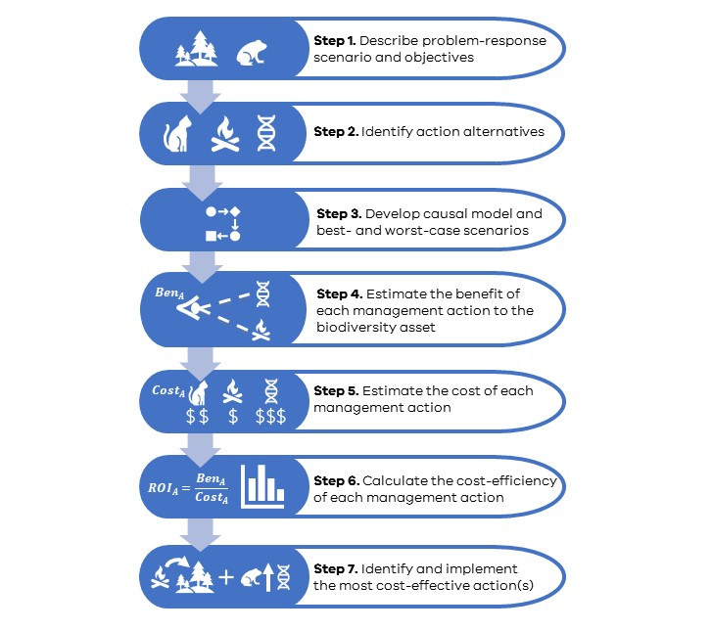
Figure 4. The seven steps of the Specific Needs Analysis

  - Define problem response scenario and objectives
To begin the Specific Needs process, the conservation objectives need to be defined for the problem-response scenario. The objective of any conservation intervention is to increase the ability of a species to persist in the wild, given available resources. The assets and threats should also be outlined at this stage.
Effectively, the objective of an individual Specific Needs analysis is to identify the action, or set of actions, that maximise a species chance of persisting at the location of interest because of those actions. Typically, this can be expressed in two general decision contexts:
- Aiming to identify the most cost-effective management strategy that maximises the persistence probability of a single species or set of species (in situ or ex situ)
- Aiming to identify the cost-effectiveness of bespoke actions to compare with broad landscape-scale actions and embed within a conservation planning framework.
Output: Brief description of problem-response scenario

  - Identify potential action
Actions will be determined by the objective of the project. The complexity of Specific Needs projects will vary depending on the number of species being targeted, and the number of actions required (see Figure 3). For example, a full recovery program will be more complex than a single action or project.
With expert input, identify the potential management actions for this problem-response scenario. This should also consider actions in existing management or recovery plans related to the scenario.
Actions must be spatially explicit (i.e. using a clearly defined project area) and well described so that there is a common understanding between experts of the proposed actions. Knowledge acquisition actions such as monitoring and research should not be included here.
This step may be repeated as part of the development of the causal model. Action scoping can be done in conjunction with development of causal model. It is recommended you carry out the steps outlined in Sections 4.2 and 4.3 in tandem, as developing the causal model may assist in determining more actions.
Output: Spatially explicit actions potentially beneficial to a species, for which benefit will be estimated (section 4.4). Expressed as a scenario comprising of a species, action(s) and location.
For each scenario describe:
- Location, a spatially explicit well resolved project area in which the proposed action will be undertaken (e.g. in the form of a shapefile)
- Action (or action combinations)
  - a description of the action itself (e.g. a translocation of 15 genetically fit individuals [8 males and 7 females] from population x to population y)
  - a description of the temporal pattern of the action (e.g. continuous, biannually, once-off, etc.), and
  - a description of any additional actions thought to be essential to the success of the action in question.
- Species for which the action will be potentially beneficial

  - Develop best and worst-case scenario causal model
A conceptual model should be developed for each problem-response scenario based on the biodiversity assets and management actions identified in steps one and two. This conceptual model represents the relationship between those biodiversity assets and management actions.
Once a conceptual model has been built, best- and worst-case scenarios can be developed with expert input. While there are many ways to develop a conceptual model, the method chosen here is to build causal models called Fuzzy Cognitive Maps. It may be necessary to repeat Step 2 if additional management actions are identified in the development of the models The steps for developing causal models and best- and worst-case scenarios are outlined in Section 6.
Outputs: Best and worst-case scenario models for the problem-response scenario

  - Estimate the benefit of each management action
Estimating persistence probabilities
Expert elicitation is commonly used to quantify and compare the benefit of alternative management strategies in conservation (Martin et al. 2012). To estimate the benefit each action has for the Specific Needs scenario, we use a structured expert elicitation approach to estimate the change in each species’ persistence probability as a result of the action (Error! Reference source not found.). This process followed the four-step IDEA protocol (Investigate, Discuss, Estimate and Aggregate) —a best practice approach for eliciting quantitative judgements from multiple experts that does not require reaching consensus (Hemming et al. 2018). Estimates of persistence probabilities are made spatially explicit by asking experts to relate their estimates to real-world locations, either points or polygons represented on a map. Ideally, this will be informed by a combination of a) where habitat for the species is modelled using habitat distribution models, b) where the action is realistic and feasible and c) where the action is genuinely being considered as a management alternative.
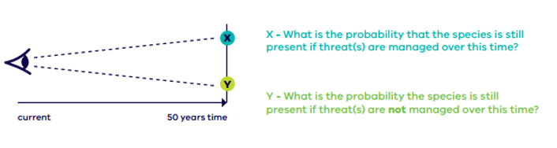
Figure 5. Conceptual illustration of the values (x and y) elicited from species experts during the Specific Needs approach.
X represents the probability the species persists in a location if a threat, or multiple threats, are addressed over the 50 years and Y represents the probability the species will persist in a location if no action is taken over the 50-year time frame. The difference between X and Y (i.e. ∆ = X – Y) is the benefit (i.e. change in persistence probability, which is termed Change in Suitable Habitat in SMP) achieved by undertaking that particular action.

To estimate changes in persistence probabilities, individual experts are first asked the probability of a species persisting at a location (e.g. a unique population of that species) in 50 years time under the ‘do nothing’ scenario, in which no actions are being undertaken in that location. Experts are asked to give their best estimate for persistence probability, as well as the credible upper and lower bounds of that persistence probability, per the three-point IDEA protocol (Hemming et al. 2018). Doing so captures the most likely persistence probability value according to each expert, as well as the level of certainty each expert has in their estimate.
Next, experts are asked to estimate the probability of a species persisting at a location in 50 years time under a particular management strategy, where an action, or suite of actions, are implemented in that location. Again, experts are asked to give their best estimate for persistence probability, as well as the credible upper and lower bounds in order to explicitly capture uncertainty. This is repeated for each relevant combination of management strategy and location (e.g. six management alternatives across two locations would mean each expert provides estimates for 12 alternative action-location combinations).

Table 2 below outlines the questions that need to be asked of experts and the outputs required from each expert for each question. These questions should be asked for each asset (e.g. Lowland Leadbeater’s Possum) at each location being explored (e.g. Yellingbo) for each action in question, and outputs obtained from each expert for this. To facilitate this, the example data sheet provided in the supplementary materials can be developed for the Specific Needs scenarios and filled in by experts. For smaller scenarios, DELWP can also provide access to an online app to facilitate this being done remotely.

Table 2. Example scenarios and questions for expert elicitation estimating the probability of species persistence.
Scenario | Example question format | Estimates
No action | First, think about the consequences for Lowland Leadbeater's Possum of no management at this location: Yellingbo . How likely do you think it is that Lowland Leadbeater's Possum would persist at this location for 50 years if no management occurs over that period?  First indicate a plausible range for the probability of persistence of Lowland Leadbeater's Possum after 50 years in Yellingbo under a Do Nothing scenario. Then indicate your Best Guess for the probability of persistence of Lowland Leadbeater's Possum after 50 years in Yellingbo | - Estimated persistence probability under no management  - Estimated lower bound for persistence probability under no management  - Estimated upper bound for persistence probability under no management
Action | Now think about the likely effect of each of the following management actions on the persistence of Lowland Leadbeater's Possum after 50 years:  Maintain population at Yellingbo | - Estimated persistence probability under management scenario  - Estimated lower bound for persistence probability under management scenario  - Estimated upper bound for persistence probability under management scenario

Calculating benefits of action (change in persistence probability)
To calculate a ‘consensus’ view of benefit across experts for each alternative management action that can be used to calculate the cost-effectiveness of each management action, we calculate a change in weighted persistence probability for a species at the a) population/location level, and b) species level.
These values are calculated so that actions in locations that contribute more to a species’ probability of persistence across all the locations where it occurs are weighted more strongly compared with actions that contribute relatively less to a species’ overall persistence. For example, if the decision problem is to choose between undertaking an action at a key breeding site for a species, or a location that just presents high quality habitat, this step in the analysis will likely weight the benefits of actions at the breeding site more strongly, as this is likely to contribute more to the species’ overall persistence probability.
To do this, the persistence probabilities for each population under the do-nothing scenario are calculated as the mean do nothing value across experts at each location. Then, these are used to calculate the probability that none of the species’ populations persist in 50 years’ time under no action ($E_{DN}$).
This value is then combined with the mean change in persistence probability for each population/location n and used to calculate the contribution of that action to a change in the overall probability of persistence for that species, assuming only that action is done. These calculations are represented as:
$$E_{A}^{All}=1-\prod_{n}^{N}{\left(1-E_{A}^{n}\right)} \left(2\right)$$
$${Ben}_{A}=E_{A}^{All}- E_{DN} (3)$$
Where $E_{A}^{n}$ is equal to the mean expected persistence probability for a given species at location n under action A and $E_{A}^{All}$ is equal to the overall persistence probability of the species across all locations (N) under action A, equation 2. Therefore, the difference between $E_{A}^{All}$and $E_{DN}$is ${Ben}_{A}$, the overall change in persistence probability for the species achieved by action A, and is the value used to characterise benefit in the calculation of cost-effectiveness of the action.
The model outlined in equation 2 is ideal for estimating a species’ overall persistence probability where the species is made up of a limited number of discrete, largely independent populations. For species in more complex situations (e.g. a species with only a few, wide ranging individuals), other models could be used (e.g. complex meta-population models). Irrespective of which model is used, the same equation (3) is used to estimate the benefit of an action, and estimates can then be validated in the field through measures of occupancy.

Outputs: Table with benefit measures for each action and each location under the problem-response scenario

  - Estimate the costs of each action
Understanding the costs of conservation actions is a key component of making good decisions and fairly comparing different management strategies (Martin et al. 2018). An important part of this is consistently considering the costs of different management actions, especially when making comparisons between discrete strategies (Iacona et al. 2018).
For the purposes of Specific Needs, the indicative costs of management strategies should be as comprehensive as possible, incorporating project costs (e.g. consumables, labour, travel costs etc.) as well as opportunity costs (e.g. forgoing income in favour of conservation). Costs should be calculated over the same time scale for which the benefit of an action is being assessed (i.e. 50 years) and should cover the entire cost of implementing an action or management strategy to ensure appropriate comparisons are being made.
Output: Table with cost estimates for each action

  - Calculate the cost-efficiency of each management action
The Return on Investment (ROI) received from undertaking action (A) over the fifty-year time frame (i.e. cost-efficiency) is calculated as:
$${ROI}_{A}=\frac{{Ben}_{A}}{{Cost}_{A}} (4)$$
Where Ben_{A} is the change in persistence probability achieved by undertaking the action over fifty years and Cost_{A} is the cost of successfully implementing the action in the project area for fifty years.
When comparing between species (e.g. comparing with SMP), ROI should be calculated using a weighted benefit estimate to maintain consistency with the broader SMP approach. This could mean weighting species according to factors such as taxonomic uniqueness or even conservation status. Weighting benefits is not required if comparing between actions for an individual species. Output: Table with the benefit, cost and cost-efficiency score for each location and problem response scenario.

  - Rank the most cost-effective action(s)
After the cost-efficiency of each management action is calculated using the benefit and cost information, actions can be ranked by their cost-effectiveness. The action (or set of actions) that has the largest cost-efficiency value will give the greatest ROI, in terms of making the greatest difference to a species’ probability of persistence per unit cost. Where the decision-context is only required to consider and compare actions and their benefits relevant to the focal species, this is enough information to make a decision based on cost-effectiveness or to choose the action(s) that deliver the best outcome for a given budget.

  - Comparing cost-efficiency with Strategic Management Prospects
If the decision problem requires it, the ROI for bespoke actions that has been estimated using the Specific Needs approach can be compared to the marginal the marginal ROI (expected change in summed species persistence per dollar) of ranked landscape-scale, multi-species focused actions within SMP (Thomson et al. 2017). The marginal ROI of ranked SMP actions is calculated as the slope of the curve when the SMP objective function (=sum of weighted persistence probabilities) is plotted against total cost, assuming that funding is allocated according to the SMP priority ranks. The persistence probabilities in SMP are derived from species-specific ‘benefit functions’ that relate the persistence of a species in the wild to a measure of net habitat area called ‘suitable habitat’ (SH). SH for a species is calculated as the sum of pixel-based local persistence probabilities derived from habitat distribution models (HDM) and expert elicited estimates of the probabilities of local persistence under a range of management scenarios (local persistence = HDM value*predicted probability of persistence / management action).
The cost-efficiency values of the selected most cost-effective landscape-scale actions in SMP are plotted against their ranking to identify what level of cost-efficiency is required for an action to be considered relatively cost-effective in SMP. This suggests that a cost-efficiency value of about 0.01 or above could be considered comparable to the high-ranking actions in the SMP library.
However, this requires both the benefits and costs of Specific Needs actions to have been conceived in a similar way, such that the cost-efficiency values are directly comparable.

- Identifying and prioritising knowledge gaps
Given limited resources and vast uncertainty there is a compelling need to prioritise the acquisition of scientific knowledge. Such prioritisation is undertaken implicitly or explicitly and can take many forms, from individual researchers making decisions about what to study next to large organisations making strategic decisions about research directions. In applied fields such as biodiversity conservation and management there is a requirement that research is useful to practitioners and that the apparent ‘science-policy gap’ is addressed. Several reasons for this gap have been identified including that there is often a mismatch between what the scientific community deems worthy of study and the requirements of policymakers and practitioners for evidence-based decision making (Dey et al. 2020). A solution to this problem involves developing prioritisation tools that explicitly link to management decision making, i.e. prioritising research that is more likely to lead to better conservation management, rather than better ecological understanding per se.
Ecological systems are inherently complex and therefore there are many sources of uncertainty that might contribute to sub-optimal or even perverse outcomes. A prioritisation approach must have the ability to synthesise this complexity and simultaneously produce prioritised knowledge gaps that can be formulated into research projects, Furthermore, there is the issue of comparing across different interventions, i.e. the value of knowledge will depend on the context.
The approach detailed here combines the uncertainty from within a system (e.g. the impact of fox control on small mammals) and the overall uncertainty surrounding the effectiveness of an action. The within-system uncertainty is derived from building causal models of the relevant ecological processes and interactions. This approach allows for the comparison of individual uncertainties with the system. The overall uncertainty is the uncertainty in benefit to a guild (group of species) from delivering an action (i.e. uncertainty in the benefit depicted in Figure 5). This allows for the comparison of uncertainties across a range of interventions and guilds. Together these two components are combined to calculate an index of uncertainty, called here the Relative Benefit of Knowledge.
  - Relative Benefit of Knowledge
Knowledge gaps are prioritised using the Relative Benefit of Knowledge (RBK). The RBK value is derived from the equation shown in Figure 6 and is calculated from two components:
- Expected gain from resolving all uncertain elements – an assessment that quantifies how additional information can improve the predicted biodiversity benefit. It is the expected difference in the benefit (in this case the weighted sum of Change in Suitable Habitat) as a result of the management action, with and without the knowledge acquisition to resolve any uncertainties. This component can either be directly calculated from SMP or where the relevant interventions are not in SMP by using the Specific Needs procedure
- Proportional reduction in uncertainty from resolving target elements – identifies the amount of uncertainty resolved by calculating the improvement in proportional distance between the best and worst-case causal models, assuming the knowledge acquisition succeeds in resolving the target knowledge gap(s). It is calculated through the causal model (i.e. the difference between the best- and worst-case models, see section 5.3)

Relative Benefit of Knowledge
Expected gain from resolving all uncertain elements
Proportional reduction in uncertainty from resolving target elements
=
x
Figure 6. Calculating the Relative Benefit of Knowledge.

  - Expected gain
Expected gain from resolving all uncertain elements can be calculated from SMP or the uncertainty in expert estimates from Specific Needs. Calculation via SMP requires specific expertise and therefore the procedure is not described in detail here. This process is relevant for threat-action scenarios where the cost-effectiveness of actions has been included in SMP (see Table 1). A more detailed description of this process can be found in Appendix 1.
  - Proportional reduction in uncertainty
The procedure for calculating the proportional reduction in uncertainty is described in this section. The basic procedure is to develop a causal model and then from that best- and worst-case versions of this model. This process is described in further detail in Section 6 of this document. The best-case model represents the most desirable biodiversity outcomes for each of the links within the realm of what is considered plausible, while worst-case model represents the least desirable but plausible biodiversity outcomes. Uncertainty, and knowledge gaps, are represented by the difference between the best- and worst-case models.
Graph theory provides a formula for calculating the difference (or distance) between two causal models maps, where greater distance implies larger and more numerous differences in the strength (e.g. weak versus strong) and polarity (i.e. positive versus negative associations) between parent and child nodes. Details of the method for comparing cognitive maps is available in Markóczy and Goldberg (1995). The distance metric varies between 0 and 1. A score of zero means there is no difference between best-case and worst-case models because all uncertainties have been resolved (or there were none in the first place). A score of 1 implies maximum differences, such that the sign and strengths of links between all nodes in the best-case map are polar opposites of those in the worst-case model. Distance metrics should not be confused with the edge strengths detailed in Table 3 as these are the values assigned to the individual links within a model. These can be given any arbitrary value, but here we have chosen a scale between -3 and 3.
Table 3. Descriptions and numerical values of edge strength of individual links within a model.
Description | Numerical value
Strongly negative | -3
Moderately negative | -2
Weakly negative | -1
No influence | 0
Weakly positive | 1
Moderately positive | 2
Strongly positive | 3

Once best- and worst-case models are developed and parameterised, the RBK can be calculated for one or more of the knowledge gaps identified in the development of the model (a knowledge gap exists where the strength and/or direction of a link differs between the best- and worst-case). To illustrate this causal model, we draw a cognitive map to visualise our understanding of the system. The underlying matrix of values is what holds the important information, but visualisation allows for a clearer elicitation process, resulting in a cognitive maps like those shown in Figure 7.
Each coloured link (blue in the best-case and red in the worst-case) represents an element of uncertainty. If we imagine that we want to explore the resolution of two sets of knowledge gaps (that may be two candidate research projects):
- Set A is to investigate the links: control foxes → fox density and fox density → macropod density
- Set B is to investigate the links: fox density → cat density and fox density → predation
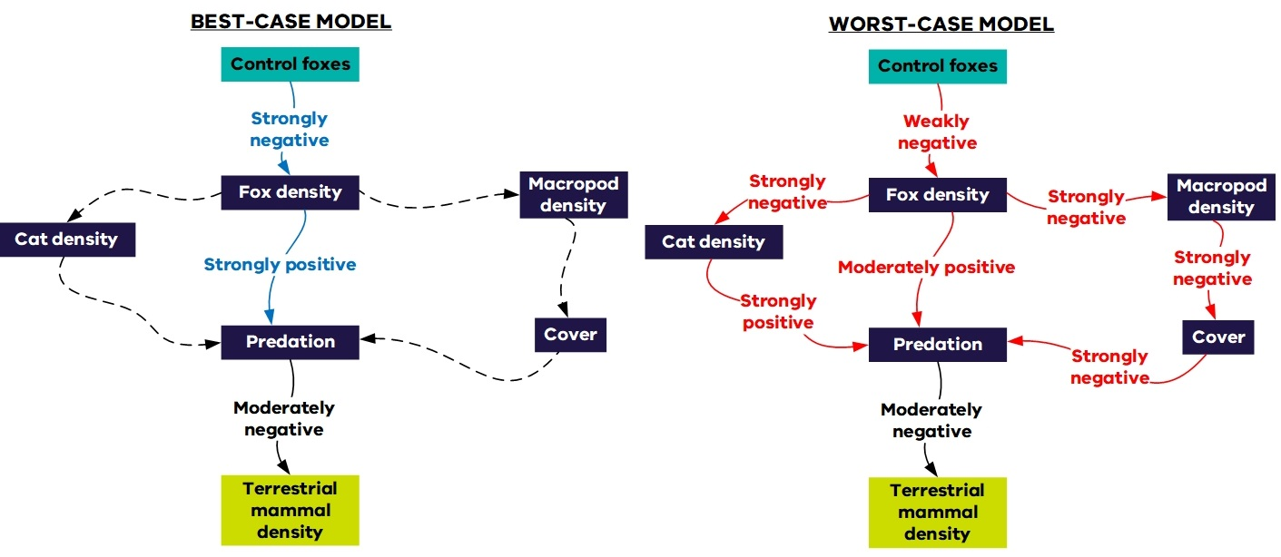
Figure 7. Example best- and worst-case models outlining the effects of fox control on terrestrial mammal density. Dashed lines indicate no influence. Negative links indicate an inverse relationship between parent and child nodes.

The distance metric (i.e. the difference between the two models), with no resolved uncertainty, for the best-case and worst-case maps for fox control-terrestrial mammal density above is 0.34 (we have provided R code for these calculations, see Appendix 3). Proportional reduction in uncertainty is calculated as 1-(distance after reduction/original distance). The distance metric with target uncertainties resolved for each of the two sets is:
- Set A = 0.15 ( a proportional reduction in uncertainty of 0.56, 1-(0,15/0.34))
- Set B = 0.18 (a proportional reduction in uncertainty of 0.48, 1-(0.18/0.34))
In this example, all other things being equal, Set A provides a higher proportional reduction in uncertainty and hence would be preferred to Set B for a given cost. The proportional reduction in uncertainty can be calculated for any combination of one or more knowledge gaps.
We have developed R code (Appendix 3) to automate the calculation of proportional reduction The code takes two files (the best and worst matrices in .csv from) and compares the distance between new models where one or more of the links is no longer uncertain (i.e. have the same strength and direction)..We do this by setting the corresponding strength in both models to the median value (so that it is the same in both models). By systematically resolving all links we can calculate the RBK for each link (or combination of links) and produce a ranked list of knowledge gaps for each model There are a lot of possible combinations and this grows exponentially, there are 2^{n-1} combinations (where n is the number of edges (links between nodes) in the model. For example, if there are 20 edges there are 1,048,575 (220 -1) possible combinations. It will take several days to compute all combinations of proportional reduction in uncertainty, but the code can be aborted at any stage as the results are saved as they are calculated. The required files (also known as adjacency matrices) can be prepared in Microsoft Excel (or other spreadsheet program and saved as a comma separated values (.csv) file. The first row and column should contain the name of each node (in the same order). Models can be translated manually into CSV files or saved directly from the graphical representation as described in Appendix 3. These files have the dimensions N x N, where N is the number of nodes in the model. The numbers in the cells represent the strength of the relationship between elements from row to column. For an example matrix, see Figure 8 in Appendix 3.

- Developing causal models
  - Introduction
Causal models are used to describe and visualise a system and the relationship between variables within that system. The causal model approach we have chosen to use here is fuzzy cognitive mapping. A cognitive map is a qualitative model of belief about how a system operates. It incorporates defined variables (represented as nodes) and the causal relationships between variables (edges). Cognitive maps are directed graphs (digraphs) and have their origins in graph theory (Ozesmi & Ozesmi 2003). The term “fuzzy cognitive map” (FCM) was first used in the literature by Kosko (1986).
FCMs are causal conceptual models that represent a simplification of our understanding of the relationships between elements of a system, in this case ecological interactions between threats, actions and species. They may also contain other elements of the system that represent components deemed important. These could be biophysical attributes, disturbances, external divers, other management actions or threats, or other species (see Table 1). FCMs have been used in ecology and conservation to explore the impacts of different management scenarios and to combine knowledge from different sources (for example see Halbrendt et al. 2014).
The individual components are represented by nodes (also known as vertices) and they are joined together with edges. The edges represent the links between individual nodes and have two components; direction and strength. Direction is the presumed direction of impact from cause (parent node) to effect (child node), for example the causal relationship fox control -> fox density. Strength is related to the relative influence that one node has on the connected node(s). In this project we use an ordinal scale (-3 to +3), where negative strengths indicate an opposite relationship (e.g. when one goes up the other goes down) and a positive strength indicates a concurrent relationship (e.g. when one goes up the other goes up). A strength of zero means no relationship. It may be desirable in some cases to show indicated on the model where there is no relationship as alternative models of the system could propose a relationship. It should be noted that the strength scale used in this project was chosen to make the model-building process tractable in workshop and it is not a required property of FCM.
The models are easier to build and interpret when the nodes are expressed as a quantity that can go up or down (or in some cases be turned on or off). For example, more fox control effort is expected to lead to lower fox densities.
  - Causal model development
There are several ways in which maps can be developed. One approach is to prepare a draft model and then use workshops with experts to refine this further. The workshop approach will depend on factors such as the objective and map type, the audience, and the level of current knowledge of the participants. Workshops for threat-action and multi-action single species will generally involve content experts (in both the action(s) and the species for which outcomes are desired). In general, the streamlining of this process requires clear definitions of actions, desired outcomes, and ecosystems (characteristics and extent) where relevant. This is needed for a shared understanding, and where actions are involved, they should be those considered to be current best practice. These map types will have the same general steps.
- Clear articulation of the objectives, including relevant definitions
- Instructions on how to build FCMs and their intended use in this process, includes definitions of FCM elements
- Map building exercise best done in small groups with a facilitator
- Creating a combined map in a larger group (see ‘combining FCMs’ below), this could be done by the facilitator/analyst after the workshop and distributed via email; and
- After the workshop send the combined map to participants for comment and update accordingly
Ecosystem workshops, especially where they involve Traditional Owners and Aboriginal Victorians, will have additional steps which may include On-Country discussion, and pre-workshop discussion of Intellectual Property issues, what knowledge can be shared, and protocols for Country visits. This should be done in partnership with each Traditional Owner group. Final models should be shared with Traditional Owner participants first, in order to seek their endorsement before these models are published. A follow-up workshop may be required to obtain endorsement.
Combining FCMs
For the calculation of proportional reduction in uncertainty we need to produce a single best-case and a single worst-case model for each problem scenario. Here we suggest a consensus approach (agreed single models) whereby the best-and worst-case models are produced via discussion with the relevant experts. There are other ways in which this could be done. For example creating average models (a summary of participants’ individual maps) or the most extreme models, These approaches have their advantages and disadvantages. Average maps don’t require consensus so might be better where this is hard to achieve but there could be a tendency to average out the variation between best- and worst-case scenarios and thus not capture the plausible extremes. The extreme map approach will produce the biggest difference between best- and worst-case, but these extremes might not be plausible if an expert is making judgements based on ignorance. Consensus requires the agreement of all participants, this may be hard to achieve where there is strong disagreement, but it is more likely to capture the plausible values between best- and worst-case. On balance we think that it is best to produce consensus maps. Experience thus far demonstrated that this is achievable in a workshop where participants have the opportunity to hear each other’s judgments and arrive at a collective position of plausible bounds representing worst and best case.. Consensus may be harder to achieve when maps are constructed via email or online. Another approach would be a modified extreme map where experts are asked to self-rate their experience for each component and the extreme value is taken from the experts that rate above a threshold for experience.

Node types
It is important that we are consistent with our descriptions and terminology, as such we have developed definitions for different node types (Table 4). There are six node types, three of which are compulsory and one (internal modifier) is highly desirable. The others will be included as required.

Table 4. Node types used to develop Fuzzy Cognitive Maps.
Node type | Description | Example | Status
Objective | The ultimate target for management could be a species, group of species, ecosystem condition, cultural objective etc. models can have one or several objectives. | Abundance of small mammals | Compulsory
Component of objective | Included where different parts of an objective are influenced differently by other model components (e.g. separate populations of a species). Likely not to be included in most models. | Abundance of a particular life stage | Optional
Internal modifier | A component of the system that is directly impacted by a threat and or an action (may also be influenced by external modifiers). Usually influences the objective. Likely to be the most common node type. | Predation pressure | Desirable
Threat | A biotic or abiotic component that is considered to negatively impact the objective and has at least one management action. One or several per model depending on model type. | Fox density | Compulsory
Management action | A deliberate action, usually to mitigate a threat but may also have undesirable outcomes (as described by internal modifiers). One or several per model depending on model type. | Fox control | Compulsory

Terminology
See Appendix 2 for terminology to use when building a causal model.

Complexity
How much complexity to include in a model is a difficult question to answer. Maps need to capture the important elements of a system but not be too complex such that they are too hard to interpret and produce components that increase complexity without contributing much information (Lindenmayer and Likens 2010). They should be produced such that links can be formulated as hypotheses and research questions (although this may not always be true for external modifiers). A rule of thumb is that about 15 nodes is the maximum.

  - Creating best- and worst-case scenarios
For our purposes an FCM has two core components; a diagram which is the visual representation of the nodes, connections and strengths and an equivalent matrix (see Appendix 3) that allows for comparison between models. Currently there is no complete solution for construction of FCMs for our purposes. The nearest solution is to use the free online tool Mental Modeler (Grey et al. 2013) which requires registration and may be a useful tool to develop the causal models. This is specifically designed for FCMs and has functionality that might be useful beyond the process described here. The key benefit of Mental Modeler is that it allows for the export of a matrices describing the structure of the FCM. The comparison of these matrices provides the basis for the determination of key uncertainties. It is possible to construct the visual representation of maps in other software (e.g. Visio) and there are R packages for FCMs but they have not been evaluated. Appendix 3 details the process for FCM construction in Mental Modeler.

- Updating models
Enhancing our knowledge is an important part of the adaptive management cycle, updated models are a repository for our current level of understanding. Models should never be seen as final but a representation of our best current understanding of a system.
Models should undergo periodic review and updates could involve a change in the uncertainty of links within the model either from research directly resulting from our prioritisation process or from other relevant sources of information (such as external research). The strength of the link between two nodes is analogous to the effect size as determined from a research project. As research is conducted the expert-derived strengths should be replaced by these effect sizes. In the case that new research produces indirect evidence, updating models will require expert evaluation of the extent to which uncertainty is reduced by new information. Model updates may also alter the model structure (e.g. by adding or deleting nodes and links). Such updates may be triggered by new and emerging threats, or an enhanced understanding of ecosystem relationships. Updates may result in a different understanding of priorities for knowledge acquisition.

- References
DELWP. 2015. Mungnin-Gadhaba ‘Achieve Together’ DELWP Aboriginal Inclusion Plan 2016-2020. Department of Environment, Land, Water and Planning.
DELWP. 2017. Protecting Victoria's Environment - Biodiversity 2037. Department of Environment, Land, Water, and Planning, Melbourne, Australia.
DELWP. 2019a. Biodiversity 2037 Monitoring, Evaluation, Reporting and Improvements Framework (MERF) Version 2.0. Department of Environment, Land, Water and Planning.
DELWP. 2019b. Biodiversity Knowledge Framework. Version 1. Department of Environment, Land, Water and Planning.
DELWP in prep. Specific needs in conservation planning: assessing the population-specific cost-effectiveness of conservation actions. Knowledge and Decision Systems and Arthur Rylah Institute for Environmental Research, Department of Environment, Land, Water and Planning.
Dey, C. J., Rego, A. I., Mildwood, J. D. & Koops, M. A. 2020. A review and meta-analysis of collaborative research prioritisation studies in ecology, biodiversity conservation and environmental science. Proceedings of the Royal Society B 287: 20200012.
Canessa, S., Guillera‐Arroita, G., Lahoz‐Monfort, J. J. & Southwell, D. M. 2015. When do we need more data? A primer on calculating the value of information for applied ecologists. Methods in Ecology and Evolution 6: 1219–1228
Gray, S. Gray, S., Cox, L., & Henly-Shepard, S. 2013. Mental modeler: A fuzzy-logic cognitive mapping modeling tool for adaptive environmental management. Proceedings of the 46th International Conference on Complex Systems. 963-973.
Gregory, R., Failing, L., Harstone, M., Long, G., McDaniels, T. & Ohlson, D. (2012) Structured decision making: a practical guide to environmental management choices. John Wiley & Sons.
Helbrendt, J., Gray, S. A., Crow, S., Radovich, T., Kimura, A. H. & Tamang, B. B. 2014. Differences in farmer and expert beliefs and the percived impacts of conservation agriculture. Global Environmental Change 28: 50-52.
Hemming, V., Burgman, M.A., Hanea, A.M., McBride, M.F. & Wintle, B.C. (2018) A practical guide to structured expert elicitation using the IDEA protocol. Methods in Ecology and Evolution 9: 169-180.
Iacona, G.D., Sutherland, W.J., Mappin, B., Adams, V.M., Armsworth, P.R., Coleshaw, T., Cook, C., Craigie, I., Dicks, L.V., Fitzsimons, J.A., McGowan, J., Plumptre, A.J., Polak, T., Pullin, A.S., Ringma, J., Rushworth, I., Santangeli, A., Stewart, A., Tulloch, A., Walsh, J.C. & Possingham, H.P. (2018) Standardized reporting of the costs of management interventions for biodiversity conservation. Conservation Biology 32: 979-988.
Kosko, B. 1986. Fuzzy cognitive maps. International Journal of Man-Machine Studies 1: 65-75.
Lindenmayer, D. B. & Likens, G. E. 2010. Effective Ecological Monitoring. CSIRO Publishing. Collingwood, Victoria, Australia.
Lindenmayer, D. B., Piggott, M. P. & Wintle, B. A. 2013. Counting the books while the library burns: why conservation monitoring programs need a plan of action. Frontiers in Ecology and the Environment 11: 549-555.
McDonald, J.A., Carwardine, J., Joseph, L.N., Klein, C.J., Rout, T.M., Watson, J.E., Garnett, S.T., McCarthy, M.A. & Possingham, H.P. (2015) Improving policy efficiency and effectiveness to save more species: A case study of the megadiverse country Australia. Biological Conservation 182: 102-108.
Markoczy, L. & Goldberg, J. 1995. A Method for Eliciting and Comparing Causal Maps, Journal of Management 21: 305-333.
Martin, T.G., Burgman, M.A., Fidler, F., Kuhnert, P.M., Low‐Choy, S., McBride, M. & Mengersen, K. (2012) Eliciting expert knowledge in conservation science. Conservation Biology, 26, 29-38.
Martin, T.G., Kehoe, L., Mantyka-Pringle, C., Chades, I., Wilson, S., Bloom, R.G., Davis, S.K., Fisher, R., Keith, J., Mehl, K., Diaz, B.P., Wayland, M.E., Wellicome, T.I., Zimmer, K.P. & Smith, P.A. (2018) Prioritizing recovery funding to maximize conservation of endangered species. Conservation Letters 11: e12604.
Nicol, S., Brazill-Boast, J., Gorrords, E., McSorely, A., Peyrarsd, N., & Chadès, I. 2019. Quantifying the impact of uncertainty on threat management for biodiversity. Nature Communications 10: 3570.
Özesmi, U., & Özesmi, S.L. 2003. Ecological models based on people’s knowledge: a multi-step fuzzy cognitive mapping approach. Ecological Modelling 176: 43-64
Thomson, J. Regan, T.J., White M., Amos, N., Ashton, R., Geary, W.L., McClean, N. & Parkes, D. 2017. Strategic Management Prospects: Phase 1 Technical Report. Arthur Rylah Institute for Environmental Research, Unpublished Client Report for Knowledge and Decision Systems, Department of Environment, Land, Water and Planning.
Thomson, J. Regan, T.J., Hollings, T., Amos, N., Geary, W.L., Parkes, D & White, M. in prep. Spatial conservation action planning in heterogenous landscapes.

Appendix 1. Expected gain from resolving all uncertain elements calculated in SMP
SMP essentially maximizes the weighed sum of expected ‘change in suitable habitat’ (CSH) values across species for a given investment. For a given solution, we can calculate the total expected CSH (across all species, across guilds, or for ind. species) for a given level of investment in priority actions.
The Monte Carlo simulations drawing from experts’ uncertainties will provide information about how robust SMP solutions (i.e. identification of most-cost effective actions) are to benefit uncertainties. The simulations will also allow us to calculate uncertainty about total CSH values for priority actions in SMP solutions based on the expert’s ‘best’ estimates (if we assume that expert uncertainties – including variation among experts - is the only source of uncertainty). The uncertainty about priority action benefits will be calculated by repeatedly calculating the total CSH values for priority actions derived from ‘best’ estimates using benefit estimates drawn from the range of expert uncertainties (including within-expert and among-expert uncertainties).
For each set of benefit estimates θ (randomly drawn from full range of experts expressed uncertainties, and randomly omitting some experts to account for between-expert uncertainty) we can also calculate the CSH that would be achieved for a plan derived from those estimates, assuming those simulated estimates were all correct, CSH_{θ}. For a given simulation, the value of ‘perfect’ knowledge is the difference between the CSH values for plans derived from θ and from the ‘best’ estimates: VOI= CSH_{θ} - CSH_{best}|θ. So we can approximate the expected VOI as E(CSH_{θ} - CSH_{best}|θ) over the distribution of θ. That is, for each simulation we calculate CSH_{θ} - CSH_{best}|θ , and use the mean of those values over all simulations to approximate the overall VOI of resolving all expert uncertainty.
We can partition that VOI among guilds and actions by assuming only the estimates for a specific guild and/or action are known perfectly. For example, the overall value of resolving uncertainty about benefits of predator control to small mammals could be approximated by:
- prioritize actions based on experts ‘best estimates’ for all species and actions
- prioritize actions in each simulation based on a combination of a) randomly sampled benefit estimates for predator control on small mammals, ɸ and b) experts ‘best estimates’ for all other action-guild combinations (i.e. repeatedly substitute the ‘best estimates’ for predator control on small mammals with randomly drawn values and redo prioritization).
- Calculate the expected CSH for priority actions from (1) and (2) using randomly sampled benefit estimates for all action-guild combinations (θ), yielding CSH_{best}|θ (1) and CSH_{ɸ}|θ (2).
- Calculate the mean difference in CSH between priority actions derived from best estimates and those derived from ‘perfect’ knowledge of predator control benefits to small mammals: E(CSH_{ɸ}|θ- CSH_{best}|θ).
Note that CSH values can be summed across all taxa or across guilds, so it is trivial to calculate E(CSH_{ɸ}|θ- CSH_{best}|θ) values for specific guilds (e.g. value of resolving uncertainty about predator control on small mammals to small mammals specifically) as well as to all taxa (value of resolving uncertainty about predator control on small mammals to all species).
The VOI partitioning will focus on actions that are most sensitive to expert uncertainty in the SMP prioritization (i.e. actions that are variably selected as the most cost-effective local actions depending on the randomly drawn benefit estimates).
Figure 8 outlines the process for calculating the expected gain using SMP.
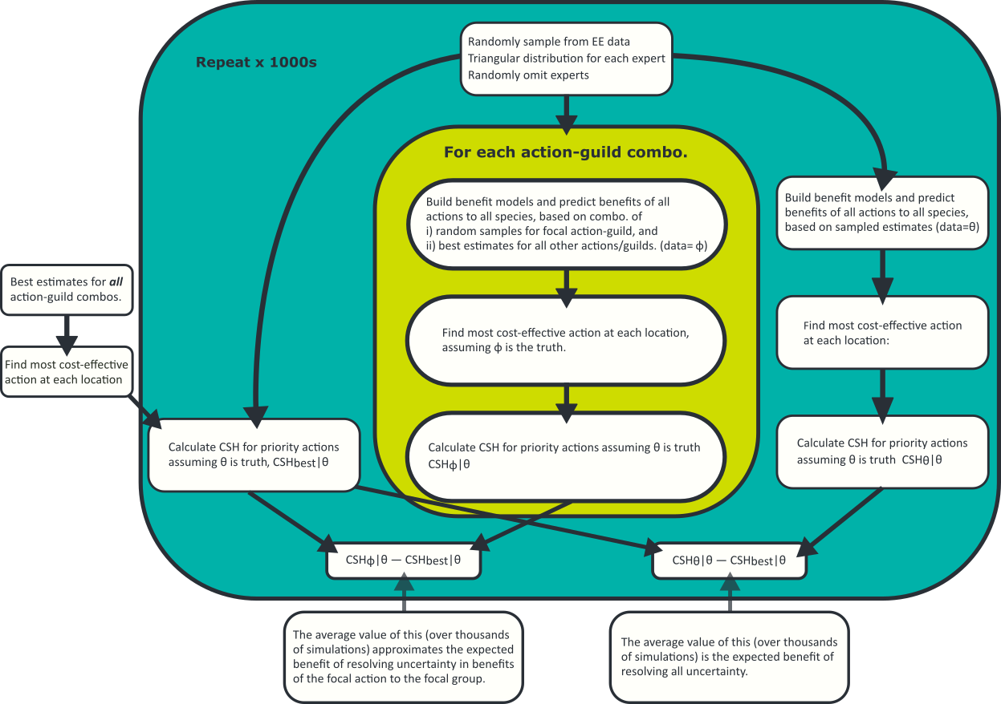
Figure 8. The process for calculating expected gain using SMP.

Appendix 2. Standard terminology

When building a causal model, the following terminology should be used to ensure consistency across models.

Threats
Feral cats
Feral deer
Red foxes
Feral goats
Feral pigs
Rabbits
Feral horses
Grazing by domestic stock
Overabundant kangaroos
Land clearing
Lack of fire
Weed invasion
Historical land clearing

Actions
Cat control
Deer control
Fox control
Goat control
Pig control
Rabbit control
Horse control
Domestic stock control
Kangaroo control
Permanent protection
Ecological burning
Weed control
Revegetation
Translocation

Appendix 3. Steps for creating FCMs in Mental Modeler
Mental Modeler is an on-line free FCM creation tool (Figure 9Error! Reference source not found.). Mental Modeler is accessed via a web browser and requires Adobe Flash Player. In theory it should work in any browser, however, it seems to work best in Firefox. It may be necessary to try a different browser if this doesn’t work.
www.mentalmodler.org
- username: mentalmodeler
- password: mentalmodeler
Figure 9. Steps to open the Mental Modeler model builder.
Build best- andworst-case as separate models, or in in case these are not parameterised, build a single base model that can be updated later. Mental Modeler allows for colouring the different components there are six of these. We suggest building the model such that the actions are at the top and the objectives are at the bottom (Figure 10), the location of other components will vary according to the model, some components will not be included in all models. The Management action, threat and objective components are compulsory, and we anticipate that all models will include processes. It is likely that most models will not have the components of objectives, this is relevant where processes act differently on different contributing parts of the objective (e.g. life stage, populations or species), should the inclusion of these components might trigger a review as these might be more appropriate as separate objectives in the model or as objectives in a separate model (Table 5Error! Reference source not found.).
Models can be saved in Mental Modeler format and saved versions can be re loaded via the web page. Note that once a model is loaded the connection with the saved version is lost (equivalent to “save as”) and therefore the original file will need to be overwritten or the current version saved with a new file name.

Figure 10. Node types as they appear in Mental Modeler.

Table 5. Description of node types for FCMs built in mental modeler.
Component | Description | Example | Status | Colour
External modifier | External influences on model components for which there is no relevant management action. | Climate change | Optional
Management action | A deliberate action, usually to mitigate a threat but may also have undesirable outcomes. | Fox control | Compulsory
Threat | A biotic or abiotic component that is considered to negatively impact the objective and has at least one management action. | Fox density | Compulsory
Process | A component of the system that is directly impacted by a threat and or an action (may also be influenced by external modifiers. Usually influences the objective. | Predation pressure | Desirable
Component of objective | Included where different parts of an objective are influenced differently by other model components (e.g. separate populations of a species). Likely not to be included in most models. | Abundance of a particular life stage | Optional
Objective | The ultimate target for management could be a species, group of species…. | Abundance of small mammals | Compulsory

Steps for creating a model (see Figure 11)
- Click add component
- Type the name of the node inside the box
- Select the colour of the node type from the Group box on the left
- Add another component and repeat the above steps
- To link components, click on the parent node and then on the arrow that emerges from the bottom of the node, drag the arrow to the child node
- To add the strength, click on the black box and move the slider up or down to select the desired strength and whether there is a positive or negative relationship between the nodes.

Figure 11. The model builder screen.

Mental modeler allows for the user to specify the strength and direction of the interaction on a scale of -1 to -0.01 and 0.01 to 1. We are using an ordinal scale and (-3 to -1 and 1 to 3). When constructing a best or worst case model the scales need to be converted such that they equal that in Table 6 . If you are creating a base model (e.g. to get the model structure) then use -0.5 for negative influence and 0.5 for positive influence. To check that

Table 6. Conversion scale for link strength.
Our scale | Mental modeler scale
-3 | -1
-2 | -0.67
-1 | -0.33
0 | 0
1 | 0.33
2 | 0.67
3 | 1

So that models can be directly compared it is necessary that they contain the same components even if those components do not have any links in the model. This is because the output is a N x N matrix where N must be the same for the best- and worst-case matrices so that analysis can be completed.

Exporting matrices for analysis
Models can be exported as either CSV or XLS. We recommend exporting as XLS as this allows it to be opened directly in Excel. Choose from Export XLS from the top menu, it might it prompt for confirmation, select open in Excel, Excel may prompt you that the extension and file type don’t match click yes to open the file. In Excel you will need to save it with a sensible file name.
There are three steps required to process the data for analysis in R
- Replace all the blank cells with 0 (zero), R will interpret missing values as missing data
- Replace the mental modeler scale with our scale according to Table 6. Conversion scale for link strength.
- Save as a CSV file.

Loading and importing matrices
Previously saved model files can be loaded into Mental Modeler by selecting the Load button. Any changes made will have to be saved and if new XLS files exported for analysis. Mental also allows for the importation of matrices from CSV files, note this will cause any information about node types to be lost.

Exporting the FCM image
Unfortunately, Mental Modeler doesn’t allow the export of editable image files. There are two ways to save generate an image of the model, by clicking print and then printing to a PDF file or by taking a screenshot (there is a dedicated screenshot button, in the top right corner, it looks like a camera). It may be better to create model images in dedicated software (such as Microsoft Visio) if high quality images are required.

Example
This example Error! Reference source not found. shows a model constructed in mental modeler for a single species (Button Wriklewort) with several threats and corresponding management interventions, it is a base model as the strength of influence to construct best- and worst-case models hasn’t been determined, the model contains all components.
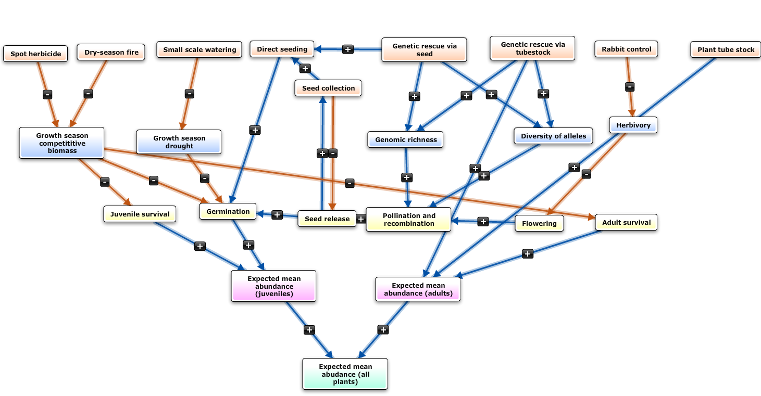
Figure 12. Example model from Mental Modeler.
This model a model depicting management options for Button Wrinklewort (Rutidosis leptorrhynchoides). This model contains all node types except external modifier.
Figure 13 shows the matrix from the above model before post processing. The direction of influence in the matrix is row to column.

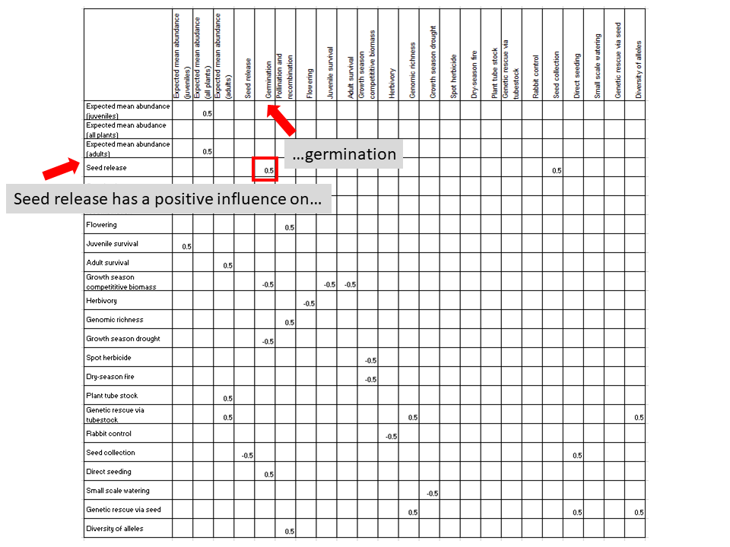
Figure 13. Example matrix produced from the Button Wrinklewort model.
Note this matrix requires processing using the steps above before it is ready for analysis. It shows the causal relationship from seed release to germination.

Appendix 4. R code for the automated comparison of best- and worst-case models
We have developed R code to compare the proportional reduction in distance for all combinations of non-zero elements in the best- and worst-case matrices. The code below takes two inputs; a best-case and a worst-case matrix as csv files (see main text and Appendix 1 for instructions on how to prepare these).
It produces three outputs, Error! Reference source not found. shows the relationship between these files and how to determine the proportional reduction in distance for a project.
- non_0_elements_info.csv: lists which links have been investigated
- manipulated_non_0_elements_id.txt: lists all changes for a given number of changes
- distance_and_reduction_after_manipulating_non_0_elements.txt: contains the proportional reduction in distance for all possible combinations of links
The analysis will take several hours to run (the time depends on the number of links) and the output files (except non_0_elements_info.csv) will be very large.

# This program is to automate the calculation of distance between causal matrices with changing elements
# using the generalized distance ratio method.

# The routines in this program were the same as in the program generalized_distance_ratio.r.

# modified on 24 July 2019 by Canran Liu.

# source("u:/accudx/distance_btwn_causal_matrices.r")

# source("\\\\10.194.214.68\\Spatial_Prod\\SAN_Projects\\liu\\U_copy\\accudx\\distance_btwn_causal_matrices.r")

##########################################################################################################################################################

# This first function gm() will be used in the next function gdr().

# gm() takes one element from each of the two maps (i.e. matrices) and a value of the parameter gamma.

gm <- function(x,y,gamma) {

if (gamma == 0) {

z <- 0

} else {

if (gamma == 1 & x == 0 & y == 0) {

z <- 0

} else {

z <- 1

}

}

return(z)

} # end of the function gm()

#-----------------------------------------------------------------------------------------------

# Function gdr() to calculate the generalized distance ratio for two causal maps

gdr <- function(a,b,alfa,beta,delt,gamma,epsn) {

# derive another parameter gamma_p from the parameter gamma

if (gamma == 0) {

gamma_p <- 0

} else {

gamma_p <- 1

}

p <- nrow(a)

a2 <- a*a
b2 <- b*b

Row2Sum_A <- apply(a2,1,sum) # row square sum
Col2Sum_A <- apply(a2,2,sum)

nodes_A <- unique(c(c(1:p)[Row2Sum_A != 0],c(1:p)[Col2Sum_A != 0])) # nodes in map A
nA <- length(nodes_A) # number of nodes in A

Row2Sum_B <- apply(b2,1,sum)
Col2Sum_B <- apply(b2,2,sum)

nodes_B <- unique(c(c(1:p)[Row2Sum_B != 0],c(1:p)[Col2Sum_B != 0])) # nodes in map B
nB <- length(nodes_B) # number of nodes in B

nodes_AB_C <- intersect(nodes_A,nodes_B) # nodes common to A and B
nodes_A_U <- setdiff(nodes_A,nodes_AB_C) # nodes unique to A
nodes_B_U <- setdiff(nodes_B,nodes_AB_C) # nodes unique to B

s <- 0

for (i in 1:p) {

for (j in 1:p) {

if (i == j & alfa == 1) {

dif <- 0

} else {

if ((length(intersect(i,nodes_AB_C))==0 | length(intersect(j,nodes_AB_C))==0)

& (length(setdiff(nodes_A,c(i,j))) == nA-2 | length(setdiff(nodes_B,c(i,j))) == nB-2)) {

dif <- gm(a[i,j],b[i,j],gamma)

} else {

if (a[i,j]*b[i,j] < 0) {

dif <- abs(a[i,j]-b[i,j]) + delt

} else {

dif <- abs(a[i,j]-b[i,j])

}

}

}

s <- s + dif

}

}

pc <- length(nodes_AB_C)
puA <- length(nodes_A_U)
puB <- length(nodes_B_U)

w <- (epsn * beta + delt) * pc * pc
+ gamma_p * (2 * pc * (puA + puB) + puA * puA + puB *puB)
- alfa * ((epsn * beta + delt) * pc + gamma_p * (puA + puB))

return(s/w)

} # end of the function gdr()

##################################################################################################################################

# main program

# five parameters. The following values roughly correspond to the method used in: Langfield-Smith, K.M. & Wirth, A. 1992. Measuring differences between cognitive maps. J. Operational Res. Soc. 43(12): 1135-1150.
# For other values, please consult: Markoczy, L. & Goldberg, J. 1995. A method for eliciting and comparing causal maps. J. Manage. 21(2): 305-333.
# But in: Markoczy, L. & Goldberg, J. 1995. A method for eliciting and comparing causal maps. J. Manage. 21(2): 305-333.
# They set gamma = 2. So, we will use this value instead of the above value 1.

alfa <- 1
beta <- 3
gamma <- 2
delt <- 0
epsn <- 2

fdir <- "J:\\Community Ecology\\Projects - shared\\MER\\Knowledge Framework\\Distance ratio\\"

#fdir <- "W:\\SAN_Projects\\liu\\U_copy\\stat_consult\\bruce-3\\"

fln1 <- paste(fdir,"foxegbest.csv",sep="")
fln2 <- paste(fdir,"foxegworst.csv",sep="")

fln_out1 <- paste(fdir,"non_0_elements_info.csv",sep="")
fln_out2 <- paste(fdir,"manipulated_non_0_elements_id.txt",sep="")
fln_out3 <- paste(fdir,"distance_and_reduction_after_manipulating_non_0_elements.txt",sep="")

dt1 <- read.csv(fln1,header=TRUE,row.names=1)
dt2 <- read.csv(fln2,header=TRUE,row.names=1)

dist0 <- gdr(dt1,dt2,alfa,beta,delt,gamma,epsn) # for the original matrices

nr <- nrow(dt1)
rc <- NULL # store (row, col) pairs for all the non-zero elements for either of the two matrices

rc_nm <- NULL # store (row name, col name) pairs for all the non-zero elements for either of the two matrices

nm <- names(dt1)

for (i in 1:nr) {
for (j in 1:nr) {
if (dt1[i,j] != 0 | dt2[i,j] != 0) {
rc <- rbind(rc,c(i,j))
rc_nm <- rbind(rc_nm,c(nm[i],nm[j]))
}
}
}

non_0_elements_info <- data.frame(element_id=1:nrow(rc),row=rc[,1],col=rc[,2],name_row=rc_nm[,1],name_col=rc_nm[,2])

write.csv(non_0_elements_info,file=fln_out1,row.names=FALSE)

nnz <- nrow(rc)
comb_id <- list() # store the row id of rc. The corresponding element(s) will be changed.
dist <- list() # distance between the best one and the manipulated one

i <- 1
comb_id[[i]] <- combn(1:nnz,i)
cat(file=fln_out2,i,"\n")
write.table(comb_id[[i]],file=fln_out2,row.names=FALSE,col.names=FALSE,append=TRUE)

ncb <- length(comb_id[[i]])
#dist[[i]] <- matrix(0,nr=ncb,nc=4)
dist1 <- numeric(ncb)
dist_r <- numeric(ncb)
for (j in 1:ncb) {
dtj1 <- dt1 # later some elements will be changed
dtj2 <- dt2
rcj <- rc[comb_id[[i]][j],]
vj <- (dt1[rcj[1],rcj[2]] + dt2[rcj[1],rcj[2]])/2
dtj1[rcj[1],rcj[2]] <- vj
dtj2[rcj[1],rcj[2]] <- vj
distj <- gdr(dtj1,dtj2,alfa,beta,delt,gamma,epsn)
#dist[[i]][j,] <- c(1,j,distj,(dist0-distj)/dist0)
dist1[j] <- distj
dist_r[j] <- (dist0-distj)/dist0
}
dist[[i]] <- data.frame(n_changes=rep(1,ncb),combn_id=1:ncb,dist_after_change=dist1,dist_prop_reduction=dist_r)
write.table(dist[[i]],file=fln_out3,col.names=TRUE,row.names=FALSE)

for (i in 2:nnz) {

cat("i = ",i,"\n")

comb_id[[i]] <- combn(1:nnz,i)
cat(file=fln_out2,i,append=TRUE,"\n")
write.table(comb_id[[i]],file=fln_out2,row.names=FALSE,col.names=FALSE,append=TRUE)

ncb <- ncol(comb_id[[i]]) # number of combinations when drawing i elements

dist1 <- numeric(ncb)
dist_r <- numeric(ncb)
for (j in 1:ncb) {
dtj1 <- dt1 # later some elements will be changed
dtj2 <- dt2
for (k in 1:i) {
rcj <- rc[comb_id[[i]][k,j],] # k-th element in the j-th combination
vj <- (dt1[rcj[1],rcj[2]] + dt2[rcj[1],rcj[2]])/2
dtj1[rcj[1],rcj[2]] <- vj
dtj2[rcj[1],rcj[2]] <- vj
}

distj <- gdr(dtj1,dtj2,alfa,beta,delt,gamma,epsn)
dist1[j] <- distj
dist_r[j] <- (dist0-distj)/dist0

}

dist[[i]] <- data.frame(n_changes=rep(i,ncb),combn_id=1:ncb,dist_after_change=dist1,dist_prop_reduction=dist_r)

write.table(dist[[i]],file=fln_out3,col.names=FALSE,row.names=FALSE,append=TRUE)
}

save.image(paste(fdir,"distance.RData",sep=""))

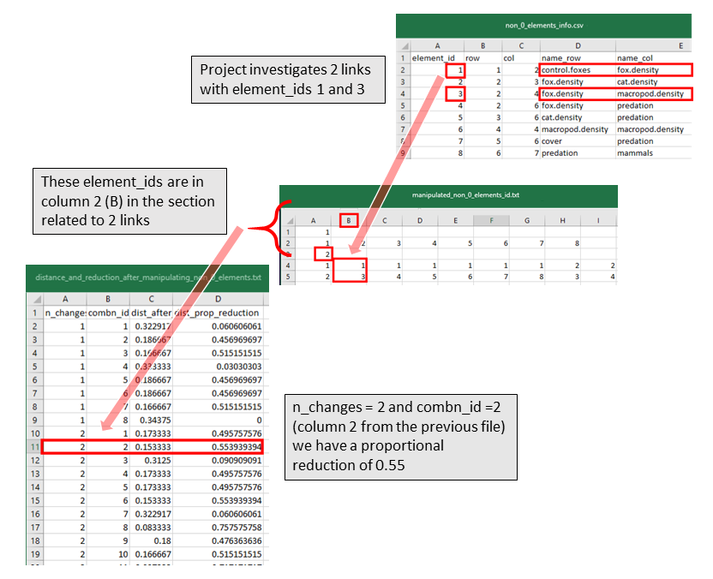
Figure 14. The relationship between the three output files needed to determine the proportional reduction in distance.
This figure uses Project A as an example.

www.delwp.vic.gov.au

