Introduction
Biodiversity Response Planning (BRP) is a long-term area-based planning approach to biodiversity conservation in Victoria. It is designed to strengthen alignment, engagement and participation between government, Traditional Owners, non-government agencies and the community.
DELWP Regional staff have been working with stakeholders on actions to conserve biodiversity in specific landscapes, informed by the best available science and local knowledge.
These Fact Sheets capture a point in time, reflecting data and knowledge available in 2020. They provide information for many (but not all) landscapes across Victoria, containing general information on the key values and threats in each area, as well as the priority cost-effective actions that provide the best protection of biodiversity. Fact Sheets are intended to provide useful biodiversity information for the community, non-government and government organisations during project planning and development.
Further information and the full list of Fact Sheets is available on the Department’s Environment website.

Landscape description
The Tottington landscape is 37,251ha, with 38% of the area covered in native vegetation. Public land reserves make up 22% which includes Morrl Morrl Nature Conservation Reserve (NCR), Mount Bolangum NCR and Big Tottington NCR. Refer to the map at the end of this Fact Sheet.

Cultural importance
We recognise that the entire landscape has high cultural value for Traditional Owners. Landscapes identified as having “notable” cultural importance is based on the density of recorded cultural heritage sites and knowledge shared by Traditional Owners. We also recognise that there are locations important to Traditional Owners not within these landscapes.

Stakeholder interest
As part of the BRP process, in October 2020 stakeholders were asked to nominate focus landscapes and actions of interest. Buloke and Northern Grampians Landcare Network, Kara Kara Conservation Management Network, and Dja Dja Wurrung all nominated Tottington.
Possible future investment/project development in this landscape will be available to any interested stakeholders in addition to those who nominated this landscape.

 | Habitat Distribution Models identify 3 species with more than 5% of their Victorian range in this landscape area | Traditional Owners, stakeholders and community groups identified the following species of interest within this landscape
 | 3 Plants:  - Brilliant Sun-orchid (Thelymitra mackibbinii), endangered with 20% of its Victorian range in area  - Red-cross Spider-orchid (Caladenia cruciformis), endangered with 11% of its Victorian range in area  - Large Rustyhood (Pterostylis maxima), vulnerable with 8% of its Victorian range in area | - Candy Spider-orchid  - Buloke
 | Birds | - Bush Stone-curlew  - Powerful Owl  - Swift Parrot  - Crested Bellbird

Strategic Management Prospects
Strategic Management Prospects (SMP) models biodiversity values such as species habitat distribution, landscape-scale threats and highlights the most cost-effective actions for specific locations. More information about SMP is available in NatureKit.

Additional threats
Threats identified (in addition to those modelled in SMP) through the consultation process were:
- alterations to hydrology
- land salinisation
- soil erosion
- habitat degradation due to extremes of climate and weather, and lack of regeneration in some vegetation classes
- recreational activities causing fragmentation
- loss of vegetation, and erosion
- legacy use of public land
- private land use impacting biodiversity
- inappropriate land use planning
- inappropriate fire regimes (planned burning and bushfires)
Some individual threatened species may also require targeted intervention, beyond actions to manage landscape-scale threats, to improve their future prospects.

Which landscape-scale actions are most cost-effective in this landscape?
The coloured areas of this map indicate where the identified landscape-scale actions and locations are most cost-effective and will maximise biodiversity benefit across Victoria for multiple species.
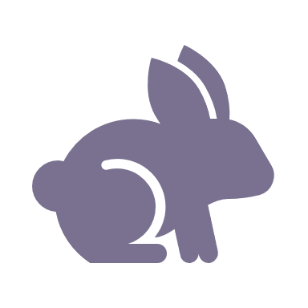 | Control rabbits 1,306ha
 | Control overabundant kangaroos 1,230ha
 | Control weeds 1,023ha
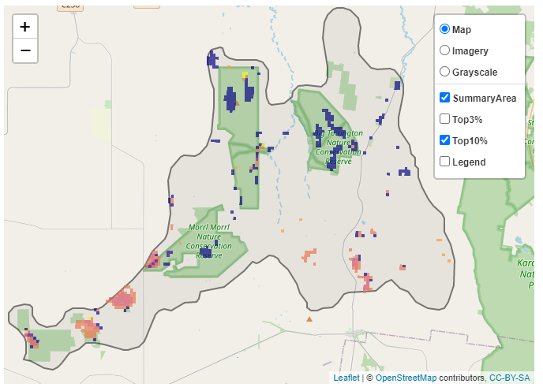
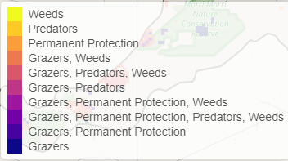
The SMP priority actions which rank among the top 10% for cost-effectiveness of that action across Victoria for much of the landscape are in order of the top 3 actions, see map and list below:

Of the top 10% of cost-effective actions, controlling rabbits provides the most cost-effective biodiversity benefits when considering all flora and fauna.

From the nomination process the following additional action was also suggested for this landscape:
- deer control

The most cost-effective actions for flora and fauna
 | Plants - Control weeds
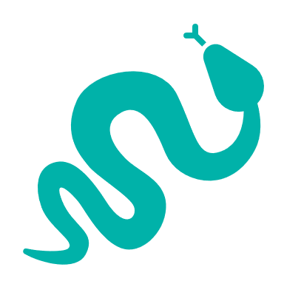 | Mammals, birds, reptiles, amphibians - Control overabundant kangaroos

For a further in depth look into SMP for this landscape please refer to NatureKit.

