Introduction
Biodiversity Response Planning (BRP) is a long-term area-based planning approach to biodiversity conservation in Victoria. It is designed to strengthen alignment, engagement and participation between government, Traditional Owners, non-government agencies and the community.
DELWP Regional staff have been working with stakeholders on actions to conserve biodiversity in specific landscapes, informed by the best available science and local knowledge.
These Fact Sheets capture a point in time, reflecting data and knowledge available in 2020. They provide information for many (but not all) landscapes across Victoria, containing general information on the key values and threats in each area, as well as the priority cost-effective actions that provide the best protection of biodiversity. Fact Sheets are intended to provide useful biodiversity information for the community, non-government and government organisations during project planning and development.
Further information and the full list of Fact Sheets is available on the Department’s Environment website.

Landscape description
This 296,621ha area is a mostly cleared landscape (10% native vegetation cover) and is mostly private land (97%). The landscape is bordered by the Yarriambiack Creek in the west and takes in the north-eastern most parts of the Wimmera Catchment Management Authority boundary.

Habitat Distribution Models identify 93 species with more than or close to 5% of their Victorian range in this landscape
90 Plants
- Notably the Wimmera Rice-flower (21% of Victorian range in landscape, EPBC*-listed Critically Endangered), Downy Swainson-pea (14% of Victorian range in landscape, FFG**-listed) and Buloke Mistletoe (5%of Victorian range in landscape)
*Environment Protection and Biodiversity Conservation Act 1999 (Federal)
**Flora and Fauna Guarantee Act 1988 (Victorian)

Strategic Management Prospects
Strategic Management Prospects (SMP) models biodiversity values such as species habitat distribution, landscape-scale threats and highlights the most cost-effective actions for specific locations. More information about SMP is available in NatureKit.

Which landscape-scale actions are most cost-effective in this landscape?
Some areas of this focus landscape (coloured areas on the map) have highly cost-effective actions which provide significant benefit for biodiversity conservation.
The SMP priority actions which rank among the top 10% for cost-effectiveness of that action across the state are in order:
Control goats 29,170ha
Control rabbits 16,215ha
Control weeds 3,177ha
Control overabundant kangaroos 1,949ha
Control domestic stock grazing 501ha
Control pigs 270ha
Permanent protection 258ha
Revegetation 127ha

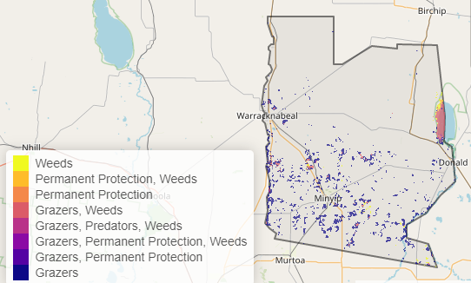

Of the top 3% of cost-effective actions, controlling overabundant kangaroos and permanent protection rank the highest.

The most cost-effective actions for flora & fauna
Plants, Birds, Mammals, Reptiles - Control rabbits, control weeds, control kangaroos

For a further in depth look into SMP for this landscape please refer to NatureKit.

