“We acknowledge the Wadawurrung people of the Kulin Nation as the Original Custodians of the lands which represents the following information. We pay respects to Elders past, present and emerging leaders that continue their obligations to care for Country. We care for Country, Culture and Wadawurrung people”.

Peninsula

Introduction
Biodiversity Response Planning (BRP) is a long-term area-based planning approach to biodiversity conservation in Victoria. It is designed to strengthen alignment, engagement and participation between government, the Original Custodians, non-government agencies and the community.
DELWP Regional staff with Wadawurrung Traditional Owners Aboriginal Corporation have been working with stakeholders on actions to conserve biodiversity in specific landscapes, informed by the best available science and local knowledge.
These Fact Sheets capture a point in time, reflecting data and knowledge available in 2020. They provide information for many (but not all) landscapes across Victoria, containing general information on the key values and threats in each area, as well as the priority cost-effective actions that provide the best protection of biodiversity. Fact Sheets are intended to provide useful biodiversity information for the community, non-government and government organisations during project planning and development.
Further information and the full list of Fact Sheets is available on the Department’s Environment website.
This Fact Sheet includes the information from the Strategic Management Prospects (SMP) Output Summary for the Peninsula zone and the feedback from our stakeholders.

Landscape description
The Peninsula area is 52,524ha. The native vegetation cover is 24% and the public land cover is 18%.
It is a diverse ecological landscape with a mix of salt dependent / salt tolerant / non-salt tolerant vegetation communities and intricate aquatic systems.
The two major waterways are Barwon River and Thompson Creek. The significant wetlands and coastal areas include Lake Connewarre (Ramsar), Lorne-Queenscliff Coast Reserve (Ramsar), and the Swan Bay cluster (Ramsar).
The highest biodiversity values are in the public land blocks, the thin shoreline strip and the wetlands.

Cultural importance
Wadawurrung Country holds many values culturally and ecologically throughout the diverse landscape. Mountain country, grassland country, sea and coastal country provides for many flora and fauna species to inhabit the landscapes. Resources were aplenty and managed sustainably by the Wadawurrung. Due to previous land activities such as mining, land fragmentation and the introduction of pest species, the landscapes require good partnerships between Wadawurrung Original Custodians and land managers to reinvigorate Country. Wadawurrung land management practices will be supported and guided by the aspirations of the Wadawurrung Healthy Country Plan.
Initial Wadawurrung priority area identified – Lake Connewarre cluster.

Landscapes of interest added through feedback process
Bellarine Bayside Foreshore Committee of Management – Point Richards Flora and Fauna Reserve, Indented Heads Wetlands, Lower Bluff Reserve, St Leonards Lake Reserve.
Geelong City Council – Biosites of high value, Remanent Trees: Waurn Ponds creek frontage, Belmont Common, Corio Bay Coastal Reserve, Clifton Springs Foreshore Reserve, Drakes Bushland Reserve, St Leonards Lake Reserve, road reserves, Barwon Heads Village Park, Mt Duneed Recreation Reserve. Eucalyptus bellarinenensis sites: Ocean Grove Education Area and surrounding area, private land blocks St Leonards. Mt Connata: Grovedale.
Trust for Nature – Covenant Focal Areas: Barwon Heads private land, Barwon Heads Golf Club, Barwon Heads Thirteenth Beach Links, Murtnagurts Swamp.

Ecological Vegetation Classes (primary EVCs)
Endangered: Plains Grassy Woodland, Plains Grassland, Coastal Saltmarsh/Mangrove Shrubland Mosaic, Damp Sands Herb-rich Woodland, Wetland Formation, Grassy Woodland, Plains Sedgy Wetland.
Environment Protection and Biodiversity Conservation Act: Natural Damp Grasslands of the Victorian Coastal Plains, Assemblages of species associated with open-coast salt-wedge estuaries of western and central Victoria ecological community.
Feedback: Plains Brackish Sedge Wetland.

Ecological Vegetation Classes (secondary EVCs)
Environment Protection and Biodiversity Conservation Act: Natural Temperate Grasslands of the Victorian Volcanic Plains, Grassy Eucalypt Woodland of Victorian Volcanic Plains, Seasonal Herbaceous Wetlands (Freshwater) of the Temperate Lowland Plains ecological community.
Flora and Fauna Guarantee Act: Western Plains Grasslands Community.

Habitat Distribution Models identify 26 species with more than 5% of their Victorian range in this landscape area (updated 26/07/2020) | The following have been identified as focal species by the Original Custodians and stakeholders
17 plants with more than 5% of Victorian range in area. Notably:  - Bellarine Yellow-gum (endangered, 67%), Eel-grass (poorly known, 61%), Australian Grass-wrack (rare, 24%), Tasman Grass-wrack (rare, 22%), Coast Wirilda (rare, 20%) | 45 plants: Melbourne Yellow-gum, Hooded Water-milfoil, Sharp Club-sedge, Salt Club-sedge, Thread Rush, Large Kangaroo Apple, Sea Rush, Kangaroo Grass, Hedge Wattle, Sheep’s Burr, Australian Salt-grass, Lake Water-milfoil, Black Wattle, Coast Bitter-bush, Swamp Gum, Running Postman, Common Tussock-grass, Golden Wattle, Drooping Sheoak, Small-leaved Clematis, Pink Bindweed, Common Spike-sedge, Pale Rush, Coast Tea-tree, Small Loosestrife, Narrow-leaf Cumbungi, Lightwood, Cranberry Heath, Silver Banksia, Water Ribbons, Kidney-weed, Weeping Grass, Common Reed, Blackwood, River Red-gum, Prickly Tea-tree, Coast Everlasting, Slender Dock, Silver Wattle, Coarse Dodder-laurel, Tangled Lignum, Cherry Ballart, Austral Crane’s-bill, Pale Knotweed, Tall Bluebell, Small-leaf Bramble
9 birds with more than 5% of Vic range in area. Notably:
- Orange-bellied Parrot (critically endangered, 39%), Whimbrel (vulnerable, 6%), Sanderling (near threatened, 6%), Black-faced Cormorant (near threatened, 6%)

Strategic Management Prospects
Strategic Management Prospects (SMP) models biodiversity values such as species habitat distribution, landscape-scale threats and highlights the most cost-effective actions for specific locations. More information about SMP is available in NatureKit.

Additional threats
Threats identified (in addition to those modelled in SMP) through the consultation process were native vegetation removal, barriers to on-ground management, water quality and quantity, rising sea levels, littering, inappropriate land use, coastal erosion, dogs, fire timing, wildfires, illegal tracks, increased visitation, mining of shell grit, and urban encroachment.

Which landscape-scale actions are most cost-effective in this landscape?
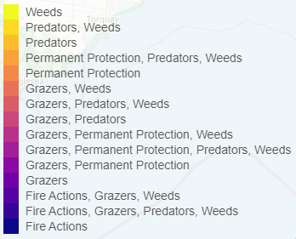
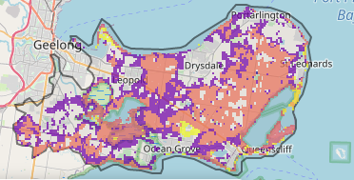
The map shows where the most cost-effective threat control actions in this landscape are. Actions in these areas will maximise biodiversity benefit across Victoria for multiple species.

The very best threat control actions to do in the Top 3% of cost-effective areas are: rabbits, overabundant kangaroos, weeds, grazing pressure (all grazers) and permanent protection.
When we bring in the Top 10%, we also add the activities: fox, cat, domestic grazing and ecological burning.
Area available for highly cost-effective revegetation
2411ha
For a further in depth look into SMP for this landscape please refer to NatureKit.

Priority Areas Map - Peninsula
Base layers: This data is from SMP and represents the best areas to carry out the most cost-effective actions for specific threats (also referred to as the Top 10% of Mean Cost-effectiveness (MCE) actions), and the Top 20% locations (these locations have been given names and are referred to as descriptors).
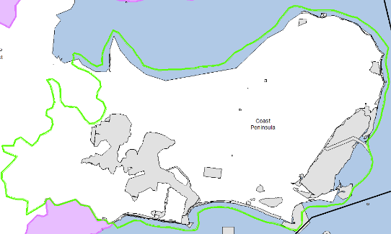
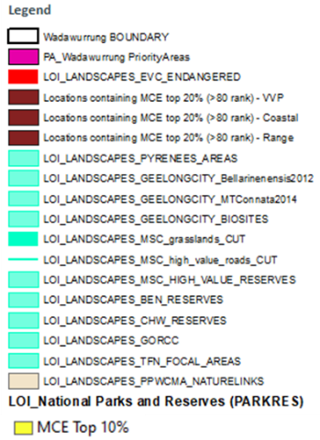
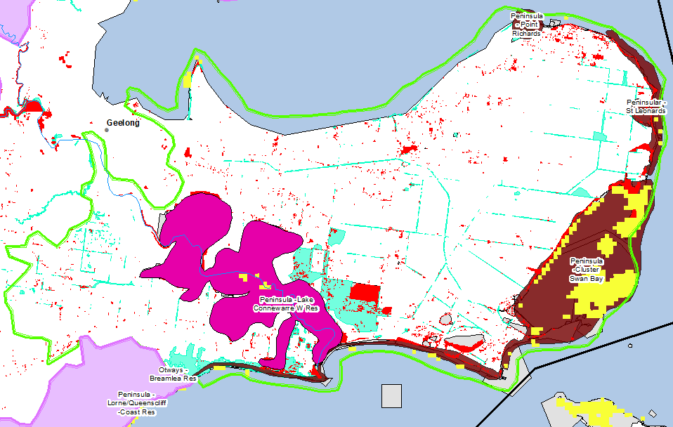
Priority Areas: Wadawurrung Priority Areas, stakeholder’s Landscapes of Interest (LoI), endangered Ecological Vegetation Classes (EVCs), National Parks and Reserves.
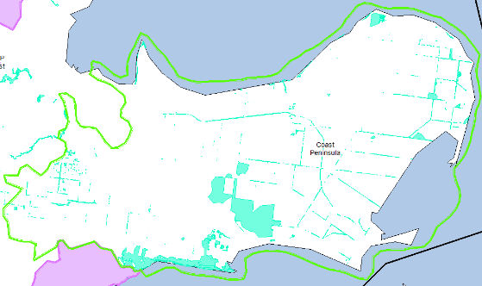
National Parks and Reserves (grey)
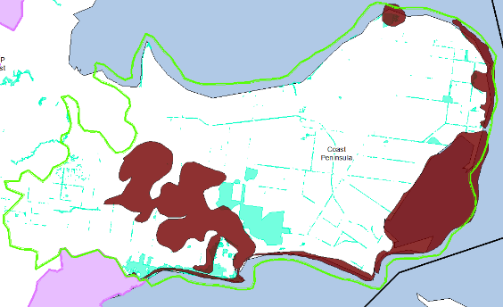
Stakeholder’s LoI (aqua)
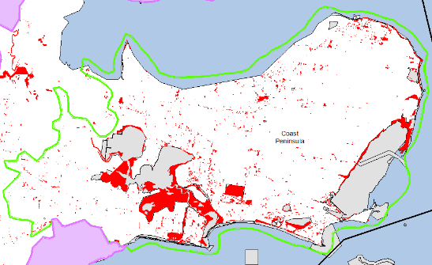
Descriptor (brown)
Endangered EVCs ((red) left)
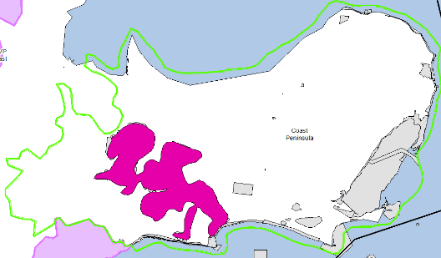
Wadawurrung initial Priority Areas ((pink) left bottom)

