Introduction
Biodiversity Response Planning (BRP) is a long-term area-based planning approach to biodiversity conservation in Victoria. It is designed to strengthen alignment, engagement and participation between government, Traditional Owners, non-government agencies and the community.
DELWP Regional staff have been working with stakeholders on actions to conserve biodiversity in specific landscapes, informed by the best available science and local knowledge.
These Fact Sheets capture a point in time, reflecting data and knowledge available in 2020. They provide information for many (but not all) landscapes across Victoria, containing general information on the key values and threats in each area, as well as the priority cost-effective actions that provide the best protection of biodiversity. Fact Sheets are intended to provide useful biodiversity information for the community, non-government and government organisations during project planning and development.
Further information and the full list of Fact Sheets is available on the Department’s Environment website.

Landscape description
This 133,000ha area has substantial native vegetation (32% cover) and has substantial public land (31%). In the west the landscape is defined by the Annuello Flora and Fauna Reserve (FFR) and the area to the east of Annuello includes some significant reserves such as Wandown and Menzies FFR. Land adjoining public land (within a 1km buffer) and significant roadsides are also included. There is a minor overlap with the Murray Sunset landscape in the west. You can find further information on Murray Sunset landscape in the full list of Fact Sheets.

Cultural importance
We recognise that the entire landscape has high cultural value for Traditional Owners. Landscapes identified as having “notable” cultural importance is based on the density of recorded cultural heritage sites and knowledge shared by Traditional Owners. We also recognise that there are locations important to Traditional Owners not within these landscapes.
There is notable cultural importance for Tati Tati Wadi Wadi people.

Stakeholder interest
As part of the Biodiversity Response Planning process, in October 2020 stakeholders were asked to nominate focus landscapes and actions of interest. Tati Tati Wadi Wadi, Mallee Catchment Management Authority, Trust for Nature, Parks Victoria and Swan Hill Rural City Council nominated Annuello - Wandown.
Possible future investment/project development in this landscape will be available to any interested stakeholders in addition to those who nominated this landscape.
Specific stakeholder interests identified through the engagement process within this landscape include:
- Parks Victoria Mallee Conservation Action Plan asset – Mallee Triodia
- Mallee Catchment Management Authority, Regional Catchment Strategy priority landscapes – 9. Annuello, Climate Change priority corridor; 4: Eastern Central Mallee. Focus on the restoration (for example, connectivity of isolated remnants) and protection (for example, grazing/competition impacts) of high value habitat for priority species outcomes.

Community interest
There was no specific community interest in biodiversity conservation identified for this area through the consultation process.
 | Habitat Distribution Models identify 79 species with more than 5% of their Victorian range in this landscape area | Traditional Owners, stakeholders and community groups identified the following species of interest
61 Plants with more than 5% of Victorian range in the area. Notably:
Cactus Bossiaeae (endangered, 37% of Victorian range in area)
Yellow Swainson Pea (vulnerable, 9% of Victorian range in area)
 | 3 Mammals with more than 5% of Victorian range in the area. Notably:  South-eastern Long-eared Bat (endangered, 7% of Victorian range in area)  Common Dunnart (vulnerable, 3% of Victorian range in area) | South-eastern Long-eared Bat  Mallee Ningaui
 | 9 Reptiles with more than 5% of Victorian range in the area. Notably:  Lined Earless Dragon (critically endangered, 5% of Victorian range in area)  Bandy Bandy (vulnerable, 5% of Victorian range in area) | Bandy-bandy  Desert Skink  Mallee Worm Lizard  Murray-Darling Carpet Python
 | 6 Birds with more than 5% of Victorian range in the area. Notably:  Threatened Mallee Birds – Mallee Emu-wren (endangered), Black-eared Miner (critically endangered), Red-lored Whistler (endangered), Striated Grasswren (near threatened), (all 5-10% of Victorian range in area) | Threatened Mallee Birds – Mallee Emu-wren, Black-eared Miner, Red-lored Whistler Striated Grasswren, Malleefowl, Regent Parrot  Pink Cockatoo

Strategic Management Prospects
Strategic Management Prospects (SMP) models biodiversity values such as species habitat distribution, landscape-scale threats and highlights the most cost-effective actions for specific locations. More information about SMP is available in NatureKit.

Additional threats
Threats identified (in addition to those modelled in SMP) through the consultation process were:
- alterations to hydrology
- land salinisation
- soil erosion
- habitat degradation due to extremes of climate and weather
- lack of regeneration in some vegetation communities
- recreational activities causing fragmentation
- loss of vegetation, and erosion
- legacy use of public land
- private land use impacting biodiversity
- inappropriate land use planning
- inappropriate fire regimes (planned burning and bushfires)

Which landscape-scale actions are most cost-effective in this landscape?
Some areas of this focus landscape (coloured areas on the map) have highly cost-effective actions which provide significant benefit for biodiversity conservation.
Control goats 36,516ha
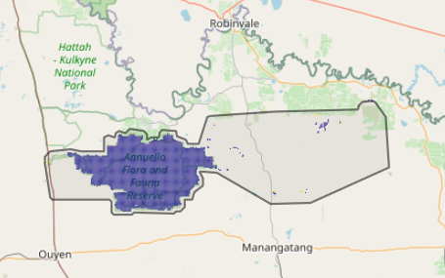
The SMP priority action which ranks among the top 3% for cost-effectiveness of that action across Victoria for much of the polygon (>25,000ha) is:

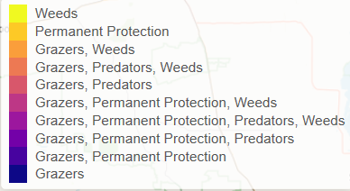
Of the top 10% of cost-effective actions, control goats provide the most cost-effective biodiversity benefits when considering all flora and fauna.

Actions suggested for this landscape through the nomination process are:
- control weed, fox, goat, rabbit and pigs
- revegetation
- permanent protection
- reintroduce cultural species – dingo

The most cost-effective action for flora and fauna
Control Goats

For a further in depth look into SMP for this landscape please refer to NatureKit.

