Background / preamble
The Gippsland Lakes landscape was recognised during the 2019/20 Gippsland Biodiversity Response Planning (BRP) process as a focus area for future collaborative biodiversity action and investment.
Under the Victorian Government’s Biodiversity 2037: Protecting Victoria’s Biodiversity plan, the BRP process is a long-term area-based planning approach to biodiversity conservation in Victoria. It is designed to strengthen alignment, engagement and participation between government, Traditional Owners, non-government agencies and the community to benefit biodiversity by working together to identify, promote and tackle local biodiversity needs as part of an ongoing collective process.
In 2019/20, significant impacts from the bushfires in East Gippsland and coronavirus (COVID-19) on community, biodiversity stakeholders and agencies, and the environment, resulted in planned engagement with many local stakeholders in Gippsland about BRP being postponed to a future process. In the interim, a multi-agency working group of local staff in Gippsland came together to identify a series of potential strategic priority actions across the region, as well as 13 focus landscapes. Membership of this working group for Gippsland included staff from the Department of Environment, Land, Water and Planning (DELWP) coasts & marine policy and local forest, fire and biodiversity teams, East Gippsland and West Gippsland Catchment Management Authorities (EGCMA & WGCMA), Parks Victoria, Trust for Nature (TfN), the Bunurong Land Council Aboriginal Corporation (BLCAC) and the Gunaikurnai Land and Waters Aboriginal Corporation (GLaWAC).
As part of this process, the Gippsland BRP working group drew upon information available from the DELWP Strategic Management Prospects (SMP) tool as well as their own local knowledge to identify key biodiversity assets, threats and potential management actions across Gippsland. A subset of this information is presented in this Fact Sheet, reflecting a point in time assessment of some of the important biodiversity needs and landscapes for focus across the region.
These BRP Fact Sheets provide useful biodiversity information for the community, non-government and government organisations during project planning and development, including guidance for stakeholders interested to contribute towards some of the strategic priorities identified in these areas to date. Further information and the full list of Fact Sheets is available on the Department’s Environment website.

Landscape description
Landscape context: 110,067ha, 69% public land, 71% native vegetation cover (including the lakes)
Major system of inland estuarine lakes and associated marginal wetlands between the Gippsland Plains and the coast. The lakes form the estuaries of the Latrobe/Thompson, Avon/Perry, Mitchell, Nicholson and Tambo Rivers. This landscape includes the barrier dune system separating the Gippsland Lakes from Bass Strait. Coastal Banksia Woodlands, Heathy Woodlands and saltmarsh vegetation are predominant on the coast and barrier.

Biodiversity highlights and important places:
The Lakes are an important Ramsar wetland and Asian-Australasian flyway site for migratory waders, particularly Lake Reeve (hypersaline) and the wetlands north of McLennan’s Strait (including Victoria Lagoon). The upper reaches of The Heart Morass and entirety of Sale Common are important freshwater wetlands (particularly for frogs), while fringing wetlands around the edges of the Lakes provide food & habitat for many species. Gippsland Water’s property at Dutson Downs supports important wetlands and the coastal heathlands and heathy woodland near Loch Sport support the largest New Holland Mouse population in the state. Blonde Bay Wildlife Reserve is an important site for threatened flora, including Swamp Everlasting and Metallic Sun-orchid and the lakes themselves include many scattered islands and support one of only two populations of Burrunan Dolphin.
Important vegetation communities in this landscape include:
*FFG listed | Forest Red Gum Grassy Woodland Community
**EPBC listed | Seasonal Herbaceous Wetlands of the Temperate Lowland Plains  Subtropical and Temperate Coastal Saltmarsh
*Flora and Fauna Guarantee Act 1988 (Victorian)
**Environment Protection and Biodiversity Conservation Act 1999 (Federal)

Cultural importance
We would like to acknowledge the Traditional Owners and custodians of the land across this landscape, the Gunaikurnai and particularly the Tatungalung and Brabralung people. We pay our respects to Country, and to Elders past and present whose knowledge and wisdom has ensured the continuation of culture and traditional practices. We are committed to genuinely partner, and meaningfully engage, with Victoria’s Traditional Owners and Aboriginal communities to support the protection of Country, the maintenance of spiritual and cultural practices and their broader aspirations into the 21st century and beyond in the spirit of self-determination.

The Gunaikurnai Land and Waters Aboriginal Corporation (GLaWAC) are the appointed Registered Aboriginal Party (RAP) and hold a Native Title Determination and Traditional Owner Recognition Settlement Agreement over this area, including Joint Management of The Lakes National Park, Gippsland Lakes Coastal Park and Gippsland Lakes Reserve on Raymond Island under Aboriginal Title. GLaWAC are an ongoing member of the local Gippsland Biodiversity Response Planning working group.

Stakeholder and community interest
Local engagement for BRP in Gippsland in 2019/20 was postponed due to impacts from fire and coronavirus (COVID-19). If you would like to contribute local knowledge about this landscape in the future, find out more about BRP or add your name to the state-wide or Gippsland BRP stakeholder lists, you can find further information on the Department’s Environment website.

Species summary
An analysis of available Habitat Distribution Models* identified 138 species with more than 5% of their Victorian range falling within the Gippsland Lakes BRP landscape, including 43 threatened species and 16 EPBC listed species.
*Note: While version 2.0 of the SMP model utilises HDMs for ~3,200 terrestrial species in its analysis, these models currently exclude aquatic, invertebrate, marine and non-vascular plant species. These HDMs and SMP will continue to be improved upon with ongoing input from species experts and natural resource management practitioners.
Species class | Species with a high proportion of their Victorian distribution in this landscape | Other notable species identified during the BRP process
73 plants, incl. 12 threatened species (5 EPBC) | Notable species include:  - Ribbed Thryptomene Thryptomene micrantha (96% of Victorian range, Victorian population occurs predominantly around the Gippsland Lakes)  - Coast Mistletoe Muellerina celastroides (53% of Victorian range)  - Marsh Saltbush Atriplex paludosa subsp. paludosa (44% of Victorian range)  - Gippsland Lakes Peppermint Eucalyptus Arenicola (37% of Victorian range, restricted to area around Gippsland Lakes through to Corner Inlet)  - Robust Spider-orchid Caladenia valida (FFG listed, endangered, 31% of Victorian range)  - Walsh’s Couch Zoysia macrantha subsp. walshii (30% of Victorian range)  - Tiny Arrowgrass Triglochin minutissima (29% of Victorian range)  - Small-leaf Star-hair Astrotricha parvifolia subsp. 1 (FFG listed, vulnerable, 14% of Victorian range, restricted to Gippsland Lakes hinterland area)  - Blotched Diuris Diuris sp. aff. dendrobioides (Bairnsdale) (FFG listed, endangered, 11% of Victorian range, restricted to grasslands around Bairnsdale)  - Maroon Leek-orchid Prasophyllum frenchii (EPBC listed, Endangered, 10% of Victorian range)  - Metallic Sun-orchid Thelymitra epipactoides (EPBC listed, Endangered, 9% of Victorian range)  - Limestone Blue Wattle Acacia caerulescens (EPBC listed, Vulnerable, 6% of Victorian range, restricted to Gippsland predominantly around Upper Tambo and Lake Tyers)  - Gaping Leek-orchid Prasophyllum correctum (EPBC listed, Endangered, 5% of Victorian range)  - Thick-lipped Spider-orchid Caladenia tessallata (EPBC listed, Vulnerable, 5% of Victorian range) | - Trailing Hop-bush Dodonaea procumbens (EPBC listed, Vulnerable, 0.3% of Victorian range, population at Dutson Downs is an important site for this species and the only known existing site in Gippsland)  - Dwarf Kerrawang Commersonia prostrata (EPBC listed, Endangered, 5% of Victorian range, Victorian population restricted to swampy land and lake margins around Rosedale-Stradbroke-Providence Ponds areas)  - Swamp Everlasting (EPBC listed, Vulnerable)
1 mammal, incl. 1 threatened species (1 EPBC) | Including:  - New Holland Mouse (EPBC listed, Vulnerable, 12% of Victorian range) | - None raised (but see below for aquatic and marine species)
2 reptiles, incl. 0 threatened species (0 EPBC) | Including:  - Four-toed Skink (8% of Victorian range)  - Metallic Skink (6% of Victorian range)
59 birds, incl. 29 threatened species (9 EPBC) | Notable species include:  - Great Knot (EPBC listed, Critically Endangered, 38% of Victorian range)  - Lesser Sand Plover (EPBC listed, Endangered, 33% of Victorian range)  - Pacific Golden Plover (FFG listed, vulnerable, 32% of Victorian range)  - Red Knot (EPBC listed, Endangered, 31% of Victorian range)  - Whimbrel (FFG listed, vulnerable, 31% of Victorian range)  - Hooded Plover (EPBC listed, Vulnerable, 30% of Victorian range)  - Grey Plover (FFG listed, endangered, 29% of Victorian range)  - Bar-tailed Godwit (EPBC listed, Vulnerable, 27% of Victorian range)  - Ruddy Turnstone (FFG listed, vulnerable, 26% of Victorian range)  - Eastern Curlew (EPBC listed, Critically Endangered, 26% of Victorian range)  - Greater Sand Plover (EPBC listed, Vulnerable, 24% of Victorian range)  - Marsh Sandpiper (FFG listed, vulnerable, 21% of Victorian range)  - Terek Sandpiper (FFG listed, endangered, 19% of Victorian range)  - Common Greenshank (FFG listed, vulnerable, 17% of Victorian range)  - Curlew Sandpiper (EPBC listed, Critically Endangered, 17% of Victorian range)  - Common Sandpiper (FFG listed, vulnerable, 15% of Victorian range)  - Little Tern (FFG listed, vulnerable, 15% of Victorian range)  - King Quail (FFG listed, endangered, 15% of Victorian range)  - Little Egret (FFG listed, endangered, 13% of Victorian range)  - White-bellied Sea-eagle (FFG listed, vulnerable, 12% of Victorian range)  - Freckled Duck (FFG listed, endangered, 11% of Victorian range)  - Australasian Bittern (EPBC listed, Endangered, 9% of Victorian range)  - Musk Duck (FFG listed, vulnerable, 8% of Victorian range)  - Little Bittern (FFG listed, endangered, 6% of Victorian range)  - Intermediate Egret (FFG listed, endangered, 6% of Victorian range)  - Eastern Great Egret (FFG listed, vulnerable, 6% of Victorian range)  - Australasian Shoveler (FFG listed, vulnerable, 5% of Victorian range) | - Fairy Tern (FFG listed, vulnerable)
3 frogs, incl. 1 threatened species (1 EPBC) | Including:  - Green and Golden Bell Frog (EPBC listed, Vulnerable, 12% of Victorian range)  - Tyler’s Toadlet (9% of Victorian range)  - Pobblebonk Frog (6% of Victorian range) | - Martin’s Toadlet (FFG listed, critically endangered, 3% of Victorian range)  - Growling Grass Frog (EPBC listed, Vulnerable, 1% of Victorian range)
Other species raised by the working group (e.g. fish, invertebrates etc):
Burrunan Dolphin (FFG listed, endangered, one of only two populations occurring in Victoria)

Strategic Management Prospects
Strategic Management Prospects (SMP) models species distributions, habitat importance, landscape-scale threats, and management costs. It then compares and highlights those places with the greatest opportunities for cost-effective action state-wide. Learn more about this tool on the SMP webpage.

Which landscape-scale actions are most cost-effective in this landscape?
The maps and information below show those places and actions modelled by SMP to provide the best opportunities for cost-effective action to benefit biodiversity across the state. Coloured areas in the maps below indicate opportunities for highly cost-effective actions that provide significant benefits to biodiversity in those places. If undertaken across Victoria, these collective actions should provide the greatest potential benefit to biodiversity by focusing on undertaking landscape-scale actions in places where they will provide the greatest benefit for cost across all species.

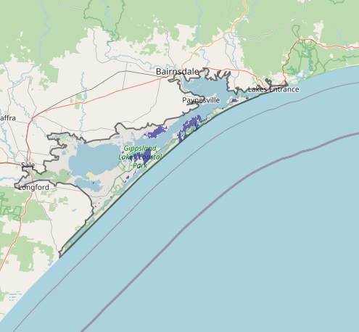
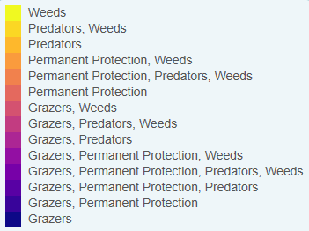
Map a) shows actions in the top 3% cost-effectiveness areas, and Map b) shows actions in the top 10% cost-effective areas.
Map a) – SMP top 3% cost-effective actions
The following landscape-scale actions were ranked among the top 3% cost-effective opportunities for biodiversity action across the state by SMP:

Control deer 3,361ha
Control overabundant kangaroos 2,273ha
Control rabbits 415ha
Control weeds 132ha
Control domestic stock grazing 96ha

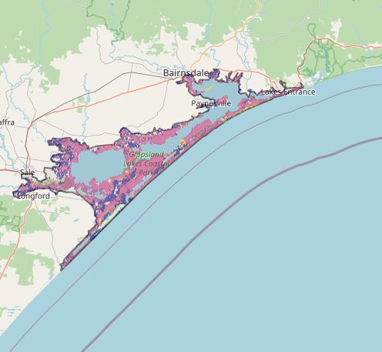
Map b) – SMP top 10% cost-effective actions
The following landscape-scale actions were ranked among the top 10% cost-effective opportunities for biodiversity action across the state by SMP:

Control weeds 46,626ha
Control rabbits 43,153ha
Combined fox and cat control 31,499ha
Control deer 26,765ha
Control cats 25,783ha

The most cost-effective actions for flora & fauna according to SMP
 | Plants – Control weeds and Control rabbits |  | Birds – Combined fox and cat control
 | Mammals – Combined fox and cat control |  | Amphibians – Combined fox and cat control (particularly cats), Control rabbits and Control deer
 | Reptiles – Combined fox and cat control (particularly cats)
For a further in depth look into SMP for this landscape please refer to NatureKit.

Additional threats raised by the working group
- Changes to natural flow regimes impacting upon wetlands
- Increased sediment and nutrient inflows to waterways / wetlands
- Drought and lack of refuges (a key threat for particular species such as New Holland Mouse)

Highest priority strategic actions
With consideration of the information available in SMP and local knowledge of this landscape, the Gippsland BRP working group identified the following priority actions for future collaboration and investment in this landscape:
The highest priority actions for the Gippsland Lakes landscape include:
- Management of sediment and nutrient inflows
- Permanent protection and domestic stock control around fringing wetlands and lower estuaries
- Predator control (particularly in fringing wetlands and along the outer barrier)
- Large herbivore control (particularly deer) in fringing wetlands
- Revegetation around fringing wetlands
- Ecological burning
- Restoration of natural flow regimes and aquatic habitats for priority waterways and wetlands
Other key actions highlighted by the working group include:
- Localised rabbit control
- Surveillance for and control / eradication of pigs and goats

