Introduction
Biodiversity Response Planning (BRP) is a long-term area-based planning approach to biodiversity conservation in Victoria. It is designed to strengthen alignment, engagement and participation between government, Traditional Owners, non-government agencies and the community.
DELWP Regional staff have been working with stakeholders on actions to conserve biodiversity in specific landscapes, informed by the best available science and local knowledge.
These Fact Sheets capture a point in time, reflecting data and knowledge available in 2020. They provide information for many (but not all) landscapes across Victoria, containing general information on the key values and threats in each area, as well as the priority cost-effective actions that provide the best protection of biodiversity. Fact Sheets are intended to provide useful biodiversity information for the community, non-government and government organisations during project planning and development.
Further information and the full list of Fact Sheets is available on the Department’s Environment website.

Landscape description
This 77,674ha area covers the north-eastern suburbs of Melbourne, peri-urban areas, as well as forested areas, including Kinglake National Park and Paul Range State Forest. The area has 54% native vegetation cover, and 28% is public land.

Cultural importance
We recognise that the entire landscape has high cultural value for Traditional Owners. Some landscapes have notable cultural importance based on knowledge shared by Traditional Owners. This landscape includes lands of the Wurundjeri people.
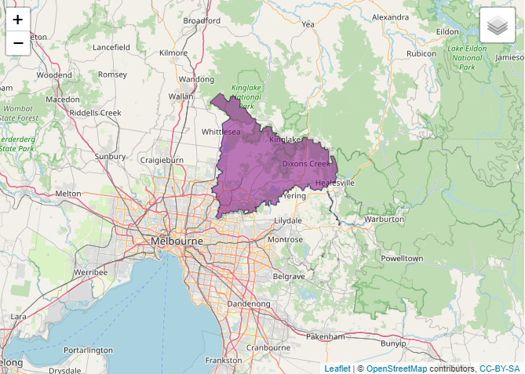

Figure 1: Map showing location of North East Region landscape (purple).

Habitat Distribution Models identify 32 species with more than 5% of their Victorian range in this landscape | Traditional Owners, stakeholders and community groups identified the following species of interest
- 30 Plant species  - 16 species with more than 10% of statewide range in area  - Notable species: Little Pink Spider-orchid (endangered, 81% of statewide range in area), Silurian Leek-orchid (endangered, 78% of statewide range in area), Charming Spider-orchid (endangered, 73% of statewide range in area); Slender Bitter-cress (poorly known, 59% of statewide range in area) | - Matted Flax-lily  - Clover Glycine  - Spider Orchids (Rosella Spider Orchid, Wine-lipped Spider Orchid, Crimson Spider Orchid)
- 0 Mammal species with more than 5% of their Victorian range in this landscape  - Notable species: Brush-tailed Phascogale (vulnerable, 3.5% of statewide range in area), Grey-headed Flying-fox (vulnerable, 1.6% of statewide range in area) | - Brush-tailed Phascogale  - Leadbeater’s Possum
- 2 Bird species  - 1 species with more than 10% of statewide range in area  - Notable species: Eastern Koel (11% statewide range in area), Helmeted Honeyeater (critically endangered, 7% statewide range in area, Bell Miner (3% statewide range in area), Regent Honeyeater (critically endangered, 2% statewide range in area) | - Swift Parrot
- 0 species of amphibians with more than 5% of their Victorian range in this landscape
- Notable species: Southern Toadlet (vulnerable, 2% statewide range in area)
Other species | - Eltham Copper Butterfly

Strategic Management Prospects
Strategic Management Prospects (SMP) models biodiversity values such as species habitat distribution, landscape-scale threats and highlights the most cost-effective actions for specific locations. More information about SMP is available in NatureKit.
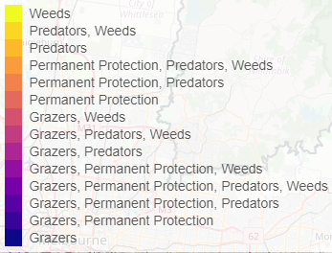
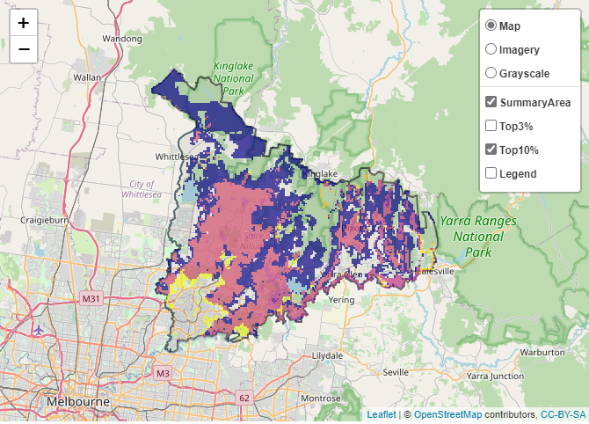
Areas of North East Region shown in Figure 2 have highly cost-effective actions (within the top 10% of cost-effectiveness for that action across the state) that provide significant benefit for biodiversity conservation.
Figure 2: The SMP priority actions which rank among the top 10% for cost-effectiveness of that action across the state. “Grazers” includes deer, domestic grazing, goats, horses, over-abundant kangaroos, pigs, rabbits and total grazing pressure

Actions with area in the top 3% and top 10%
Specific Action | Area in top 3% (ha) | Area in top 10% (ha)
Control Rabbits | 6,182 | 40,247
Control Weeds | 591 | 22,697
Control Goats | 9,794 | 16,744
Control Pigs | 8,748 | 11,299
Overabundant Kangaroo Control | 419 | 6,997
Revegetation | 0 | 4,924
Control Foxes | 598 | 4,909
Control Cats | 281 | 1,993
Deer Control | 8 | 1,484
Domestic Grazing Control | 124 | 1,468
Total Grazing Pressure | 41 | 1,369
Permanent Protection | 57 | 465

For a further in depth look into SMP for this landscape, please refer to NatureKit

The most cost-effective action for flora & fauna
Plants, Birds, Mammals, Amphibians and Reptiles - Control rabbits

For a further in depth look into SMP for this landscape, please refer to NatureKit.

Current actions in North East Region
Specific Actions | Current actions – top 10% (ha) | Current actions – outside top 10% (ha)
Rabbit Control | 557 | 195
Weed Control | 542 | 811
Fox Control | 71 | 1,336
Domestic Grazing Control | 29 | 619
Pig Control | 26 | 622
Permanent Protection | 11 | 636
Revegetation | 0 | 23

Current actions – top 10% = The area (ha) of the specific action currently occurring in locations identified by SMP as being in the top 10% for cost-effectiveness for that action across the state
Current actions – outside top 10% = The area (ha) of the specific action currently occurring in locations within this landscape that are not identified by SMP as being in the top 10% for cost-effectiveness for that action across the state

What you told us
SMP is one tool to use in the process of defining focus landscapes. Feedback from our stakeholders is also vitally important and forms the basis of our understanding of knowledge gaps.

North East Region was identified by stakeholders as a focus landscape in the ‘large’ category in Port Phillip region.

Stakeholder interest

Important landscapes and species
- Melbourne Water – Yan Yean Reservoir, Sugarloaf Reservoir Reserve, Yarra Catchment storm water treatment wetlands
- Yarra River
- Plenty Gorge Parklands
- Warrandyte to Kinglake habitat corridor
- Bend of Islands
- There are a large number of orchid species within this landscape
- St Helena Bush Reserve – 311 St Helena Rd Eltham North
- Eltham Copper Butterfly reserves in Eltham
- Eltham Lower Park
- Andrew Yandells Habitat Reserve – 37 St Helena Rd Greensborough
- Panton Hill Bushland Reserves
- Bend of Islands, below Sugarloaf Reservoir
- Kinglake National Park
- High conservation value roadside reserves
- Swift Parrot Stepping Stone habitat

Current activities/programs/partnerships
- Port Phillip and Westernport CMA – Yarra4Life – multiple creeks/catchments
- Biodiversity Response Planning project 018 – Whittlesea integrated pest animal management and monitoring program (WIPAMMP)
- Biodiversity Response Planning project 053 – Sugarloaf Link
- Nillumbik Shire Council: deer control (Sugarloaf link – Christmas Hills, Watsons Ck, Bend of Islands). Pest plant and animal control at various bushland reserves
- Parks Victoria partnership projects, including Native Vegetation Improvement (NVI), Peri-urban Weeds
- Parks Victoria/Melbourne Water riparian partnerships
- Parks Victoria: deer control – One Tree Hill Reserve, Warrandyte-Kinglake Nature Reserve
- Dianella amoena translocations (Plenty Gorge), Spider orchid caging (Laughing Waters)
- Metropolitan Open Space Strategy
- Living Melbourne – Our Metropolitan Urban Forest
- Trust for Nature land covenanting program (including as part of Biodiversity Response Planning project 093 – Iconic Estates: Port Phillip/Westernport)
- Various Friends of groups, Landcare groups and other community groups focusing on biodiversity conservation

Additional threats
Threats identified through the consultation process (in addition to those modelled in SMP):
- Invasive weeds: Chilean Needlegrass, Boneseed
- Climate change and increased fire incidence, drought
- Pressure on remaining pockets of biodiversity from urban encroachment
- Loss of habitat
- Illegal clearing

