Introduction
Biodiversity Response Planning (BRP) is a long-term area-based planning approach to biodiversity conservation in Victoria. It is designed to strengthen alignment, engagement and participation between government, Traditional Owners, non-government agencies and the community.
DELWP Regional staff have been working with stakeholders on actions to conserve biodiversity in specific landscapes, informed by the best available science and local knowledge.
These Fact Sheets capture a point in time, reflecting data and knowledge available in 2020. They provide information for many (but not all) landscapes across Victoria, containing general information on the key values and threats in each area, as well as the priority cost-effective actions that provide the best protection of biodiversity. Fact Sheets are intended to provide useful biodiversity information for the community, non-government and government organisations during project planning and development.
Further information and the full list of Fact Sheets is available on the Department’s Environment website.

Landscape description
This 12,940ha area is located northwest of Melbourne. It includes the upper Maribyrnong River and tributaries (Deep and Emu Creeks) and the upper reaches of the Moonee Ponds Creek. Woodlands Historic Park, which contains a predator-proof area, is also included. The landscape has 32% native vegetation, and 27% public land.

Cultural importance
We recognise that the entire landscape has high cultural value for Traditional Owners. Some landscapes have notable cultural importance based on knowledge shared by Traditional Owners. This landscape includes lands of the Wurundjeri people.

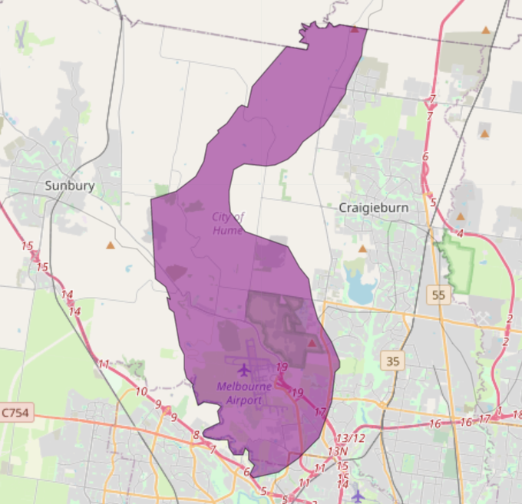
Figure 1: Map showing location of Maribyrnong Valley landscape (purple).
Habitat Distribution Models identify 0 species with more than 5% of their Victorian range in this landscape | Traditional Owners, stakeholders and community groups identified the following species of interest
- 0 Plant species with more than 5% of their Victorian range in this landscape
- Notable species: Bicolour Everlasting (4.6% statewide range in area), Oval Wedge-fern (endangered, 4.5% statewide range in area), Werribee Blue-box (endangered, 4.0% statewide range in area), Bacchus Marsh Wattle (vulnerable, 3.1% statewide range in area)
- 0 Mammal species with more than 5% of their Victorian range in this landscape  - Notable species: Common Dunnart (vulnerable, 0.22% statewide range in area), Eastern Freetail Bat (0.19% statewide range in area), Water Rat (0.16% statewide range in area), Fat-tailed Dunnart (near threatened, 0.14% statewide range in area) | - Eastern Barred Bandicoot (in enclosure)
- 0 Reptile species with more than 5% of their Victorian range in this landscape
- Notable species: Grassland Earless Dragon (critically endangered, 4.3% statewide range in area)
- 20 Bird species
- Notable species: Purple-crowned Lorikeet (0.56% statewide range in area), Diamond Firetail (near threatened, 0.35% statewide range in area), Spotted Harrier (near threatened, 0.29% statewide range in area), Black-eared Cuckoo (near threatened, 0.27% statewide range in area)
- 0 species of amphibians with more than 5% of their Victorian range in this landscape
- Notable species: Pobblebonk Frog (Limnodynastes dumerilii variegatus, 0.34% statewide range in area), Growling Grass Frog (endangered, 0.3% statewide range in area)

Strategic Management Prospects
Strategic Management Prospects (SMP) models biodiversity values such as species habitat distribution, landscape-scale threats and highlights the most cost-effective actions for specific locations. More information about SMP is available in NatureKit.
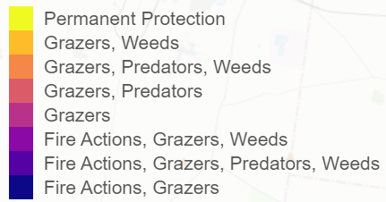
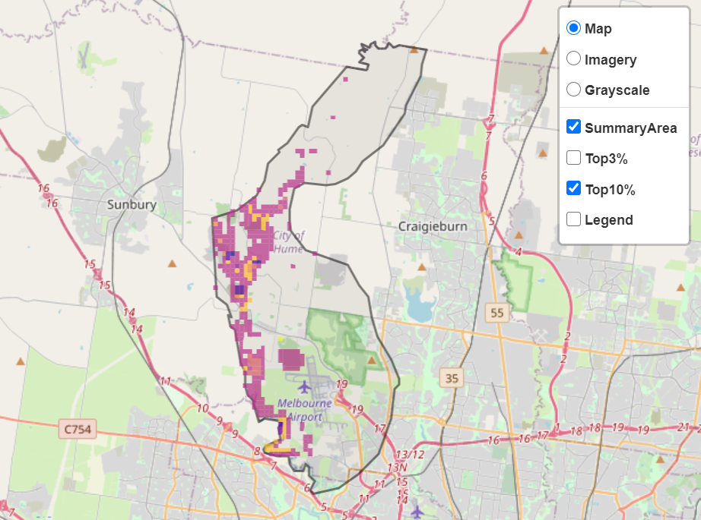
Areas of Maribyrnong Valley shown in Figure 2 have highly cost-effective actions (within the top 10% of cost-effectiveness for that action across the state) that provide significant benefit for biodiversity conservation.
Figure 2: The SMP priority actions which rank among the top 10% for cost-effectiveness of that action across the state. “Grazers” includes deer, domestic grazing, goats, horses, over-abundant kangaroos, pigs, rabbits and total grazing pressure

Actions with area in the top 3% and top 10%
Specific Action | Area in top 3% (ha) | Area in top 10% (ha)
Control Pigs | 51 | 1,390
Control Rabbits | 48 | 1,375
Control Weeds | 0 | 241
Revegetation | 0 | 159
Control Foxes | 0 | 134
Control Overabundant Kangaroos | 0 | 91
Control Cats | 0 | 71
Control Domestic Grazing | 0 | 61
Ecological Burning | 0 | 45
Permanent Protection | 0 | 5

The most cost-effective action for flora & fauna
Plants, Birds, Mammals, Amphibians and Reptiles - Control rabbits

For a further in depth look into SMP for this landscape, please refer to NatureKit.

Current actions in Maribyrnong Valley
Specific Actions | Current actions – top 10% (ha) | Current actions – outside top 10% (ha)
Control Foxes | 0 | 232
Control Rabbits | 0 | 114
Revegetation | 0 | 10

Current actions – top 10% = The area (ha) of the specific action currently occurring in locations identified by SMP as being in the top 10% for cost-effectiveness for that action across the state
Current actions – outside top 10% = The area (ha) of the specific action currently occurring in locations within this landscape that are not identified by SMP as being in the top 10% for cost-effectiveness for that action across the state

What you told us
SMP is just one tool to use in the process of understanding biodiversity values. Feedback from our stakeholders is also vitally important and forms the basis of our understanding of knowledge gaps.

Stakeholder interest

Important landscapes
- Maribyrnong River
- Moonee Ponds Creek
- Woodlands Historic Park

Current activities/programs/partnerships
- Melbourne Open Space Strategy
- Port Phillip and Westernport CMA Regional Catchment Strategy – Naturelinks – Meeting of the minds to manage the Maribyrnong
- Living Melbourne – Our Metropolitan Urban Forest
- Management of Eastern Barred Bandicoots at Woodlands Historic Park
- Greening the Maribyrnong
- Ecological burning
- Melbourne Strategic Assessment
- Biodiversity Response Planning project 096 – Deepening connections – engaging communities and enhancing habitat of the Deep Creek
- Various Friends of groups, Landcare groups and other community groups focusing on biodiversity conservation
- Trust for Nature land covenanting program

Additional threats
No additional threats (beyond those modelled in SMP) were identified through the consultation process.

