Introduction
Biodiversity Response Planning (BRP) is a long-term area-based planning approach to biodiversity conservation in Victoria. It is designed to strengthen alignment, engagement and participation between government, Traditional Owners, non-government agencies and the community.
DELWP Regional staff have been working with stakeholders on actions to conserve biodiversity in specific landscapes, informed by the best available science and local knowledge.
These Fact Sheets capture a point in time, reflecting data and knowledge available in 2020. They provide information for many (but not all) landscapes across Victoria, containing general information on the key values and threats in each area, as well as the priority cost-effective actions that provide the best protection of biodiversity. Fact Sheets are intended to provide useful biodiversity information for the community, non-government and government organisations during project planning and development.
Further information and the full list of Fact Sheets is available on the Department’s Environment website.

Landscape description
This 177,053ha area is a mostly cleared landscape (13% native vegetation cover) and is mostly private land (97%). The landscape is bordered by the Wimmera River in the south and the Yarriambiack Creek in the east.

Habitat Distribution Models identify 21 species with more than or close to 5% of their Victorian range in this landscape
20 Plants
- Notably Floodplain Rustyhood (10% of Victorian range in this landscape, EPBC*-listed Vulnerable, FFG**-listed ) and Turnip Copperburr (11% of Victorian range in this landscape, EPBC*-listed Vulnerable, FFG**-listed )
- Reptile
- Tessellated Gecko (3% of Victorian range in this landscape)
*Environment Protection and Biodiversity Conservation Act 1999 (Federal)
**Flora and Fauna Guarantee Act 1988 (Victorian)

Strategic Management Prospects
Strategic Management Prospects (SMP) models biodiversity values such as species habitat distribution, landscape-scale threats and highlights the most cost-effective actions for specific locations. More information about SMP is available in NatureKit.

Which landscape-scale actions are most cost-effective in this landscape?
Some areas of this focus (coloured areas on the map) have highly cost-effective actions which provide significant benefit for biodiversity conservation.
The SMP priority actions which rank among the top 10% for cost-effectiveness of that action across the state are in order:
Control rabbits 11,208ha
Control weeds 2,816ha
Control pigs 862ha
Control overabundant kangaroos 553ha
Control foxes 416ha
Permanent protection 157ha
Revegetation 10ha
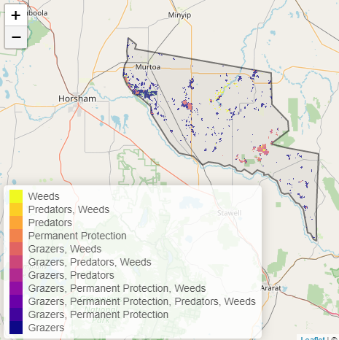

Of the top 3% of cost-effective actions, control rabbits, control weeds, control overabundant kangaroos, and permanent protection also ranked the highest.

The most cost-effective actions for flora & fauna
Plants - Control rabbits, control weeds, control kangaroos, control foxes
Birds - Control rabbits, control weeds, control pigs
Mammals, Reptiles - Control rabbits, control weeds
Amphibians - Control rabbits

For a further in depth look into SMP for this landscape please refer to NatureKit.

