Introduction
Biodiversity Response Planning (BRP) is a long-term area-based planning approach to biodiversity conservation in Victoria. It is designed to strengthen alignment, engagement and participation between government, Traditional Owners, non-government agencies and the community.
DELWP Regional staff have been working with stakeholders on actions to conserve biodiversity in specific landscapes, informed by the best available science and local knowledge.
These Fact Sheets capture a point in time, reflecting data and knowledge available in 2020. They provide information for many (but not all) landscapes across Victoria, containing general information on the key values and threats in each area, as well as the priority cost-effective actions that provide the best protection of biodiversity. Fact Sheets are intended to provide useful biodiversity information for the community, non-government and government organisations during project planning and development.
Further information and the full list of Fact Sheets is available on the Department’s Environment website.

Landscape description
The Kow Swamp landscape is 3,741ha in size with 62% of the area covered in native vegetation and 77% consisting of public land.

Cultural importance
We recognise that the entire landscape has high cultural value for Traditional Owners. Landscapes identified as having “notable” cultural importance is based on the density of recorded cultural heritage sites and knowledge shared by Traditional Owners. We also recognise that there are locations important to Traditional Owners not within these landscapes.

Stakeholder interest
As part of the BRP process, in October 2020 stakeholders were asked to nominate focus landscapes and actions of interest. Campaspe Shire Council, Agriculture Victoria (North Central Irrigation Program), Northern Plains Conservation Management Network, Barapa Country Aboriginal Corporation and Goulburn-Murray Water all nominated Kow Swamp.
Possible future investment/project development in this landscape will be available to any interested stakeholders in addition to those who nominated this landscape.

0BEcological values identified by Traditional Owners, partners and community within this landscape
Cultural fire on Country:
- Yorta Yorta - Kow Swamp
Locally important roosting and feeding area for wetland birds
The extensive reed beds are home to Swamp Harrier, Nankeen Night Heron, Ibis, Purple Swamphen and Black-tailed Native-hen and, on occasion, the nationally threatened Australasian Bittern has been recorded

 | Habitat Distribution Models identify 0 species with more than 5% of their Victorian range in this landscape area | Traditional Owners, stakeholders and community groups identified the following species of interest within this landscape
 | Reptiles | - Carpet Python
 | Birds | - Australasian Bittern  - Straw necked Ibis  - Brolga  - Royal Spoonbill  - Caspian Tern  - White-bellied Sea Eagle  - Azure Kingfisher
Other | Fish:  - Silver Perch  - Murray Cod  - Eastern Great Egret  - Golden Perch  - Freshwater Catfish  - Bony Herring

Traditional Owners, stakeholders and community groups identified the following threats within this landscape
None identified

Strategic Management Prospects
Strategic Management Prospects (SMP) models biodiversity values such as species habitat distribution, landscape-scale threats and highlights the most cost-effective actions for specific locations. More information about SMP is available in NatureKit.

Additional threats
Threats identified (in addition to those modelled in SMP) through the consultation process were:
- alterations to hydrology
- land salinisation
- soil erosion
- habitat degradation due to extremes of climate and weather
- lack of regeneration in some vegetation communities
- recreational activities causing fragmentation
- loss of vegetation, and erosion
- legacy use of public land
- private land use impacting biodiversity
- inappropriate land use planning
- inappropriate fire regimes (planned burning and bushfires)
Some individual threatened species may also require targeted intervention, beyond actions to manage landscape-scale threats, to improve their future prospects.

Which landscape-scale actions are most cost-effective in this landscape?
The coloured areas indicate where the identified landscape-scale actions and locations are most cost-effective and will maximise biodiversity benefit across Victoria for multiple species.
 | Control rabbits 11,046ha
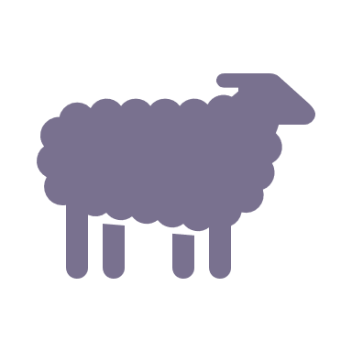 | Control grazing 127ha
 | Control overabundant kangaroos 15ha
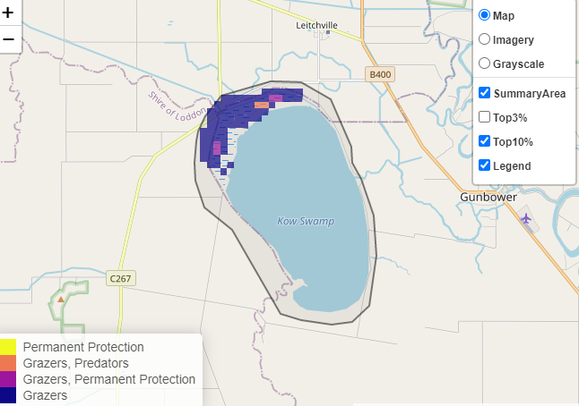
The SMP priority actions which rank among the top 10% for cost-effectiveness of that action across Victoria for much of the landscape are in order of the top 3 actions, see map and list below:

Of the top 10% of cost-effective actions, controlling rabbits provides the most cost-effective biodiversity benefits when considering all flora and fauna.
From the nomination process the following additional actions were also suggested for this landscape:
- weed control
- pig control
- erosion control
- permanent protection
- revegetation
- foreshore protection
- cultural fire
- protection of areas of high cultural heritage value

The most cost-effective action for flora and fauna
Plants, reptiles, mammals, birds, amphibians - Control rabbits

For a further in depth look into SMP for this landscape please refer to NatureKit.

