Introduction
Biodiversity Response Planning (BRP) is a long-term area-based planning approach to biodiversity conservation in Victoria. It is designed to strengthen alignment, engagement and participation between government, Traditional Owners, non-government agencies and the community.
DELWP Regional staff have been working with stakeholders on actions to conserve biodiversity in specific landscapes, informed by the best available science and local knowledge.
These Fact Sheets capture a point in time, reflecting data and knowledge available in 2020. They provide information for many (but not all) landscapes across Victoria, containing general information on the key values and threats in each area, as well as the priority cost-effective actions that provide the best protection of biodiversity. Fact Sheets are intended to provide useful biodiversity information for the community, non-government and government organisations during project planning and development.
Further information and the full list of Fact Sheets is available on the Department’s Environment website.

Landscape description
This 285,143ha area is a mixed cleared and vegetated landscape (42% native vegetation cover) and is mostly private land (78%). The landscape is characterised by dunes that run north-south through West Wimmera from the Little Desert to the Glenelg River.

Habitat Distribution Models identify 214 species with more than 5% of their Victorian range in this landscape
210 Plants
- 4 species with more than 50% of Victorian range in area, including:
- Swamp Onion-orchid (93% of Victorian range in landscape, vulnerable), Blunt Club-sedge (68% of Victorian range in landscape), Gimlet Bog-sedge (52% of Victorian range in landscape, rare) and Forked Spyridium (51% of Victorian range in landscape, FFG*-listed)
1 Mammal
- Silky Mouse (6% of Victorian range in area, near threatened)
2 Reptiles
- Striped Worm-Lizard (11% of Victorian range in area, near threatened)
- Rosenberg’s Goanna (4% of Victorian range in area, endangered)
1 Bird
- Elegant Parrot (3% of Victorian range in area, vulnerable)
*Flora and Fauna Guarantee Act 1988 (Victorian)

Strategic Management Prospects
Strategic Management Prospects (SMP) models biodiversity values such as species habitat distribution, landscape-scale threats and highlights the most cost-effective actions for specific locations. More information about SMP is available in NatureKit.

Which landscape-scale actions are most cost-effective in this landscape?
Some areas of this focus landscape (coloured areas on the map) have highly cost-effective actions which provide significant benefit for biodiversity conservation.
The SMP priority actions which rank among the top 10% for cost-effectiveness of that action across the state are in order:
Control rabbits 89,202ha
Control overabundant kangaroos 64,896ha
Control weeds 50,331ha
Control deer 28,851ha
Control domestic stock grazing 17,514ha
Revegetation 5,513ha
Permanent protection 5,000ha
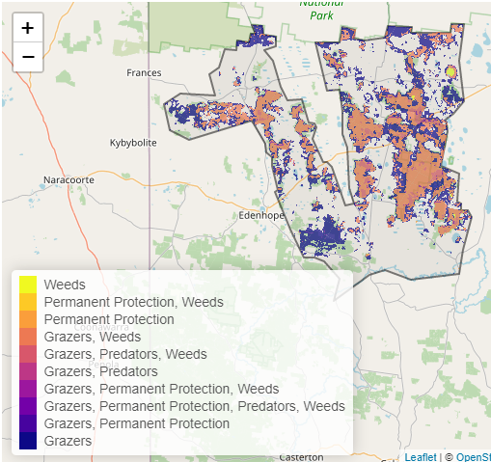

Of the top 3% of cost-effective actions, control kangaroos, permanent protection and weed control ranked the highest.

The most cost-effective actions for flora & fauna
Plants, Birds - Control rabbits, control weeds, control kangaroos, control deer
Mammals, Reptiles - Control rabbits, control weeds, control kangaroos
Amphibians - Control rabbits, control kangaroos, control deer

For a further in depth look into SMP for this landscape please refer to NatureKit.
