“We acknowledge the Wadawurrung people of the Kulin Nation as the Original Custodians of the lands which represents the following information. We pay respects to Elders past, present and emerging leaders that continue their obligations to care for Country. We care for Country, Culture and Wadawurrung people”.

Otway East

Introduction
Biodiversity Response Planning (BRP) is a long-term area-based planning approach to biodiversity conservation in Victoria. It is designed to strengthen alignment, engagement and participation between government, the Original Custodians, non-government agencies and the community.
DELWP Regional staff with Wadawurrung Traditional Owners Aboriginal Corporation have been working with stakeholders on actions to conserve biodiversity in specific landscapes, informed by the best available science and local knowledge.
These Fact Sheets capture a point in time, reflecting data and knowledge available in 2020. They provide information for many (but not all) landscapes across Victoria, containing general information on the key values and threats in each area, as well as the priority cost-effective actions that provide the best protection of biodiversity. Fact Sheets are intended to provide useful biodiversity information for the community, non-government and government organisations during project planning and development.
Further information and the full list of Fact Sheets is available on the Department’s Environment website.
This Fact Sheet includes the information from the Strategic Management Prospects (SMP) Output Summary for the Bay zone and the feedback from our stakeholders.

Landscape description
The Otway East area is 48,450ha. The native vegetation cover is 52% and the public land cover is 46%.
It is an undulating landscape with varying vegetation communities that includes heathy woodlands, lowland forest and dry forest. It makes up a small but significant section of the Great Otway National Park (NP).
Important waterways in this zone are Spring Creek, Anglesea River and Painkalac Creek. There are no significant wetlands or bays.
The highest biodiversity values are within the public land blocks that form the Great Otway National Park and the shoreline reserves.

Cultural importance
Wadawurrung Country holds many values culturally and ecologically throughout the diverse landscape. Mountain country, grassland country, sea and coastal country provides for many flora and fauna species to inhabit the landscapes. Resources were aplenty and managed sustainably by the Wadawurrung. Due to previous land activities such as mining, land fragmentation and the introduction of pest species, the landscapes require good partnerships between Wadawurrung Original Custodians and land managers to reinvigorate Country. Wadawurrung land management practices will be supported and guided by the aspirations of the Wadawurrung Healthy Country Plan.
Initial Wadawurrung Priority Area identified – Otway cluster.

Landscapes of interest added through feedback process
Geelong City Council – Lorne-Queenscliff Coastal Reserve
Trust for Nature – Breamlea Flora and Fauna Reserve, Lorne-Queenscliff Coastal Reserve, Great Otway National Park, Eumeralla Education Area, Otway Forest Park, Gherang Gherang Bushland Reserve and Bambra Bushland Reserve.

Ecological Vegetation Classes (primary EVCs)
Endangered: Coastal Saltmarsh/Mangrove Shrubland Mosaic, Grassy Woodland, Estuarine Wetland, Swampy Riparian Woodland, Grassy Forest, Plains Grassy Woodland, Floodplain Riparian Woodland.
Environment Protection and Biodiversity Conservation Act: Natural Damp Grasslands of the Victorian Coastal Plains, Assemblages of species associated with Otway Peninsula-coast salt-wedge estuaries of western and central Victoria ecological community, Seasonal Herbaceous Wetlands (Freshwater) of the Temperate Lowland Plains ecological community.
Flora and Fauna Guarantee Act: Coastal Moonah Woodland Community.

Ecological Vegetation Classes (secondary EVCs)
Environment Protection and Biodiversity Conservation Act: Natural Temperate Grasslands of the Victorian Volcanic Plains, Grassy Eucalypt Woodland of Victorian Volcanic Plains, Seasonal Herbaceous Wetlands (Freshwater) of the Temperate Lowland Plains ecological community.
Flora and Fauna Guarantee Act: Western Plains Grasslands Community.

Habitat Distribution Models identify 39 species with more than 5% of their Victorian range in this landscape area (updated 26/07/2020) | The following have been identified as focal species by the Original Custodians and stakeholders
36 plants with more than 5% of Victorian range in area. Notably:  - Pallid Sun-orchid (endangered, 100%)  - Large Plume-orchid (rare, 98%), Anglesea Leek-orchid (endangered, 94%)  - Angahook Pink-fingers (endangered, 92%)  - Anglesea Grevillea (vulnerable, 76%)  - Otway Grey-gum (vulnerable, 76%) | 41 plants: Bellarine Yellow-gum, Hooded Water-milfoil, Thread Rush, Large Kangaroo Apple, Sea Rush, Kangaroo Grass, Hedge Wattle, Sheep’s Burr, Australian Salt-grass, Black Wattle, Coast Flax-lily, Swamp Gum, Running Postman, Common Tussock-grass, Golden Wattle, Drooping Sheoak, Small-leaved Clematis, Pink Bindweed, Common Spike-sedge, Pale Rush, Coast Tea-tree, Small Loosestrife, Narrow-leaf Cumbungi, Lightwood, Cranberry Heath, Silver Banksia, Water Ribbons, Kidney-weed, Weeping Grass, Common Reed, Blackwood, River Red-gum, Prickly Tea-tree, Coast Everlasting, Slender Dock, Silver Wattle, Coarse Dodder-laurel, Cherry Ballart, Austral Crane’s-bill, Tall Bluebell, Small-leaf Bramble
1 reptile with more than 5% of Victorian range in area
- Mountain Dragon Anglesea form (data deficient, 98%)
2 birds with more than 5% of Victorian range in area
- Rufous Bristlebird (near threatened, 6%)
- Rufous Bristlebird ((Otway) near threatened, 6%)

Strategic Management Prospects
Strategic Management Prospects (SMP) models biodiversity values such as species habitat distribution, landscape-scale threats and highlights the most cost-effective actions for specific locations. More information about SMP is available in NatureKit.

Additional threats
Threats identified (in addition to those modelled in SMP) through the consultation process were native vegetation removal, barriers to on-ground management., water quality and quantity, rising sea levels, littering, inappropriate land use.

Which landscape-scale actions are most cost-effective in this landscape?
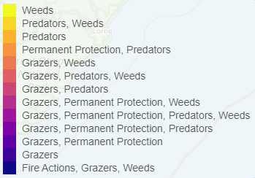
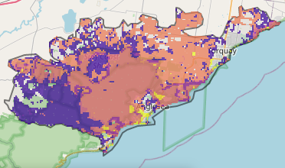
The map shows where the most cost-effective threat control actions in this landscape are. Actions in these areas will maximise biodiversity benefit across Victoria for multiple species.
The very best threat control action to do in the Top 3% and 10% of cost-effective areas are: pigs, grazing pressure (all grazers), rabbits, deer, overabundant kangaroos, permanent protection, weeds, domestic grazing, foxes, and cats.
Area available for highly cost-effective revegetation
1,830ha
For a further in depth look into SMP for this landscape please refer to NatureKit.

Priority Areas Map – Otway East
Base layers: This data is from SMP and represents the best areas to carry out the most cost-effective actions for specific threats (also referred to as the Top 10% of Mean Cost-effectiveness (MCE) actions), and the Top 20% locations (these locations have been given names and are referred to as descriptors).
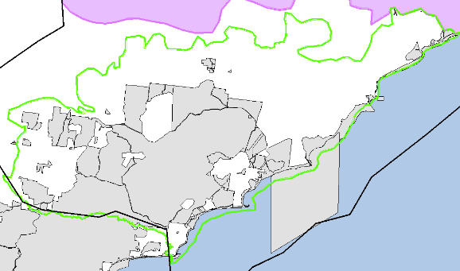
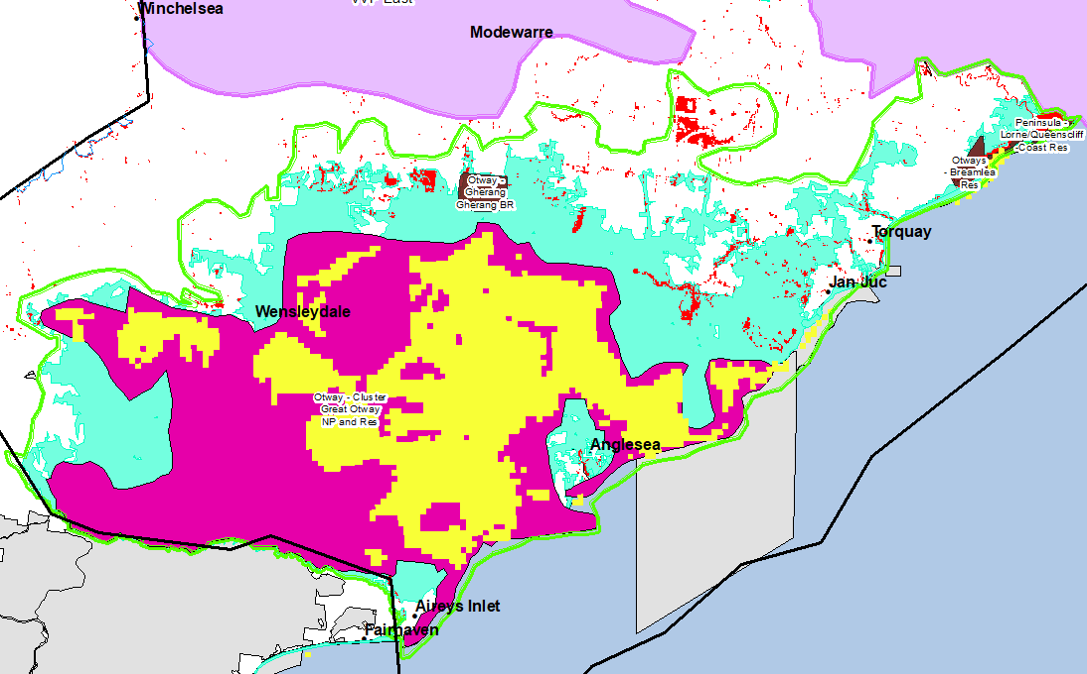
Priority Areas: Wadawurrung Priority Areas, stakeholder’s Landscapes of Interest (LoI), endangered Ecological Vegetation Classes (EVCs), National Parks and Reserves.
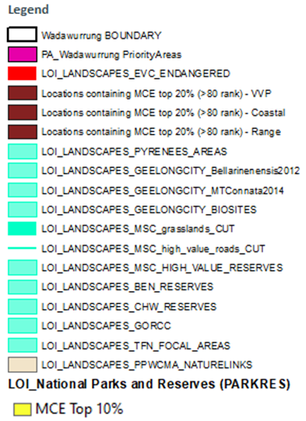
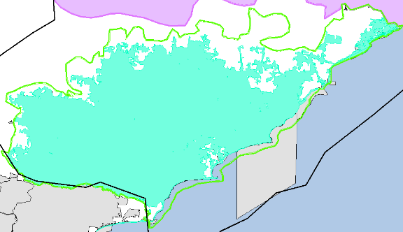
National Parks and Reserves (grey)
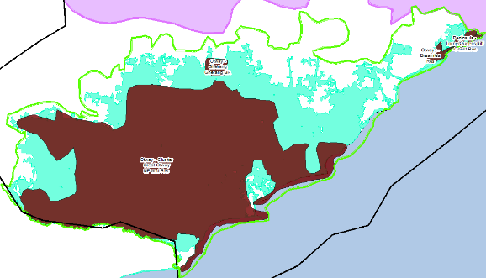
Stakeholder’s LoI (aqua)
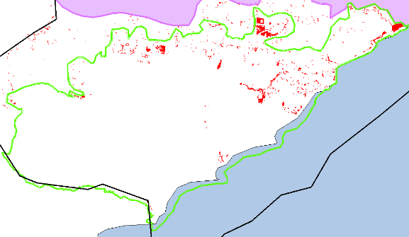
Descriptor (brown)
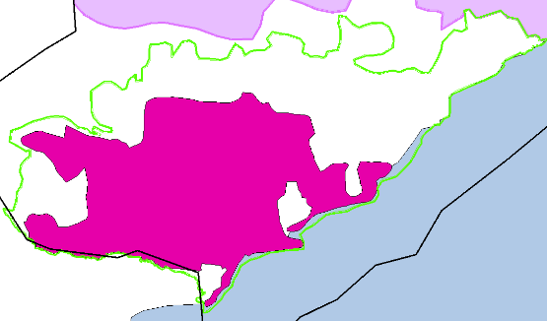

Endangered EVCs ((red) above)
Wadawurrung intital Priority Areas ((pink) right)

