Introduction
Biodiversity Response Planning (BRP) is a long-term area-based planning approach to biodiversity conservation in Victoria. It is designed to strengthen alignment, engagement and participation between government, Traditional Owners, non-government agencies and the community.
DELWP Regional staff have been working with stakeholders on actions to conserve biodiversity in specific landscapes, informed by the best available science and local knowledge.
These Fact Sheets capture a point in time, reflecting data and knowledge available in 2020. They provide information for many (but not all) landscapes across Victoria, containing general information on the key values and threats in each area, as well as the priority cost-effective actions that provide the best protection of biodiversity. Fact Sheets are intended to provide useful biodiversity information for the community, non-government and government organisations during project planning and development.
Further information and the full list of Fact Sheets is available on the Department’s Environment website.

Landscape description
The Gunbower landscape is 46,260ha in size with 49% of the area covered in native vegetation. Public land makes up just over half (53%) of the area and includes Gunbower State Forest, Gunbower Island and Guttram State Forest. Refer to the map at the end of this Fact Sheet.

Cultural importance
We recognise that the entire landscape has high cultural value for Traditional Owners. Landscapes identified as having “notable” cultural importance is based on the density of recorded cultural heritage sites and knowledge shared by Traditional Owners. We also recognise that there are locations important to Traditional Owners not within these landscapes of interest.
Notable cultural importance for the Yorta Yorta Nations Aboriginal Corporation is the areas of River Red Gum floodplain and areas of extensive native remnant intact vegetation in this landscape.

Stakeholder interest

0Ecological values identified by Traditional Owners, partners and community within this landscape
The Gunbower Forest contains the river red gum grassy woodland ecological community listed under the Flora and Fauna Guarantee Act 1988
Gunbower Forest is a wetland of international significance under the Ramsar Convention
Gunbower Forest includes the Grey box grassy woodlands and derived native grasslands of south-eastern Australia listed (under the Environment Protection and Biodiversity Conservation Act 1999) as an endangered ecological community
As part of the BRP process, in October 2020 stakeholders were asked to nominate focus landscapes and actions of interest. Campaspe Shire Council, Northern Plains Conservation Management Network, DELWP (Public Land), North Central Catchment Management Authority, Agriculture Victoria (North Central Irrigation Program), Goulburn-Murray Water, Barapa Country Aboriginal Corporation and Parks Victoria all nominated Gunbower.
Possible future investment/project development in this landscape will be available to any interested stakeholders in addition to those who nominated this landscape.

 | Habitat Distribution Models identify 16 species with more than 5% of their Victorian range in this landscape | Traditional Owners, stakeholders and community groups identified the following species of interest within this landscape
 | 16 Plants, notably:  - Hairy Caustic Weed (Euphorbia australis), with 16% of its Victorian range in area  - Squat Picris (Picris squarrosa), rare, with 13% of its Victorian range in area  - Wavy Marshwort (Nymphoides crenata), vulnerable, with 12% of its Victorian range in area | - Winged Peppercress  - River Swamp Wallaby Grass  - Buloke  - Still Groundsel  - Umbrella Grass  - Umbrella Wattle  - Northern Sandalwood
 | Mammals | - Yellow-footed Antechinus, Squirrel Glider
 | Reptile | - Carpet Python  - Broad-shelled Turtle
 | Birds | - Eastern Great Egret  - Intermediate Egret  - Whistling Kite  - White-bellied Sea Eagle  - Australasian Grebe
 | Amphibians | - Giant Banjo Frog
Other: |  | - Murray Cod  - Catfish  - Trout Cod  - Bony Herring

Traditional Owners, stakeholders and community groups identified the following threats within this landscape
Weeds and pest animals (lack of on-ground work and coordination of work)
Climate change
Agricultural chemicals and encroachment
Logging
Lack of environmental water flows to floodplain areas for various species, including waterbirds (such as the critically endangered Intermediate Egret) and native fish
Light pollution

Strategic Management Prospects
Strategic Management Prospects (SMP) models biodiversity values such as species habitat distribution, landscape-scale threats and highlights the most cost-effective actions for specific locations. More information about SMP is available in NatureKit.

Additional threats
Threats identified (in addition to those modelled in SMP) through the consultation process were:
- alterations to hydrology
- land salinisation
- soil erosion
- habitat degradation due to extremes of climate and weather
- lack of regeneration in some vegetation classes
- recreational activities causing fragmentation
- loss of vegetation, and erosion
- legacy use of public land
- private land use impacting biodiversity
- inappropriate land use planning
- inappropriate fire regimes (planned burning and bushfires)

Some individual threatened species may also require targeted intervention, beyond actions to manage landscape-scale threats, to improve their future prospects.

Which landscape-scale actions are most cost-effective in this landscape?
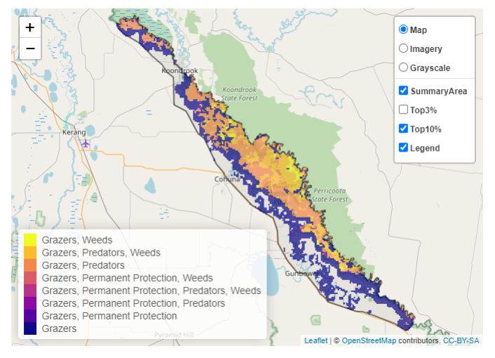
The coloured areas indicate where the identified landscape-scale actions and locations are most cost-effective and will maximise biodiversity benefit across Victoria for multiple species.
The SMP priority actions which rank among the top 10% for cost-effectiveness of that action across Victoria for much of the landscape are in order of the top 3 actions, see map and list below:
Control pigs 28,866ha
Combined cat and fox control 16,478ha
Control rabbits
13,922ha

Of the top 10% of cost-effective actions, controlling pigs provides the most cost-effective biodiversity benefits when considering all flora and fauna.
From the nomination process the following additional actions were also suggested for this landscape:
- weed control
- deer control
- domestic grazing control
- firewood removal
- monitoring
- erosion management
- tree-felling compliance

The most cost-effective action for each taxon
Plants - Control pigs
Mammals, birds, amphibians, reptiles - Combined cat and fox control

For a further in depth look into SMP for this landscape please refer to NatureKit.

