Introduction
Biodiversity Response Planning (BRP) is a long-term area-based planning approach to biodiversity conservation in Victoria. It is designed to strengthen alignment, engagement and participation between government, Traditional Owners, non-government agencies and the community.
DELWP Regional staff have been working with stakeholders on actions to conserve biodiversity in specific landscapes, informed by the best available science and local knowledge.
These Fact Sheets capture a point in time, reflecting data and knowledge available in 2020. They provide information for many (but not all) landscapes across Victoria, containing general information on the key values and threats in each area, as well as the priority cost-effective actions that provide the best protection of biodiversity. Fact Sheets are intended to provide useful biodiversity information for the community, non-government and government organisations during project planning and development.
Further information and the full list of Fact Sheets is available on the Department’s Environment website.

Landscape description
This 203,000ha area has some native vegetation (20% cover) and some public land (16%). It includes the general area around Lakes Tyrrell and Timboran and the cluster of associated salt lakes and plains on public land. It also includes the Tyrrell and Lalbert Creeks. It does not overlap with any other landscape.

Cultural importance
We recognise that the entire landscape has high cultural value for Traditional Owners. Landscapes identified as having “notable” cultural importance is based on the density of recorded cultural heritage sites and knowledge shared by Traditional Owners. We also recognise that there are locations important to Traditional Owners not within these landscapes.
Notable cultural importance for the First People of the Millewa Mallee Aboriginal Corporation, Tati Tati Wadi Wadi and Wamba Wamba Nation Traditional Owners.

Stakeholder interest
As part of the Biodiversity Response Planning process, in October 2020 stakeholders were asked to nominate focus landscapes and actions of interest. First People of the Millewa Mallee, Tati Tati Wadi Wadi, Mallee Catchment Management Authority, Trust for Nature, Parks Victoria, DELWP, Swan Hill Rural City Council, Hindmarsh Landcare Network and South East Mallee Landcare Network nominated Lake Tyrrell.
Possible future investment/project development in this landscape will be available to any interested stakeholders in addition to those who nominated this landscape.
Specific stakeholder interests identified through the engagement process within this landscape include:
- Parks Victoria Conservation Action Plan assets – Inland saline soaks.
- Mallee Catchment Management Authority, Regional Catchment Strategy priority landscape – 12. Avoca Basin Terminal Lakes System and Creeklines. Focus on the restoration (for example, connectivity of isolated remnants) and protection (for example, grazing/competition impacts) of high value habitat for priority species outcomes.
- Department of Environment, Land, Water and Planning – areas of interest within the landscape are the west side of Lake Tyrell and Tyrell Creek.

Community interest
There is high community interest in biodiversity values of remnant habitat on public and private land (including woodland birds) as well as Landcare interest in restoring natural flow regimes to Tyrrell Creek.

 | Habitat Distribution Models identify 144 species with more than 5% of their Victorian range in this landscape area | Traditional Owners, stakeholders and community groups identified the following species of interest
 | 128 Plants with more than 5% Victorian range in area. Notably:  - Angular Saltbush (endangered, 80% of Victorian range in area)  - Bead Glasswort (23% of Victorian range in area) | - Buloke Mistletoe  - Camel bush  - Buloke woodland  - Erect Peppercress  - Chariot Wheel
4 Mammals with more than 5% Victorian range in area. Notable species with less than 5% range in area:
- South-eastern Long-eared bat (endangered, 4% of Victorian range in area)
- Common Dunnart (vulnerable, 2% of Victorian range in area)
 | 2 Reptiles with more than 5% Victorian range in area. Notably:  - Lined Earless Dragon (critically endangered, 23% of Victorian range in area)  - Samphire Skink (endangered, 14% of Victorian range in area) | - Murray-Darling Carpet Python
 | 10 Birds with more than 5% Victorian range in area. Notably:  - Curlew Sandpiper (endangered, 7% of Victorian range in area)  - Greater Sand Plover (critically endangered, 8% of Victorian range in area) | - Brown Tree Creeper  - Eastern Great Egret  - Hooded Robin  - Intermediate Egret  - Grey Crowned Babbler  - Plains Wanderer  - Diamond Firetail
- Bibron’s Toadlet
- Growling grass frog

Strategic Management Prospects
Strategic Management Prospects (SMP) models biodiversity values such as species habitat distribution, landscape-scale threats and highlights the most cost-effective actions for specific locations. More information about SMP is available in NatureKit.

Additional threats
Threats identified (in addition to those modelled in SMP) through the consultation process were:
- alterations to hydrology
- land salinisation
- soil erosion
- habitat degradation due to extremes of climate and weather
- lack of regeneration in some vegetation communities
- recreational activities causing fragmentation
- loss of vegetation, and erosion
- legacy use of public land
- private land use impacting biodiversity
- inappropriate land use planning
- inappropriate fire regimes (planned burning and bushfires)

Which landscape-scale actions are most cost-effective in this landscape?
Some areas of this focus landscape (coloured areas on the map) have highly cost-effective actions which provide significant benefit for biodiversity conservation.
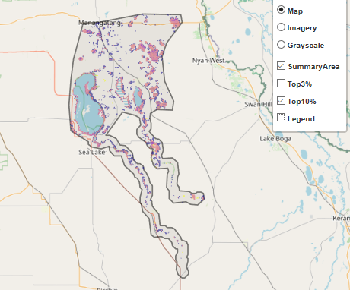
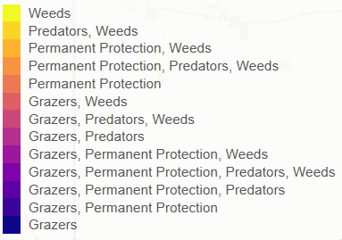
The SMP priority action which ranks among the top 3% for cost-effectiveness of that action across Victoria for much of the area (>1,000ha) is Control overabundant kangaroos. The top 10% actions are in order:
Control rabbits 28,947ha
Control weeds 18,276ha

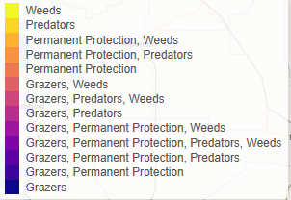
Of the top 10% of cost-effective actions, control rabbits provides the most cost-effective biodiversity benefits when considering all flora and fauna.

Actions suggested for this landscape through the nomination process are:
- control weeds, rabbits and foxes
- revegetation
- environmental watering
- permanent protection
- reintroduce cultural species – dingo

The most cost-effective action for flora and fauna
Plants – Control rabbits
Birds, mammals, reptiles – Combined cat and fox control

For a further in depth look into SMP for this landscape please refer to NatureKit.

