Introduction
Biodiversity Response Planning (BRP) is a long-term area-based planning approach to biodiversity conservation in Victoria. It is designed to strengthen alignment, engagement and participation between government, Traditional Owners, non-government agencies and the community.
DELWP Regional staff have been working with stakeholders on actions to conserve biodiversity in specific landscapes, informed by the best available science and local knowledge.
These Fact Sheets capture a point in time, reflecting data and knowledge available in 2020. They provide information for many (but not all) landscapes across Victoria, containing general information on the key values and threats in each area, as well as the priority cost-effective actions that provide the best protection of biodiversity. Fact Sheets are intended to provide useful biodiversity information for the community, non-government and government organisations during project planning and development.
Further information and the full list of Fact Sheets is available on the Department’s Environment website.

Landscape description
This 5,015ha area extends along the Port Phillip Bay coastline of the Mornington Peninsula from Frankston to Portsea (and 600m inland). The area also includes Tootgarook Wetland, a shallow freshwater marsh. The landscape has 20% native vegetation, and 7% public land.

Cultural importance
We recognise that the entire landscape has high cultural value for the Bunurong People. The area (as pictured below) has recorded over 685 cultural sites of importance, with the discovery of shell midden sites, quarry sites and artefacts recovered and recorded, along with the Ancestral remains sites found along this landscape.
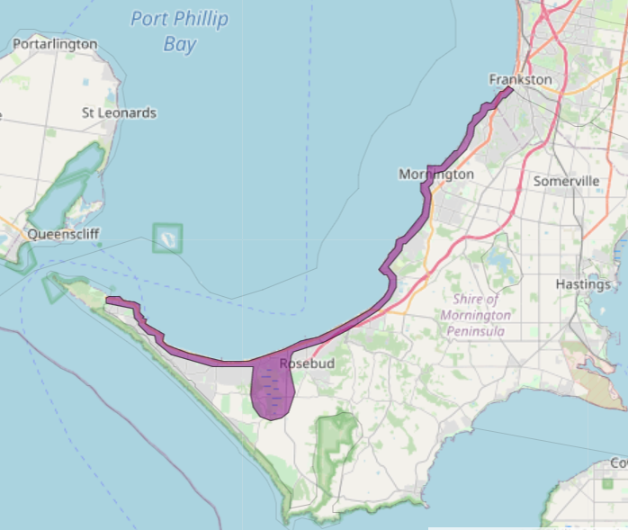
Figure 1: Map showing location of the Peninsula Wetlands and Bay Coast landscape (purple).

Habitat Distribution Models identify 5 species with more than 5% of their Victorian range in this landscape | Traditional Owners, stakeholders and community groups identified the following species of interest
- 5 Plant species  - 0 species with more than 10% of statewide range in area  - Notable species: Coast Bitter-bush (vulnerable, 7.3% statewide range in area), Coast Bush-pea (rare, 5.8% statewide range in area), Frankston Spider-orchid (endangered, 5.5% statewide range in area), Coast saltwort (rare, 5.5% statewide range in area), Beaded Glasswort (poorly known, 5.4% statewide range in area) | - Corybas despectans  - Poa poiformis var. ramifer  - Adraina quadripartia  - Nicotiana maritima  - Pterostylus cucullate  - Stackhousia spathulate  - Colobanthus apetalus var. apetalus  - Lotus australis  - Zygophyllum billardierei  - Olearia sp. 2  - Berula erecta  - Pultanaea canaliculate  - Corybas sp. aff. diemenicus  - Glycine latrobeana  - Euphrasia collina  - Adiantum capillus-veneris  - Pterostylis grandiflora
- 0 Mammal species with more than 5% of statewide range in area  - Notable species: Grey-headed Flying-fox (vulnerable, 0.33% statewide range in area), Southern Brown Bandicoot (near threatened, 0.15% statewide range in area), Swamp Rat (0.12% statewide range in area), Yellow-bellied Sheathtail Bat (data deficient, 0.11% statewide range in area), Water Rat (0.10% statewide range in area) | - Long-nosed Bandicoot  - White-footed Dunnart
- 0 Reptile species with more than 5% of statewide range in area  - Notable species: Four-toed Skink (near threatened, 1.1% statewide range in area) | - Swamp Skink
- 0 Bird species with more than 5% of statewide range in area  - Notable species: Black-faced Cormorant (near threatened, 0.89% statewide range in area), Sanderling (near threatened, 0.86% statewide range in area) | - White-browed Babbler  - White-bellied Sea Eagle  - Powerful Owl  - Lewin's Rail  - Black Falcon  - Chestnut-rumped Heathwren  - Grey-crowned Babbler  - Hooded Plover  - Ruddy Turnstone  - Sooty Oystercatcher  - Spotted Harrier
- 0 species of amphibians with more than 5% of statewide range in area  - Notable species: Pobblebonk Frog (Limnodynastes dumerilii insularis, 0.20% statewide range in area), Southern Toadlet (vulnerable, 0.12% statewide range in area), Southern Brown Tree Frog (0.10% statewide range in area), Growling Grass Frog (endangered, 2.3% statewide range in area) | - Southern Toadlet

Strategic Management Prospects
Strategic Management Prospects (SMP) models biodiversity values such as species habitat distribution, landscape-scale threats and highlights the most cost-effectiveness action for specific locations. More information about SMP is available in NatureKit.
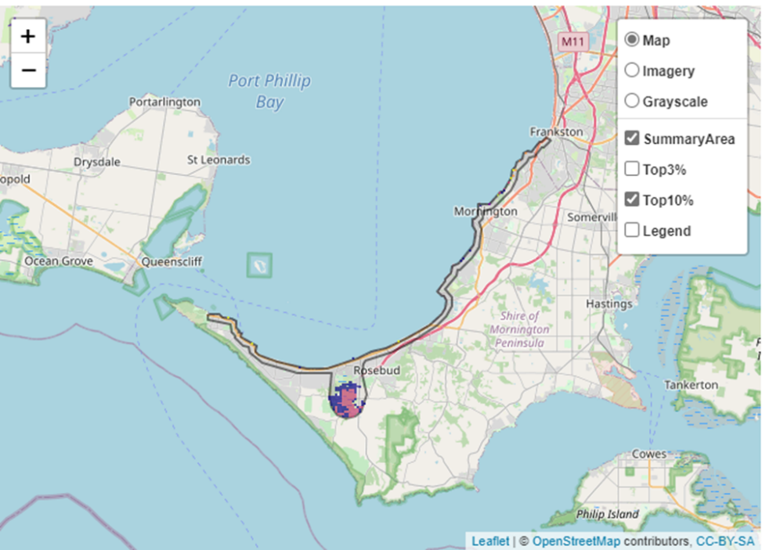
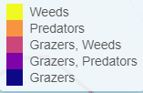
Areas of Peninsula Wetlands and Coast shown in Figure 2 have highly cost-effective actions (within the top 10% of cost-effectiveness for that action across the state) that provide significant benefit for biodiversity conservation.
Figure 2: The SMP priority actions which rank among the top 10% for cost-effectiveness of that action across the state. “Grazers” includes deer, domestic grazing, goats, horses, over-abundant kangaroos, pigs, rabbits and total grazing pressure

Actions with area in the top 3% and top 10%
Specific Action | Area in top 3% (ha) | Area in top 10% (ha)
Control Rabbits | 0 | 883
Control Weeds | 0 | 348
Control Foxes | 0 | 212
Revegetation | 0 | 98
Control Domestic Grazing | 0 | 53
Permanent Protection | 0 | 38
Control Cats | 0 | 9

The most cost-effective action for flora & fauna
Plants, Birds, Mammals, Amphibians and Reptiles - Control rabbits

For a further in depth look into SMP for this landscape, please refer to NatureKit.

Current actions in Peninsula Wetlands and Bay Coast
Specific Actions | Current actions – top 10% (ha) | Current actions – outside top 10% (ha)
Rabbit Control | 160 | 65
Weed Control | 84 | 141
Domestic Grazing Control | 5 | 219
Permanent Protection | 0 | 224
Fox Control | 0 | 224

Current actions – top 10% = The area (ha) of the specific action currently occurring in locations identified by SMP as being in the top 10% for cost-effectiveness for that action across the state
Current actions – outside top 10% = The area (ha) of the specific action currently occurring in locations within this landscape that are not identified by SMP as being in the top 10% for cost-effectiveness for that action across the state

What you told us
SMP is just one tool to use in the process of defining priority landscapes. Feedback from our stakeholders is also vitally important and forms the basis of our understanding of knowledge gaps.

Stakeholder interest

Important landscapes
- Tootgarook wetlands
- Landcare Biolinks
- Mornington Peninsula Biolinks

Current activities/programs/partnerships
- Works on Council reserves and roadsides (Mornington Peninsula Shire)
- Tootgarook Wetland Management Plan (Mornington Peninsula Shire)
- Living Melbourne – Our Metropolitan Urban Forest
- Metropolitan Open Space Strategy
- Southern Peninsula Indigenous Flora & Fauna Association
- Various Friends of groups, Landcare groups and other community groups focusing on biodiversity conservation
- Trust for Nature land covenanting program (including as part of Biodiversity Response Planning project 093 – Iconic Estates: Port Phillip/Westernport)

Additional threats
Threats identified through the consultation process (in addition to those modelled in SMP):
- Sea level rise, storm surge
- Coastal trampling
- Ongoing in-fill development
- Ongoing illegal clearing
- European rat
- Illicit BMX bike jumps and tracks and mountain bike tracks

