## Introduction

Biodiversity Response Planning (BRP) is a long-term area-based planning approach to biodiversity conservation in Victoria. It is designed to strengthen alignment, engagement and participation between government, Traditional Owners, non-government agencies and the community.

DELWP Regional staff have been working with stakeholders on actions to conserve biodiversity in specific landscapes, informed by the best available science and local knowledge.

These Fact Sheets capture a point in time, reflecting data and knowledge available in 2020. They provide information for many (but not all) landscapes across Victoria, containing general information on the key values and threats in each area, as well as the priority cost-effective actions that provide the best protection of biodiversity. Fact Sheets are intended to provide useful biodiversity information for the community, non-government and government organisations during project planning and development.

Further information and the [full list of Fact Sheets](http://www.environment.vic.gov.au/biodiversity/working-together-for-biodiversity) is available on the Department’s Environment website.

## Landscape description

This 73,773ha area encompasses the inner and middle suburbs of Melbourne. Although highly urbanised and modified, the area contains the lower reaches of a number of creeks, some larger parks, and small parcels of native vegetation. Due to the high population of the area, the open space plays an important role in helping people value and connect with nature. The landscape has 6% native vegetation, and 7% public land.

*Note: the lower reaches of the Yarra River, which passes through this landscape, are considered separately in the Yarra River South West landscape. See the*[*full list of Fact Sheets*](http://www.environment.vic.gov.au/biodiversity/working-together-for-biodiversity)*for information about that landscape.*

## Cultural importance

We recognise that the entire landscape has high cultural value for Traditional Owners. Some landscapes have notable cultural importance based on knowledge shared by Traditional Owners.

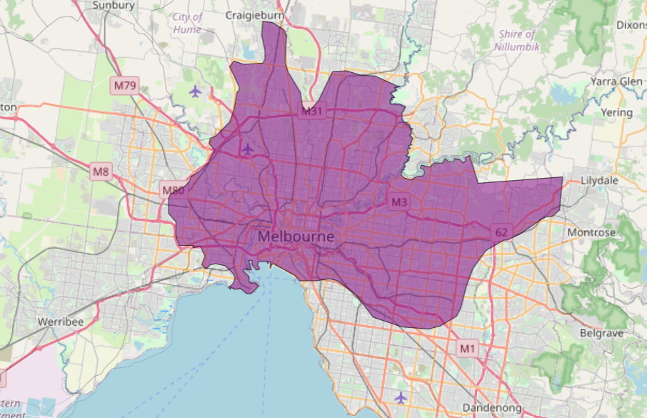

This landscape includes lands of the Wurundjeri people and the Bunurong people.

Figure 1: Map showing location of Melbourne – Inner Urban, North and East landscape (purple).

|  |  |
| --- | --- |
| Habitat Distribution Models identify 17 species with more than 5% of their Victorian range in this landscape | Traditional Owners, stakeholders and community groups identified the following species of interest |
| * Plant14 Plant species * 5 species with more than 10% of statewide range in area * Notable species: Slender Bitter-cress (poorly known, 16% statewide range in area), Kilsyth South Spider-orchid (endangered, 16% statewide range in area), Silurian Striped Greenhood (endangered, 15% statewide range in area), Oval Wedge-fern (endangered, 13% statewide range in area), Clustered Lily (rare, 11% statewide range in area) | * Endangered species incl. *Platylobium infecundum*, *Chiloglottis sp. aff valida* * Numerous Victorian rare or threatened listed flora species including *Prasophyllum brevilabre*, *Acacia stictophylla* * Locally endangered flora includes *Persoonia juniperina*, *Lyperanthus suaveolens*, *Hibbertia riparia*, *Hibbertia impetrifolia*, *Eucalyptus cephalocarpa* |
| * Rat1 Mammal species * 0 species with more than 10% of statewide range in area * Notable species: Grey-headed Flying-fox (vulnerable, 8.3% statewide range in area) | * Playtpus |
| * Snake1 Reptile species * 0 species with more than 10% of statewide range in area * Notable species: Grass skink FORM (P.pag/cry) (6.7% statewide range in area), Eastern Snake-necked Turtle (data deficient, 4.1% statewide range in area), Glossy Grass Skink (vulnerable, 1.8% statewide range in area) |  |
| * Sparrow1 Bird species * 0 species with more than 10% of statewide range in area | * Powerful Owl |
| * Frog0 species of amphibians with more than 5% of statewide range in area * Notable species: Growling Grass Frog (endangered, 1.9% statewide range in area), Pobblebonk Frog (1.8% statewide range in area), Southern Toadlet (1.7% statewide range in area), Brown Toadlet (1.6% statewide range in area) | * Southern Toadlet |

## Strategic Management Prospects

Strategic Management Prospects (SMP) models biodiversity values such as species habitat distribution, landscape-scale threats and highlights the most cost-effective actions for specific locations. More information about SMP is available in [NatureKit](https://www.environment.vic.gov.au/biodiversity/natureprint).

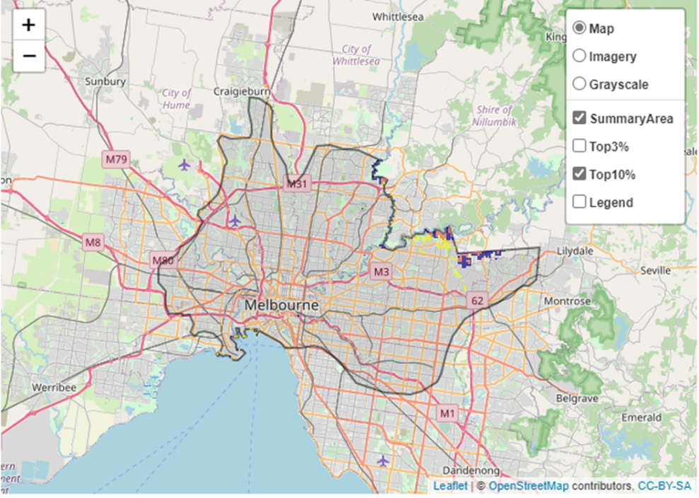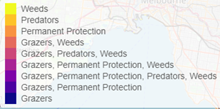Areas of Melbourne – Inner Urban, North and East shown in Figure 2 have highly cost-effective actions (within the top 10% of cost-effectiveness for that action across the state) that provide significant benefit for biodiversity conservation.

|  |  |  |
| --- | --- | --- |
| **Actions with area in the top 3% and top 10%** | | |
| Specific Action | Area in top 3% (ha) | Area in top 10% (ha) |
| Control Rabbits | 20 | 1,008 |
| Control Weeds | 0 | 639 |
| Revegetation | n/a | 307 |
| Control Domestic Grazing | 0 | 183 |
| Control Foxes | 0 | 76 |
| Permanent Protection | 23 | 72 |
| Control Cats | 0 | 20 |

Figure 2: The SMP priority actions which rank among the top 10% for cost-effectiveness of that action across the state. “Grazers” includes deer, domestic grazing, goats, horses, over-abundant kangaroos, pigs, rabbits and total grazing pressure

|  |  |
| --- | --- |
| The most cost-effective action for flora & fauna | |
| PlantSparrowRatFrogSnake | **Plants, Birds, Mammals, Amphibians and Reptiles - Control rabbits** |

For a further in depth look into SMP for this landscape, please refer to [NatureKit](https://www.environment.vic.gov.au/biodiversity/naturekit).

## Current actions in Melbourne – Inner Urban, North and East

|  |  |  |
| --- | --- | --- |
| Specific Actions | Current actions – top 10% (ha) | Current actions – outside top 10% (ha) |
| Rabbit Control | 118 | 253 |
| Weed Controls | 13 | 90 |
| Permanent Protection |  | 42 |
| Domestic Grazing Control |  | 42 |
| Fox Control |  | 42 |
| Revegetation |  | 15 |

Current actions – top 10% = The area (ha) of the specific action currently occurring in locations identified by SMP as being in the top 10% for cost-effectiveness for that action across the state

Current actions – outside top 10% = The area (ha) of the specific action currently occurring in locations within this landscape that are **not** identified by SMP as being in the top 10% for cost-effectiveness for that action across the state

## What you told us

SMP is just one tool to use in the process of understanding biodiversity values. Feedback from our stakeholders is also vitally important and forms the basis of our understanding of knowledge gaps.

|  |
| --- |
| Melbourne – Inner Urban, North and East was identified by stakeholders as a focus landscape of interest in the ‘small’ category in Port Phillip region. |

### Stakeholder interest

##### Important landscapes

* The Maribyrnong River – this landscape may have less biodiversity values, but there are social values to be considered
* Afton Street Conservation Park - Maribyrnong River, West Essendon (extension of the Maribyrnong Valley Regional Parkland)
* Moonee Valley Grassland Reserves (3) East Keilor & Avondale Heights – 1ha remnants in residential areas
* The Yarra River, parks, shoreline etc.
* Kororoit Creek
* Mullum Park
* Hochkins Ridge Flora Reserve
* Plenty Gorge Parklands
* Merri Creek
* Darebin Creek
* Moonee Ponds Creek
* Newport Lakes
* Westgate Park
* Banyule Northern Grasslands – Heidelberg West
* Port Phillip's foreshore including the beaches and adjoining paths, buildings, parks and open spaces
* Royal Park

##### Current activities/programs/partnerships

* Living Melbourne – Our Metropolitan Urban Forest
* Port Phillip and Westernport CMA Regional Catchment Strategy – Naturelinks, Meeting of the minds to manage the Maribyrnong
* Greening the Maribyrnong
* Port Phillip and Westernport CMA Regional Catchment Strategy – Kororoit Creek Regional Strategy
* Various Friends of groups, Landcare groups and other community groups focusing on biodiversity conservation
* Melbourne Strategic Assessment
* Chain of Ponds (Moonee Ponds Creek Plan)
* Trust for Nature land covenanting program

### Additional threats

Threats identified through the consultation process (in addition to those modelled in SMP):

* High development pressure
* Invasive weeds
* Peri-urban pressures
* Mountain bike tracks
* Climate change