In the five years since he purchased his property at Poowong East in Gippsland, Trevor Warren has planted over 8000 trees and fenced off more than 10 hectares of land.

Recent work has been supported by funding through the Port Phillip Westernport EcoTender, run by the Department of Sustainability and Environment in conjunction with Bass Coast Landcare Network, Port Phillip Westernport CMA and Melbourne Water.

Trevor said participating in the EcoTender has been a great ‘feel-good’ process.

“I found out about the EcoTender through an ad in the newspaper and put in a submission and thought I’d see how it went,” said Trevor.

“It was a really personalised process. The field officer came out to the property and they were great in giving advice on how bids would be ranked and how the scoring worked. It made you think about the submission you were going to put in.

“Payments are staggered and weighted towards the front end which is good because that’s where your main costs are, and usually for fencing.

“There are so many benefits. You can see the improvements in the property and your neighbours get interested when perhaps they hadn’t been interested before.

“A big benefit is purely the aesthetic value. In the past in these areas, farmers tended to denude the whole landscape and not leave anything at all.

“Now there are also the shelter belts for cattle in summer and winter and for pasture protection. It’s hard to put a monetary value on that but all these things are working in your favour and have to be adding to the value of your property in the long term.

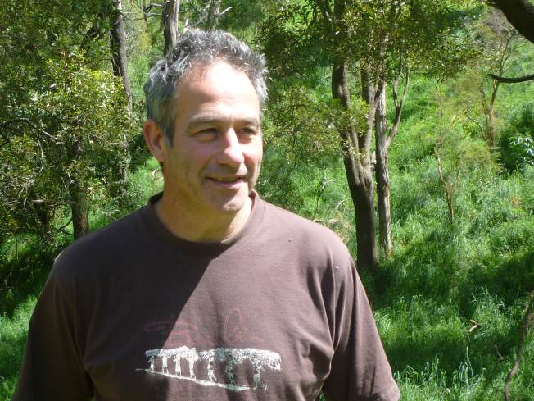

Trevor Warren

“I now use rotational grazing so stock doesn’t see the paddock again for up to 12 weeks. There are benefits for the health of the animals, also from fencing off dams as well.

“Plus the wildlife: when I first came back here it was so quiet – too quiet. There was hardly a bird in the area. There were very few remnant
areas and they were few and far between. Now there are loads of birds: black cockatoos and rosellas, small finches.

“There are also wombats: it’s nice to think that they are here in numbers. Just recently I saw my first koala here.

“It’s such a rewarding process to plant some tube stock that’s a couple of millimetres high and it grows into a thing of beauty.

“With EcoTender you can also put permanent protection on the title. That’s something that’s dear to my heart. You’re building something for future generations that can’t be torn down or changed in the future,” he said.

Trevor is one of 41 landholders who received funding of $800,000 through the Port Phillip Westernport EcoTender. As a result, over 190 hectares of native vegetation and waterways in the area are being managed, conserved and protected for the future.
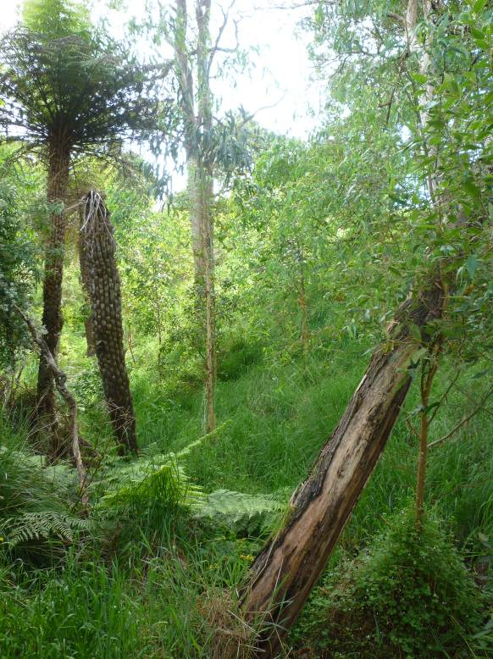

Trevor’s property in Poowong East

