|  |
| --- |
| **ActivityKit: shapefile requirements** |
| Requirements for uploading a shapefile to ActivityKit |

**When mapping projects and activities it is important to draw the shapes consistent with what is delivered.**

*ActivityKit* is available for viewing at <https://activitykit.biodiversity.vic.gov.au>

The *ActivityKit* administrators recommend you use Google Chrome to access the Registration site and *ActivityKit* as results can be unexpected on other browsers.

For instructions on how to upload a shapefile in *ActivityKit* please see ([ActivityKit tutorial – Creating a project](https://publish.viostream.com/play/c-nghqrzq) video)

To add or edit a feature in ActivityKit you must be signed in.

## Shapefile requirements.

* Shapefiles that are only single features can be uploaded to *ActivityKit*. The feature can be a single feature (polygon, line or point), or it can be a multipart feature.
* The shapefile can only contain one type of feature: polygon, line, or point
* The shapefile must include the following files: *.shp, *.prj, *.dbf and *.shx
* The shapefile must be in VICGRID projection (Datum: Geocentric Datum of Australia 1994)

The following message appears when a shapefile with multiple features is uploaded:

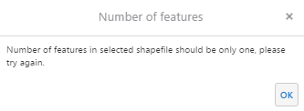

## If a Project or Activity is being delivered in multiple locations, the features (polygon, line, or point) for each project location and/or activity must be uploaded one by one, or a multipart feature must be created

## Creating a multipart feature

Only single feature shapefiles can be uploaded into *ActivityKit* in each uploading process. (It could be a multi-point shapefile for point features or a multipart shapefile for polygon or line features).

A multipart feature is suitable for:

* A project delivered at multiple locations some distance from each other (each project shape has the same attributes, that is, it is one project only).
* activites with the same attributes delivered at multiple locations, within the same project.

A multipart feature is a feature that has multiple polygons, lines or points spatially separated combined in a single feature and the same attributes. It is important to note that only features with the same attributes can be ‘merged’ to create a multi-part feature.

To create a multipart feature, the ‘Merge’ tool in ArcMap allows you to combine features within the same layer. In the following example, three selected features in the same layer are combined into one feature. When merging the tool asks which attributes are to be preserved during the merge operation.

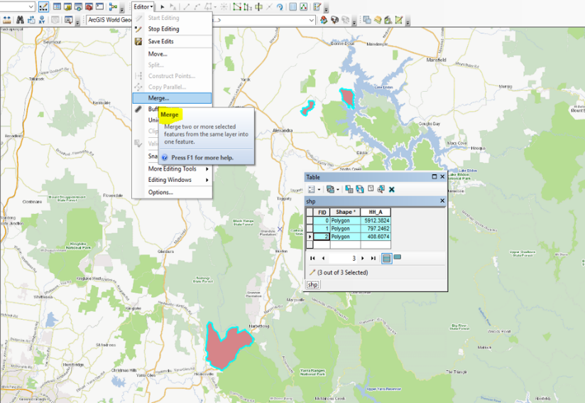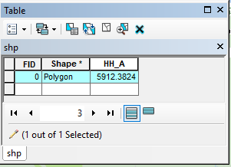

The following illustrates a multipart polygon feature representing a Project delivered in three spatially separed locations uploaded in *ActivityKit*. All polygons share the same attributes.

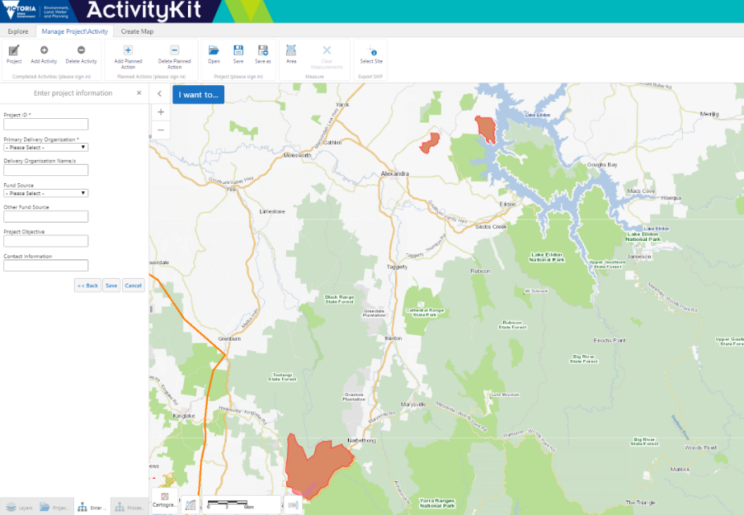

The following illustrates a multipart polygon representing an Activity - ‘Vegetation’ - uploaded in *ActivityKit*. All polygons share the same attributes.

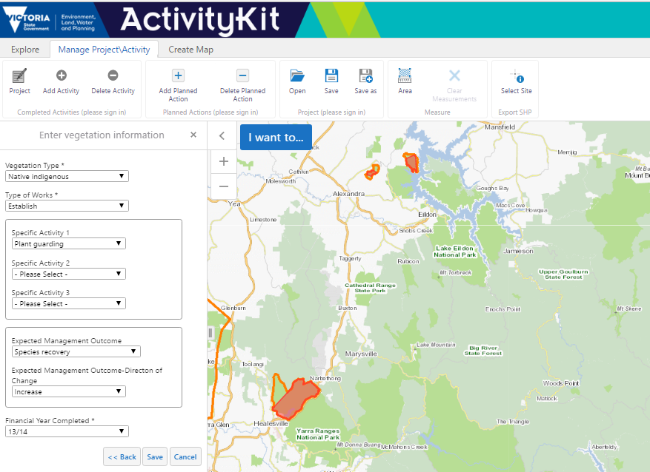

|  |  |
| --- | --- |
| © The State of Victoria Department of Environment, Land, Water and Planning 2019  LogoThis work is licensed under a Creative Commons Attribution 4.0 International licence. You are free to re-use the work under that licence, on the condition that you credit the State of Victoria as author. The licence does not apply to any images, photographs or branding, including the Victorian Coat of Arms, the Victorian Government logo and the Department of Environment, Land, Water and Planning (DELWP) logo. To view a copy of this licence, visit http://creativecommons.org/licenses/by/4.0/  Disclaimer  This publication may be of assistance to you, but the State of Victoria and its employees do not guarantee that the publication is without flaw of any kind or is wholly appropriate for your particular purposes and therefore disclaims all liability for any error, loss or other consequence which may arise from you relying on any information in this publication. | Accessibility  If you would like to receive this publication in an alternative format, please telephone the DELWP Customer Service Centre on 136186, email [customer.service@delwp.vic.gov.au](mailto:customer.service@delwp.vic.gov.au) or via the National Relay Service on 133 677 [www.relayservice.com.au](http://www.relayservice.com.au). This document is also available on the internet at [www.delwp.vic.gov.au](http://www.delwp.vic.gov.au). |