|  |
| --- |
| VBA – Create a Project |
| How to create a project in the Victorian Biodiversity Atlas |

### This is a basic step by step guidance document to help you create a Project in preparation for recording your wildlife sightings in the VBA

## Tips

*Throughout the VBA each window has a* ***?*** *in the top right hand corner – this is window-specific help that will provide further details about how to complete the fields.*

*Make sure that you have allowed pop-ups from your browser (you will need to allow these from the VBA site)*

*Also, throughout the VBA fields marked with a red dot (●) are mandatory fields and must be completed. The fields marked with a yellow dot (●) are conditional - if you complete one you must complete the others*.

## Projects

As part of the data management in the VBA, all species records must be associated with either a Project or a General Observation. Projects are structured data, typically survey based with one or more surveys grouped together, and can include instances where additional detail about the individual species is recorded (eg voucher specimens, measurements etc). General Observations are unstructured observations, typically not part of a formal survey with the observations more generalised/simplified.

1. Visit VBA (https://vba.dse.vic.gov.au/vba/) and Login using your Login Name & Password (see VBA Registration Help Guide).
2. Go to Data Entry in the top left screen and select My Projects, Select Create.

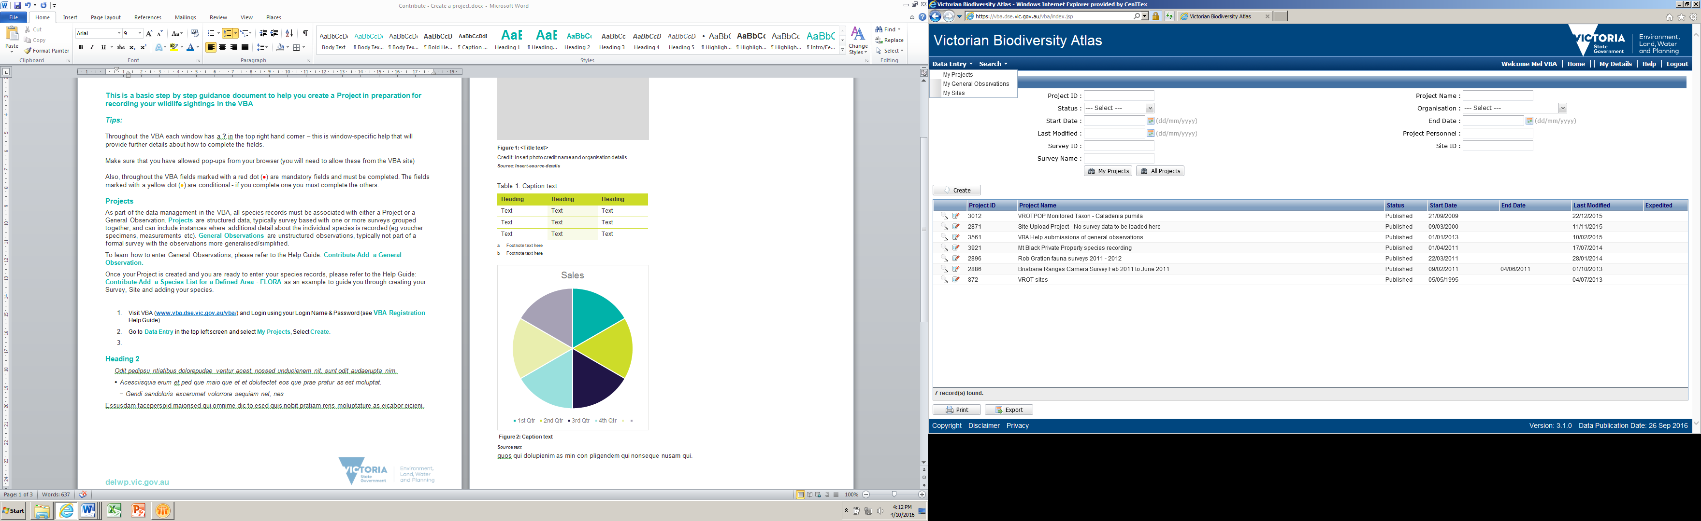

1. Fill in all the mandatory fields: Project Name, Description and Start Date.
2. Add all the Organisations that will be involved in surveys for this Project – your default Organisation will already be populated. To add additional Organisations, click Manage Organisation
3. If you are collecting data under a Permit(s), you can enter the details of the Permit(s) here: complete all fields with a yellow dot and click Add. The Permit details will be saved in the tabulated area.
4. Add all the Personnel (contributors/observers) that will be involved in surveys for this Project – you will be added by default. To add additional people, click Manage Personnel
5. When you are happy with the details, click Save & Close

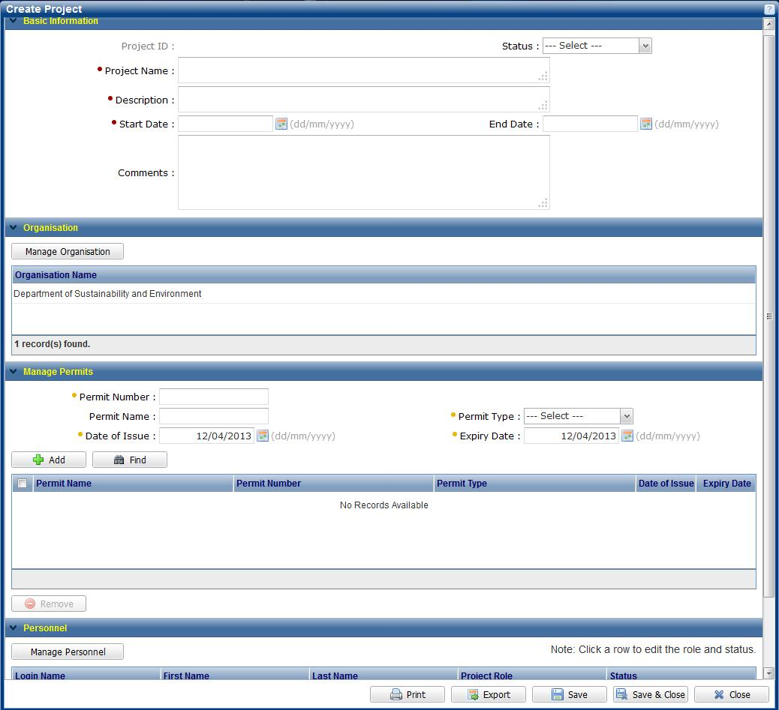

When you save your Project, the VBA will allocate a Project ID and the project will appear in the list of projects in the My Projects area for all members of this project. Any member of this Project can now create Surveys associated with this Project.

You (as the Project Owner) can edit this Project at any point by clicking 

Once your Project is created and you are ready to enter your species records, please refer to the Help Guide: Contribute-Add a Species List for a Defined Area - FLORA as an example to guide you through creating your Survey, Site and adding your species.

To learn how to enter General Observations, please refer to the Help Guide: Contribute-Add a General Observation.

|  |
| --- |
| **Related Quick Help Guides:**   * Contribute - Add a Survey and Species Records to a Project * Contribute - Add a Breeding Record * Contribute - Add a Specimen Record * Search - Summary Species List for an Area * Search - Detailed Species List for an Area |

|  |  |
| --- | --- |
| © The State of Victoria Department of Environment, Land, Water and Planning 2017  LogoThis work is licensed under a Creative Commons Attribution 4.0 International licence. You are free to re-use the work under that licence, on the condition that you credit the State of Victoria as author. The licence does not apply to any images, photographs or branding, including the Victorian Coat of Arms, the Victorian Government logo and the Department of Environment, Land, Water and Planning (DELWP) logo. To view a copy of this licence, visit http://creativecommons.org/licenses/by/4.0/  Disclaimer  This publication may be of assistance to you but the State of Victoria and its employees do not guarantee that the publication is without flaw of any kind or is wholly appropriate for your particular purposes and therefore disclaims all liability for any error, loss or other consequence which may arise from you relying on any information in this publication. | Accessibility  If you would like to receive this publication in an alternative format, please telephone the DELWP Customer Service Centre on 136186, email [customer.service@delwp.vic.gov.au](mailto:customer.service@delwp.vic.gov.au) or via the National Relay Service on 133 677 [www.relayservice.com.au](http://www.relayservice.com.au). This document is also available on the internet at [www.delwp.vic.gov.au](http://www.delwp.vic.gov.au). |