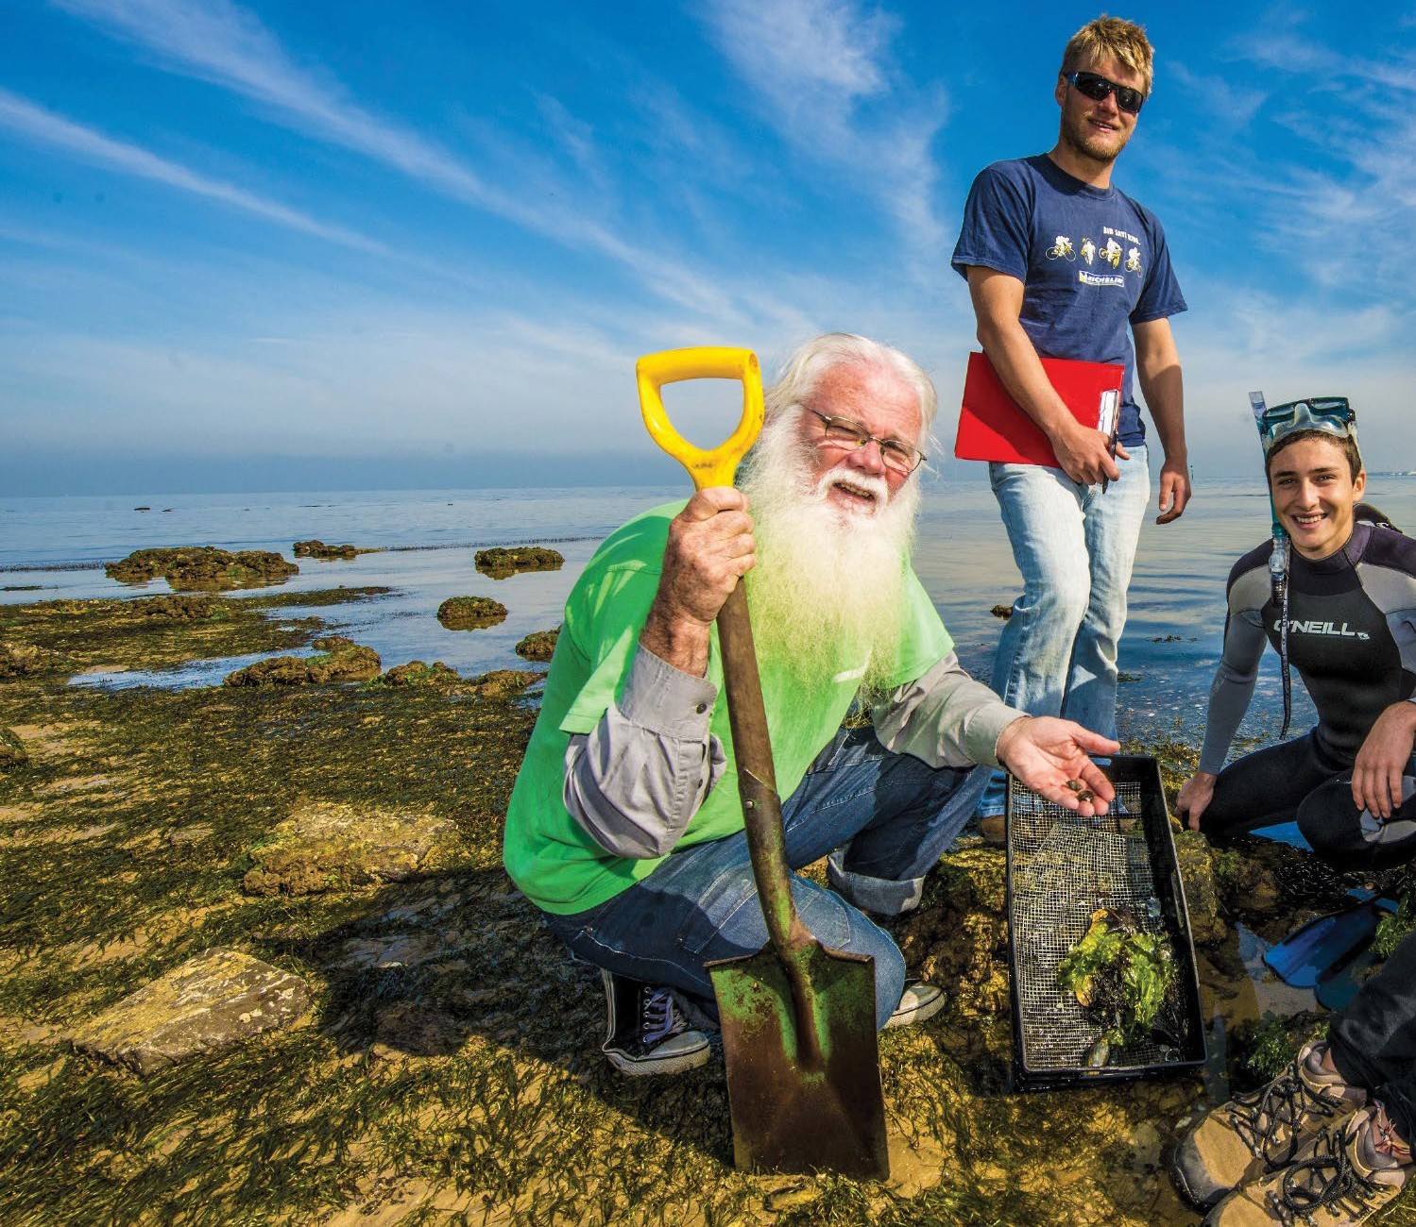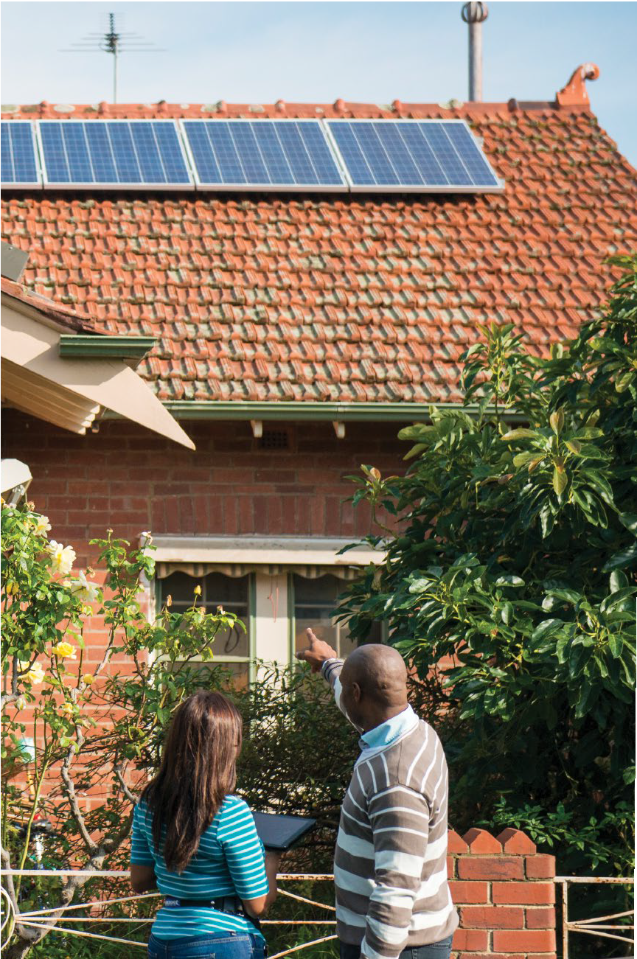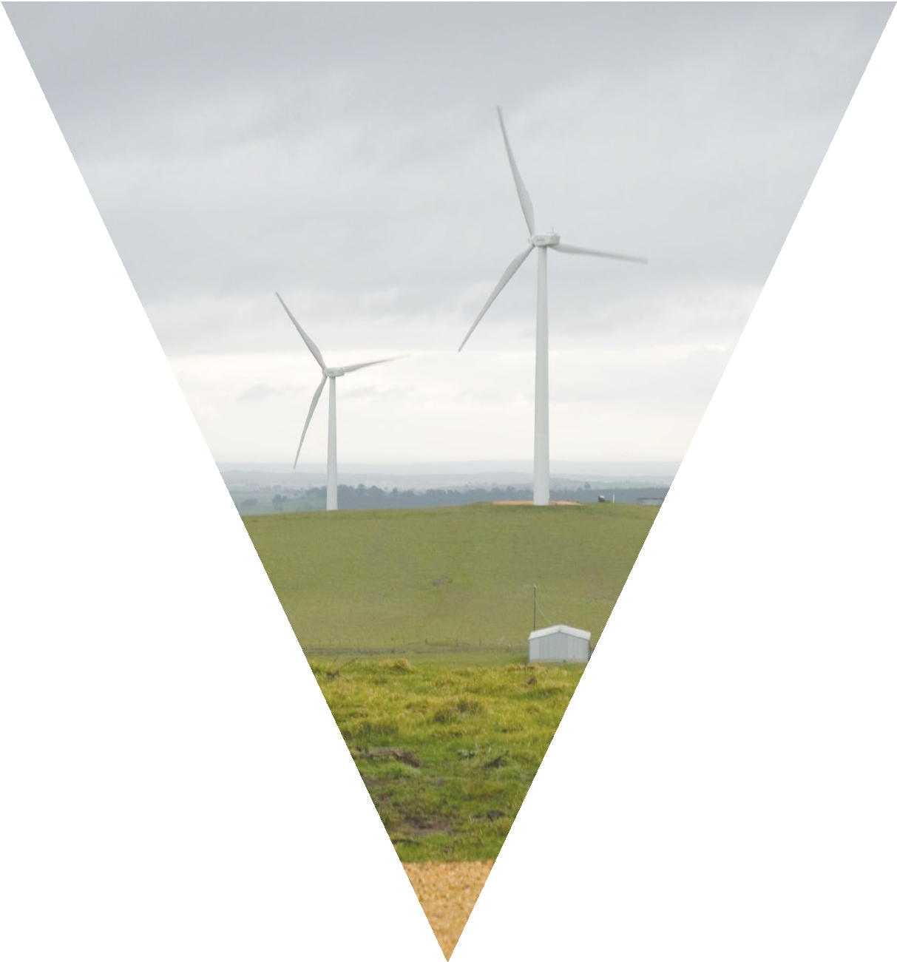Investing in a more sustainable future
Victorian Government Sustainability Fund
2015-2017 Activities Report

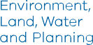

This report is public and available online at www.delwp.vic.gov.au
© The State of Victoria Department of Environment, Land, Water and Planning 2018
This work is licensed under a Creative Commons Attribution 4.0 International licence. You are free to re-use the work under that licence, on the condition that you credit the State of Victoria as author. The licence does not apply to any images, photographs or branding,
including the Victorian Coat of Arms, the Victorian Government logo and the Department of Environment, Land, Water and Planning (DELWP) logo. To view a copy of this licence,
visit http:// creativecommons.org/licenses/by/4.0/
ISBN 978-1-76047-997-8 (pdf/online)

Disclaimer
This publication may be of assistance to you but the State of Victoria and its employees do not guarantee that the publication is without flaw of any kind or is wholly appropriate for your particular purposes and therefore disclaims all liability for any error, loss or other consequence which may arise from you relying on any information in this publication.

Accessibility
If you would like to receive this publication in an alternative format, please telephone the DELWP Customer Service Centre on 136 186, or email customer.service@delwp.vic.gov. au (or relevant address), or via the National Relay Service on 133 677, www.relayservice.com.au. This document is also available on the internet at www.delwp.vic.gov.au
Cover windfarm image © Sustainability Victoria 2017

Victorian Government Sustainability Fund

Contents

Secretary’s Foreword 2
Overview 4
What is the Sustainability Fund? 5
The source of the Sustainability Fund 6
Priority Statement 8
Supporting the Priority Statement 10
Supporting different types of organisations 12
Sustainability Fund expenditure over time 14
Case study: Love Food Hate Waste 16
Case study: Victorian Residential Efficiency Scorecard 18
Case study: Biodiversity – Threatened Species 20
Case study: Litter Hotspots 22
Sustainability Fund 1 July 2015 – 30 June 30 2017 24
Programs funded 2015/2016 24
Programs funded 2016/2017 25
Sustainability Fund supported projects 2015/2016 26
Sustainability Fund supported projects 2016/2017 45

2015-2017 Activities Report 1

Victorian Government Sustainability Fund

Secretary’s Foreword


Our environment underpins the wellbeing and liveability of Victoria. Every time we reduce, reuse, or recycle we are using less resources, generating less
waste, reducing greenhouse gases associated with production and from landfill, and lowering our environmental impact.

Victoria’s landfill levies provide an important mechanism to reduce the amount of waste to landfill. A portion of the revenue generated from the municipal and industrial landfill levies is used to fund key government environmental agencies. The remainder is transferred to the Sustainability Fund.
The Fund’s aims are clear: ensure that Victoria lowers our impact on the environment by reducing impacts from waste, through innovation and the stimulation of viable industries, limiting our greenhouse gas emissions, helping communities and natural environments adapt to climate change, and building a more sustainable future.

- 2015-2017 Activities Report

This report details the Fund’s investments from 1 July 2015 to 30 June 2017. It aims to provide a record of the breadth of work taking place to support waste
reduction and climate adaptation and mitigation, and the role
the Fund plays in catalysing employment, new technology, innovation and resource efficiency.
The case studies provide tangible examples of how this funding supports a diverse range of on- ground activity. These targeted programs funded from the Sustainability Fund, can reduce the need for new landfills, increase productive uses of resources,
and reduce our greenhouse gas emissions, while preparing communities, businesses and industry for the changes in the climate that have already been locked in.
In July 2015, in response to the advice of the 2013 Ministerial Advisory Committee report on Waste and Resource Recovery Governance Reform, the management of the Sustainability Fund was transferred to the Department of Environment, Land, Water and Planning (DELWP).
With community consultation, new strategic priorities for the Fund were established, prioritising initiatives that foster employment, new technology and innovation, resource efficiency or ongoing behaviour change.
These priorities guide the management of the Fund as it significantly expands the investments made back into
the community. Funds from the Sustainability Fund must be allocated in accordance with the Environment Protection Act
1970, and the Sustainability Fund Priority Statement.
The Government has steadily increased its committed funding through the last three State Budgets. Funding has increased from $24 million in 2015-16, to $136 million in the 2016-17 Victorian State Budget.
In the 2017-18 budget an unprecedented $419 million in new investment from the Sustainability Fund was approved over the forward estimates.
This has resulted in significant investment from the Sustainability Fund into projects that will take decisive action on climate change, support innovation and stimulate viable waste management industries.
This funding will help increase the resource recovery rate for priority materials and reduce the amount of waste going to landfill. It supports a ban on e-waste from landfill, assists councils with collection infrastructure and processes, and results in reduced greenhouse gas emissions.
It will also help Victoria reach its emissions reduction targets for 2020 through to 2050 and lay the foundations for successful
adaptation and net zero emissions.

John Bradley
Secretary

2015-2017 Activities Report 3

Victorian Government Sustainability Fund

Overview

Established by the Victorian
Government in 2004, the Sustainability Fund is a remarkable investment in the State’s sustainable future.
In its twelve years the Fund has invested in many hundreds of projects that have been initiated by community organisations, local governments, industry, and research institutions. More than $900 million has been allocated in this endeavour, reaching communities in all parts of Victoria.
The Fund has helped Victorians in many different types of projects. It has helped to green and retrofit buildings,
improve sustainable transport and water efficiency, reduce waste going to landfill, and improved resource recovery. It has supported programs that educate and inspire people to change to a more sustainable way of life.
This Activities Report details the activities of the Sustainability Fund from 1 July 2015 to 30 June 2017.
It explains how the Fund is set up and what its focus will be in the coming years. Importantly, it also provides detail on how the funds have been allocated in this two-year period, and each of the programs that have been supported. It showcases several projects with case studies highlighting their achievements.

4

The Environment Protection Act 1970 defines waste to include:
- any matter whether solid, liquid, gaseous or radio- active which is discharged, emitted or deposited in the environment in such volume, constituency or manner as to cause an alteration in the environment;
- any greenhouse gas substance emitted or discharged into the environment;
- any discarded, rejected, unwanted, surplus or abandoned matter;
- any otherwise discarded, rejected, abandoned, unwanted or surplus matter intended for
  - recycling, reprocessing, recovery, or purification by a separate operation from that which produced the matter; or
  - sale;
- any matter prescribed to be waste.

What is the Sustainability Fund?

The Sustainability Fund exists to support programs and government initiatives to deliver a range of waste management, recycling, resource efficiency and climate change programs.
The first funding was released in 2005 by Sustainability Victoria, who administered the Fund until July 2015 when management transferred to the Department of Environment, Land, Water and Planning (DELWP).
The purpose of the Sustainability Fund, as defined by Section 70 of the Environment Protection Act 1970, is to:
- foster environmentally sustainable uses of resources and best practices in waste management to advance the social and economic development of Victoria;
- foster community action or innovation in relation to the reduction of greenhouse gas substance emissions or adaptation or adjustment to climate change in Victoria.
Funds are allocated with the joint consent of the Minister for Energy, Environment and Climate Change and the Premier, consistent with the Priority Statement. The Municipal and Industrial Landfill Levy (MILL) is the sole source of revenue for the Sustainability Fund.
The Sustainability Fund Committee provides impartial advice to ensure funding allocations offer value for money and align with legislated priorities, as well as overseeing strategic and accountable management of the Fund. The members of the Committee during the period have been:
- Freya Marsden, Chair (2016 - current)
- Joe Groher, Deputy Chair (2016 - current)
- Kath Rowley (2016 - current)
- Mark Feather (2016 - March 2017)
- Paul Murfitt (March 2017 - current)
- Anthony Connelly (2016 - May 2017).

2015-2017 Activities Report 5

The source of the Sustainability Fund
Each year around four million tonnes of waste is deposited in Victoria’s landfills.

We use the levy to drive better outcomes for our environment

More recycling and recovery of materials

Less waste to landfill

More waste to energy markets

Capacity building councils and communities

Accelerating Victoria’s transition to a low carbon future

A levy on waste
The Municipal and Industrial Landfill Levy (MILL) acts as a deterrent to increasing our landfill. Just as a higher price on sugary drinks makes it more likely that people will choose a healthier option*, putting a levy on landfill deposits is an incentive to reuse,
recycle, or reduce waste. This helps to prevent it ending up in our local tips. The money collected through the MILL funds the agencies and programs that are working to drive better environmental outcomes for Victoria.
The MILL is paid by licensed landfill operators for each tonne of waste deposited, with the cost passed on to the user through gate fees. The MILL is collected by the Environment Protection Authority (EPA) then transferred to a trust account managed by the Department of Environment, Land, Water and Planning (DELWP), (see Figure 2).

6 2015-2017 Activities Report

How levy funds are used
The MILL funds the essential work of environmental agencies and initiatives that improve waste management or take action on climate change. In 2017-18 $123 million from the MILL will be distributed to
environmental agencies, such as the EPA and Sustainability Victoria.
The remaining funds are transferred to the Sustainability Fund. Under the Environment Protection Act 1970, this Fund is to:
  - foster environmentally sustainable uses of resources and best practices in waste management to advance the social and economic development of Victoria;
  - foster community action or innovation in relation to the reduction of greenhouse gas substance emissions or adaptation or adjustment to climate change in Victoria.
* www.alfredhealth.org.au/news/reducing-the- appeal-of-sugar-sweetened-drinks/
Figure 1: The Municipal and Industrial Landfill Levy (MILL) acts as a deterrent to increasing our landfill. The funds collected support agencies and programs that are working to drive better environmental outcomes for Victoria.

Municipal and Industrial Landfill Levy
$86 million was distributed in 2016/2017 to $123 million will be distributed in 2017/2018 to agencies improving waste management or agencies improving waste management or taking taking action on climate change action on climate change
2016/2017* 2017/2018
Environment Protection Authority | $49  million | $78  million | - Prevention focus  - Industrial waste  - Illegal dumping
Sustainability Victoria | $20  million | $19  million | - Education and behaviour change  - State-wide waste planning  - Reuse and recovery  - Energy and materials efficiency
Waste & Resource Recovery Groups | $9  million | $10  million | Work with councils on:  - Waste minimisation and management  - Resource recovery  - Collective procurement of waste services and infrastructure  - Grants
Parks Victoria Commissioner for  Environmental Sustainability Committees of Management for Crown Land | $8  million | $22  million
Remainder of Levy distributed to Sustainability Fund
This supports resource efficiency or best practice waste management or action on climate change.

2016/2017 2017/2018
$122 million flowed into Sustainability Fund $80 million expected to flow into Sustainability Fund
$53 million - distributed from Sustainability Fund $176 million will be distributed from Sustainability Fund
* Data sourced from page 283 of the 2017 DELWP Annual Report

Figure 2: How the Municipal and Industrial Landfill Levy is distributed

Investment will be guided by Victorian government policies, including the Climate Change Act 2017, Victoria’s Climate Change Framework, the Victorian Climate Change Adaptation Plan
2017-20, Energy Efficiency and Productivity Statement, Renewable Energy Action Plan, Biodiversity 2037 and associated regulations and waste management policies.
Investment will be guided by Victorian government policies, including the Environment Protection Act 1970, the Statewide Waste and Resource Recovery Infrastructure Plan, Regional Waste and Resource Recovery Implementation Plans and associated regulations and waste management policies.

Priority Statement

The Priority Statement sets out the priorities of the Victorian Government and guides how funds are invested. The Priority Statement was refreshed in 2015/16 after consulting with the Victorian community, to position Victoria as a leader in resource recovery, waste management and climate change mitigation and adaptation. The statement clarifies how eligible programs will be prioritised to ensure funds are applied in a way that maximises benefits for Victoria.

Sustainability Fund’s legislated purpose:
Fostering environmentally sustainable uses of resources and best practices in waste management to advance  the social and economic development of Victoria | Fostering community action or innovation in relation to the reduction of greenhouse gas substance emissions  [mitigation] or adaptation or adjustment to climate change in Victoria
Strategic priorities:  - making alternatives to landfill more viable and cost competitive through the stimulation, creation and expansion of viable markets for recycled and recovered materials;  - facilitating a network of best practice waste and resource recovery infrastructure which minimises public health and environmental impacts and maximises resource recovery opportunities;  - providing equity in access to, and reducing impacts of, waste and resource recovery services on communities;  - improving waste education and waste management capability to reduce waste generation, recover resources, and prevent littering and illegal dumping; and  - modernising the management of legacy contamination or pollution. | Strategic priorities:  - supporting individuals, communities and industry to transition to a low carbon economy;  - supporting Victorians to adapt to the impacts of climate change, particularly those most vulnerable and least able to do so;  - building Victorian communities’ capacity, capability and skills in responding to climate change; and  - assisting Victoria’s ecosystems and native species to be more resilient to climate change and/or support mitigation outcomes.

1.2 Network of best practice waste and recovery infrastructure

1.1 Viable markets for recycling and recovery

1.3 Equitable access and reduce
the impacts of waste and

2.1 Support the transition to a low carbon economy

2.2 Support how we adapt to the impacts of
climate change
resource recovery services on communities

+

1. WASTE MANAGEMENT
Better practice and use of resources
2. CLIMATE CHANGE
Taking action and adaptation

1.4 Education to reduce waste and prevent
littering and illegal dumping

1.5 Modernise how we manage contamination and pollution from
the past

2.3 Build our capacity and capability to respond to climate change

2.4 Assist ecosystems and native species to be more resilient to climate change

Supporting the Priority Statement

The Priority Statement sets out the strategic priorities of the Sustainability Fund within its legislated purpose (refer page 8). The following charts illustrate how the Sustainability Fund investments in 2015/16 and 2016/17 align with the Fund’s strategic priorities.
The first charts show how the Sustainability Fund was allocated against the waste management and climate change action priority themes, noting that some funding addresses all strategic priorities and a small amount is used for the operation of the Fund.
Following the Ministerial Advisory Committee report on Waste and Resource Recovery Governance Reform and the community consultation that established new clear strategic priorities for the Fund, there is a notable increase in funding to act on climate change. By targeting funding, the government can reduce greenhouse gas emissions from waste, while preparing our communities, businesses and industry for the changes in the climate that have already been locked in.
Following the review and refinement of the Priority Statement in 2015/16 considerable funds were allocated to climate change action in the following year.

Sustainability Fund Allocation by priority theme

Fund objectives | 2015-16 | 2016-17

Address both objectives | $1,250,000 | $550,000
Waste | $11,020,000 | $19,430,000
Climate change | $10,460,000 | $38,000,000
Sustainability Fund operations | $500,000 | $740,000

Investment by strategic priority in 2015/16*

Sustainability Fund operations - $0.5m (5%)

Supporting all priorities - $1.25m (5%)

  - Support the transition to a
low carbon economy - $0.23m (1%)

  - Support how we adapt to the impacts of climate change - $3.83m (16%)

  - Viable markets for recycling and recovery
- $2.51m (11%)
  - Network of best practice waste
and recovery infrastructure - $0.82m (4%)

  - Equitable access and reducing the impacts of waste and resource recovery services
on communities - $2.65m (11%)

  - Build our capacity and capability
to respond to climate change - $0.4m (2%)

  - Education to reduce waste and prevent littering and illegal dumping - $5.04m (22%)

  - Assist ecosystems and native species to be more resilient to climate change
- $6m (26%)

  - Modernise how we manage contamination and pollution from the past - $0m (0%)

* Data sourced from pages 269-270 of the DELWP 2016 Annual Report

Figure 4: Sustainability Fund expenditure in 2015/16 against each area of focus in the Priority Statement.

Investment by strategic priority in 2016/17*

Sustainability Fund operations - 0.74m (1%) Supporting all priorities - $0.55m (1%)
1.1 Viable markets for recycling and recovery
- $1.91m (4%)
  - Network of best practice waste
and recovery infrastructure - $2.49m (5%)

  - Equitable access and reducing the impacts of waste and resource recovery services
on communities - 0m (0%)

  - Support the transition to a
low carbon economy - $14.15m (27%)

  - Support how we adapt to the impacts of climate change - $6.37m (12%)

  - Build our capacity and capability
to respond to climate change - $0.2m (<1%)

  - Education to reduce waste and prevent littering and illegal dumping - $5.12m (10%)

  - Modernise how we manage contamination and pollution from the past - $3.91m (7%)

  - Assist ecosystems and native species to be more resilient to climate change
- $17.46m (33%)

* Data sourced from pages 285-286 of the 2017 DELWP Annual Report
Figure 5: Sustainability Fund expenditure in 2016/17 against each area of focus in the Priority Statement.

Supporting different types of organisations

In the past two years, the Sustainability
Fund has assisted 587 organisations to undertake initiatives that deliver better environmental outcomes
for Victoria, by providing funding for
delivery agencies to run targeted grant programs.
Organisations that receive funding via grants programs, include local councils and community groups, universities and research institutions, charities and corporations, government agencies and volunteer groups. This diversity of organisations supported is one of the great strengths of the Fund, ensuring that it reaches across many Victorian communities.
Figure 6 illustrates how the Fund has supported projects led by different sectors in 2015/16 and 2016/17 and how the mix of organisations supported through the Sustainability Fund varies from year to year.
In both years more projects delivered by non-government and community organisations were funded than any other sector. This reflects the significant impact of the community sector through leadership, collaboration and their encouragement of local participation and involvement.
In 2015/16, 27 per cent of projects supported were led by councils, and they comprised ten per cent of the project mix in 2016/17. Local governments tackled the impacts of climate change with projects such as shellfish reefs for shoreline protection of highly erodible coasts (Greater Geelong) and renewable energy feasibility (East Gippsland). Other initiatives included
a community facility sustainable audit (Buloke), cooling canopies for community resilience (Towong Shire) and a cigarette butt litter education and enforcement project (South Gippsland). This is in addition to the funding and resources developed and provided each year to local government by Sustainability Victoria and the EPA to reduce waste going to landfill and help local councils improve resource recovery.
Around one quarter of the projects funded in both years were led by Victorian Government departments or agencies. Departments
piloted initiatives such as retrofitting public housing to reduce energy consumption and improve thermal comfort for vulnerable residents, and managing other threats to biodiversity of flora and fauna.
The role of corporations in driving change has not been overlooked, with business and industry-led projects being 8% and 5% of funded projects in each year.

2015/16*

Victorian Government Department & Authorities - 24%

NGO's &
Community Organisations - 39%
Business & industry - 8% Education & Research - 2%

Local government - 27%

* Data sourced from pages 270-283 of the 2016 DELWP Annual Report

2016/17*

Victorian Government Department & Authorities - 27%

NGO's &
Community Organisations - 57%
Business & industry - 5% Education & Research - 1%

Local government - 10%

* Data sourced from pages 287-304 of the 2017 DELWP Annual Report

Figure 6: Percentage of projects supported by sector in 2015/16 and 2016/17

2015-2017 Activities Report 13

Sustainability Fund expenditure over time

Since it began in 2004, the
Sustainability Fund has committed more than $350 million
to a broad range of sustainability projects across Victoria.

Projects have ranged from small local community initiatives to large scale resource recovery investments. The Fund is wholly focussed on delivering better environmental outcomes for Victoria.
As Figure 7 illustrates, between 2010 and 2016 annual expenditure from the Sustainability Fund ranged from $14.5 million to $41 million.
The amount of funding jumped in 2016/17 to $52.7 million, reflecting the refreshed Priority Statement, and renewed focus on positioning Victoria as a leader in resource recovery, waste management and climate change mitigation and adaptation.
This increase is set to continue, with the Victorian Government committing substantial funding to innovative environmental initiatives in the 2016-
17 Victorian State Budget with substantial commitments to address the areas of focus identified in the Priority Statement. The significant
increase is reflected in the forecast expenditure in the chart below which shows committed expenditure in the Forward Estimates from the 2017-18 Victorian State Budget.

Approved expenditure from 2017-18

180
$175.9m
Victorian State Budget

160
$164.4m

$130m

$84.9m

Actual expenditure 2010-17

$52.7m
$41.1m
$35.6m

$23.5m
$14.5m
$23.5m
$29.6m

140

120
EXPENDITURE

100

80

60

40

20

0
2010/11

2011/12

2012/13

2013/14

2014/15

2015/16

2016/17

2017/18

2018/19

2019/20

2020/21

YEARS

Figure 7: Illustrates the Sustainability Fund expenditure over time, with actual expenditure from July 2010 to June 2017, and forecast expenditure from the 2017-18 Victorian State Budget.

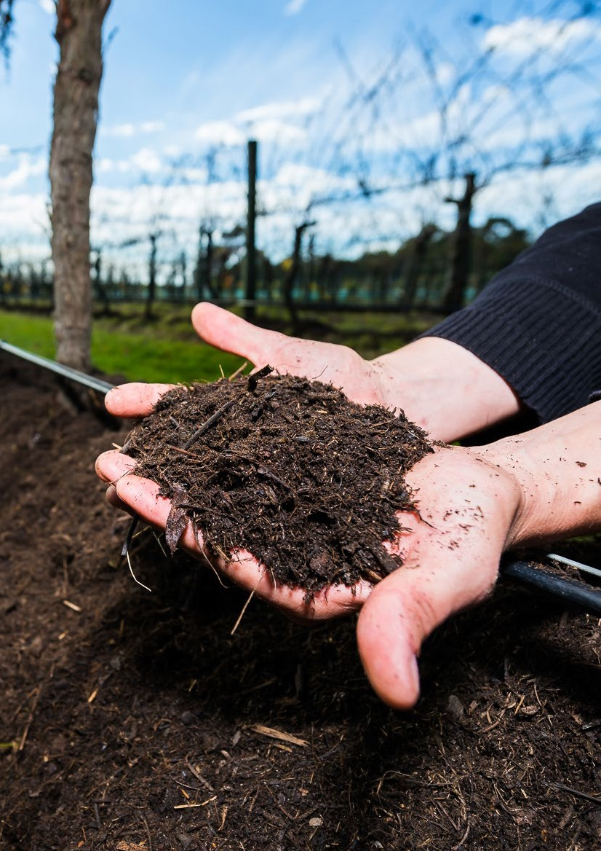Victorian Government Sustainability Fund

2015-2017 Activities Report 15

Case study: Love Food Hate Waste
What’s in the bin?

Helping households change wasteful behaviour

Each year, Victorian households throw away 400,000 tonnes of food waste, an amount that would fill the Eureka Tower.
The Love Food Hate Waste campaign ran from June 2015 to August 2016, and focused on the issue of food waste, which forms a surprisingly large component of household waste in Victoria.
Supported by the Sustainability Fund since 2015, the success and recognition of the Love Food Hate Waste campaign has helped to position Victoria as being amongst the global leaders in work on food waste.
25% of the contents of an average household’s garbage bin is avoidable food waste – food that was purchased with the intention of being eaten but was instead discarded.
Each year, Victorian households throw away 400,000 tonnes of food waste, an amount that would fill the Eureka Tower.
Households estimate that this thrown-away food is worth more than $2000 a year and, if the costs of growing, producing, transporting, retailing and landfill are also included, the real environmental and financial costs are even higher.
Reducing food waste could save households money, potentially decrease CO2 emissions and substantially reduce pressure on landfill sites. Research shows that families with children, young people aged 18-24, and higher income families waste the most food.
It’s clear that householders don’t want to waste food, but over-buy or cook more because people want to make sure that they provide for their families and have enough food, especially with fresh fruit and vegetables.
The Love Food Hate Waste campaign, delivered by Sustainability Victoria, used the combination of a digital media campaign to help families find practical ways to reduce their weekly food waste, and a support program for local councils to help them deliver events and activities at a local level.
Using the simple focus of I love leftovers, the digital media campaign reached over one million Victorians – 700,000 via Facebook and 300,000 through videos developed for the campaign.
Evaluation showed that people exposed to the digital messages were more aware of the amount of food they waste and the impact this has on climate change, compared to those who hadn’t seen the campaign.
Sustainability Victoria also worked with 11 local governments on local
Love Food Hate Waste events and workshops, as well as providing material and training to all Councils to support the delivery of local projects.
The campaign was awarded with two Public Relations Institute of Australia National Awards and further endorsement has come through the campaign’s strategy and tools being adopted by similar programs in New South Wales and New Zealand.

Find 1
00
s

Victorian Government Sustainability Fund

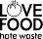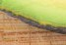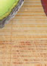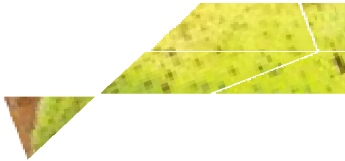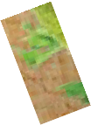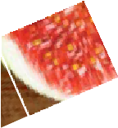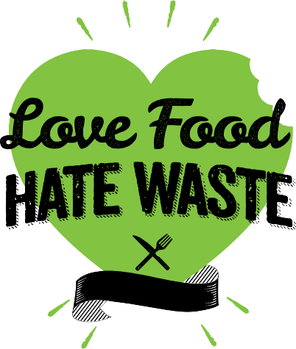Five biggest type of avoidable food waste sent to landfill by Victorian households each year
love

Find 100s of ways to cut your fOOd waste ove OOdhate ste.vic.gov.au
S

64,500 tonnes of bread, pastry and biscuits
1
51,000 tonnes of pre-prepared and home cooked meals
3
2
35,000 tonnes of dairy and eggs
31,500 tonnes of fresh vegetables
4
5
22,500 tonnes of fresh fruit

Figure 8: Avoidable food waste sent to landfill by Victorian households each year

Case study:
Victorian Residential Efficiency Scorecard
Ten-star rating for home energy use


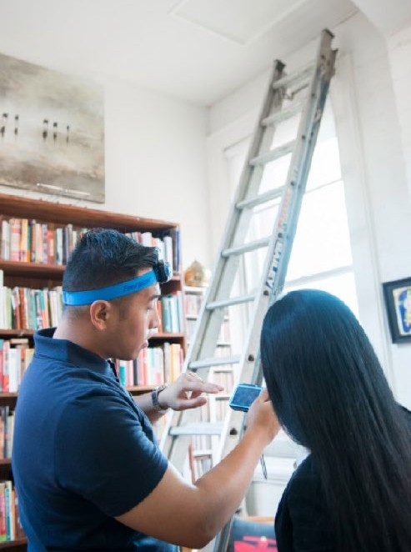Everyone would like to reduce their household energy costs, but knowing what to do next is the tricky part.
The Victorian Residential Efficiency Scorecard assesses the energy rating of existing houses, and helps householders make informed decisions about improvements to boost their home’s energy efficiency.

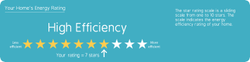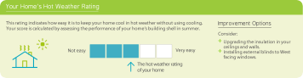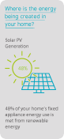“The scorecard will help all Victorians understand and value the features of energy efficient homes.”
Accredited assessors visit homes and examine fixed features – such as heating and cooling systems – putting data into a web tool that creates an energy-use rating out of a possible ten stars. A high star rating means a home will use less energy, and cost less to run than
a home with a lower star rating, and reduce carbon emissions from energy used to heat and cool properties, reducing our climate impact.
Scorecard Manager, April Muirden, of the Department of Environment, Land, Water and Planning, said existing homes are often performing poorly as most were built before energy standards. “The scorecard will help all Victorians understand and value the features of energy efficient homes.”
“Many people know about the simple things we can do – like using energy efficient light globes – but when it comes to the next level, we’re often unsure what improvements are relevant or suitable in our home. This assessment gives householders clear, tailored recommendations on where to focus their efforts.”
The Scorecard translates the complex interactions that influence home energy use into an easy-to-understand star rating, showing how well a home copes with Victoria’s hot and cold weather and how expensive it can be to keep it comfortable. This allows householders to compare energy use with similar homes,
or compare different renovation
options, and to quickly see how to save money on energy bills.
The rating considers various elements of a home which are otherwise difficult to assess such as construction materials, major appliances, hot water system, insulation, lighting and any renewable energy sources.
The Scorecard also includes an assessment of the hot weather performance of homes, rating how easy it is to keep your house cool on hot days without using the air conditioner.
April said solutions often included dealing with gaps and cracks and draught-proofing – everything from unsealed chimneys to covering up old wall vents, or


Victorian Government Sustainability Fund

filling gaps in skirting boards and under doors. “The government- accredited assessors come with good knowledge and skills and they can provide practical advice on next steps to increase your energy efficiency rating.”

Improving Energy Efficiency in Victoria’s Public Housing
The Victorian Residential Efficiency Scorecard will be used to make Victoria’s public housing more comfortable and energy efficient for householders.
The cost of utilities has hit many Victorians hard and has been particularly challenging for those in public housing who are on reduced incomes.
EnergySmart Public Housing, part of the Home Energy Assist program, will establish a baseline for the current energy and thermal performance of public housing and undertake a range of actions to improve that performance.
The program includes retrofitting old inefficient hot water systems and space heaters in 1300 households with an energy efficient alternative – at no cost to the tenant. Benefits could include reduced greenhouse gas
emissions and energy usage, lower energy bills and a more comfortable living environment for householders.
A baseline assessment of 200 dwellings will be done using the Scorecard to better understand current rates of energy efficiency and plan for future opportunities to limit energy related greenhouse gas emissions.
By providing better insulation and draught sealing to the floors, walls and roofs there will be less heat transfer in winter and summer.
The results of the program will be evaluated and these learnings used to inform further decision-making around future public housing initiatives.
A win for the environment and for some of Victoria’s most disadvantaged households.
The Scorecard and web tool were developed and piloted over a number of years, with more than 300 homes assessed so far. In April 2018, the program will be
broadened to cover more locations, with support from the Sustainability Fund continuing until 2020.
Currently assessments are available in metropolitan Melbourne, Geelong, Gippsland and Warrnambool south-west coast, with more accredited assessors and locations to come.
April points out the potential for the Scorecard to stimulate and promote better energy efficient
products. “With this objective rating scale, businesses can prove the effectiveness of their products – where once they were competing alongside products that may not have delivered actual energy efficiency rewards.”
The Victorian Residential Efficiency Scorecard has a strong future. A version of the Scorecard is being developed under the National Energy Productivity Plan so that other states can trial this Australian- first home energy rating tool.
For more information or to book an assessment go to: www.victorianenergysaver.vic.gov.au

Case study:
Biodiversity – Threatened Species
Building biodiversity in rolling green hills

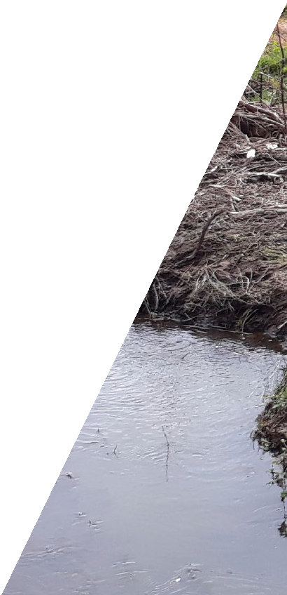

Swamp Antechinus
- Photo courtesy of Flickr User Michael Sale

It’s a win-win outcome for the environment when enthusiastic volunteers, landcare experts, and specialist services work together.
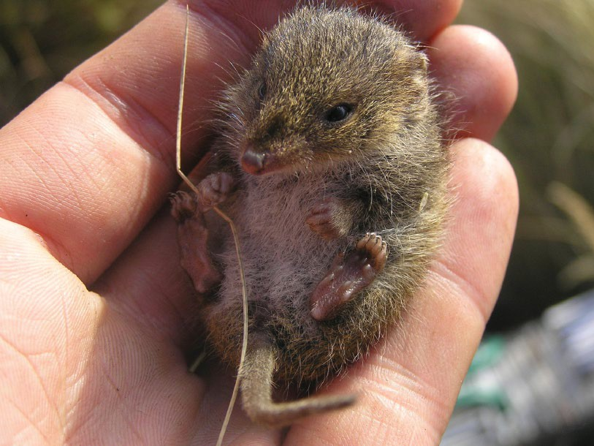The Swamp Antechinus is a small native marsupial and, like kangaroos, wallabies, koalas and Tasmanian Devils, it grows its young in a pouch. Typically weighing about as much as a chicken’s egg, it is amongst Australia’s smallest marsupials and is classified as a Threatened Species.
On the Australian mainland, the Swamp Antechinus exists only in a narrow band along the Victorian coastline, in habitats that are at risk from the impacts of development and climate change, including increased extreme weather events and fire. This small nocturnal animal lives on insects, worms and lizards supplemented with vegetable matter.
Much of its traditional habitat has been destroyed by decades of logging and grazing and only around 6% of the Bass Coast area is now covered by remnant native vegetation. By assisting these native species to be more resilient to climate change we substantially reduce their risk of extinction.
The future for the Swamp Antechinus and other native species in the local area is now a bit brighter, thanks to the work of the Bass Coast Landcare group, with

Victorian Government Sustainability Fund

support from DELWP’s Threatened Species program which provided a $24,000 grant. Local landowners and volunteers planted out 6000 seedlings over three community planting days around the Three Creeks area near Kilcunda to create new Antechinus-friendly, fenced-off habitats.
The success of these types of local revegetation projects depends on getting support from local landowners, having enthusiastic volunteers willing to help and being able to access landcare experts
and specialist services like fencing, weed control and wildlife population surveying.
The Three Creeks revegetation project involved an enthusiastic local group of Landcare volunteers.
They provided the muscle to put the seedlings in the ground, local landowners saw the benefits that this project would create for their properties, and the funding helped to fence off the newly planted areas around the steep creek beds protecting seedlings, creek banks and cattle.
According to Dave Bateman, Natural Resource Management Coordinator, at Bass Coast Landcare, this is typical of the win-win outcomes that community projects produce for the environment and for local landowners.
“We generally target areas of farms that are already eroded and that are often dangerous for cattle. So as well as the environmental outcomes, this sort of

“Decades of logging and grazing have destroyed traditional habitat and only around 6% of the Bass Coast area is now covered by remnant native vegetation.”

revegetation work typically creates shelter benefits for livestock, makes farms more aesthetically pleasing to look at, and often improves the capital value of farms as well.”
Technology now makes it easier to monitor the outcomes of these revegetation projects. The availability of relatively low-cost equipment such as infrared cameras and drones makes it possible to quickly and easily collect baseline information and monitor wildlife.
Whilst the Swamp Antechinus has been spotted in some of the few local areas of remnant vegetation, this newly protected area will be starting with just four recorded bird species.
Revegetation projects don’t produce results overnight and the newly protected area will be resurveyed in one, three and five years’ time to see whether this local biodiversity initiative has created a landscape that is equally attractive to the eyes
of humans and Antechinuses. The project will also assist other biodiversity in the area.

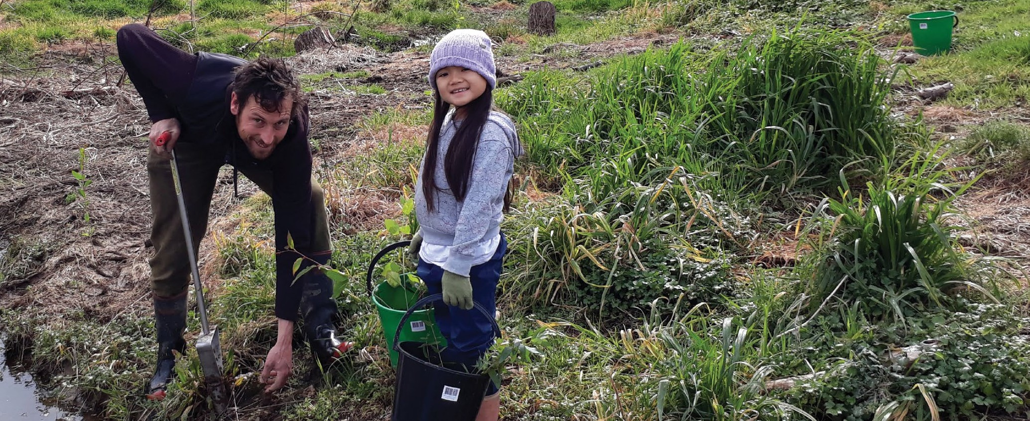

Three Creeks Landcare Group President Nick Sibly and Yasmin Gloria at one of three community planting days on Chris Puyol’s property

Case study: Litter Hotspots

A unique mix of government and community partners working together to reduce litter in Melbourne’s waterways

Cooling the hotspots
Litter is more than an eyesore. It causes major environmental and health damage and costs the Victorian community around $80 million each year in clean-up costs.
It’s a problem made more acute by the ability of litter to travel by water through the catchments of Melbourne into creeks and rivers and Port Philip Bay.
A multi-faceted approach was at the heart of the Litter Hotspots Program, developed by the Metropolitan Waste and Resource Recovery Group and funded
by a $2.1 million grant from the Sustainability Fund.

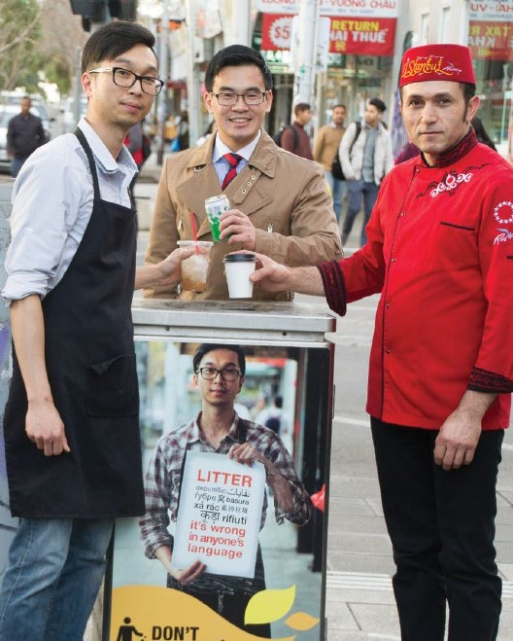
Maribyrnong City Council and Footscray business traders partnering to reduce street litter.

Using this funding, the Litter Hotspots Program has supported 35 local projects over three years, which have played an important role in reducing litter across Melbourne’s waterways.
Outcomes from the projects included 179 tonnes of litter being collected – including more than 1.29 million cigarette butts – micro-plastics being identified as a new source of environmental risk and development of new, cost-effective, litter-collection technologies.
The program evaluation showed that the projects resulted in significant litter reduction (up to 96.8%) at 436 hotspot sites. The evaluators highlighted that the delivery approach – including good project management, operational delivery support, grants, and partnership, collaboration and capacity building components – was a key factor in the success and effectiveness of the program.
Another success aspect was the leverage that these types of local community grants can create. In total, resources available for the 35 Hotspot projects were effectively doubled through an equal amount of cash and in-kind support coming from funded organisations and project delivery partners.
Another major benefit from these types of litter reduction programs is their potential to create a virtuous circle of behaviour. Littering
behaviour is contextual, which means that people are less likely to litter an area that is already clean.
According to Stan Vermeeren, Program Coordinator at the Metropolitan Waste and Resource Recovery Group, it can be summed up as clean equals clean.
“If a place looks really bad, then you have no respect for it and you don’t treat it very well. If something looks and feels clean, if it is looked after and loved, then you are much more likely to have your behaviour in sync with that”.
This type of attitude shift is particularly important because so many of Melbourne’s waterways flow into Port Philip Bay. As Melbourne’s population grows, the outcomes of programs like Litter Hotspots will
help to set up the Bay as a place that future generations will still be able to enjoy.

Victorian Government Sustainability Fund

Solutions to this problem require a mix of government and community partners working together to build local infrastructure, involvement
of local communities and enforcement of anti-littering laws.

Litter Hotspot leaders celebrating their achievements.

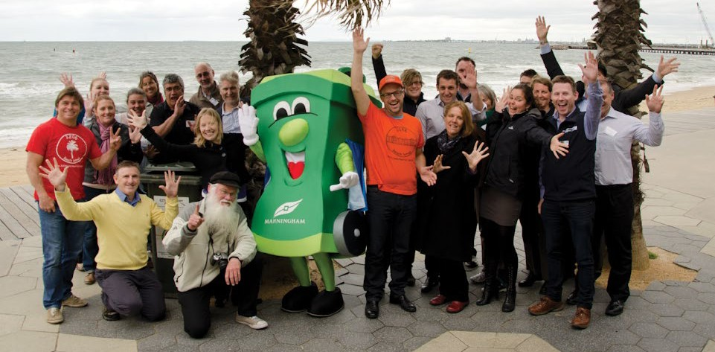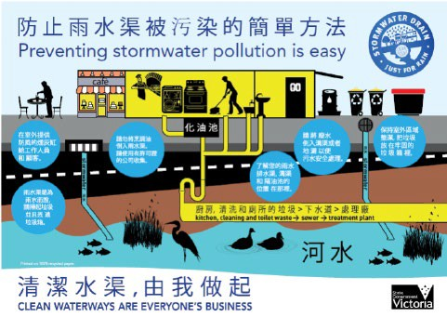

As part of the City of Monash’s Keep Kingsway Clean Litter Hotspot project, 32 local food traders received multiple one-on-one visits and a bilingual poster explaining the local sewage and stormwater systems.

Ten examples of local projects funded through the Litter Hotspot Program
City of Greater Dandenong – cigarette butt litter prevention campaign Reducing cigarette butt litter pollution in and around the rain gardens that filter through to nearby Dandenong Creek. ($15,000)
City of Whittlesea – Cover Your Load Campaign
Changing the long term behaviour of residents using the Wollert Landfill and the Cooper Street Recycling Precinct. ($14,300)
Friends of Williamstown Wetlands’ Wader – Beach For Birds Not Litter Project
Identifying the nature and extent of litter that is washing up on Wader Beach just east of the mouth of Kororoit Creek near Williamstown. ($8,000)
Hobsons Bay City Council – Cigarette Litter Reduction Project Reducing cigarette butt litter at six key hotspots identified as impacting on the health and amenity of local beaches and waterways. ($42,000)
Manningham City Council – Development of ‘Riversafe’
Trialing the use of low-cost maintenance gross pollution trap prototypes to manage the collection of stormwater litter pollution. ($175,000)
Maroondah City Council - My Mullum Mullum Creek Project
Reducing small litter and dog poo along the Mullum Mullum Creek trail in Maroondah. ($14,535)
Melbourne City Council
– Food Businesses and Stormwater Pollution Project
Improving the water quality of stormwater run-off from Chinatown. ($7,000)
Monash City Council – Keep Kingsway Clean
A shopping strip trader engagement program focusing on protecting stormwater from cigarette butt litter, oils and food waste arising from traders in Kingsway, Glen Waverley. ($14,000)
Nillumbik Shire Council – Ramp Up Litter Prevention
Transforming Eltham Skate Park and the Bridge Street underpass from an area that is heavily littered to a site that sees less litter entering the nearby Diamond Creek. ($14,420)
Wyndham City Council – Hook, Line and Litter
Tackling fishing-related litter at key fishing locations along the Werribee River and Werribee South Foreshore. ($9,930)

Sustainability Fund
1 July 2015 – 30 June 2017

The Sustainability Fund is allocated to programs and specific projects that align to the legislated purpose, the strategic objectives and to government policy. These programs often result in the establishment of grant rounds, and projects funded by these grants are outlined in the following pages.

Programs Funded 2015/2016*
Living Victoria Water Rebate | $3.03m
A Cleaner Yarra and Port Phillip Bay | $1.59m
Getting Full Value | $2.21m
National Association of Charitable Recycling Organisations (NACRO) | $1.20m
Threatened Species | $6.00m
Climate Change Grants | $0.80m
Climate Change Research | $0.23m
Climate Change Adaptation | $0.20m
Victorian Adaptation and Sustainability Partnership | $1.25m
Driving Investment for New Recycling | $0.30m
Community Sustainability Infrastructure Fund | $0.57m
Household Chemical Collection | $2.65m
Love Food Hate Waste | $0.32m
Community Education on Waste | $0.09m
Victorian Litter Plan | $0.05m
Optimising Kerbside Collection System | $0.09m
Climate Change Engagement | $0.20m
Metropolitan Local Government Waste and Recovery Fund | $0.25m
Illegal Dumping Strikeforce Program | $1.70m
Sustainability Fund Operations | $0.50m
Total payments | $23.22m
* See pages 269-270 of the DELWP 2016 Annual Report

Programs Funded 2016/2017*
A Cleaner Yarra and Port Phillip Bay | $1.57m
Advanced Organics Processing Technology | $0.01m
Back to Earth | $0.22m
Bringing our EPA into the Modern Era | $2.10m
Climate Change Adaptation Plan | $0.02m
Climate Change Research Grants – Climate Change Adaptation 2015-16 | $0.15m
Collaborative Councils | $0.55m
Community Education on Waste | $0.01m
Community Sustainability Infrastructure Fund | $0.41m
Contaminated Crown Land Assessment and Remediation | $1.81m
Driving Growth in Renewable Energy | $2.58m
Driving Investment in New Recycling | $0.02m
Energy Efficiency and Productivity 2015-16 | $1.87m
Getting Full Value | $1.88m
Industry Waste Reduction | $0.09m
Jobs and Innovation in Resource Recovery | $1.83m
Latrobe Valley Package – Energy Efficiency Initiatives | $0.50m
Love Food Hate Waste | $0.03m
Managing Victoria’s Waste Materials - Illegal Dumping Strikeforce | $2.30m
Metropolitan Local Government Waste and Resource Recovery Fund | $0.25m
National Association of Charitable Recycling Organisations (NACRO) | $0.80m
Optimising Kerbside Collection System | $0.01m
Preserving Victoria’s unique Biodiversity | $17.46m
Reducing the environmental impact of plastic bags – transitioning to ban | $0.03m
Reinstating Victoria as the national leader in Climate Change | $6.44m
Saving Energy, Growing Jobs | $6.37m
Securing our Energy Future | $1.95m
Understanding and Adapting to Climate Change | $0.57m
Victoria Litter Plan | $0.15m
Sustainability Fund Operations | $0.74m
Total payments | $52.69m
* See pages 285-286 of the DELWP 2017 Annual Report

Sustainability Fund projects funded by grants 2015/2016*
The Sustainability Fund enters into a Memorandum of Understanding with a number of agencies to administer grant programs that further support the strategic priorities of the Fund.
The following table lists all of the projects funded by grants in the 2015/2016 year, originating from programs (see page 24) allocated funding from the Sustainability Fund. All programs and grant funded projects are also published annually in the DELWP Annual Report.
Funding Program

Recipient | Project | Funding Support

Climate | City of  Greater Geelong | Shellfish reefs for shoreline protection of highly erodible  coasts Shellfish reefs have been used in a range of | $80,000
Change |  | environments in North America to mitigate the effects of
Competitive |  | storm tides. These structures have the potential to restore
 |  | habitat in the shallow waters of Port Phillip and Western
Grants |  | Port Bays.
This program is managed by | East Gippsland Shire Council | East Gippsland renewable energy feasibility with innovative options Investigate renewable energy | $80,000
DELWP |  | feasibility for East Gippsland, including potential
 |  | feedstock, distribution network conditions, heat
 |  | and power customers and community appetite for
 |  | different technologies.
 | Hepburn Shire Council | Climate resilient recreation facilities Strategy to minimise the vulnerability of Council’s recreation facilities to climate | $67,670
 |  | change, including innovative solutions to reduce carbon
 |  | emissions and water/resource consumption.
 | Moreland City Council | Working together to cool communities Investigate how the Urban Heat Island Effect’s negative impacts can be | $80,000
 |  | minimised for vulnerable social housing residents, creating
 |  | a replicable model for wider implementation.
 | City of Yarra | Embedding green infrastructure best practice toolkit | $80,000
 |  | Develop a toolkit to embed evidence-based green
 |  | infrastructure outcomes into local government decision-
 |  | making and operations, to increase tree planting, water
 |  | sensitive urban design and other green infrastructure.
 | Yarra Ranges Council | Eastern sporting savers Engagement program helps the region’s sports clubs save on their energy bills, | $30,000
 |  | delivered by the seven councils of the Eastern Alliance for
 |  | Greenhouse Action (EAGA).
 | South Gippsland Shire Council | Investigation into the impact of climate change on seawalls Assessing the condition and adequacy of | $80,000
 |  | the existing seawalls/drains in South Gippsland and
 |  | Wellington shires against a combined king tide/storm
 |  | surge and climate change sea level rise.
 | Warrnambool City Council | Barwon South West local coastal hazard assessment (phase 1) G21 Coastal hazard assessment for far South | $80,000
 |  | West Coast councils.
 | Towong Shire Council | Banking on our solar future – innovation for resilient communities Demonstration solar bank to educate the | $80,000
 |  | community and provide opportunities for individuals and
 |  | business owners to make informed investments in energy
 |  | storage and solar electricity systems.
 | Indigo  Shire Council | Battery storage revolution Establish a battery storage demonstration site to build understanding of | $45,000
 |  | the technology and the energy storage benefits for
 |  | vulnerable communities.

* See pages 270-283 of the 2016 DELWP Annual Report

Recipient | Project | Funding Support

Climate Change Non- competitive Grants
Funding Program
Mount Alexander Shire | Mount Alexander waste to energy feasibility study A study of three identified waste-to-energy technologies that could be used at the Castlemaine waste and heavy industry precincts. | $10,000
Pyrenees Shire Council | Beaufort sustainable water use plan A sustainable water use plan for Beaufort township, matching alternative | $10,000
 | water sources to potential users to reduce current
 | demand on the water supply.
Bass Coast Shire Council | Communities making energy together across southern Gippsland Assessing the feasibility of mid-to-large scale | $10,000
 | climate change mitigation and adaptation projects in
 | partnership with the community.
Gannawarra Shire Council | Be cool in Gannawarra Development of heat packs, resources and information to support vulnerable clients | $10,000
 | identified in the Home and Community Care and
 | Maternal Child Health assessment processes.
Golden Plains Shire Council | Online mapping tools and templates – fire, conservation and construction New tools and templates to support the | $10,000
 | community to produce informed environmental, fire and
 | land management plans.
Borough of Queenscliffe | Supporting Queenscliff and Point Lonsdale to prepare for climate change Providing householders, businesses | $10,000
 | and schools with one-to-one advice on energy efficiency
 | and renewable energy options.
Moyne  Shire Council | East Beach seawall design Design a replacement rock seawall to defend East Beach, Port Fairy from forecast | $10,000
 | sea level rise.
South Grampians Shire | On for young and old: kindergarten and senior citizen facilities Assessing kindergartens and senior citizen’s | $10,000
 | buildings in the Shire for thermal efficiency, water supply
 | reliability and energy efficiency, and implementing value-
 | for-money solutions.
Moorabool Shire Council | Sustainable buildings initiative Assessment of Council- owned buildings to identify priority actions to reduce | $10,000
 | Council emissions and expenditure.
Northern Grampians Shire Council | Supporting vulnerable households to respond to climate risk Tailored, practical advice on behaviour change,  low- cost retrofits and simple energy efficiency measures | $10,000
 | to improve the thermal comfort and health and wellbeing
 | of individuals.
Campaspe Shire Council | Campaspe community clubs combat climate change  Assessing and climate-proofing vulnerable community | $10,000
 | recreation reserves to minimise greenhouse, energy and
 | water costs.
West Wimmera Shire Council | Paving the way Installing solar panels and engaging the community in a positive climate change response, | $10,000
 | using social media to promote and track Council’s solar
 | power generation.

This program is managed by DELWP

The majority of grants supported through the Fund are contested however occasionally uncontested grants are provided to target local government, and specific issues within their communities.

Moira Shire Council | Collaborative climate change reporting  Developing a coordinated environmental sustainability reporting program. | $10,000
South Gippsland Shire Council | Communities making energy together across southern Gippsland Assessing the feasibility of mid-to-large scale | $10,000
 | climate change mitigation and adaptation projects in
 | partnership with the community.
Horsham Rural City Council | Green waste makes a greener place Diverting three waste streams into a local composting system, with the | $9,000
 | compost and mulch used in municipal parks, gardens,
 | ovals and with street trees.
Macedon Ranges Shire Council | Designing a revolving energy fund for community-use buildings Identifying a model for a revolving energy fund | $9,500
 | for energy efficiency upgrades to community buildings.
Murrindindi Shire Council | Collaborative climate change reporting  Developing a coordinated environmental sustainability | $10,000
 | reporting program.
Central Goldfields Shire | Yarriambiack. Planning for the future. Conducting energy audits on selected Shire buildings and | $10,000
 | identifying measures to reduce energy use; examining
 | options for more energy efficient management of
 | Council’s vehicle fleet.
Benalla Rural City Council | Collaborative climate change reporting  Developing a coordinated environmental sustainability | $10,000
 | reporting program.
Buloke  Shire Council | Community facilities sustainability audit Conducting energy and water sustainability audits in community | $10,000
 | buildings with the highest energy use in Buloke’s
 | major towns.
Warrnambool City Council | Barwon South West coastal hazard assessment phase 1 (non-competitive) Phase 1 of Coastal Hazard Assessment | $30,000
 | for Barwon South West Coast.
Wodonga Council | Collaborative climate change reporting | $10,000
 | Developing a coordinated environmental sustainability
 | reporting program.
Alpine  Shire Council | Plantation waste to energy Assess potential for plantation waste to be used in co-generation behind-the- | $10,000
 | meter scheme in a business or community facility.
Nillumbik Shire Council | Adapting to a new climate Developing a toolkit for use by householders to identify their own risks from the impacts | $9,970
 | of climate change and to plan mitigation actions.
Ararat Rural City Council | Stay in play: Recreation reserves and climate change workshop A free workshop and information about best- | $8,000
 | practice principles for turf maintenance in recreation
 | reserves, in drought-affected rural areas.
Hepburn Shire Council | Carbon free communities Facilitating community conversations about towns and localities becoming | $10,000
 | carbon neutral.
Towong Shire Council | Beating the heat – cooling canopies for community resilience Increasing the Shire’s urban park/street | $10,000
 | tree canopy to 40% by 2025 to contribute to cooler
 | urban environments and build community resilience
 | in heat events.

 | Indigo  Shire Council | Collaborative climate change reporting  Developing a coordinated environmental sustainability reporting program. | $10,000
 | Rural City of Wangaratta | Collaborative climate change reporting  |Developing a coordinated environmental sustainability | $10,000
 |  | reporting program.
 | Mitchell Shire Council | Feasibility study for the Chittick Park micro-grid project  Reducing energy use at Council and community facilities | $10,000
 |  | by determining design and funding implications of an
 |  | electricity generation, storage and distribution network
 |  | based on rooftop solar panels.
 | Baw Baw Shire Council | Baw Baw Shire community responding to climate change  Training sessions to raise climate change mitigation and | $10,000
 |  | adaptation actions in the local community, businesses
 |  | and amongst Council staff.
 | Corangamite Shire | Corangamite biolinks project A coordinated, strategic | $10,000
 |  | approach to creating landscape-scale vegetation
 |  | corridors or ‘biolinks’ in the Corangamite region to
 |  | mitigate impacts of climate change, link natural assets
 |  | and provide habitat for wildlife.
 | Surf Coast Shire Council | Local food program Supporting the Shire’s agriculture sector and local producers to become more resilient | $10,000
 |  | to the effects of a hotter, dryer climate by improving
 |  | sustainable agriculture practices and exploring local
 |  | issues and opportunities.
 | Swan Hill Rural City Council | Opportunity for a regional composting facility – Swan Hill Investigating the viability of a regional composting | $10,000
 |  | facility to reduce fruit dumping by the horticulture
 |  | industry, transforming a problem in a valuable resource
 |  | and improving the water efficiency on irrigation crops by
 |  | using compost as a soil conditioner.

Recipient | Project | Funding Support

Climate | Climate KIC | European Union Climate Knowledge Innovation | $95,000
 | (Knowledge | Community Summer School Grants
Change | Innovation
Research | Community)
 | Australia,
Grants | represented by
This program | the University of
is managed by | Melbourne
DELWP | Australian | ARC Centre of Excellence Scholarship | $70,000
 | Research
 | Council Centre
 | of Excellence
 | for Climate
 | System Science,
 | represented by
 | the University of
 | Melbourne
 | Australian | ARC Centre of Excellence Scholarship | $70,000
 | Research
 | Council Centre
 | of Excellence
 | for Climate
 | System Science,
 | represented by
 | Monash University

Recipient | Project | Funding Support

National Association of Charitable Recycling
Funding Program
Organisations Grants
This program is managed by DELWP
Benalla Uniting Church Bendigo UnitingCare Outreach Brotherhood of St Laurence Cooinda Hill Inc
Diabetes Australia Vic Doncare
Encompass Community Service Inc Friends of Hillside Lodge Inc Kilmore Anglican Parish Op Shop Lifeline Geelong
Barwon Region Inc
Lifeline South West Victoria Inc Paravin
(Spine and Limb Foundation VIC)
Red Cross (Australia) REMAR
Rotary Club of Warrandyte Donvale Inc Op Shop RSPCA
Salvation Army Cranbourne Corp – Salvo Access Thrift Shop
Salvos Stores SIDS and Kids
St Vincent de Paul Society Victoria Inc
Violet Town Community Opportunity Shop
To mitigate the costs imposed on Victorian charities by illegal dumping.
$1,200,000

Funding Program

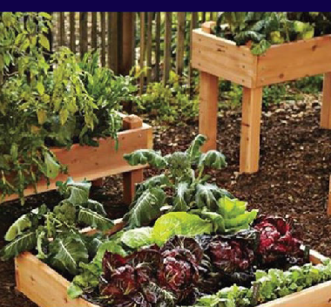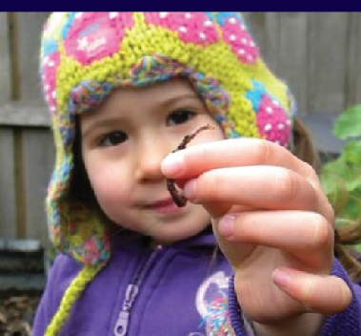Case study: Back to Earth South Eastern Garden Competition
The Back to Earth campaign in 2016 aimed to educate and encourage households to allocate organic waste to the
correct council bin and increase organic recycling. The average Melbourne household garbage bin contains around 40-50% food and garden waste, leading to over 300,000 tonnes of organic waste collected from the wrong bin each year.
Community groups in participating council areas were invited to nominate gardening projects to receive financial assistance, with the local public voting online for their top four favourite projects and the winner chosen by a panel of expert judges.

Recipient | Project | Funding Support

Threatened Species Grants
Funding Program
Arthur Rylah Institute | Roundsnout Galaxias recovery actions | $27,000
Arthur Rylah | McDowalls Galaxias and East Gippsland Galaxias | $27,000
Institute | recovery actions
Arthur Rylah | Dargo Galaxias recovery actions | $23,000
Institute
Arthur Rylah | Predator removal to save Shaw Galaxias from extinction | $45,000
Institute
Arthur Rylah | Tapered Galaxias and West Gippsland Galaxias | $23,000
Institute | recovery actions
Arthur Rylah | Helping hand: Glenelg freshwater mussel recovery actions | $35,000
Institute
Arthur Rylah | Barred Galaxias recovery actions | $45,000
Institute
Arthur Rylah | Determining threat management options for Masters’ | $28,675
Institute | Snake
Arthur Rylah | Management to aid the survival of the highly localised | $51,500
Institute with | Heath Skink in Victoria
Parks Victoria
Department of | Threat busting in key Jericho Wire-grass populations | $10,300
Environment,
Land, Water and
Planning (DELWP)
Arthur Rylah | Mapping and monitoring Caltha introloba Herbland | $49,900
Institute with La | Community
Trobe University
DELWP with Royal | Putting Shiny Daisy-bush back in its place: | $32,000
Botanic Gardens | Protecting diversity and unlocking the mysteries of low
(Vic) | seed viability
Trust for Nature | Protecting the New Holland Mouse | $51,050
with Parks Victoria
and DELWP
BirdLife Australia | Reintroduction and reinforcement of the endangered | $20,000
 | Black-eared Miner (Manorina melanotis) to the Victorian
 | Mallee: Translocation plan
DELWP with | Ballantinia’s road to recovery: Hydrological restoration | $52,600
Amaryllis | and moving to new heights
Environmental
DELWP with Trust | Gippsland Plains Environment Protection and | $136,200
for Nature | Biodiversity Conservation grassland ecosystems and
 | flora species
Trust for Nature | Critical assessment and protection of Velvet Daisy-bush | $61,700
(Vic) and Arthur | (Olearia pannosa subsp. cardiophylla)
Rylah Institute
DELWP | Murray hardyhead recovery program | $156,000

This program is managed by DELWP

La Trobe | Saving the threatened Alpine and Mount Stirling stoneflies | $105,498
University with
Murray-Darling
Freshwater
Research Centre,
Mt Buller-Mt
Stirling Resort
Management,
Falls Creek Resort
Management and
Parks Victoria
Zoos Victoria | Establishment of a self-sustaining captive insurance | $46,530
 | population of the Baw Baw Frog that supports wild
 | recovery of the species.
North Central | Winged Peppercress – in-situ monitoring and ex-situ | $13,851
Catchment | seedbank maintenance
Management
Authority with
Fire Flood &
Flora, Murray
Darling Fresh
Water Research
Centre and Royal
Botanical Gardens
Victoria
Hume City Council | Broadmeadows Valley Park – Geranium sp. 1 | $26,300
Arthur Rylah | Conservation management response to the arrival | $19,958
Institute with | of the Amphibian Chytrid Fungus at the last fungus-
Museum Victoria | free population of the nationally Vulnerable (Critically
 | Endangered in Victoria) Alpine Tree Frog
Port Phillip and | Securing the future of Victoria’s State emblems | $100,000
Westernport
Catchment
Management
Authority
Parks Victoria with | Yarra Ranges Endemic Shiny Nematolepis | $32,000
DELWP | (Nematolepis wilsonii) protection
Trust for Nature | Private land action for threatened species | $32,700
(Vic)
DELWP | Rare and Restored – Orchids of the Loddon Mallee | $88,000
Glenelg Hopkins | Glenelg Hopkins Pine Wildling removal | $66,000
Catchment
Management
Authority
DELWP with | Reintroduction of Eastern Barred Bandicoots into | $25,000
Tiverton Property | Tiverton, Western Victoria
Partners Pty Ltd,
Zoos Victoria,
Eastern Barred
Bandicoot
Recovery Team

DELWP with | Supporting the captive insurance population of | $35,000
Mt Rothwell | Southern Brush-tailed Rock Wallabies
Biodiversity
Conservation
Centre, Tidbinbilla
Nature Reserve,
Zoos South
Australia
DELWP | Discovery Bay Coastal Park Limestone Ridge, Orchid | $25,000
 | Conservation Project
Arthur Rylah | A survey protocol for the threatened Heath Mouse | $15,000
Institute
Parks Victoria | Moorabool Environmental Weed Control for Rocky | $17,000
 | Chenopod communities
DELWP with | Lowland Rainforest: Littoral Rainforest and Coastal Vine | $25,000
East Gippsland | thickets of Eastern Australia – Measuring for recovery
Rainforest
Conservation
Management
Network
Parks Victoria | Metallic Sun Orchid Protection | $30,000
DELWP with Parks | Alpine Flora – managing threats from large | $50,000
Victoria | introduced herbivores
Trust for Nature | Strategic actions for Mornington Peninsula and | $84,000
(Vic) with Parks | Westernport threatened species & communities
Victoria, Royal
Botanic Gardens
(Vic), Southern
Peninsula
Indigenous Flora &
Fauna Association
and Australasian
Native Orchid
Society.
Parks Victoria | Threatened orchids of Middle Yarra and the Warrandyte- | $50,000
 | Kinglake Habitat Corridor
DELWP with Royal | Saving Plains Orchids | $21,063
Botanic Gardens
(Vic)
DELWP with Cesar | Genetic sampling – critical to management imperatives | $40,000
Pty Ltd | of a highly fragmented threatened woodland population
 | in Victoria
Nature Glenelg | Identifying the distribution of, and restoration | $15,000
Trust with Deakin | opportunities for, the critically endangered Western
University | Swamp Crayfish in the Grampians
Parks Victoria | Plenty Gorge Park Orchid Sites | $25,000
Yarra Ranges | Addressing stormwater threats to sensitive | $70,000
Council | riparian ecosystems in Sassafras and Perrins Creek
 | sub-catchment

DELWP | Southern right whale data assessment and risk analysis (south-east population) | $49,628
Yarra Ranges | Pomaderris vacciniifolia protection Yarra Ranges | $34,750
Council
DELWP with Trust | Gippsland Plains Threatened Species and | $93,800
for Nature | Communities - 2
DELWP with | Threatened Invertebrates of the Western Strzelecki’s | $30,100
Recovery Team
and Trust for
Nature
Nature Glenelg | Strategic on-ground management to retain and enhance | $13,000
Trust | threatened flora and ecological communities of the
 | Mortlake Common Flora Reserve
Parks Victoria | Eastern Barred Bandicoot (EBB) Recovery – pest animal | $30,000
 | control in the Back Paddock, Woodlands Historic Park
Nature Glenelg | Recovery of threatened species (Wimmera Bottlebrush | $30,000
Trust | and Dwarf Galaxias) in response to the permanent
 | restoration of Gooseneck and Brady Swamps
Royal Botanic | Wild Orchids of the Wimmera | $141,572
Gardens (Vic)
Arthur Rylah | Protecting spawning conditions for Freshwater catfish | $32,000
Institute | at Tahbilk Lagoon
Goulburn Murray | Threatened woodland birds of the Goulburn-Murray | $54,924
Catchment | irrigation district: Are we prioritising works in the
Management | right landscapes?
Authority with
Birds Bush and
Beyond, Superb
Parrot Action
Group
Nature Glenelg | Protecting stream habitat for the critically endangered | $25,000
Trust | Glenelg Freshwater Mussel
DELWP with Parks | Threatened Orchids of the West Gippsland coast | $28,300
Victoria and Royal
Botanic Gardens
(Vic)
DELWP and Royal | Basalt Rustyhood Translocation Project | $25,000
Botanic Gardens
(Vic)
DELWP | Mapping review of optimal Orange-bellied Parrot habitat | $40,000
DELWP with | Expanded Orange-bellied Parrot winter survey | $49,940
Birdlife Australia
Arthur Rylah | Re-establishing Macquarie perch in the Ovens River | $84,246
Institute with
North East
Catchment
Management
Authority, Fisheries
Victoria
Trust for Nature | Survey of the Rayed Blue Butterfly (Wimmera form) and | $15,200
(Vic) | its food plant

Nature Glenelg Trust | Protecting a western basalt plains endemic: conservation for the Salt-lake Tussock Grass at Lake Linlithgow Lake Reserve | $12,000
Nature Glenelg | Rapid assessments informing critical recovery | $4,000
Trust | actions for threatened grassland flora of the
 | Linear Reserves Program
Greening Australia | Protecting threatened icons of the volcanic plains and | $36,000
with Parks Victoria | lakes – Salt-lake Tussock-grass
DELWP with | The design of a rock corridor linking Mountain Pygmy- | $25,000
Mt Hotham | possum habitat at Little Higginbotham, Mt Hotham –
Alpine Resort | remove the barriers to the conservation movement
Management
Board
Trust for Nature | Protection and augmentation of populations of | $66,500
(Vic) | seven threatened Orchid species on Trust for Nature
 | covenanted properties in the Goldfields bio-region
Royal Botanic | Reducing extinction threat by seed banking | $6,000
Gardens (Vic)
Nature Glenelg | Protecting threatened orchids on the urban fringe: | $5,000
Trust | conserving the Basalt Leek-orchid at Maam Reserve
Zoos Victoria | Captive-breeding to protect and recover the last | $19,375
 | lowland Leadbeater’s Possum population at Yellingbo
 | Nature Conservation Reserve
DELWP | On a Wing and Prayer – protecting the Loddon Mallee’s | $77,000
 | most endangered butterflies
Cesar Pty Ltd, | Eastern Barred Bandicoot gene widening project | $55,000
Melbourne
University, Zoos
Victoria, DELWP,
Mt Rothwell
Biodiversity and
Interpretation
Centre, Parks
Victoria,
Department of
Primary Industries,
Parks, Water
and Environment
Tasmania),
Victorian Eastern
Barred Bandicoot
Recovery Team
Southern Otway | Landcare is critical | $10,000
Landcare Network
Cairnlea | Saving six grassland species | $12,000
Conservation
Reserve
Committee of
Management and
Friends of Iramoo
Friends of the | Homes for Brush-tailed Phascogales | $10,000
Brisbane Ranges

East Gippsland | Peri-urban littoral rainforest stand improvement and | $19,000
Rainforest | community education program
Conservation
Management
Network
Parklands Albury | West Wodonga nest-box corridors | $20,000
Wodonga
Friends of | Resurrection of Dianella amoena along Campbells Creek | $5,562
Campbells Creek
Landcare Group
(sponsored)
Upper Goulburn | Ribbons of remnant roadsides | $20,000
Landcare Network
(sponsored)
Friends of the | Caring for Bannockburn Bush | $19,310
Bannockburn
Bush Reserve
(sponsored)
Mid-Loddon | Citizens Science threatened species training, monitoring | $14,406
Sub-Catchment | and habitat restoration program
Management
Group (sponsored)
Mt Worth and | Mt Worth Strzelecki Gum biolink | $6,220
District Landcare
Group Inc
Southern Otway | Community based monitoring of threatened species | $19,660
Landcare Network | habitat in the Otway Ranges
Millewa-Carwarp | Rabbit eradication for the protection of threatened species | $16,500
Landcare Group
Whroo Goldfields | Gliders in the Goldfields – providing habitat and raising | $16,000
Conservation | awareness for the endangered Squirrel Glider
Management
Network
(sponsored)
Campaspe | Australian Anchor Plant – protection; propagation; | $15,779
River and Land | revegetation
Management
group
Middle Yarra | Future-proofing threatened species and their habitat | $19,968
Landcare Network | within the Middle Yarra River catchment
(sponsored)
Friends of Brisbane | Nest boxes for Brush-tailed Phascogale habitat | $9,300
Ranges Inc | and monitoring
(sponsored)
Cairnlea | Endangered reptile habitat restoration and improvement | $18,150
Conservation
Reserves
Committee of
Management
Friends of | Friends of Sassafras Creek battle weed infestations to | $19,900
Sassafras Creek | save seven threatened species in Sassafras Creek.
Inc
Southern Otway | Restoring the Woodland Habitat of the Leafy Greenhood | $17,204
Landcare Network | on Cape Otway

Kulkyne Way Landcare Group | Understanding Hopbush dieback and potential implications for Mildura Ogyris in north west Victoria | $4,320
Boolarra South | Boolarra South Landcare threatened species training | $17,800
Landcare | workshops, and on-ground Works Program
(sponsored)
Pinkerton | Pinkerton Link Project | $12,220
Landcare &
Environment
Group Inc
Kowree Farm Tree | Kids creating habitat for Cockies | $17,900
Group (sponsored)
Post Office | Delivering Habitat for Phascogales on Post Office Hill | $4,460
Hill Action
Group (POHAG)
(sponsored)
Northern Plains | Northern Plains Grasslands threatened flora and | $19,991
Conservation | fauna project
Management
Network
Friends of Nyah- | Community surveying and weed removal in | $12,100
Vinifera Forest | Nyah-Vinifera Park
– through Friends
of the Earth
Melbourne
Friends of | Hooded Plover nesting sites protection at Betka Beach | $2,000
Mallacoota
(sponsored)
Ararat Regional | Restoration of the native grasslands areas within part | $4,428
Bio-Links Network | of the Ararat Cemetery Creek bio-link
Inc
St Arnaud Field | Protection and Recruitment of the depleted iconic Grey | $8,500
Naturalist Club Inc. | Grass-tree (Xanthorrhoea glauca ssp. angustifolia)
Dunmoochin | Expanding Orchid Conservation on private land in the | $8,642
Landcare Group | Dunmoochin Landcare Region
Dja Dja Wurrung | Mt Barker Temperate Woodland Bird Restoration | $19,900
Clans Aboriginal
Corporation
Hughes Creek | Brush-tailed Phascogale | $7,850
Catchment
Collaborative
(sponsored)
Nullawil Landcare | Nullawil threatened species revegetation | $2,640
Group
Lalbert Landcare | Goschen Bushland Reserve – community action to | $18,000
Group (sponsored) | protect threatened flora and fauna
Greta Valley | Protecting paddock trees for threatened species | $20,000
Landcare Group
Inc
Leigh Catchment | Saving the Growling Grass Frog from Chytrid Fungus | $10,640
Group

Milawa Markwood Oxley Landcare Group | Nesting boxes for hollow dependant threatened species in a fragmented landscape | $13,500
Strathbogie | Striped Legless Lizard Surveys – Cluster 8, North East Vic | $17,000
Ranges
Conservation
Management
Network
Yackandandah | Creating homes and habitat for Yackandandah Creek | $14,050
Landcare Group | threatened species: A community-led initiative
(sponsored)
Friends of Turtons | Turtons Creek survey for South Gippsland Spiny Crayfish | $20,000
Creek (sponsored) | and habitat rehabilitation
Wedderburn | Conservation of Mallee fowl in the Wychitella Nature | $16,665
Conservation | Conservation Reserve
Management
Network
Birchip Landcare | Birchip Buloke Woodlands Protection | $17,600
Group (sponsored)
South Beach | Lathams Snipe Project | $14,440
Wetlands and
Landcare Group
Gippsland Plains | Artificial hollows for the endangered Masked Owl | $18,000
Conservation
Management
Network
Moorabool | Raising awareness of threatened grasslands and their | $20,000
Catchment | species in the Moorabool Region
Landcare Group
Fungimap Inc | Develop surveys, training and data collection | $20,000
 | systems to improve the conservation status of
 | Clasping Hypocreoposis
Koetong Landcare | Protecting habitat values and mitigating threats to the | $16,740
Group | Summer Leek Orchid in Pheasant Creek Reserve
Friends of Kurth | Tall Astelia Recovery Project, Kurth Kiln Regional Park: | $3,850
Kiln, Tall Astelia | Phase 1 – plant propagation
Recovery Group,
Kurth Kiln Regional
Park
Cardinia | Cardinia Creek Threatened Species Protection Program | $19,500
Catchment
Landcare Inc.
Mt Korong Eco | Rewilding Korong Ridge – short story nursery | $8,800
Watch (sponsored)
Christmas Hills | Christmas Hills Community – protecting our | $19,915
Landcare Group | threatened species.
(sponsored)
3 Creeks Landcare | Creating Growling Grass Frog and Orange-bellied | $20,000
Group | Parrot habitat in 3 Creeks
Latrobe | Gippsland Red Gum Woodland species win hearts | $20,000
Catchment | through community engagement
Landcare Network

Wooragee Landcare Group (sponsored) | Protecting our fauna through empowering people | $12,700
Warrenbayne Boho | Railway Reserve Links | $5,366
Land Protection
Group Inc
(sponsored)
Friends of Merri | Matted and tangled: Fine scale threat reduction for | $19,890
Creek (FoMC) | urban Matted Flax-lily populations
Bass Valley | Holden the Ground – predator proofing and fox control | $20,000
Landcare Group | at Holden Proving Ground
Friends of | “Friends, Frogs and Fishes”: practical community | $11,200
Winton Wetlands | actions to help monitor and restore a wetland system
(sponsored)
Jack and Albert | Bringing the community together to tackle threatened | $20,000
River Restoration | species conservation
Committee (JARR)
(sponsored)
Binginwarri | Protecting and enhancing Warm Temperate Rainforest | $20,000
Landcare Group
(sponsored)
Phillip Island | Mapping, monitoring, protecting and enhancing Phillip | $20,000
Landcare Group | Island Coastal Moonah Woodlands
Inc (sponsored)
Watson Creek | Protecting Dwarf Galaxias in Watson Creek Catchment | $19,800
Catchment
Landcare Group
(sponsored)
Southwest | Protect and Connect – restoring bushland on properties | $20,000
Mornington | adjoining Peninsula Gardens Bushland Reserve
Peninsula
Landcare
(sponsored)
Powlett Project | Protecting the Powlett: Improving Australian Grayling | $20,000
Landcare Group | and Orange Bellied Parrot habitat
(sponsored)
Friends of | “That’s one giant leap!” Increasing the availability of | $10,600
Winton Wetlands | habitat for threatened arboreal mammals
(sponsored)
Friends of | Fabian’s threatened flora and fauna species survey | $9,480
Terrick Terrick
National Park Inc
(sponsored)
Entomological | Survey for the Cryptic Sun Moth Synemon Theresa | $7,150
Society of Victoria
(sponsored)
Port Campbell | Port Campbell biolinks – threatened species protection | $10,490
Public Purposes
Reserve
(sponsored)
Upper Maribyrnong | Protecting remnants, enhancing biodiversity and linking | $20,000
Catchment Group | corridors project
(sponsored)

 | Castlemaine Landcare Group (sponsored) | Protecting Bibron’s habitat in Happy Valley Castlemaine, stage 1 | $4,120
 | Longwood Plains | Baits, boxes and biodiversity corridors for Bush-stone | $19,725
 | Conservation | Curlews and Squirrel Gliders in Longwood Plains
 | Management
 | Network
 | Mt Korong Eco- | Rewilding Korong Ridge – short-storey planting, | $16,550
 | Watch (sponsored) | retelling a threatened understorey
 | Violet Town Action | Honeysuckle Creek, Violet Town: A hot-spot for | $19,156
 | Group | threatened fauna
 | Rainbow & District | Preservation, protection and restoration of Rainbow’s | $13,980
 | Landcare Group | Buloke populations
 | Inc.
 | Friends of the | Copper Fields: Sustaining change for the Eltham | $19,832
 | Eltham Copper | Copper Butterfly
 | Butterfly
 | (sponsored)
 | Kinglake Landcare | Kinglake Landcare threatened species monitoring, | $19,000
 | Group (sponsored) | survey, and revegetation
 | Hindmarsh | Project Hindmarsh 2016 | $20,000
 | Landcare Network
 | Southern Ranges | Muddy Creek Headwaters biodiversity protection program | $20,000
 | Environment
 | Alliance
 | Kilmore Mechanics | Kilmore Monument Hill Reserve threatened species | $11,660
 | Institute & Free | conservation and community education project.
 | Lending Library
 | Inc.
 | Ovens Landcare | What’s in our patch – Silver Tea-tree | $6,300
 | Network
 | (sponsored)
 | Korumburra | Protecting and enhancing Giant Gippsland Earthworm and | $20,000
 | Landcare Group | Strzelecki Gum habitat in the upper Powlett catchment
 | (sponsored)
 | Meredith Police | Meredith Police Paddocks threatened species project | $8,980
 | Paddocks Support
 | Group (sponsored)
 | Cardinia | Improving the habitat for Southern Brown Bandicoot at | $13,860
 | Environment | Five Mile Reserve
 | Coalition Inc.
 | Mt Rothwell | Let the threatened natives thrive: let’s be rabbit free | $20,000
 | Landcare
 | Volunteers Inc.
 | Upper Loddon & | Ullina and Talbot remnant Pimelea spinescens and | $9,220
 | Avoca Landcare | Victorian Volcanic Plain grassland awareness raising
 | Network | and on-ground conservation
 | Ballarat | Ballarat Environment Network threatened species project | $11,660
 | Environment
 | Network

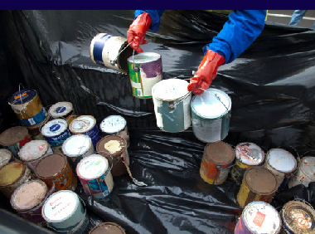
Case study: Household Chemical Collection Program – Sustainability Victoria
The Household Chemical Collection Program (HCCP) provides the Victorian community with free, safe accessible and environmentally responsible disposal options for everyday household chemicals and target products.
•
a mobile HCC service- ‘Detox your Home’ for the disposal of toxic household chemicals, with 31 collections held annually across regional and metropolitan Victoria; and
- a network of 30 permanent drop off sites for low risk target products including paint, batteries and fluorescent lights, which are located at 26 council
owned transfer stations and 4 privately owned transfer stations.
Attribution: © Sustainability Victoria 2018
Household Chemicals can be dangerous, and the safe
disposal of these chemicals will keep them out of our waterways, reduce the risk of poisoning
and keep our homes safe and minimise environmental
pollution and bushfire hazards
It is estimated that 94 per cent of Victorians have reasonable access to HCC services.
The mobile events assisted more than 3,500 people to safely dispose of over 1,700 tonnes of harmful household chemicals.
Sustainability Victoria provides two services to facilitate
the collection of household chemicals across the state:

Recipient | Project | Funding Support

Smarter
Funding Program
Melba Support Services Resource assessments: energy
$4,285

Resources | Skillinvest | efficiency assessment | $4,600
Smarter | Del Re National Food Group |  | $5,200
Business  Grants | Kyabram Cold Storage Pty Ltd |  | $8,000
This program | Southern Ocean Mariculture |  | $7,750
is managed by | Saltwater Coast Lifestyle Centre |  | $5,700
Sustainability  Victoria | Wilson and Bradley |  | $4,825
 | Foamex Victoria Pty Ltd |  | $8,000
 | The Comics Lounge |  | $5,000
 | The Leveson |  | $6,000
 | AF Gason |  | $6,000
 | E-Laundry and Dry Cleaning Service Pty Ltd (trading as South Pacific Laundry) |  | $8,000
 | Western Private Hospital |  | $8,000
 | Goldacres Trading Pty Ltd |  | $5,750
 | Committee of Portland | Business champions project | $9,800
 | City of Kingston – Kingston Sustainable Business network |  | $3,987
 | East Gippsland Food Cluster – Event Series |  | $9,650
 | South Gippsland Shire Council – South Gippsland Manufacturing Event Series |  | $9,500

Recipient | Project | Funding Support

Industry
Funding Program
Zilzie Wines Pty Ltd Materials efficiency assessment $10,000

Waste | Merino and Jumbuck |  | $11,415
Reduction  Grants | Southern Cross Recycling Group Pty Ltd |  | $12,990
This program is managed by | Alberton Timber and Treatment Plant Pty Ltd |  | $12,460
Sustainability
Victoria

Funding Program

Recipient | Project | Funding Support

Litter  Hotspots | City of Greater Dandenong | Greater Dandenong cigarette butt litter prevention campaign | $15,000
Grants | Nillumbik Shire | Ramp up litter prevention – Eltham Skate Park | $14,420
 | Council
This program  is managed by | Upper Yarra | Plastic bag free Warburton – litter prevention program | $15,000
 | River Reserves
Sustainability | Committee of
Victoria | Management
 | Wyndham City | Hook, line and litter | $9,930
 | Council
 | Friends of | Wader Beach for birds not litter – tracking the plastic | $14,300
 | Williamstown
 | Wetlands
 | Incorporated
 | Maroondah City | Dorset Recreation Reserve impact on Tarralla Creek | $10,184
 | Council
 | Beautiful | Love where you live drain project | $13,880
 | Brimbank/Friends
 | of Kororoit Creek
 | Hume City Council | Smart bins, stop litter | $14,985
 | City of Whittlesea | Cover Your Load | $14,300

Sustainability Fund projects funded by grants 2016/2017*
The Sustainability Fund enters into a Memorandum of Understanding with a number of agencies to administer programs that support the strategic priorities of the Fund.
The following table lists all of the projects funded by grants in the 2016/2017 year, originating from programs (see page 25) allocated funding from the Sustainability Fund. All programs and grant funded projects are also published annually in the DELWP Annual Report.

Recipient | Project | Funding Support

Biodiversity On-ground Action Grants
Funding Program
Arthur Rylah Institute | Emergency Response Framework: getting the rapid response right | $100,000
Arthur Rylah Institute | Intervention monitoring: Assessing the effectiveness of biodiversity management | $420,000
Arthur Rylah Institute | Galaxias | $153,000
Arthur Rylah Institute | Masters’ Snake | $100,000
Arthur Rylah Institute | Heath Skink | $105,000
Arthur Rylah Institute | Threatened Orchid Package | $259,420
Arthur Rylah Institute | Greater Glider | $100,000
Arthur Rylah Institute | Fire, ferals and mammals | $10,600
Arthur Rylah Institute | Connecting communities | $500,000
Birdlife Australia | Hooded Plover | $100,000
Bush Heritage Australia | Habitat restoration and woodland bird resilience in the Box Ironbark West Regional Spatial Priority Landscape. | $225,000
Connecting Country (Mount Alexander Region) Inc | Woodland bird community habitat protection and enhancement | $225,000
Dja Dja Wurrung Clans Aboriginal Corporation | Dja Dja Wurrung in landscape | $225,000
Forest, Fire and Regions – Barwon South West | South-eastern red-tailed Black Cockatoo | $12,000
Forest, Fire and Regions – Barwon South West | Southern Right Whale  – vessel impact mitigation | $10,000
Forest, Fire and Regions – Barwon South West | Southern Right Whale  – calf survival assessment | $30,500
Forest, Fire and Regions – Barwon South West | Eastern Barred Bandicoot | $50,000
Forest, Fire and Regions – Barwon South West | Orange-bellied Parrot recovery | $50,000
Forest, Fire and Regions – Gippsland | Brush-tailed Rock Wallaby (Southern ESU) | $60,000
Forest, Fire and Regions – Gippsland | Threatened Victorian plants – Gippsland region | $41,000
Forest, Fire and Regions – Gippsland | Brush-tailed Rock Wallaby | $40,000
Forest, Fire and Regions – Gippsland | Giant Burrowing Frog | $40,000

This program is managed by DELWP

* See pages 287-304 of the DELWP 2017 Annual Report

2015-2017 Activities Report 45

Forest, Fire and Regions – Gippsland | Isopogon prostratus (Prostrate Cone Bush) | $10,000
Forest, Fire and Regions | New Holland Mouse | $40,000
– Gippsland
Forest, Fire and Regions | Large Brown Tree Frog | $75,000
– Gippsland
Forest, Fire and Regions | Brush-tailed Rock Wallaby | $50,000
– Gippsland
Forest, Fire and Regions | Basalt Peppercress (Lepidium | $5,150
– Grampians | hyssopifolium) and Geranium sp. 1
 | (Large-flower Crane’s-bill)
Forest, Fire and Regions | Mountain Pygmy-possum | $50,000
– Hume
Forest, Fire and Regions | Regent Honeyeater | $50,000
– Hume
Forest, Fire and Regions | Threatened Victorian plants – Hume region | $10,000
– Hume
Forest, Fire and Regions | Plains Wanderer | $50,000
– Loddon Mallee
Forest, Fire and Regions | Helmeted Honeyeater | $50,000
– Port Phillip
Forest, Fire and Regions | Threatened Victorian plants | $10,000
– Port Phillip | – Port Phillip region
Forrest, Fire and Regions | Improving the quality and connectedness | $225,000
– Barwon South West | of grassland communities on the Victorian
 | Volcanic Plain – Cressy
Forrest, Fire and Regions | Improving the quality and connectedness | $225,000
– Barwon South West | of grassland communities on the Victorian
 | Volcanic Plain – Woorndoo
Glenelg Hopkins Catchment | Glenelg Estuary and Discovery Bay | $180,000
Management Authority | weed control
Goulburn Broken Catchment | Managing threats in the Longwood Plains | $230,000
Management Authority | priority landscape
Greening Australia | Enhancing significant ecological | $225,000
 | communities and threatened flora and
 | fauna of the Western District Lakes
Mallee Catchment Management | Northern Mallee Woodlands | $224,553
Authority
Mallee Catchment Management | Murray to Mallee Connections | $224,972
Authority
Mallee Catchment Management | Mallee Dunefields to the Big Desert | $224,711
Authority
Nature Glenelg Trust | Threatened species habitat restoration in | $225,000
 | the Wilkin Woodlands and Wetlands
Nature Glenelg Trust | Habitat restoration for threatened species | $225,000
 | of wetlands in the Glenelg Plain
Nillumbik Shire Council | Conservation Futures – protecting | $177,713
 | and conserving species in the Northern
 | Yarra Ranges

 | North East Catchment Management Authority | Warby – Ovens | $225,000
 | North East Catchment Management Authority | Chiltern – Mt Pilot | $187,500
 | Parks Victoria | Fox control to protect New Holland Mouse and other threatened vertebrates on the Gippsland Plains | $150,000
 | Parks Victoria | Mountains to Murray: The Upper Murray / North – North East Mountain outliers | $225,000
 | Parks Victoria | Northern Plains landscape restoration project | $225,000
 | Parks Victoria | Wilsons Prom Ark | $225,000
 | Parks Victoria | Landscape control of weeds of national significance for biodiversity | $150,000
 | Port Phillip and Westernport Catchment Management Authority | Protecting and connecting species and communities in Melbourne’s west | $225,000
 | Port Phillip and Westernport Catchment Management Authority | Protecting and connecting species and communities on the Mornington Peninsula | $199,000
 | Project Platypus | Greater Grampians threatened flora | $190,025
 | Wimmera Catchment Management Authority | Western Victorian woodlands protection and enhancement | $250,000
 | Yarra Ranges Council | Protecting cool temperate rainforest and associated threatened species of the Upper Woori Yallock Creek Catchment | $140,000
 | Zoos Victoria | Baw Baw Frog | $100,000
 | Zoos Victoria | Leadbeater’s Possum | $100,000

Recipient | Project | Funding Support

Boosting
Funding Program
Burton’s Supa IGA Energy Assessment Grant – Burton’s Supa IGA $3,600

Productivity Energy
CDC Geelong Pty Ltd
Energy Assessment – CDC Geelong $2,000

Assessment
CERES Inc Energy Assessment Grant – CERES $3,000

Grants
This program is managed by Sustainability
Flexible Drive Pty Ltd
Green Acres Golf Club
Energy Assessment Grant – Flexible Drive $1,740

Energy Assessment Grant – Green Acres Golf Club $3,012

Victoria | Hindustan Imports | Energy Assessment Grant – Hindustan Imports | $660
 | Merriwa Industries Limited | Energy Assessment – Merriwa Industries Ltd | $1,620

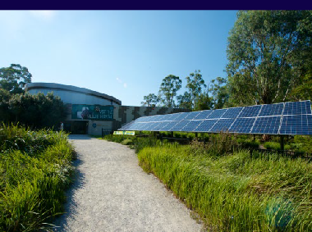Case study: Victorian Energy Upgrades (Saving Energy, Growing Jobs)

Victorian Energy Upgrades program provides discounts to businesses and households on energy-efficient products and appliances, leading to upgraded facilities with lower energy costs, as well as reducing the burden and reliance on the energy system and reducing greenhouse gas emissions.
The program makes is cheaper for businesses and households to buy energy saving products, saving the typical household
$150 a year on energy bills, while small to medium-sized businesses may save up to $670 annually. For larger businesses, the savings can run into the hundreds of thousands of dollars.

Healesville Sanctuary
Healesville Sanctuary, located in the Yarra Valley, is a wildlife haven which offers visitors the chance to see native Australian animals up close in their natural environment. The Sanctuary is also home to a wildlife hospital, treating more than 2,000 sick and injured animals each year.
Through the Victorian Energy Upgrades, the Sanctuary upgraded to energy efficient LED lighting in its animal hospital and retail area with minimal disruption, improving lighting and visibility in these areas. It is estimated that
by using Victorian Energy Upgrades, the Sanctuary has been able to save $1500 on energy costs each year.
“This is fantastic for the vets here. Better lighting allows us to give the best possible care to our animals.”
Vet, Healesville Sanctuary

Violet Town Bush Nursing Centre
The Violet Town Bush Nursing Centre used Victorian Energy Upgrades to undertake energy- efficiency upgrades and replace old and inefficient lighting with new LED lights in 64 bedrooms, communal spaces kitchens
and offices. By going through Victorian Energy Upgrades, the Centre saved 90 per cent on
up-front investment costs and greatly reduced their energy use, leading to savings of more than $5,000 on their annual energy bills.
“We saved 90% on the installation costs and are now saving more than $5,000 a year. And the payback on our investment was less than 3 months - unbelievable.”
CEO, Violet Town Bush Nursing Centre

Recipient | Project | Funding Support

Building
Funding Program
City of Ballarat Kerbside Organics Procurement in City of Ballarat $92,000

Victoria’s Organics
City of Greater Bendigo
Kerbside Organics Procurement in City of Greater Bendigo
$60,000

Recovery Grants
This program is managed by Sustainability Victoria
City of Greater Geelong
Building Victoria’s Organics Recovery – Geelong $100,000

Recipient | Project | Funding Support

Business Champion Network Grants
Funding Program
This program is managed by Sustainability Victoria
Committee for Portland
Portland Manufacturing, Assembly and Design Engineering Network
$3,185

Recipient | Project | Funding Support

Business Productivity | Alberton Timber and Treatment Plant Pty Ltd | Resource Assessment – materials and energy | $3,676
Program – | Alternative Glass | Resource Assessment – Materials | $7,500
Resource | Supplies Pty Ltd
Assessment | Connell’s Bakery | Resource Assessment – Materials | $11,712
Grants | Pty Ltd
This program | Global | Resource Assessment – Materials | $9,700
is managed by | Rotomoulding
Sustainability | Pty Ltd
Victoria | Kyabram Cold | Resource Assessment – Materials | $190
 | Storage Pty Ltd
 | Larnec Doors and | Resource Assessment – Materials | $10,000
 | Systems
 | Merino and | Resource Assessment – Materials | $4,849
 | Jumbuck
 | Company
 | (Australia) Pty Ltd
 | Snooza Pet | Resource Assessment – Materials | $7,330
 | Products (Aust)
 | Pty Ltd
 | Southern Cross | Resource Assessment – Materials | $4,690
 | Recycling Group
 | Pty Ltd

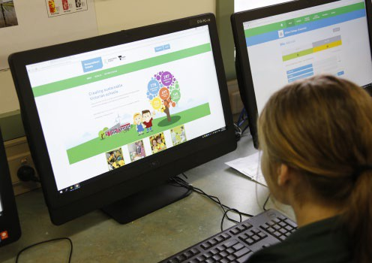Case study: ResourceSmart Schools
Funding Program

Attribution: © Sustainability Victoria 2018
The ResourceSmart Schools program aims to embed sustainability into Victorian schools by improving infrastructure and operations, teaching practices, student learning and community engagement to reduce their resource consumption and improve biodiversity.
The program supported more than 550 schools to exceed their targets by reducing their electricity consumption by 7,302,371 KWh and reducing their water consumption by 238,106 Kilolitres which saved collectively more than $4 million through resource efficiency.
Students at the 2016 ResourceSmart School of the Year, Banyule Primary
School, have been the drivers of a variety of projects in energy efficiency and water conservation at the school - creating new nesting boxes, an irrigation system and a
greenhouse – and have become sustainability champions outside the school, improving local ecosystems and engaging the broader community to care for the planet.

Recipient | Project | Funding Support

Climate Change
Funding Program
University of Melbourne (EU Centre on
Climate Change Research Grants Project – EU Climate KIC Summer schools (2015-16 budget) – two-year initiative until 2018
$95,000

under the Australian Research Council Centre of
Research  Grants | Shared Complex Challenges)
This program is managed by DELWP | University of Melbourne | Two scholarships for Victorian early career academics  Excellence in Climate System Science (ARC CoE) (2015-16 budget) two-year initiative until 2018 | $90,000
Funding Program | Recipient | Project | Funding Support
Collaborative Councils – | Hepburn Shire Council | Waste to energy micro-power network | $75,000
Sustainability | Latrobe  City Council | Gippsland resource recovery collaborative  business case | $75,000
Partnership | Manningham City Council | Smart lighting infrastructure | $36,300
Grants  This program | Melbourne City Council | CO2 Performance Ladder Feasibility Study | $32,500
is managed by  DELWP and Local Government Victoria | Mitchell Shire Council | Collaborative waste and recovery Infrastructure for electronic waste | $59,867
 | Nillumbik Shire Council | Regional low emissions fleet assessment | $33,200
 | Northern Grampians Shire Council | Joint waste facility | $75,000
 | Shepparton Rural City Council | Electric fleet feasibility study | $75,000
 | Wodonga City Council | Business case for shared services enabling energy efficient council buildings | $70,000
 | Wodonga City Council | Environmentally Sustainable Design (ESD) subdivision policy – proof of concept for regional Victoria | $65,000

Fund

Recipient | Project | Funding Support

Grants
Funding Program
Peri Urban  Weed | Brimbank City Council | Peri-urban Weed Management Partnership – Maribyrnong Valley Connection project | $30,000
Management | Cardinia Shire Council | Peri-urban Weed Management Partnership  – Cardinia Creek Riparian Rehabilitation project | $85,457
This program is | City of Casey | Peri-urban Weed Management Partnership – Grasmere Creek Catchment project | $30,000
managed by  DELWP | City of Greater Dandenong | Peri-urban Weed Management Partnership – Lower Dandenong Creek project | $87,400
 | Mornington Peninsula Shire Council | Peri-urban Weed Management Partnership – Mornington Peninsula weed control project | $40,000
 | Nillumbik Shire Council | Peri-urban Weed Management Partnership – River to Ranges project | $30,000
 | Parks Victoria | Peri-urban Weed Management Partnership – all projects | $351,514
 | Yarra Ranges Council | Peri-urban Weed Management Partnership – Dandenong Ranges weed removal project | $30,000

Recipient | Project | Funding Support

Research and Development
Funding Program
- Recovered Glass & Flexible Plastics Grants
This program is managed by Sustainability Victoria
Swinburne University Hawthorn
University of Melbourne
Swinburne plastics and glass in footpaths R&D grant project

Melbourne University lightweight concrete R&D grant project
$100,000

$25,000

Recipient | Project | Funding Support

Rural & Regional Landfill Support Grants
Funding Program
Golden Plains Shire Council | Golden Plains Shire Council  – Rokewood and Teesdale Landfills | $140,000
Loddon  Shire Council | Loddon Shire Council – Inglewood Landfill | $140,000
Mildura Rural City Council | Mildura Rural City Council – Murrayville Landfill | $138,500
Northern Grampians Shire Council | Northern Grampians Shire Council – Hard Hills Landfill | $100,000

This program is managed by Sustainability Victoria

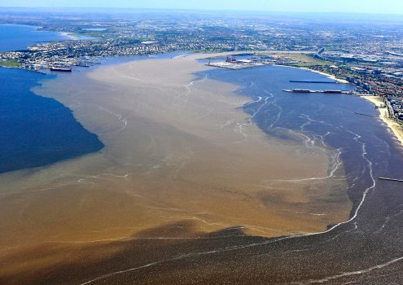Case study: Illegal Dumping Strikeforce Program

The Illegal Dumping Strikeforce Program assists the Environment Protection Authority (EPA) to tackle illegal industrial waste dumping.
Three priority projects were implemented in 2015-16 and 2016-17, including:
- Stockpiling of Tyres;
- Mid-Tier Construction and Demolition Generators; and
- Interstate Movement of Prescribed Industrial Waste.

Stockpiling of Tyres
It is estimated that nearly 50,000 tonnes of waste tyres were unaccounted for in Victoria in 2012-13, which are believed
to be stockpiled or illegally dumped. Tyres stored together in large volumes can create
a serious fire hazard and are extremely difficult to extinguish once ignited.
The Stockpiling of Tyres project implemented licence requirements for waste tyre facilities that store over a certain number of tyres, distributed a brochure on the risks of tyre stockpiles on rural properties and began
investigating whether satellite technologies can be used to detect illegal stockpile sites. The EPA has seen a notable reduction in stockpile sites, and at the end of 2016-17 the EPA had just one licenced site.

Mid-Tier Construction and Demolition Generators
The Mid-Tier Construction and Demolition Generators project was introduced to assist the EPA to encourage firms to dispose of their construction and demolition waste legally in permitted facilities.
Research and consultation suggests that many mid-tier construction and demolition firms are not meeting their obligations for appropriate disposal of industrial waste, costing the state a significant amount in clean-up costs each year.
Outcomes of the project include:
- An increase in inspections of selected demolition sites;
- the development of an education video, Know Where Your Waste Goes, which informs the sector on industrial waste responsibilities.
- introducing the requirement for Victorian Building Authority to notify the EPA of applications for demolition permits, increasing visibility
of demolition activities across the state and allowing the EPA to send builders and
site owners information on their waste management obligations before site works begin.
Around 25 per cent of Victorian construction activity is related to government contracts. To ensure government contractors dispose of waste correctly, and increase the oversight and auditing of waste management requirements, EPA worked
with government to develop a draft Procurement Toolkit. This Toolkit requires government infrastructure project tenders to incorporate waste disposal costs and evidence of correct disposal by contractors.
The project also saw the development and implementation of the Build Aware Program,
aimed to educate building practitioners on their regulatory responsibilities regarding
waste disposal through media channels and inspections of building sites. The program has been so successful that
additional campaigns are being planned in 2017 18.

Interstate Movement of Prescribed Industrial Waste
Since 2013, there has been an increase in the number of allegations of prescribed industrial waste (PIW) being transported interstate from
Victoria without EPA’s approval. The movement of hazardous waste from Victoria can increase the environmental risks associated with transporting PIW to inappropriate locations.
In response, the Interstate Movement of Prescribed Industrial Waste project was established to reduce the amount of non-liquid PIW being transported interstate for disposal without approval.
Outcomes of the project include:
- 171 per cent increase in applications to transport PIW out of Victoria,
- development of draft principles on the cross-border movement of waste
- development of an educational video game to increase awareness of EPA approval requirements
- a workshop with other jurisdictions on managing waste nationally; and
- an increase in roadside inspections and inspections of PIW producer sites.

Recipient | Project | Funding Support

Support for Landcare Grants
Funding Program
This program is managed by DELWP

Avon Landcare Group Inc | Landcare facilitator | $7,630
Barongarook Landcare Group |  | $1,250
Basalt to Bay Landcare Network Inc |  | $1,244
Bass Coast Landcare Network Inc |  | $1,250
Bellarine Landcare Group Inc $1,250

Blampied Kooroocheang Landcare Group
Broken Catchment Landcare Network Inc (Gecko CLaN)
Buloke and Northern Grampians Landcare Network
Connecting Country
(Mt Alexander Region) Inc
Corangamite Catchment Management Authority

Regional Landcare coordination 2016-17

$1,250

$1,250

$1,140

$1,250

$149,200

Department of Justice and Regulation Landmate environment program $250,000

East Gippsland Catchment Management Authority

Regional Landcare coordination 2016-17

$149,200

East Gippsland Landcare Network Inc Landcare facilitator $1,250

Far East Victoria Landcare Inc $1,250

Geelong Landcare Network Inc $1,250

Glenaladale Landcare Group $1,250

Glenelg Hopkins Catchment Management Authority
Goulburn Broken Catchment Management Authority

Regional Landcare coordination 2016-17
Regional Landcare coordination 2016-17

$149,200

$149,200

Goulburn Murray Landcare Network Inc
H11-H12 Community Action Group (Beyond Bolac Catchment
Action Group)
Hamilton to Coleraine Railway Line Landcare Group Inc
Heytesbury District Landcare Network Inc
Landcare facilitator $1,250

$1,250

$1,250

$1,250

Hindmarsh Landcare Network Inc $1,250

Hughes Creek Catchment Collaborative

$1,250

Kaniva District Landcare $1,144

Kara Conservation Management Network

$1,202

Kiewa Catchment Landcare Group $1,250

Kowree Farm Tree Group |  | $1,250
Laharum Landcare Group |  | $1,250
Latrobe Catchment Landcare Network |  | $1,250
Lismore Land Protection Group |  | $1,250
Loddon Plains Landcare Network |  | $1,250
Maffra and Districts Landcare Network |  | $1,250
Making A Difference (MAD) for the Merri Inc |  | $392
Mallee Catchment Management Authority | Regional Landcare coordination 2016-17 | $149,200
Manangatang Landcare Inc | Landcare facilitator | $1,250
Mandurang Strathfieldsaye Landcare Network |  | $448
Merton Landcare Inc |  | $1,250
Mid Loddon Sub-Catchment Management Group |  | $341
Mid Ovens Landcare Consortium |  | $1,250
Millewa Carwarp Landcare Group |  | $1,250
Mitta Valley Landcare Group |  | $1,250
Moorabool Landcare Network |  | $1,250
Mornington Peninsula Landcare Network |  | $1,195
Murrayville Landcare Group |  | $1,250
NatureWest |  | $1,125
North Central CMA | Regional Landcare coordination 2016-17 | $149,200
North East CMA | Regional Landcare coordination 2016-17 | $149,200
Nullawil Landcare Group | Landcare facilitator | $1,250
Ovens Landcare Network |  | $1,250
Panyyabyr Landcare Group Inc |  | $1,239
Parks Victoria | Victorian environment friends network award | $5,000
Port Phillip and Westernport Catchment Management Authority | Regional Landcare Coordination 2016-17 | $149,200
Rainbow and District Landcare Group | Landcare facilitator | $1,250

 | Snowy River Interstate Landcare Committee Inc | Landcare facilitator | $1,124
 | South Gippsland Landcare Network |  | $1,250
 | South West Goulburn Landcare Network |  | $1,250
 | Southern Otway Landcare Network |  | $1,119
 | Southern Ranges Environment Alliance |  | $1,250
 | Strathewen Landcare Group Inc |  | $1,250
 | Surf Coast and Inland Plains Network |  | $1,250
 | Sustainability Victoria | ResourceSmart Schools sponsorship | $22,000
 | Tarragal Landcare Group | Landcare facilitator | $1,250
 | Tom’s Creek Landcare Group |  | $1,250
 | Up2Us Landcare Alliance |  | $1,250
 | Upper Campaspe Combined Landcare Groups |  | $1,250
 | Upper Deep Creek Landcare Network |  | $1,247
 | Upper Goulburn Landcare Network |  | $1,250
 | Upper Hopkins  Land Management Group Inc |  | $993
 | Upper Loddon and Avoca Landcare Network |  | $1,250

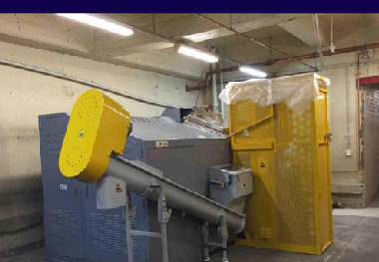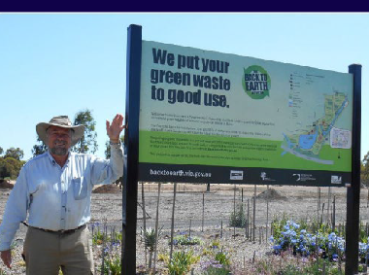
Case study: Metropolitan Organics Strategy
The Organics Fund aimed to assist councils in Metropolitan Melbourne to implement best practice waste collection and management systems in line with the Metropolitan Waste and Resource Recovery Strategic Plan.
•
Outcomes include:
•
that the Compost made to Victorian standards is a fit-for-purpose alternative
to commonly used material like sandy loam soil in biofiltration systems and that these findings could create significant demand for recycled organics in the Victorian market
The award-winning Melton Botanical Gardens used over 300 tonnes of compost as a soil improver to create a new garden and compost trials found the most effective compost to soil ratio for Southern African plants was 1:10. The garden showcases how the application of compost benefits soil health and structure; and
- The installation of an on-site organics dehydrator at the Royal Melbourne Hospital now diverts and processes 160 tonnes of organic waste from hospitals and businesses in the Parkville precinct.

Recipient | Project | Funding Support

Tallangatta Eco- Education Hub Grants
Funding Program
This program is managed by Sustainability Victoria
Towong Shire Council Tallangatta Eco-Education and Integrated Services Hub
$50,000

Recipient | Project | Funding Support

Threatened Species Grants
Funding Program
Arthur Rylah Institute | Galaxias | $153,000
Arthur Rylah Institute | Heath Skink | $105,000
Arthur Rylah Institute | Master’s Snake | $100,000
Arthur Rylah Institute | Greater Glider | $100,000
Arthur Rylah Institute | Round snout Galaxias recovery actions | $27,000
Arthur Rylah Institute | McDowall’s Galaxias and East Gippsland Galaxias recovery actions | $27,000
Arthur Rylah Institute | Fire, ferals and mammals | $10,600
Australasian Native Orchid Society (Victoria Group) Inc | Plains Grassland | $8,190
Balcomb Moorooduc Landcare Group | Balcomb Creek habitat | $2,600
Bass Coast Landcare Network | Holden the ground – completion of predator proofing at Holden Proving Ground | $24,597
Bass Valley Landcare Group | Creating, protecting and enhancing Swamp Skink and Powerful Owl habitat in the Bass Valley | $25,000
Beechworth Urban Landcare and Sustainability | Beechworth Cemetery Rabbit Exclusion Zone (for the protection of threatened species) | $24,015
Beyond Bolac Catchment Action Group | Wongan Creek threatened species protection project | $10,000
Binginwarri Landcare Subgroup | Protecting and enhancing Strzelecki warm temperate rainforest | $25,000
BirdLife Australia | Providing tools and capacity building for community protection of Victoria’s most threatened beach bird | $18,590
BirdLife Australia | Hooded Plover | $50,000
BirdLife Australia | Rehabilitation of various nesting sites of Fairy Tern in Westernport and Port Phillip Bays. | $24,520
Broken Boosey Conservation Management Network | A turquoise landscape – working towards improving habitat for the threatened Turquoise Parrot | $16,224
Bush Heritage Australia | Habitat restoration and woodland bird resilience in the Box Ironbark West Regional Spatial Priority Landscape | $250,000
Cairnlea Conservation Reserves Committee of Management | Restoring endangered reptile habitat | $13,300
Campaspe River and Land Management Group | Australian Anchor Plant – protection, propagation, and revegetation in the Campaspe catchment | $16,883
Cardinia Catchment Landcare Group Inc | Cardinia Creek threatened species protection program | $18,500

This program is managed by DELWP

Christmas Hills Landcare Group | Artificial hollows for Pygmy Possums and Powerful Owls in Christmas Hills | $8,090
Concongella Landcare group | More local habitat for our threatened species | $22,490
Connecting Country (Mount Alexander Region) Inc | Woodland bird community habitat protection and enhancement | $225,000
Connecting Country (Mount Alexander Region) Inc | Boosting Bulokes and Diamond Firetails in the Muckleford valley and surrounds of central Victoria | $25,000
Conservation Volunteers Australia | Monitoring species post wildlife recovery within the Grampians landscape | $6,900
Darebin Creek Management Committee Inc | Protecting Dianella species of the Darebin parkland | $5,100
Deep Creek Landcare Group | Dianella amoena conservation project | $2,409
Department of Environment, Land, Water and Planning (DELWP) | Improving the quality and connectedness of grassland communities on the Victorian Volcanic Plain – Cressy | $225,000
DELWP | Improving the quality and connectedness of grassland communities on the Victorian Volcanic Plain – Woorndoo | $225,000
DELWP | Large Brown Tree Frog | $75,000
DELWP | Brush-tailed Rock Wallaby (Southern ESU) | $60,000
DELWP | Orange-bellied Parrot | $50,000
DELWP | Bush-tailed Rock Wallaby | $50,000
DELWP | Eastern Barred Bandicoot | $50,000
DELWP | Helmeted Honeyeater | $50,000
DELWP | Mountain Pygmy-possum | $50,000
DELWP | Regent Pygmy-possum | $50,000
DELWP | Plains Wanderer | $50,000
DELWP | Threatened Victorian plants (Gippsland region) | $41,000
DELWP | Brush Tailed Rock Wallaby | $40,000
DELWP | Giant Burrowing Frog | $40,000
DELWP | New Holland Mouse | $40,000
DELWP | Southern Right Whale (calf survival assessment) | $30,500
DELWP | South-eastern red tailed Black Cockatoo | $12,000
DELWP | Threatened Victorian plants (Port Phillip region) | $10,000
DELWP | Threatened Victorian plants (Hume region) | $10,000
DELWP | Southern Right Whale (Vessel impact mitigation) | $10,000
DELWP | Isopogon Prostratus (Prostrate Cone Bush) | $10,000
DELWP | Basalt Peppercress | $ 4,400
DELWP | Geranium sp.1 (Large-flower Crane’s Bill) | $750

DELWP and  Arthur Rylah Institute | Orchid package | $259,420
Dja Dja Wurrung Clans | Dja Dja Wurrung in landscape | $225,000
Aboriginal Corporation
Dja Dja Wurrung Clans | Dja Dja Wurrung Caring for Country | $10,485
Aboriginal Corporation | – Pimelea conservation
Donald and District | Protecting Buloke Woodlands 2016 | $9,350
Landcare Group
East Gippsland | Landcare supporting threatened species in East | $24,950
Landcare Network Inc | Gippsland
Emu Plains Racecourse | Eradication of Wild Watsonia in Remnant Damp | $5,115
and Recreation Reserve | Heathland (Ecological Vegetation Class 710)
Committee
of Management
Euroa Arboretum | Ecological education, training and practical | $17,500
 | conservation for Grassy Woodlands in the
 | Longwood Plains
Euroa Arboretum Inc | Improving species diversity in Buloke Grey Box | $21,800
 | Grassy Woodland sites of the Longwood Plains
Euroa Environment | Seven Creeks, Euroa: A nationally significant | $25,000
Group | spot for threatened species
Friends of Eastern | GPS training to enhance threatened | $5,000
Otways Inc | species surveys
Friends of | Bringing our native grassland, Bababi Marning, | $5,250
Merri Creek Inc | to life
Friends of Werribee | Rocky Chenopod conservation project | $7,976
Gorge and Long
Forest Mallee
Friends of | Protecting threatened plant species and habitat | $7,900
Westgate Park Inc | at Westgate Park using community volunteers
Gecko CLaN | Bush Stone-curlews in the Koonda Hills | $8,500
Landcare Network
Gippsland Plains | Moormung Bridal Creeper Mapping Project | $11,500
Conservation
Management Network
Glen Katherine | Planting and propagating the Pale-flower | $16,500
Primary School | Crane’s-bill and Velvet Apple-berry
Glenelg Hopkins | Glenelg Estuary and Discovery Bay weed control | $180,000
Catchment
Management Authority
Goulburn Broken | Managing threats in the Longwood Plains | $230,000
Catchment | priority landscape
Management Authority
Goulburn Murray | Protecting three icon threatened species of the | $11,500
Landcare Network | Goulburn Murray Landcare area
Greening Australia | Enhancing significant ecological communities | $225,000
 | and threatened flora and fauna of the Western
 | District Lakes
Greening Australia | Building Community Support for the Salt Lake | $25,000
 | Tussock Grass and Spiny Peppercress
Greta Valley | Connecting the ranges to the rivers for | $25,000
Landcare Group | threatened species in the Greta Valley

Highlands Landcare Group | Supporting our forest heavyweights – Powerful Owls and Greater Gliders | $6,800
Hindmarsh | Monitoring threatened species in community | $10,200
Landcare Network | revegetation sites
Hindmarsh | Strategic community planting for threatened | $11,200
Landcare Network Inc | species in the northern Wimmera
Honeysuckle | Increasing habitat for Squirrel Gliders and | $17,800
Recreational | Grey-crowned Babblers
Environment Project,
Violet Town Action Group
Jallukar Landcare Group | Jallukar Bandicoot habitat | $15,819
Kara Conservation | Action for threatened species in Victoria’s | $23,300
Management Network | western goldfields
Kongwak Hills | Gums, Owls and Growls in Kongwak | $24,960
Landcare Group
Kooloonong-Natya | Kooloonong-Natya Malleefowl | $16,750
Landcare Group
Korumburra | Community led revegetation and weed control | $24,990
Landcare Group | to protect and enhance the Strzelecki Gum
Leigh Catchment Group | Find Ballarat’s threatened frogs | $22,900
Lismore Land | Protecting and restoring Corangamite Water | $25,000
Protection Group | Skink habitat and Victorian Volcanic Plains
 | Eucalyptus Woodlands along Mt Emu Creek
Loddon Plains | Restoring a key habitat corridor for the Bush | $24,980
Landcare Network | Stone Curlew on the Calivil Creek, Yarrawalla
Longwood Plains | Increasing habitat, nest boxes and fox baiting | $25,000
Conservation | for threatened species
Management Network
Mallee Catchment | Murray to Mallee Connections | $224,972
Management Authority
Mallee Catchment | Mallee Dunefields to the Big Desert | $224,711
Management Authority
Mallee Catchment | Northern Mallee Woodlands | $224,553
Management Authority
Marlborough | Marlborough habitat restoration, revegetation, | $21,745
Primary School | monitoring and education for the Powerful Owl
Moolort Landcare Inc | Moolort Plains remnant Pimelea spinescens and | $4,700
 | Victorian Volcanic Plains grassland awareness
 | raising and on-ground conservation
Moorabool Catchment | The Tale of the Tuan – discovering Brush-tailed | $15,227
Landcare Group | Phascogales in the Moorabool
Moorabool | Camera trap surveys for threatened species in | $21,000
Landcare Network | the Moorabool Landcare Network
Mount Korong Eco Watch | Rewilding Korong Ridge – pest species | $8,000
 | eradication: feral fox, cat and rabbit control
Mt Rothwell | Captive Bandicoot Cleanse: Ensuring the | $25,000
Landcare Volunteers | survival of the Bandicoot genetics on the
 | Australian mainland

Mt Worth and District Landcare Group Inc | Mt Worth threatened species biolink | $15,420
Natural Resources Conservation League of Victoria | Monitoring Threatened Species in Southern Brown Bandicoot Management Area | $21,500
Nature Glenelg Trust | Threatened species habitat restoration in the Wilkin Woodlands and Wetlands | $225,000
Nature Glenelg Trust | Habitat restoration for threatened species of wetlands in the Glenelg | $225,000
Neerim and District Landcare Group | Protecting and restoring stream habitat for threatened species of the Red Hill Creek | $19,700
Nillumbik Landcare Network | Habitat improvement and monitoring of Nillumbik’s iconic threatened species | $23,230
Nillumbik Landcare Network | Nillumbik threatened Orchid program – community engagement and site preparation for reintroductions | $21,190
Nillumbik Shire Council | Conservation Futures – protecting and conserving species in the Northern Yarra Ranges | $177,713
North East CMA | Warby – Ovens | $225,000
North East CMA | Chiltern – Mt Pilot | $187,500
Northern Bendigo Landcare Group | Huntly Streamside Reserve biolink | $18,000
Northern Grampians Landcare Group | Northern Grampians save our threatened species | $15,690
Nyah West Landcare Group | Towan Plains protecting diversity | $22,500
Ovens Landcare Network | Indian Myna awareness – highlighting the increasing risk to hollow dependant threatened species | $4,600
Panyyabyr Landcare Group | Finding nature | $11,030
Parklands Albury Wodonga Limited | Building a network of threatened species monitors | $18,650
Parks Victoria | Mountains to Murray: The Upper Murray/ North – North East Mountain outliers | $225,000
Parks Victoria | Northern Plains landscape restoration project | $225,000
Parks Victoria | Wilsons Prom Ark | $225,000
Parks Victoria | Fox control to protect New Holland Mouse and other threatened vertebrates on the Gippsland Plains | $150,000
Parks Victoria | Landscape control of weeds of national significance for biodiversity | $150,000
Peranbin Primary College | Making our school a haven for threatened species: habitat regeneration at Peranbin Primary College | $25,000
Phillip Island Landcare Group Inc | Eastern Barred Bandicoot buffer zone | $17,500

Port Phillip and Westernport Catchment Management Authority | Protecting and connecting species and communities in Melbourne’s west | $225,000
Port Phillip and Westernport Catchment Management Authority | Protecting and connecting species and communities on the Mornington Peninsula | $199,000
Project Platypus | Greater Grampians threatened flora | $190,025
Project Platypus | Black Range Bandicoot link | $25,000
Project Platypus Association Inc | A whole lot of rubbish  – cleaning up the ‘Ironbarks’  (Deep Lead Nature Conservation Reserve) | $24,800
Project Platypus Association Inc | Native Pasture for Wildlife | $15,761
Project Platypus Association Inc | Upper Wimmera habitat enhancement and wildlife monitoring | $9,499
Regent Honeyeater Project Inc | Habitat Restoration for Threatened Species – people power in action | $25,000
Rutherglen Landcare Group | Bolstering Brolga Breeding  – fox threat and hazard abatement | $20,800
Shepparton Mooroopna Landcare Network | Squirrel Glider nest box monitoring and community awareness program | $5,066
Southern Otway Landcare Network | Restoration of Long Nosed Potoroo habitat in fire affected landscapes of the Great Ocean Road | $24,367
Southern Otway Landcare Network | Keeping an eye on Cape Otways Potoroos | $12,353
St Arnaud Field Naturalist Club Inc | Protection and recruitment of the Wax Garden Reserve’s threatened Buloke and Goldfields Grevillea colonies | $17,793
Strathallan Family Landcare | Gliders along the Campaspe | $7,499
Strathbogie Ranges Conservation Management Network | Strathbogie Forest citizen science | $16,490
Swamps Rivers and Ranges | Jessie’s Creek – community Riparian Restoration of complex Indigenous habitats | $24,790
Tag for Life | Sharks – Maligned, mysterious and misunderstood | $23,500
The Basalt to Bay Landcare Network | Tracks for Dunnarts | $16,875
The Basalt to Bay Landcare Network | Growing volunteer experiences and habitat at St Helens, Victoria | $10,940
Up2Us Landcare Alliance | Locating the Lost Brush Tailed Phascogale | $19,500
Up2Us Landcare Alliance | Nectar for Fords Creek | $15,750
Upper Barwon Landcare Network | Preserving the genetic diversity of the Yarra Gum in the Upper Barwon | $14,077
Upper Goulburn Landcare Network | Ribbons of Remnant Roadsides | $21,135

 | Upper Goulburn Landcare Network | Discovering two gems of threatened species in grassland country | $20,950
 | Victoria University | Seeds from school | $9,890
 | Victorian National Parks Association | Caught on Camera | $15,800
 | Victorian National Parks Association | Growling Grass Frog community monitoring project | $15,600
 | Western Port Catchment Landcare Network | Protecting the present, planning for the future – Powerful Owl habitat | $24,875
 | Wimmera Catchment Management Authorities | Western Victorian woodlands protection and enhancement | $250,000
 | Wodonga Urban Landcare Network Inc | Creating a Wodonga Nestbox Network | $9,480
 | Wonyip  Landcare Subgroup | Wonyipedia – education, identification and protection of threated species in the Strzelecki Ranges | $25,000
 | Woodend Landcare | Filling in the Black Gum gaps along Five Mile Creek | $6,650
 | Woodside Landcare Group | Enhancing Reedy Creek for critically endangered Martin’s Toadlet and the endangered Tree Goanna | $25,000
 | Yarra Ranges Council | Protecting cool temperate rainforest and associated threatened species of the Upper Woori Yallock Creek Catchment | $140,000
 | Zoos Victoria | Baw Frog | $50,000
 | Zoos Victoria | Leadbeater’s Possum | $50,000
 | 3 Creeks Landcare Group | Increasing and enhancing the area of habitat for the Swamp Antechinus through targeted revegetation | $24,904

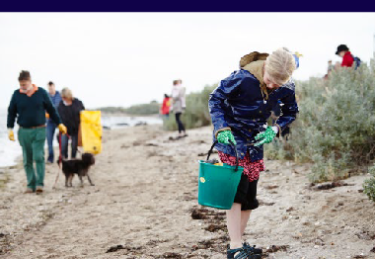Case study: Cleaner Yarra and Port Phillip Bay

Litter and nurdle clean up
University students and the community have teamed up and got their hands sandy with the Port Phillip Eco Centre at a beach litter and microplastics/ nurdle clean up and survey in St Kilda.
Participants learnt about the work of the Port Phillip Eco Centre, the natural and
indigenous history of the area, and St Kilda’s evolution over time before hitting the sand to clean up.
Together the group collected three, full Clean Up Australia bags of rubbish, and learnt how to sweep the sand for microplastics and nurdles.
Litter auditing and clean up are key components to successful litter prevention programming. Port Phillip EcoCentre is a local leader in this space, facilitating and enabling other groups working in this field to run successful programs

Recipient | Project | Funding Support

Victorian Litter Innovation  Fund | Greater Shepparton City Council | Shepparton solar bin project | $18,000
 | Mitchell Shire Council | Litter: It’s a waste of our time | $2,500
 | Mt Buller and Mt Stirling Resort Alpine Management Board | Reducing litter at remote locations on Mt Stirling pilot study | $9,000
 | Phillip Island Nature Park | Litter innovation fund – turn the tide | $18,000
 | San Remo Foreshore Committee of Management Inc | Pelican reflecting on plastic usage and litter generation | $9,000
 | South Gippsland Shire Council | Cigarette butt litter education and enforcement project | $12,600
 | Southern Cross Recycling Group Pty Ltd | SMART public place clothing recycling banks | $5,000
 | Strathbogie Shire Council | Love our lake: Put your waste in the right place | $9,000

Recipient | Project | Funding Support

Victorian Organics Resource Recovery Strategy
Funding Program
Veolia Environmental Services
Veolia – Kilter three-year compost demonstration trial for Broadacre crops in the Mallee Region, Victoria
$10,500

Funding Program

