Introduction
Biodiversity Response Planning (BRP) is a long-term area-based planning approach to biodiversity conservation in Victoria. It is designed to strengthen alignment, engagement and participation between government, Traditional Owners, non-government agencies and the community.
DELWP Regional staff have been working with stakeholders on actions to conserve biodiversity in specific landscapes, informed by the best available science and local knowledge.
These Fact Sheets capture a point in time, reflecting data and knowledge available in 2020. They provide information for many (but not all) landscapes across Victoria, containing general information on the key values and threats in each area, as well as the priority cost-effective actions that provide the best protection of biodiversity. Fact Sheets are intended to provide useful biodiversity information for the community, non-government and government organisations during project planning and development.
Further information and the full list of Fact Sheets is available on the Department’s Environment website.

Landscape description
This 145,081ha area is a mostly vegetated landscape (78% native vegetation cover) and is mostly public land (92%). The landscape is contained within the Little Desert National Park but also includes significant private property adjoining the park.

Habitat Distribution Models identify 140 species with more than 5% of their Victorian range in this landscape
121 Plants
6 species with more than 50% of Victorian range in area. Notably the:
- Wimmera Manna-gum (81% of Victorian range in landscape)
- Midget Stylewort (75% of Victorian range in landscape)
- Little Desert Peppermint (74% of Victorian range in landscape, FFG*-listed)
- Feather Bush-pea (73% of Victorian range in landscape, vulnerable)
- Small Darwinia (53% of Victorian range in landscape, vulnerable)
2 Mammals
- Silky Mouse (15% of Victorian range in landscape, near threatened) and Western Pygmy-possum (10% of Victorian range in landscape, near threatened)
9 Reptiles
3 species with more than 20% of their Victorian range in the landscape. These are the:
- Bardick (94% of Victorian range in landscape, FFG*-listed)
- Rosenberg’s Goanna (31% of Victorian range in landscape, FFG*-listed)
- Striped Worm-Lizard (Near threatened, 28% of Victorian range in landscape)
7 Birds
- Notably Rufous Fieldwren (18% of Victorian range in landscape, near threatened) and Malleefowl (11% of Victorian range in landscape EPBC**-listed Endangered)
1 Amphibian
- Pobblebonk Frog (9% of Victorian range in landscape)
*Flora and Fauna Guarantee Act 1988 (Victorian)
**Environment Protection and Biodiversity Conservation Act 1999 (Federal)

Strategic Management Prospects
Strategic Management Prospects (SMP) models biodiversity values such as species habitat distribution, landscape-scale threats and highlights the most cost-effective actions for specific locations. More information about SMP is available in NatureKit.

Which landscape-scale actions are most cost-effective in this landscape?
Some areas of this focus landscape (coloured areas on the map) has highly cost-effective actions which provide significant benefit for biodiversity conservation.

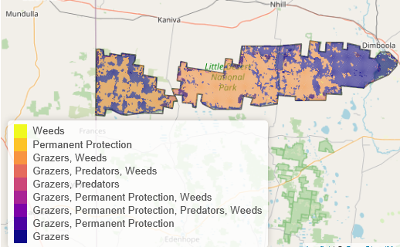
The SMP priority actions which rank among the top 10% for cost-effectiveness of that action across the state are in order:
Control goats 1,411,25ha
Control rabbits 79,032ha
Control weeds 72,635ha
Control deer 49,782ha
Control overabundant kangaroos 40,733ha
Domestic grazing control 12,536ha
Permanent protection 2,613ha
Revegetation 331ha

Of the top 3% of cost-effective action, goat control, kangaroo control, grazing control and permanent protection rank highest.

The most cost-effective actions for flora & fauna
Plants - Control total grazing pressure, control weeds, control rabbits, control deer
Birds - Control goats, control total grazing pressure, control weeds, control deer, control rabbits
Mammals, Reptiles - Control total grazing pressure, control goats, control weeds
Amphibians - Control total grazing pressure

For a further in depth look into SMP for this landscape please refer to NatureKit.

