“We acknowledge the Wadawurrung people of the Kulin Nation as the Original Custodians of the lands which represents the following information. We pay respects to Elders past, present and emerging leaders that continue their obligations to care for Country. We care for Country, Culture and Wadawurrung people”.

Bay

Introduction
Biodiversity Response Planning (BRP) is a long-term area-based planning approach to biodiversity conservation in Victoria. It is designed to strengthen alignment, engagement and participation between government, the Original Custodians, non-government agencies and the community.
DELWP Regional staff with Wadawurrung Traditional Owners Aboriginal Corporation have been working with stakeholders on actions to conserve biodiversity in specific landscapes, informed by the best available science and local knowledge.
These Fact Sheets capture a point in time, reflecting data and knowledge available in 2020. They provide information for many (but not all) landscapes across Victoria, containing general information on the key values and threats in each area, as well as the priority cost-effective actions that provide the best protection of biodiversity. Fact Sheets are intended to provide useful biodiversity information for the community, non-government and government organisations during project planning and development.
Further information and the full list of Fact Sheets is available on the Department’s Environment website.
This Fact Sheet includes the information from the Strategic Management Prospects (SMP) Output Summary for the Bay zone and the feedback from our stakeholders.

Landscape description
The Bay area is 6,287ha. The native vegetation cover is 17% and the public land cover is 20%.
It is a diverse ecological landscape a with a mix of salt dependent / salt tolerant / non-salt tolerant vegetation communities.
The major waterways are Werribee River, Little River and Hovells Creek. There are two significant wetlands; Western Treatment Plant (Ramsar, non-natural) and Limeburners Bay (Lagoon) (Ramsar). The Avalon Coastal Reserve (non-natural) is of local importance.
The highest biodiversity values are in the public land blocks, the thin shoreline strip, and the wetlands.
This landscape has a partial overlap with the Port Phillip and Western Shoreline Ramsar landscape. For more information, please refer to the Port Phillip and Western Shoreline Ramsar Fact Sheet in the full list of Fact Sheets.

Cultural importance
Wadawurrung Country holds many values culturally and ecologically throughout the diverse landscape. Mountain country, grassland country, sea and coastal country provides for many flora and fauna species to inhabit the landscapes. Resources were aplenty and managed sustainably by the Wadawurrung. Due to previous land activities such as mining, land fragmentation and the introduction of pest species, the landscapes require good partnerships between the Wadawurrung Original Custodians and land managers to reinvigorate Country. Wadawurrung land management practices will be supported and guided by the aspirations of the Wadawurrung Healthy Country Plan.
Initial Wadawurrung Priority Area identified – Limeburners-Dandos cluster.

Landscapes of interest added through feedback process
Geelong City Council – Port Phillip Bay Coastal Reserve.

Ecological Vegetation Classes (primary EVCs)
Endangered: Coastal Saltmarsh, Creekline Grassy Woodland, Coastal Saltmarsh/Mangrove Shrubland Mosaic, Natural Damp Grasslands of the Victorian Coastal Plains.
Environment Protection and Biodiversity Conservation Act: Seasonal Herbaceous Wetlands (Freshwater) of the Temperate Lowland Plains ecological community.

Ecological Vegetation Classes (secondary EVCs)
Endangered: Plains Grassy Woodland, Plains Grassland.
Environment Protection and Biodiversity Conservation Act: Natural Temperate Grasslands of the Victorian Volcanic Plains, Grassy Eucalypt Woodland of Victorian Volcanic Plains.
Flora and Fauna Guarantee Act: Western Plains Grasslands Community.

Habitat Distribution Models identify 7 species with more than 5% of their Victorian range in this landscape area (updated 26/07/2020) | The following have been identified as focal species by the Original Custodians and stakeholders
6 plants with more than 5% of Victorian range in area  - Tasman Grass-wrack (rare, 34%), Sea Water-mat (vulnerable, 20%), Coast Saltwort (rare, 10%), Australian Grass-wrack (rare, 6%), Tuberous Tassel (poorly known, 6%), Hairy Shepard’s Purse (endangered, 5%) | 25 plants: Streaked Arrowgrass, Sharp Club-sedge, Salt Club-sedge, Thread Rush, Large Kangaroo Apple, Sea Rush, Kangaroo Grass, Hedge Wattle, Sheep's Burr, Australian Salt-grass, Black Wattle, Golden Wattle, Pink Bindweed, Common Spike-sedge, Coast Tea-tree, Narrow-leaf Cumbungi, Water Ribbons, Kidney-weed, Weeping Grass, Common Reed, Blackwood, River Red-gum, Slender Dock, Silver Wattle, Common Nardoo
1 bird with more than 5% of Victorian range in area
- Orange-bellied Parrot (critically endangered, 14%)

Strategic Management Prospects
Strategic Management Prospects (SMP) models biodiversity values such as species habitat distribution, landscape-scale threats and highlights the most cost-effective actions for specific locations. More information about SMP is available in NatureKit.

Additional threats
Threats identified (in addition to those modelled in SMP) through the consultation process were native vegetation removal, barriers to on-ground management, water quality and quantity, rising sea levels, littering and inappropriate land use.

Which landscape-scale actions are most cost-effective in this landscape?
The map shows where the most cost-effective threat control actions in this landscape are. Actions in these areas will maximise biodiversity benefit across Victoria for multiple species.

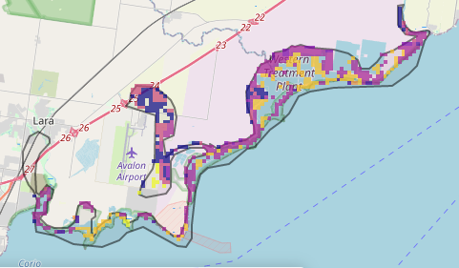

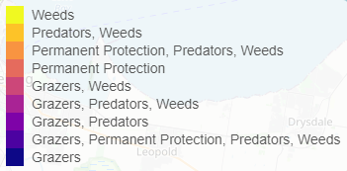

The best threat control actions to do in the Top 3% of cost-effective areas are: rabbits, weeds, domestic grazing, overabundant kangaroos, cats, foxes and permanent protection.
When we bring in the Top 10%, we also add the activity: total grazing pressure (all grazers).

Area available for highly cost-effective revegetation
175ha

For a further in depth look into SMP for this landscape please refer to NatureKit.

Priority Areas Map - Bay
Base layers: This data is from SMP and represents the best areas to carry out the most cost-effective actions for specific threats (also referred to as the Top 10% of Mean Cost-effectiveness (MCE) actions), and the Top 20% locations (these locations have been given names and are referred to as descriptors)
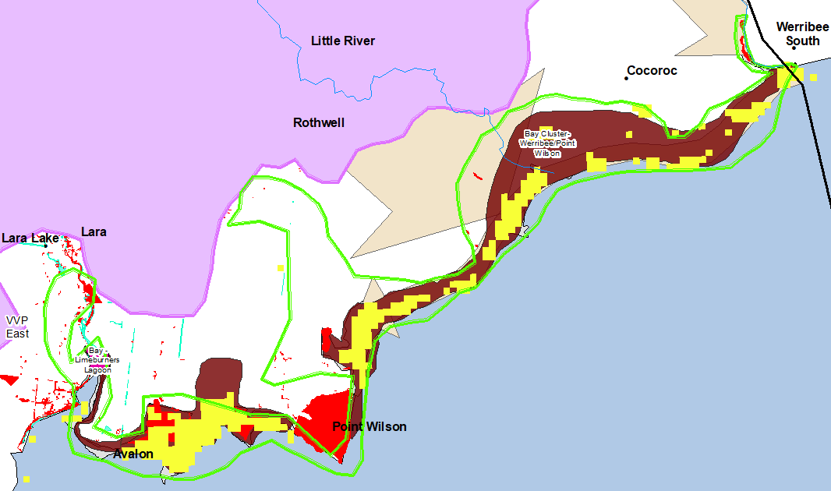
Priority Areas: Wadawurrung Priority Areas, stakeholder’s Landscapes of Interest (LoI), endangered Ecological Vegetation Classes (EVCs), National Parks & Reserves

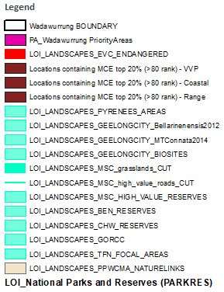
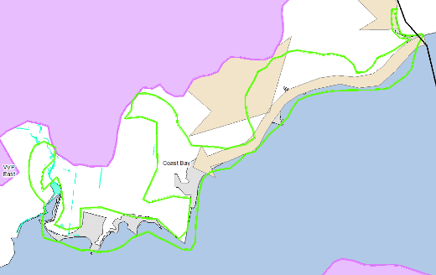
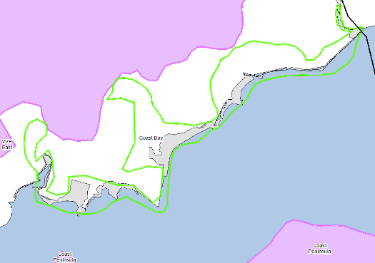
National Parks and Reserves (grey)
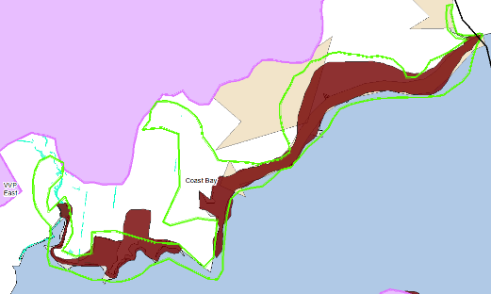
Stakeholder’s LoI (fawn & aqua)
Descriptors (brown)
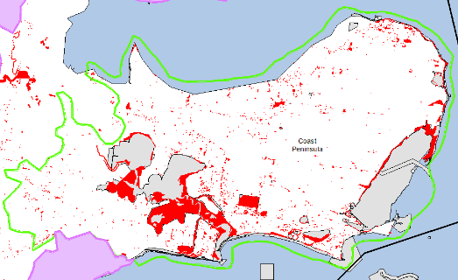
Endangered EVCs (red)
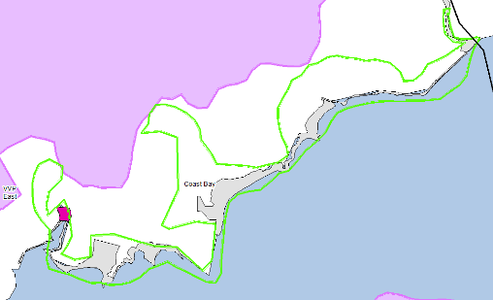
Wadawurrung initial Priority Areas (pink (left))

