Introduction
Biodiversity Response Planning (BRP) is a long-term area-based planning approach to biodiversity conservation in Victoria. It is designed to strengthen alignment, engagement and participation between government, Traditional Owners, non-government agencies and the community.
DELWP Regional staff have been working with stakeholders on actions to conserve biodiversity in specific landscapes, informed by the best available science and local knowledge.
These Fact Sheets capture a point in time, reflecting data and knowledge available in 2020. They provide information for many (but not all) landscapes across Victoria, containing general information on the key values and threats in each area, as well as the priority cost-effective actions that provide the best protection of biodiversity. Fact Sheets are intended to provide useful biodiversity information for the community, non-government and government organisations during project planning and development.
Further information and the full list of Fact Sheets is available on the Department’s Environment website.

Landscape description
The Leaghur landscape is 43,817ha in size, with 25% of the area covered in native vegetation. Public land covers 9% of the area and includes Leaghur State Park and Lake Leaghur. Refer to the map at the end of this Fact Sheet.
This landscape has an overlap with the Dja Dja Wurrung Clans Aboriginal Corporation RSA landscape. For more information, please refer to this Fact Sheet in the full list of Fact Sheets.

Cultural importance
We recognise that the entire landscape has high cultural value for Traditional Owners. Landscapes identified as having “notable” cultural importance is based on the density of recorded cultural heritage sites and knowledge shared by Traditional Owners. We also recognise that there are locations important to Traditional Owners not within these landscapes.

Stakeholder interest
As part of the BRP process, in October 2020 stakeholders were asked to nominate focus landscapes and actions of interest. Loddon Plains Landcare Network, Barapa Country Aboriginal Corporation and Dja Dja Wurrung nominated Leaghur.
Possible future investment/project development in this landscape will be available to any interested stakeholders in addition to those who nominated this landscape.

0BEcological values identified by Traditional Owners, partners and community within this landscape
Small stand of White Cypress Pine – Buloke Woodland
River Red Gum, Mallee and other vegetation communities including 14 significant flora species
Largely intact Black Box wetlands and woodlands; a range of age classes in Black Box resulting from periodic flooding
Important fauna habitat for breeding waterfowl and other birds
 | Habitat Distribution Models identify 6 species with more than 5% of their Victorian range in this landscape area | Traditional Owners, stakeholders and community groups identified the following species of interest within this landscape
 | 3 Plants; notably:  - Soft Sunray (Leucochrysum molle), vulnerable with 14% of its Victorian range in area  - Downs Nutgrass (Cyperus bifax), vulnerable with 10% of its Victorian range in area  - Annual Buttons (Leptorhynchos orientalis), endangered with 9% of its Victorian range in area | - Buloke  - Hoary Scurf-pea  - Swamp Buttercup
 | 1 Reptile:  - Hooded Scaly-foot, critically endangered with 8% of its Victorian range in area | - Broad-shelled Turtle  - Murray River Turtle  - Eastern Long-necked Turtle
 | 1 Bird:  - Plains-wanderer, critically endangered with 7% of its Victorian range in area | - Great Egret  - Grey-crowned Babbler  - Nanken Night Heron  - Royal Spoonbill  - Freckled Duck  - Australian Pelican  - White-bellied Sea-eagle  - Straw-necked Ibis
Other | Fish:  - Murray Cod  - Golden Perch  - Silver Perch  - Freshwater catfish

Traditional Owners, stakeholders and community groups identified the following threats within this landscape
Leaghur State Park – long history of disturbance (grazing, clearing, timber harvesting and scattered settlement)
Weeds – Paterson’s Curse, African Boxthorn, St John’s Wort and Horehound
Inappropriate fire regime (fire sensitive species such as Buloke)
Pest animals, including foxes, pigs

Strategic Management Prospects
Strategic Management Prospects (SMP) models biodiversity values such as species habitat distribution, landscape-scale threats and highlights the most cost-effective actions for specific locations. More information about SMP is available in NatureKit.

Additional threats
Threats identified (in addition to those modelled in SMP) through the consultation process were:
- alterations to hydrology
- land salinisation
- soil erosion
- habitat degradation due to extremes of climate and weather, and lack of regeneration in some vegetation classes
- recreational activities causing fragmentation
- loss of vegetation, and erosion
- legacy use of public land
- private land use impacting biodiversity
- inappropriate land use planning
- inappropriate fire regimes (planned burning and bushfires)
Some individual threatened species may also require targeted intervention, beyond actions to manage landscape-scale threats, to improve their future prospects.

Which landscape-scale actions are most cost-effective in this landscape?
The coloured areas indicate where the identified landscape-scale actions and locations are most cost-effective and will maximise biodiversity benefit across Victoria for multiple species.
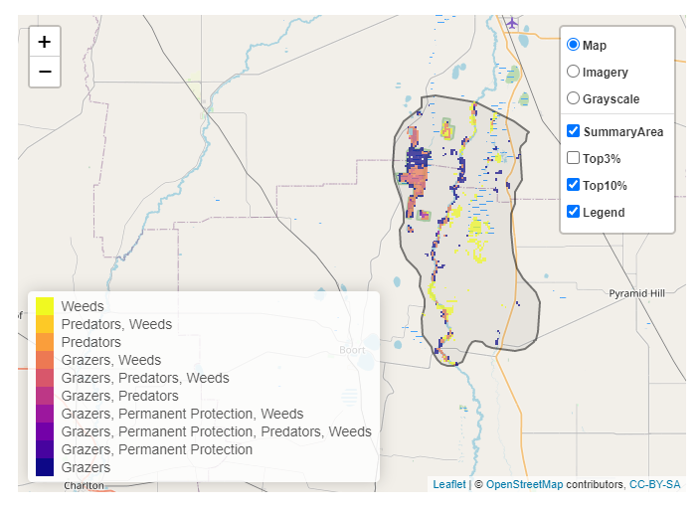
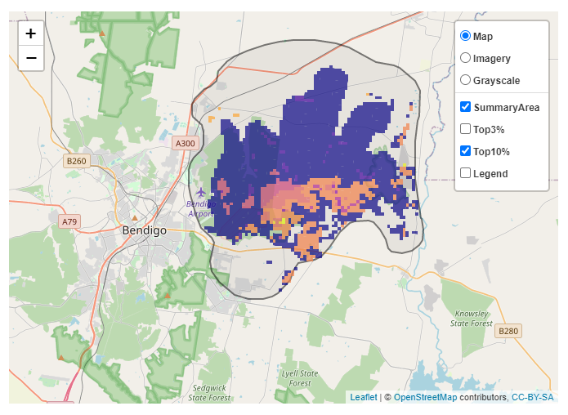
The SMP priority actions which rank among the top 10% for cost-effectiveness of that action across Victoria for much of the landscape are in order of the top 3 actions, see map and list below:
Control weeds 3,691ha
Control rabbits 3,554ha
Control overabundant kangaroos 1,347ha

Of the top 10% of cost-effective actions, controlling goats provides the most cost-effective biodiversity benefits when considering all flora and fauna.
From the nomination process the following additional actions were also suggested for this landscape:
- domestic grazing control
- remnant protection

The most cost-effective action for flora and fauna
Plants, birds, mammals, reptiles, amphibians, - Control goats

For a further in depth look into SMP for this landscape please refer to NatureKit.

