Introduction
Biodiversity Response Planning (BRP) is a long-term area-based planning approach to biodiversity conservation in Victoria. It is designed to strengthen alignment, engagement and participation between government, Traditional Owners, non-government agencies and the community.
DELWP Regional staff have been working with stakeholders on actions to conserve biodiversity in specific landscapes, informed by the best available science and local knowledge.
These Fact Sheets capture a point in time, reflecting data and knowledge available in 2020. They provide information for many (but not all) landscapes across Victoria, containing general information on the key values and threats in each area, as well as the priority cost-effective actions that provide the best protection of biodiversity. Fact Sheets are intended to provide useful biodiversity information for the community, non-government and government organisations during project planning and development.
Further information and the full list of Fact Sheets is available on the Department’s Environment website.

Landscape description
Heathcote - Graytown landscape is 115,233ha in size with over half (61%) of the area covered in native vegetation. Public land reserves make up 41% of the area which includes Heathcote-Graytown National Park, Redcastle State Forest and Whroo Nature Conservation Reserve. Refer to the map at the end of this Fact Sheet.

Cultural importance
We recognise that the entire landscape has high cultural value for Traditional Owners. Landscapes identified as having “notable” cultural importance is based on the density of recorded cultural heritage sites and knowledge shared by Traditional Owners. We also recognise that there are locations important to Traditional Owners not within these landscapes.

Stakeholder interest
As part of the BRP process, in October 2020 stakeholders were asked to nominate focus landscapes and actions of interest. Campaspe Shire Council, City of Greater Bendigo, DELWP (Public Land), Coliban Water, Parks Victoria, and Central Victorian Biolinks all nominated Heathcote - Graytown.
Possible future investment/project development in this landscape will be available to any interested stakeholders in addition to those who nominated this landscape.

Ecological values identified by Traditional Owners, partners and community within this landscape
Unique and extensive Box-Ironbark forests
Mature stands of large, old Grey Grass Trees
Critical habitat for:
- Powerful Owl
- Brush-tailed Phascogale
- Swift Parrot
- Woodland bird community
Significant threatened vegetation classes including Creekline Grassy Woodland and Alluvial Terraces Herb-rich Woodland
Significant large old trees
 | Habitat Distribution Models identify 40 species with more than 5% of their Victorian range in this landscape | Traditional Owners, stakeholders and community groups identified the following species of interest within this landscape
 | 30 Plants, notably:  - Bald-tip Beard-orchid (Calochilus richiae), endangered with 92% of its Victorian range in area  - Long-tail Greenhood (Pterostylis woollsii), endangered with 84% of its Victorian range in area  - Plain Quillwort (Isoetes drummondii subsp. anomala), poorly known with 31% of its Victorian range in area | - Crimson Spider-orchid  - Scented Bush-pea  - Clover Glycine  - Ausfeld’s Wattle  - Whirrakee Wattle  - Maroon Leek-orchid
 | 1 Mammal:  - Squirrel Glider, endangered with 7% of its Victorian range in area | - Squirrel Gliders  - Brush-tailed Phascogale  - Common Dunnart
 | 1 Reptile:  - Dwyer's Snake, no rating with 7% of its Victorian range in area | - Bearded Dragon
 | 8 Birds, notably:  - Swift Parrot, endangered with 12% of its Victorian range in area  - Speckled Warbler, vulnerable with 11% of its Victorian range in area  - Turquoise Parrot, near threatened with 8% of its Victorian range in area | - Swift Parrot  - Powerful Owl  - Painted Honeyeater  - Grey-crowned Babbler  - Spotted Quail-thrush  - Regent Honeyeater
 | Amphibians | - Brown Toadlet  - Growling Grass Frog

Traditional Owners, stakeholders and community groups identified the following threats within this landscape
Weeds including Bridal Creeper, Wheel Cactus and Paterson’s Curse
Inappropriate fire regimes
Over grazing
Wildfire
Climate Change
Pest animals including foxes, cats and rabbits
Land clearing
Timber and firewood cutting
Erosion

Strategic Management Prospects
Strategic Management Prospects (SMP) models biodiversity values such as species habitat distribution, landscape-scale threats and highlights the most cost-effective actions for specific locations. More information about SMP is available in NatureKit.

Additional threats
Threats identified (in addition to those modelled in SMP) through the consultation process were:
- alterations to hydrology
- land salinisation
- soil erosion
- habitat degradation due to extremes of climate and weather
- lack of regeneration in some vegetation classes
- recreational activities causing fragmentation
- loss of vegetation, and erosion
- legacy use of public land
- private land use impacting biodiversity
- inappropriate land use planning
- inappropriate fire regimes (planned burning and bushfires)

Some individual threatened species may also require targeted intervention, beyond actions to manage landscape-scale threats, to improve their prospects.

Which landscape-scale actions are most cost-effective in this landscape?
The coloured areas indicate where the identified landscape-scale actions and locations are most cost-effective and will maximise biodiversity benefit across Victoria for multiple species.
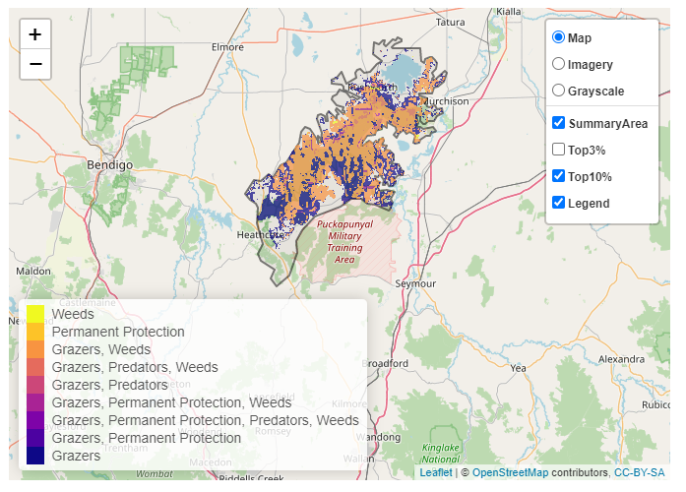
The SMP priority actions which rank among the top 10% for cost-effectiveness of that action across Victoria for much of the landscape are in order of the top 3 actions, see map and list below:
Control rabbits 55,486ha
Control goats 48,261ha
Control weeds 45,730ha

Of the top 10% of cost-effective actions, controlling goats provides the most cost-effective biodiversity benefits when considering all flora and fauna.
From the nomination process the following additional actions were also suggested for this landscape:
- domestic grazing control
- planned burns
- management of recreational activities and public access
- fire management, ecological restoration
- permanent protection
- revegetation (including habitat creation/recovery and connectivity restoration)
- hydrological/landscape function restoration
The most cost-effective action for flora and fauna
Birds, reptiles, mammals - Control goats
Plants, amphibians - Control rabbits

For a further in depth look into SMP for this landscape please refer to NatureKit.

