Introduction
Biodiversity Response Planning (BRP) is a long-term area-based planning approach to biodiversity conservation in Victoria. It is designed to strengthen alignment, engagement and participation between government, Traditional Owners, non-government agencies and the community.
DELWP Regional staff have been working with stakeholders on actions to conserve biodiversity in specific landscapes, informed by the best available science and local knowledge.
These Fact Sheets capture a point in time, reflecting data and knowledge available in 2020. They provide information for many (but not all) landscapes across Victoria, containing general information on the key values and threats in each area, as well as the priority cost-effective actions that provide the best protection of biodiversity. Fact Sheets are intended to provide useful biodiversity information for the community, non-government and government organisations during project planning and development.
Further information and the full list of Fact Sheets is available on the Department’s Environment website.

Landscape description
This 125,000ha area is mostly native vegetation (62% cover) and is mostly public land (69%), and includes Hattah Kulkyne National Park, Hattah and Nowingi State Forest. The landscape is bordered by the Murray River in the east and Murray Sunset National Park in the west. The northern boundary extends towards Carwarp to include some significant reserves and private land around Raak Plain. The southern landscape boundary is buffered 1km from the public land.
This landscape has a major overlap with the Murray River and Floodplain landscape in areas of Riverine Grassy Woodland or Forests Ecological Vegetation Classes. For more information please refer to the Murray River and Floodplain Fact Sheet in the full list of Fact Sheets.

Cultural importance
We recognise that the entire landscape has high cultural value for Traditional Owners. Landscapes identified as having “notable” cultural importance is based on the density of recorded cultural heritage sites and knowledge shared by Traditional Owners. We also recognise that there are locations important to Traditional Owners not within these landscapes.
Notable cultural importance for the First People of the Millewa Mallee Aboriginal Corporation and Tati Tati Wadi Wadi people.

Stakeholder interest
As part of the Biodiversity Response Planning process, in October 2020 stakeholders were asked to nominate focus landscapes and actions of interest. First People of the Millewa Mallee, Tati Tati Wadi Wadi, Mallee Catchment Management Authority, DELWP and Parks Victoria nominated Hattah West - Raak.
Possible future investment/project development in this landscape will be available to any interested stakeholders in addition to those who nominated this landscape.
Specific stakeholder interests identified through the engagement process within this landscape include:
- Parks Victoria, Conservation Action Plan assets – Mallee Triodia, Sunset Plains and Swales, Semi-arid woodlands in eastern Hattah Kulkyne National Park.
- Mallee Catchment Management Authority, Regional Catchment Strategy priority landscape – 7. Hattah Lakes and Hattah Kulkyne National Park; Hattah Lakes Ramsar site; focus on addressing River Red Gum (RRG) and Feral Pig impacts on Lakebed herbland as per Ramsar Ecological Character Description (ECD)/Management Plan to further secure Environmental-water outcomes.
- Department of Environment, Land, Water and Planning, significant area of public land including Hattah and Nowingi State Forest.

Community interest
Community interest in biodiversity conservation was identified for this area through the consultation process.

 | Habitat Distribution Models identify 184 species more than 5% of their Victorian range in this landscape area | Traditional Owners, stakeholders and community groups identified the following species of interest
 | 149 Plants, 17 species with more than 20% of Victorian range in area. Notably:  - Prickly Bottlebrush (rare, 51% of Victorian range in area)  - Skeleton Fanflower (endangered, 61% of Victorian range in area) | - Buloke woodlands  - Semi-arid woodlands
 | 6 Mammals with more than 5% of Victorian range in area. Notably:  - Little Broad-nosed Bat (near threatened, 11% of Victorian range in area)  - South eastern Long-eared Bat (endangered, 11% of Victorian range in area) | - South-eastern Long-eared Bat  - Red Kangaroo
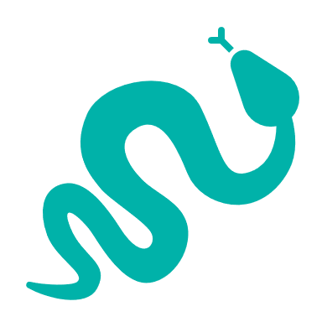 | 14 Reptiles with more than 5% of Victorian range in area. Notably:  - Lined Earless Dragon (critically endangered, 21% of Victorian range in area)  - Yellow-faced Whip Snake (near threatened, 12% of Victorian range in area) | - Bandy-bandy  - Murray-Darling Carpet Python
 | 15 Birds with more than 5% of Victorian range in area. Notably:  - Scarlet Chested Parrot (vulnerable, 29% of Victorian range in area)  - Mallee Emu-wren (endangered, 13% of Victorian range in area) | - Threatened Mallee Birds – Mallee Emu-wren, Black-eared Miner, Red-lored Whistler, Striated Grasswren. Malleefowl, Regent Parrot  - Pink Cockatoo

Strategic Management Prospects
Strategic Management Prospects (SMP) models biodiversity values such as species habitat distribution, landscape-scale threats and highlights the most cost-effective actions for specific locations. More information about SMP is available in NatureKit.

Additional threats
Threats identified (in addition to those modelled in SMP) through the consultation process were:
- alterations to hydrology
- land salinisation
- soil erosion
- habitat degradation due to extremes of climate and weather
- lack of regeneration in some vegetation communities
- recreational activities causing fragmentation
- loss of vegetation, and erosion
- legacy use of public land
- private land use impacting biodiversity
- inappropriate land use planning
- inappropriate fire regimes (planned burning and bushfires)

Which landscape-scale actions are most cost-effective in this landscape?
Some areas of this landscape (coloured areas on the map) have highly cost-effective actions which provide significant benefit for biodiversity conservation.
 | Control goats 87,303ha
 | Control overabundant kangaroos 56,877ha
 | Control pigs 48,241ha
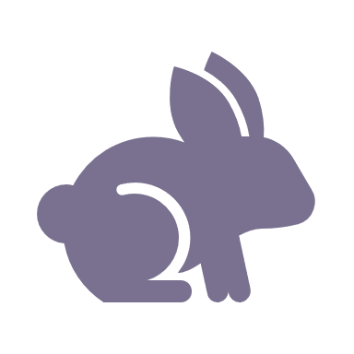 | Control rabbits 28,694ha
 | Control weeds 28,456ha
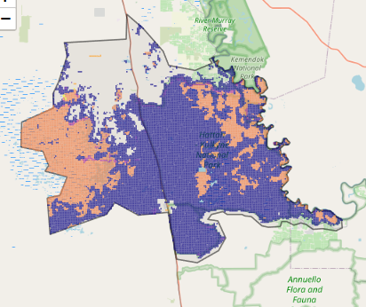
The SMP priority actions which rank among the top 3% for cost-effectiveness of that action across Victoria for much of the area (>25,000ha) are in order:

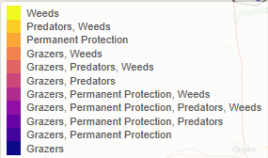

Of the top 10% of cost-effective actions, control all grazers provides the most cost-effective biodiversity benefits when considering all flora and fauna.
Actions suggested for this landscape through the nomination process are:
- control weeds, goats, rabbits and pigs
- environmental watering
- cultural flows
- fire management
- reintroduce cultural species – dingo

The most cost-effective actions for flora and fauna
Plants - Control weeds and control rabbits
Mammals, Reptiles - Combined cat and fox control
Birds - Combined cat and fox control, control total grazing pressure

For a further in depth look into SMP for this landscape please refer to NatureKit.

