Introduction
Biodiversity Response Planning (BRP) is a long-term area-based planning approach to biodiversity conservation in Victoria. It is designed to strengthen alignment, engagement and participation between government, Traditional Owners, non-government agencies and the community.
DELWP Regional staff have been working with stakeholders on actions to conserve biodiversity in specific landscapes, informed by the best available science and local knowledge.
These Fact Sheets capture a point in time, reflecting data and knowledge available in 2020. They provide information for many (but not all) landscapes across Victoria, containing general information on the key values and threats in each area, as well as the priority cost-effective actions that provide the best protection of biodiversity. Fact Sheets are intended to provide useful biodiversity information for the community, non-government and government organisations during project planning and development.
Further information and the full list of Fact Sheets is available on the Department’s Environment website.

Landscape description
This 85,508ha area encompasses the south eastern suburbs of Melbourne. In its northeast, it includes the western slopes of Mt Dandenong, and extends across to St Kilda in the west. Although highly urbanised and modified, the area contains coastal and wetland areas, some larger parks, and important parcels of native vegetation, including Lysterfield Park and Langwarrin Flora and Fauna Reserve. Due to the high population of the area, the open space plays an important role in helping people value and connect with nature. The landscape has 14% native vegetation, and 10% public land.

Cultural importance
We recognise that the entire landscape has high cultural value for Traditional Owners. Some landscapes have notable cultural importance based on knowledge shared by Traditional Owners. This landscape includes traditional country of the Bunurong people and the Wurundjeri people.
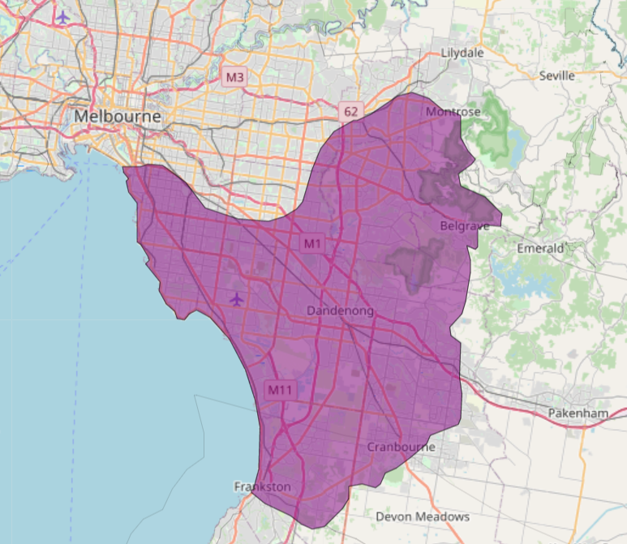

Figure 1: Map showing location of Melbourne – South East landscape (purple).
Habitat Distribution Models identify 13 species with more than 5% of their Victorian range in this landscape | Traditional Owners, stakeholders and community groups identified the following species of interest
- 12 Plant species  - 6 species with more than 10% of statewide range in area  - Notable species: Swamp Plantain (48% statewide range in area), Kilsyth South Spider-orchid (endangered, 45% statewide range in area), Clustered Lily (rare, 26% statewide range in area), Red-tip Greenhood (rare, 13% statewide range in area), Grey Billy-buttons (endangered 11% statewide range in area), Sunshine Diuris (endangered, 10% statewide range in area) | - Entolasia stricta  - Asterolasia asteriscophora subsp. albiflora  - Many orchids including: Pterostylis tasmanica, Corybas aconitiflorus, Pterostylis grandiflora, Caladenia oenochila, Prasophyllum lindleyanum
- 1 Mammal species  - 0 species with more than 10% of statewide range in area  - Notable species: Grey-headed Flying-fox (vulnerable, 7.9% statewide range in area), Southern Brown Bandicoot (near threatened, 2.0% statewide range in area) | - Southern Brown Bandicoot  - Eastern Pygmy Possum
- 0 Reptile species with more than 5% of their Victorian range in this landscape  - Notable species: Eastern Snake-necked Turtle, data deficient, 4.1% statewide range in area), Four-toed Skink (near threatened, 3.4% statewide range in area), Glossy Grass Skink (vulnerable, 3.2% statewide range in area) | - Swamp Skink
- 0 Bird species with more than 5% of their Victorian range in this landscape  - Notable species: Little Wattlebird (5.0% statewide range in area), Eastern Koel (4.8% statewide range in area) | - White-bellied Sea-Eagle  - Powerful Owl  - Latham's Snipe
- 0 species of amphibians with more than 5% of their Victorian range in this landscape  - Notable species: Pobblebonk Frog (Limnodynastes dumerilii insularis, 2.9% statewide range in area), Southern Toadlet (vulnerable, 2.4% statewide range in area) | - Growling Grass Frog  - Victorian Smooth Froglet  - Southern Toadlet
Other species | - Dwarf Galaxias

Strategic Management Prospects
Strategic Management Prospects (SMP) models biodiversity values such as species habitat distribution, landscape-scale threats and highlights the most cost-effective actions for specific locations. More information about SMP is available in NatureKit.
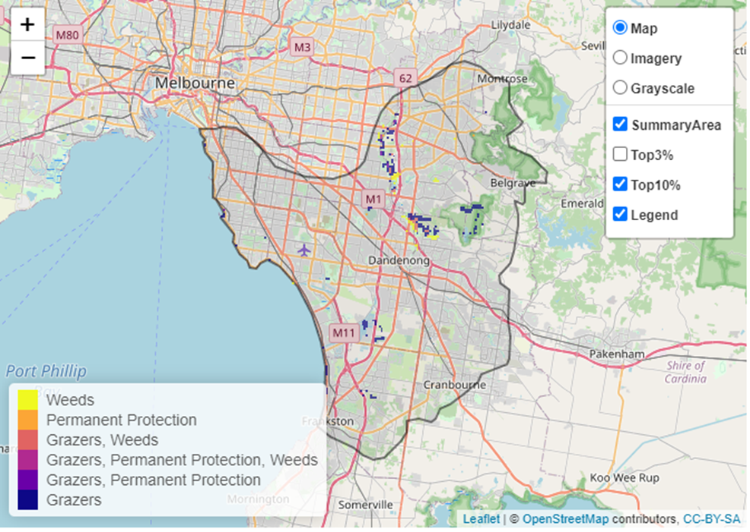
Areas of Melbourne – South East shown in Figure 2 have highly cost-effective actions (within the top 10% of cost-effectiveness for that action across the state) that provide significant benefit for biodiversity conservation.
Figure 2: The SMP priority actions which rank among the top 10% for cost-effectiveness of that action across the state. “Grazers” includes deer, domestic grazing, goats, horses, over-abundant kangaroos, pigs, rabbits and total grazing pressure

Actions with area in the top 3% and top 10%
Specific Action | Area in top 3% (ha) | Area in top 10% (ha)
Domestic Grazing Control | 0 | 870
Control Rabbits | 0 | 395
Revegetation | n/a | 343
Control Weeds | 0 | 233
Permanent Protection | 40 | 106
Control Foxes | 0 | 25
Control Cats | 0 | 20

The most cost-effective action for flora & fauna
Plants, Birds, Mammals, Amphibians and Reptiles - Control domestic stock grazing
For a further in depth look into SMP for this landscape, please refer to NatureKit.

Current actions in Melbourne – South East
Specific Actions | Current actions – top 10% (ha) | Current actions – outside top 10% (ha)
Control Weeds | 17 | 207
Control Rabbits | 2 | 32
Permanent Protection | 10 | 19
Domestic Grazing Control | 10 | 19
Control Foxes | 0 | 19
Revegetation | 0 | 19

Current actions – top 10% = The area (ha) of the specific action currently occurring in locations identified by SMP as being in the top 10% for cost-effectiveness for that action across the state
Current actions – outside top 10% = The area (ha) of the specific action currently occurring in locations within this landscape that are not identified by SMP as being in the top 10% for cost-effectiveness for that action across the state

What you told us
SMP is just one tool to use in the process of understanding biodiversity values. Feedback from our stakeholders is also vitally important and forms the basis of our understanding of knowledge gaps.

Melbourne – South East was identified by stakeholders as a focus landscape in the ‘small’ category in Port Phillip region.

Stakeholder interest

Important landscapes
- A very large number of parks, reserves, waterways, wetlands and biozones were identified by stakeholders in this landscape
- Elster Creek and Elwood Canal
- Cranbourne Botanic Gardens
- Cranbourne Race Training Complex and surrounds
- Cranbourne Wetlands
- Wilson Botanic Park
- Edithvale-Seaford Wetlands/Eastern Treatment Plant – Eumemmerring Creek (Melbourne Water)
- Pines Flora and Fauna Reserve
- Langwarrin Flora and Fauna Reserve
- Baluk Willam Nature Conservation Reserve
- Dandenong Police Paddocks Reserve
- Lysterfield Park
- Churchill National Park
- Dandenong Ranges National Park
- Dandenong Valley Parklands
- Braeside Park

Current activities/programs/partnerships
- Living Links program – multiple creeks, rivers and catchments
- Living Melbourne – Our Metropolitan Urban Forest
- Dandenong Catchment – Living Links region; Living Links priority corridors
- Port Phillip and Westernport CMA Regional Catchment Strategy – Naturelinks – Living Links Dandenong Ranges to Port Phillip Bay
- City of Casey – Biodiversity Assessment
- Revitalising Dandenong Creek (Port Phillip and Westernport CMA)
- City of Casey – Lower Dandenong Creek Management Plan
- City of Casey – Grey Headed Flying Fox Management Plan
- Fauna Monitoring – Olinda Ridge track
- Metropolitan Open Space Strategy
- Melbourne Strategic Assessment Program
- Parks Victoria Dandenong Ranges National Park Peri-urban weeds program
- Various Friends of groups, Landcare groups and other community groups focusing on biodiversity conservation
- Trust for Nature land covenanting program

Additional threats
Threats identified through the consultation process (in addition to those modelled in SMP):
- Hard rubbish dumping
- Loss of remnant vegetation, including clearing on private land
- Predation on wildlife by dogs, cats and foxes
- Genetic isolation of flora and fauna populations
- Clearing for urban development
- Disconnection of people from nature as area becomes more urbanised

