Introduction
Biodiversity Response Planning (BRP) is a long-term area-based planning approach to biodiversity conservation in Victoria. It is designed to strengthen alignment, engagement and participation between government, Traditional Owners, non-government agencies and the community.
DELWP Regional staff have been working with stakeholders on actions to conserve biodiversity in specific landscapes, informed by the best available science and local knowledge.
These Fact Sheets capture a point in time, reflecting data and knowledge available in 2020. They provide information for many (but not all) landscapes across Victoria, containing general information on the key values and threats in each area, as well as the priority cost-effective actions that provide the best protection of biodiversity. Fact Sheets are intended to provide useful biodiversity information for the community, non-government and government organisations during project planning and development.
Further information and the full list of Fact Sheets is available on the Department’s Environment website.

Landscape description
This 104,741ha area stretches from the southern edge of Sunbury to Werribee, and from Melton to the outer western suburbs of Melbourne. It covers the future Western Grasslands Nature Conservation Reserve, the Organ Pipes National Park, Brimbank Park and many smaller grassland reserves. The grasslands and grassy woodlands in this area are severely depleted from their original extent. The landscape has 27% native vegetation, and 5% public land.
This landscape has a partial overlap with the VVP - East (Victorian Volcanic Plains - East) landscape. For more information please refer to the VVP - East Fact Sheet in the full list of Fact Sheets.

Cultural importance
We recognise that the entire landscape has high cultural value for Traditional Owners. Some landscapes have notable cultural importance based on knowledge shared by Traditional Owners.
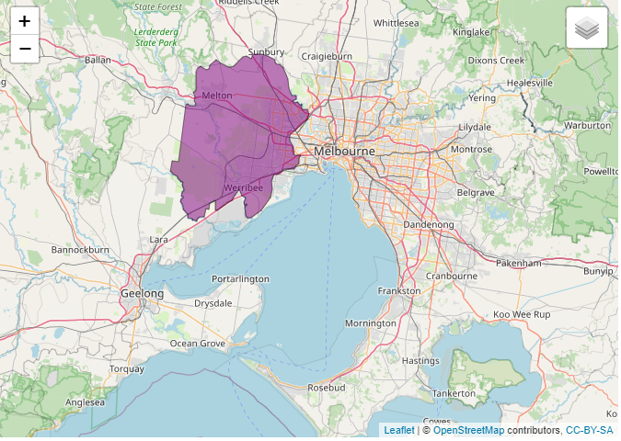
This landscape includes lands of the Wurundjeri people, Wadawurrung people and the Bunurong people.
Figure 1: Map showing location of the Grasslands of Western Melbourne landscape (purple).

Habitat Distribution Models identify 32 species with more than 5% of their Victorian range in this landscape | Traditional Owners, stakeholders and community groups identified the following species of interest
- 29 Plant species  - 11 species with more than 10% of statewide range in area  - Notable species: Small Golden Moths (endangered, 66% of statewide range in area), Heath Spear-grass (rare, 48% of statewide range in area), Werribee Blue-box (endangered, 42% of statewide range in area), Fragrant Saltbush (rare, 41% statewide range in area) | - Button Wrinklewort  - Spiny Rice Flower  - Sunshine Diuris  - Large-fruit Groundsel  - Matted Flax Lily  - Small Scurf-pea  - Curly Sedge  - Small Milkwort
- 0 Mammal species with more than 5% of statewide range in area  - Notable species: Fat-tailed Dunnart (near threatened, 1.7% statewide range in area), Common Dunnart (vulnerable, 1.5% statewide range in area) | - Fat-tailed Dunnart
- 2 Reptile species  - 2 species with more than 10% of statewide range in area  - Notable species: Grasslands Earless Dragon (critically endangered, 24% statewide range in area), Grass Skink FORM (P.pag/cry) (16% statewide range in area) | - Striped Legless Lizard  - Grassland Earless Dragon
- 0 Bird species with more than 5% of statewide range in area
- Notable species: Spotted Harrier (4.3% statewide range in area)
- 1 species of amphibian  - 1 species with 10% of statewide range in area  - Notable species: Pobblebonk Frog (Limnodynastes dumerilii variegatus, 10% statewide range in area), Pobblebonk Frog (Limnodynastes dumerilii insularis, 3.1% statewide range in area), Growling Grass Frog (endangered, 2.3% statewide range in area) | - Growling Grass frog
Other species | - Golden Sun Moth

Strategic Management Prospects
Strategic Management Prospects (SMP) models biodiversity values such as species habitat distribution, landscape-scale threats and highlights the most cost-effective actions for specific locations. More information about SMP is available in NatureKit.
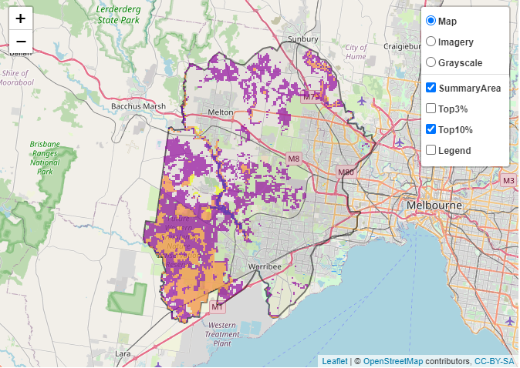
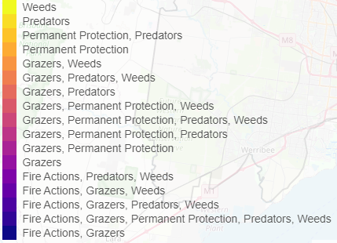
Some areas of Grasslands of Western Melbourne (coloured areas on Figure 2) have highly cost-effective actions (within the top 10% of cost-effectiveness for that action across the state) that provide significant benefit for biodiversity conservation.
Figure 2: The SMP priority actions which rank among the top 10% for cost-effectiveness of that action across the state. “Grazers” includes deer, domestic grazing, goats, horses, over-abundant kangaroos, pigs, rabbits and total grazing pressure
Actions with area in the top 3% and top 10%
Action | Area in top 3% (ha) | Area in top 10% (ha)
Control Rabbits | 1,354 | 31,821
Control Weeds | 420 | 9,094
Revegetation | n/a | 4,448
Control Foxes | 5 | 1,828
Ecological Burning | 0 | 1,003
Control Cats | 0 | 783
Control Pigs | 0 | 651
Control Overabundant Kangaroos | 0 | 538
Domestic Grazing Control | 0 | 154

The most cost-effective action for flora & fauna
Plants, Birds, Mammals, Amphibians and Reptiles - Control rabbits

For a further in depth look into SMP for this landscape, please refer to NatureKit.

Current actions in the Grasslands of Western Melbourne
Specific Actions | Current actions – top 10% (ha) | Current actions – outside top 10% (ha)
Control Weeds | 53 | 133
Control Foxes | 44 | 47
Control Rabbits | 37 | 82
Permanent Protection |  | 47
Domestic Grazing Control |  | 47
Control Pigs |  | 47

Current actions – top 10% = The area (ha) of the specific action currently occurring in locations identified by SMP as being in the top 10% for cost-effectiveness for that action across the state
Current actions – outside top 10% = The area (ha) of the specific action currently occurring in locations within this landscape that are not identified by SMP as being in the top 10% for cost-effectiveness for that action across the state

What you told us
SMP is just one tool to use in the process of understanding biodiversity values. Feedback from our stakeholders is also vitally important and forms the basis of our understanding of knowledge gaps.

Grasslands of Western Melbourne was identified by stakeholders as a focus landscape of interest in the ‘large’ category in Port Phillip region.

Stakeholder interest

Important landscapes
- A large number of conservation reserves, grassland communities and species were identified within this landscape, including Organ Pipes National Park, Jacksons Creek Streamside Reserve (SSR), Banchory Grove Grassland Nature Conservation Reserve (NCR), Clarke Road SSR, Ravenhall NCR, Gilbertsons Grassland NCR, Angliss Grassland NCR, Derrimut Grassland NCR, Laverton Grasslands Flora Reserve, Werribee Regional Park, Western Grasslands NCR, Werribee River SSR, Mount Cottrell NCR
- The Werribee River, Kororoit Creek and Little River
- Cunningham Swamp (Melbourne Water)

Additional important communities
- Plains Grassland Ecological Vegetation Class

Current activities/programs/partnerships
- Living Melbourne - Our Metropolitan Urban Forest
- Port Phillip and Westernport CMA Regional Catchment Strategy – Naturelinks – Werribee River Biolinks Action Plan Werribee River
- Port Phillip and Westernport CMA Regional Catchment Strategy – Naturelinks – Brisbane Ranges to You Yangs (concept phase)
- Port Phillip and Westernport CMA Regional Catchment Strategy – Naturelinks – Kororoit Creek Regional Strategy
- Greening the West – 1 Million Trees (Maribyrnong)
- DELWP threatened species programs
- Melbourne Strategic Assessment
- Parks Victoria on ground actions, including Western Grasslands Reserve and programs such as Peri-urban Weeds
- Biodiversity Response Planning project 077 – Peaks to plains: enhancing and connecting the You Yang Ranges and Werribee Plains
- Various Friends of groups, Landcare groups and other community groups focusing on biodiversity conservation
- Trust for Nature land covenanting program

Additional threats
Threats identified through the consultation process (in addition to those modelled in SMP):
- Over-browsing
- Water regimes, drought
- Inappropriate fire regimes
- Association between rabbits and Chilean Needle Grass
- European Hare
- Adjacent development hampering ability to conduct planned burning
- Modified watershed
- Climate change

